This lesson focuses on which animals make good pets and how to care for them. It builds on the work from the lesson We all have basic needs.

Curriculum objectives
Pupils should learn:
- that pets need to be looked after
- that all animals should be treated with respect
- that all animals have needs.

Learning outcomes
At the end of this lesson:
- most pupils: know that animals have needs just like humans, and that these needs include food, water, companionship, a suitable place to live, being looked after by a vet if they are ill, and the freedom to behave naturally. They begin to appreciate the ways in which humans have a responsibility towards all animals - wild animals, farm animals and pets
- some pupils have not made so much progress and: know that animals have needs just like humans and that these needs include food, water, companionship, a suitable place to live, being looked after by a vet if they are ill, and the freedom to behave naturally. They appreciate that humans have a responsibility to look after animals properly
- some pupils have progressed further and: know that animals have needs just like humans, and that these needs include food, water, companionship, a suitable place to live, being looked after by a vet if they are ill, and the freedom to behave naturally. They begin to appreciate the ways in which humans have a responsibility towards all animals - wild animals, farm animals and pets. They recognise that pets have different needs, and that not everyone makes a suitable pet owner.

Starter activity
Review basic needs
- Run through the basic needs for animals that the class established in the lesson We all have basic needs (see Useful websites tab).
- Some children could make a grid to compare the needs of different animals, such as carnivores, herbivores and rodents.
Learning styles: auditory.

Main activity
Good pets
- Show the pupils pictures of different animals (see the image collections Pets, Farm animals and School grounds) and ask them to say which they would like to have as a pet. Ask them to explain their choices. The pictures of farm animals and wildlife might make the pupils giggle, but it should also make them think about why some animals make good pets and others do not.
- Talk about the way different animals live and what they need to be happy and healthy (see the factsheet The five freedoms in the Dowloads tab. Could you keep a cow in your bedroom? Would a badger be happy in a cage?
How do we look after our pets?
- When you have a shortlist of potential pets, ask the pupils to work in groups and to talk about what one of the animals on your list would need. Encourage the pupils to listen to what the others in their group have to say. As a whole class, ask each group in turn to contribute one need. Collate these on the board. Do any of the pupils have their own pets?
- Encourage them to talk through the daily or weekly routine involved in caring for their pets (see the Pet care section of the RSPCA website - see Useful websites tab).
- Show the pupils examples of equipment that helps us to look after pets, such as a brush, collar, food bowl and so on. Talk about other aspects of pet care, such as going to the vet's and arranging for the animal to be looked after if you go on holiday. Make sure the pupils understand that it is a huge responsibility to have a pet. It takes a lot of time and commitment and can be expensive.
Learning styles: visual, kinaesthetic.

Plenary activity
How hard is it?
- Ask the pupils what they have learned about keeping a pet. Ask them how they feel about people who don't care for their pets properly. Invite them to explain what, if anything, they might do differently as a result of this activity.
- Work in groups, using the collection of pets images. Each group should decide which pets are the most difficult to look after and which are not so difficult. Place the pets in order, from least to most difficult. The groups may have different ideas, which they can discuss. Alternatively, use soft toys for this activity.
Learning styles: visual, auditory, kinaesthetic.

Assessment
Plenary activity - review and discussion of work covered.

Extension activities
- Set up the vet role play area (see Display section) in the classroom. Pupils can take it in turns to be the animal's owner and the vet. Ask the pupils to invent questions for each other based on what they have learned about pet care.
- They can then move on to the questions on the worksheet At the vet's (see Downloads tab). The pupils will be able to find the answers to these questions in the Pet care section of the RSPCA website (see Useful websites tab).
- Alternatively, you can cut up the question and answer sheets and ask pupils to match the right answers to the questions (see answer sheet and teachers' notes in Downloads tab).
- Watch the videos in the Useful websites tab. Ask the pupils to suggest some of the things they have learnt about what pets need.

Display
- Create a vet's corner or surgery. You will need boxes and soft toy animals. Put one animal in a box with a card that says, for instance, 'The dog has a sore paw' or draw a picture and ring where the dog is hurt.
- Add the things that the animal needs to be treated, such as a toy syringe, paper lampshade to stop it biting its stitches and vaseline for ointment. (Use with the usual health and safety cautions.)
- You could also provide a toy phone, and writing pads for making appointments. Old white shirts make good vets' coats and a toy medical kit will be popular.

Vocabulary
cysur / comfort cwmnïaeth / companionship ymarfer / exercise
bwyd / food iachus / healthy cariad / love
anghenion / needs cost anifeiliaid anwes / pets
chwarae / play parch / respect cyfrifoldeb / responsibility
lloches / shelter milfeddyg / vet dur / water

Useful websites
Free images packs
RSPCA - All about animals - General pet care
RSPCA - Science group
RSPCA Assured
RSPCA - About us
RSPCA resource - We all have basic needs (Welsh)
Video - What do pets need?
Video - Happy bunnies

Worksheet - At the vet's – questions

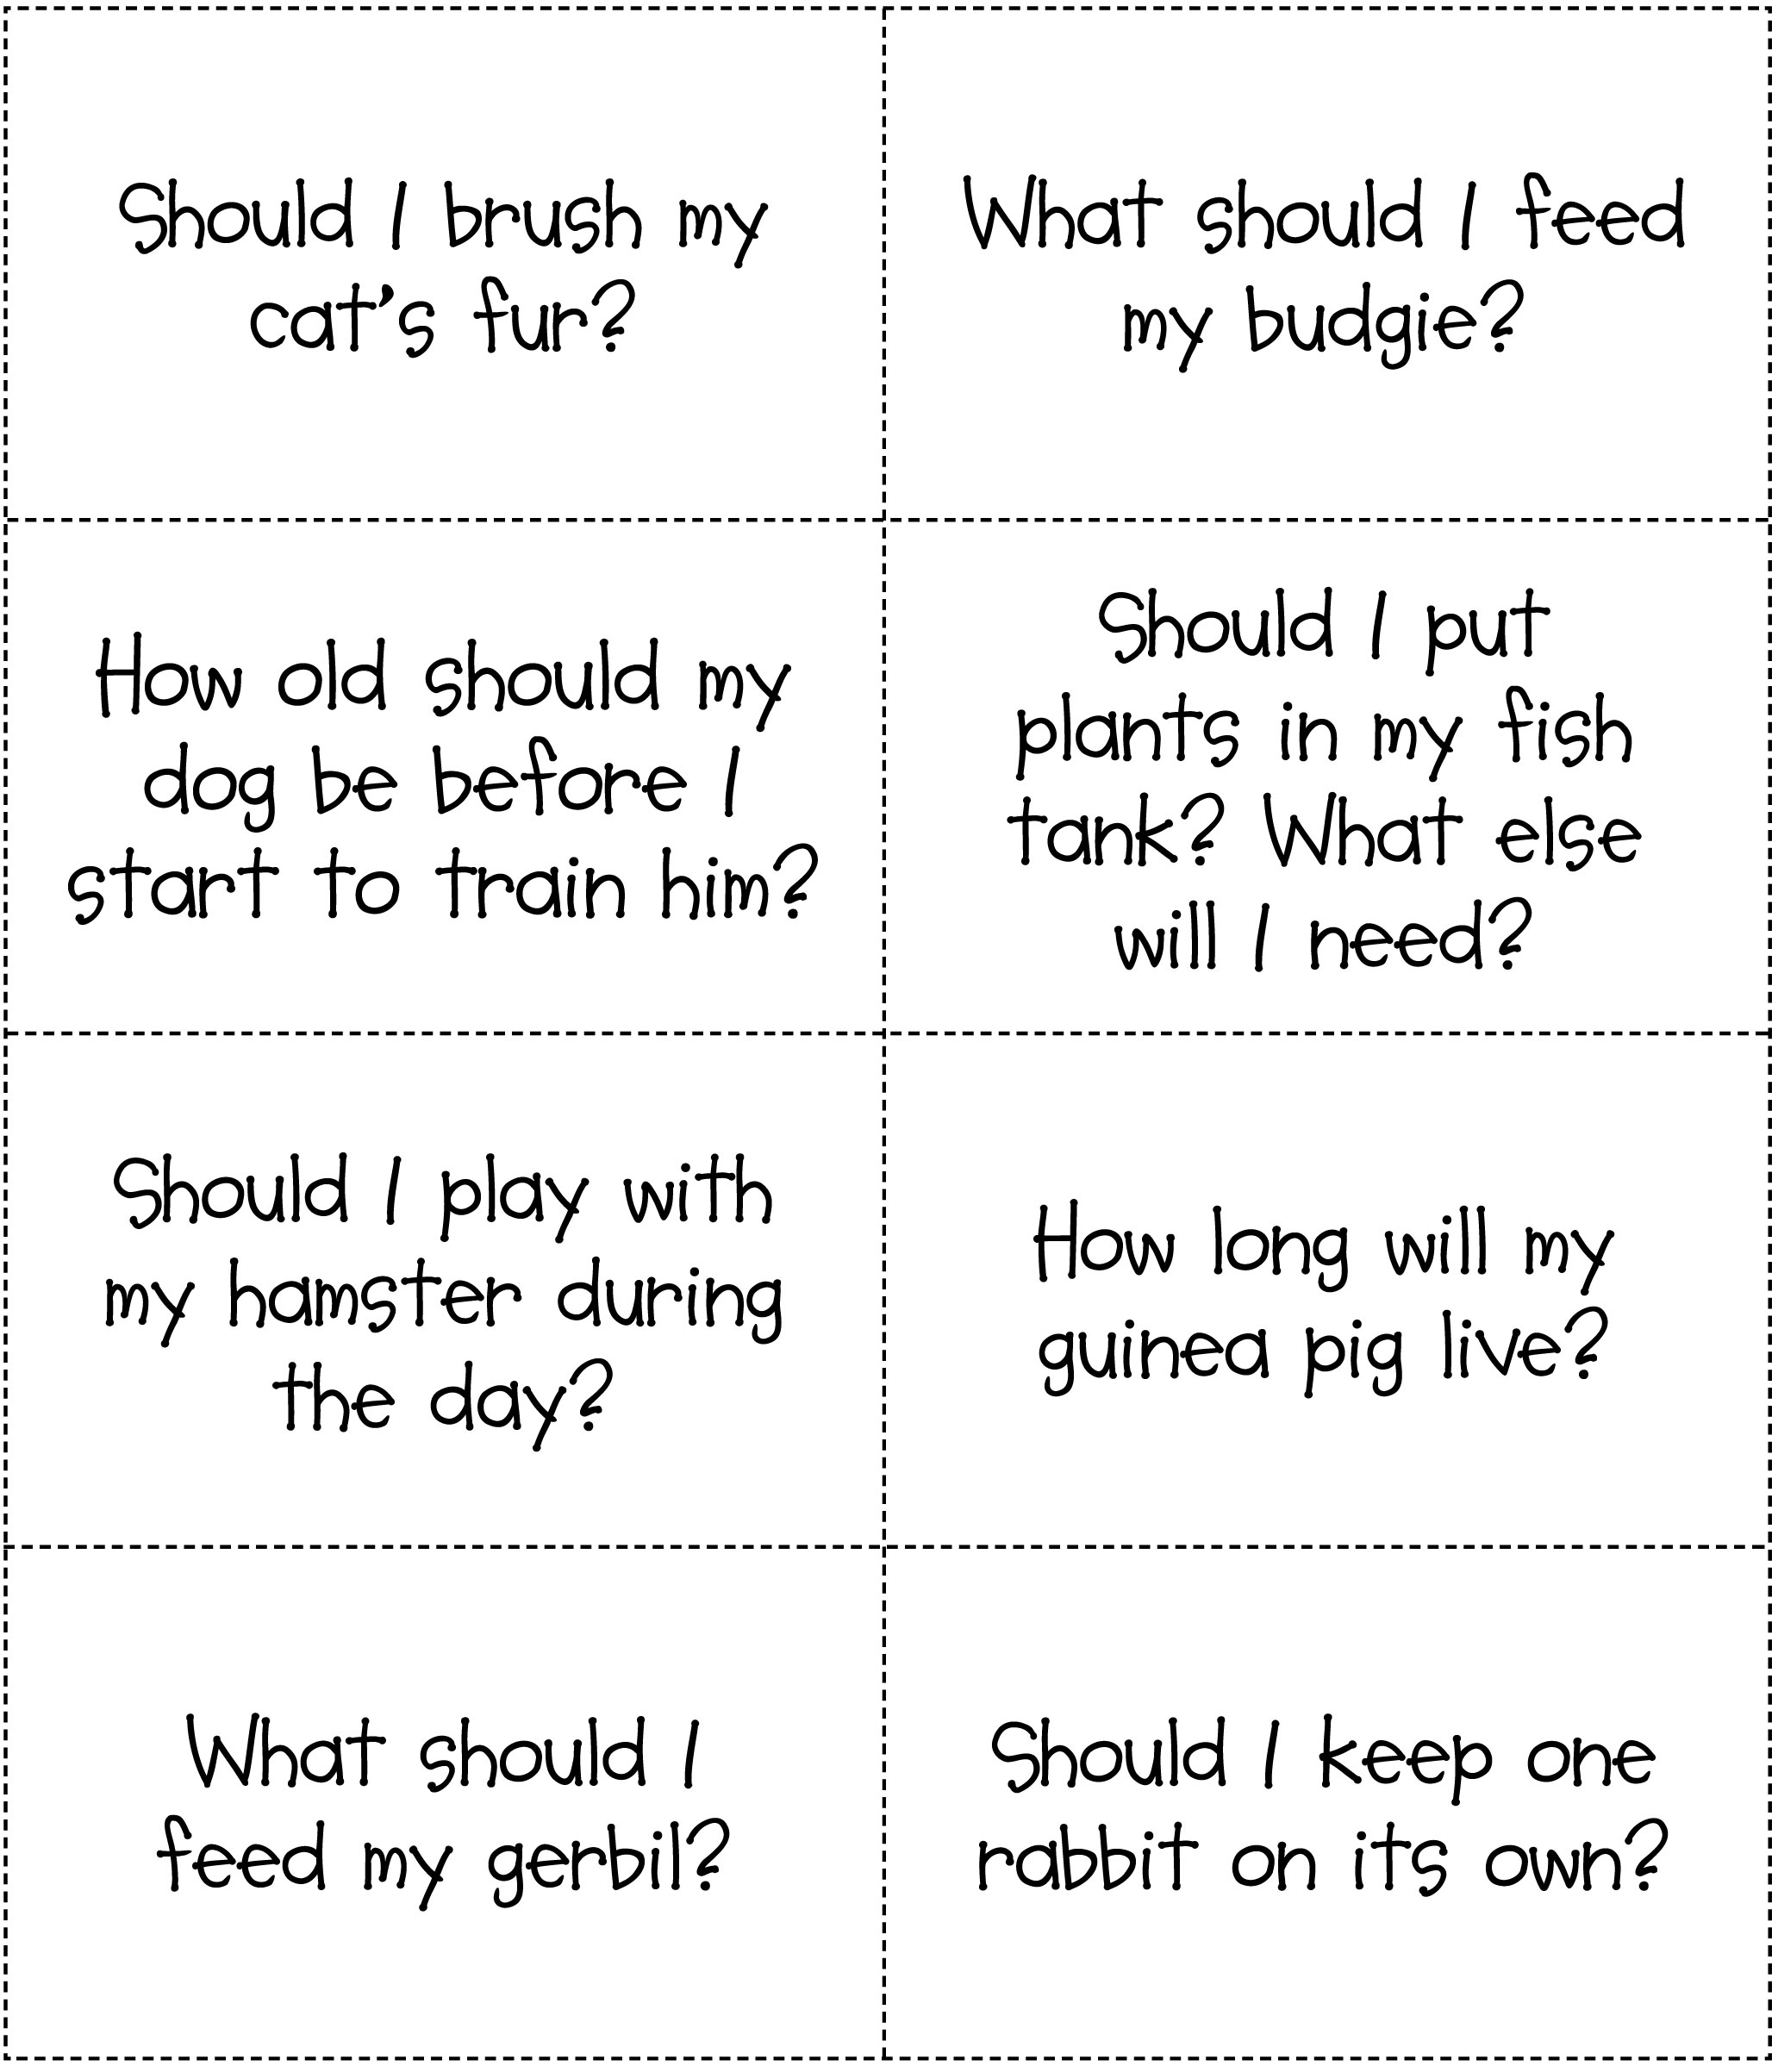
Worksheet - Gyda'r milfeddyg – cwestiynau

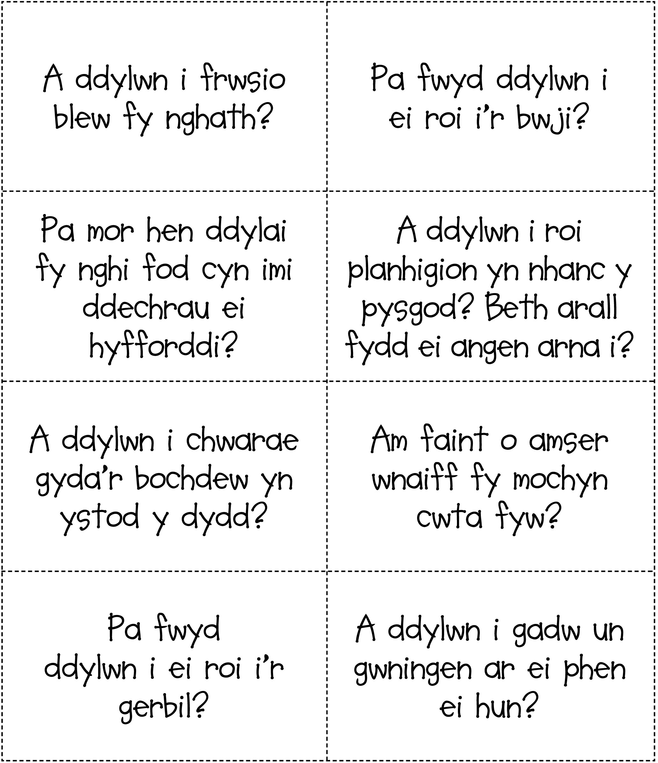
Worksheet - At the vet's – answers

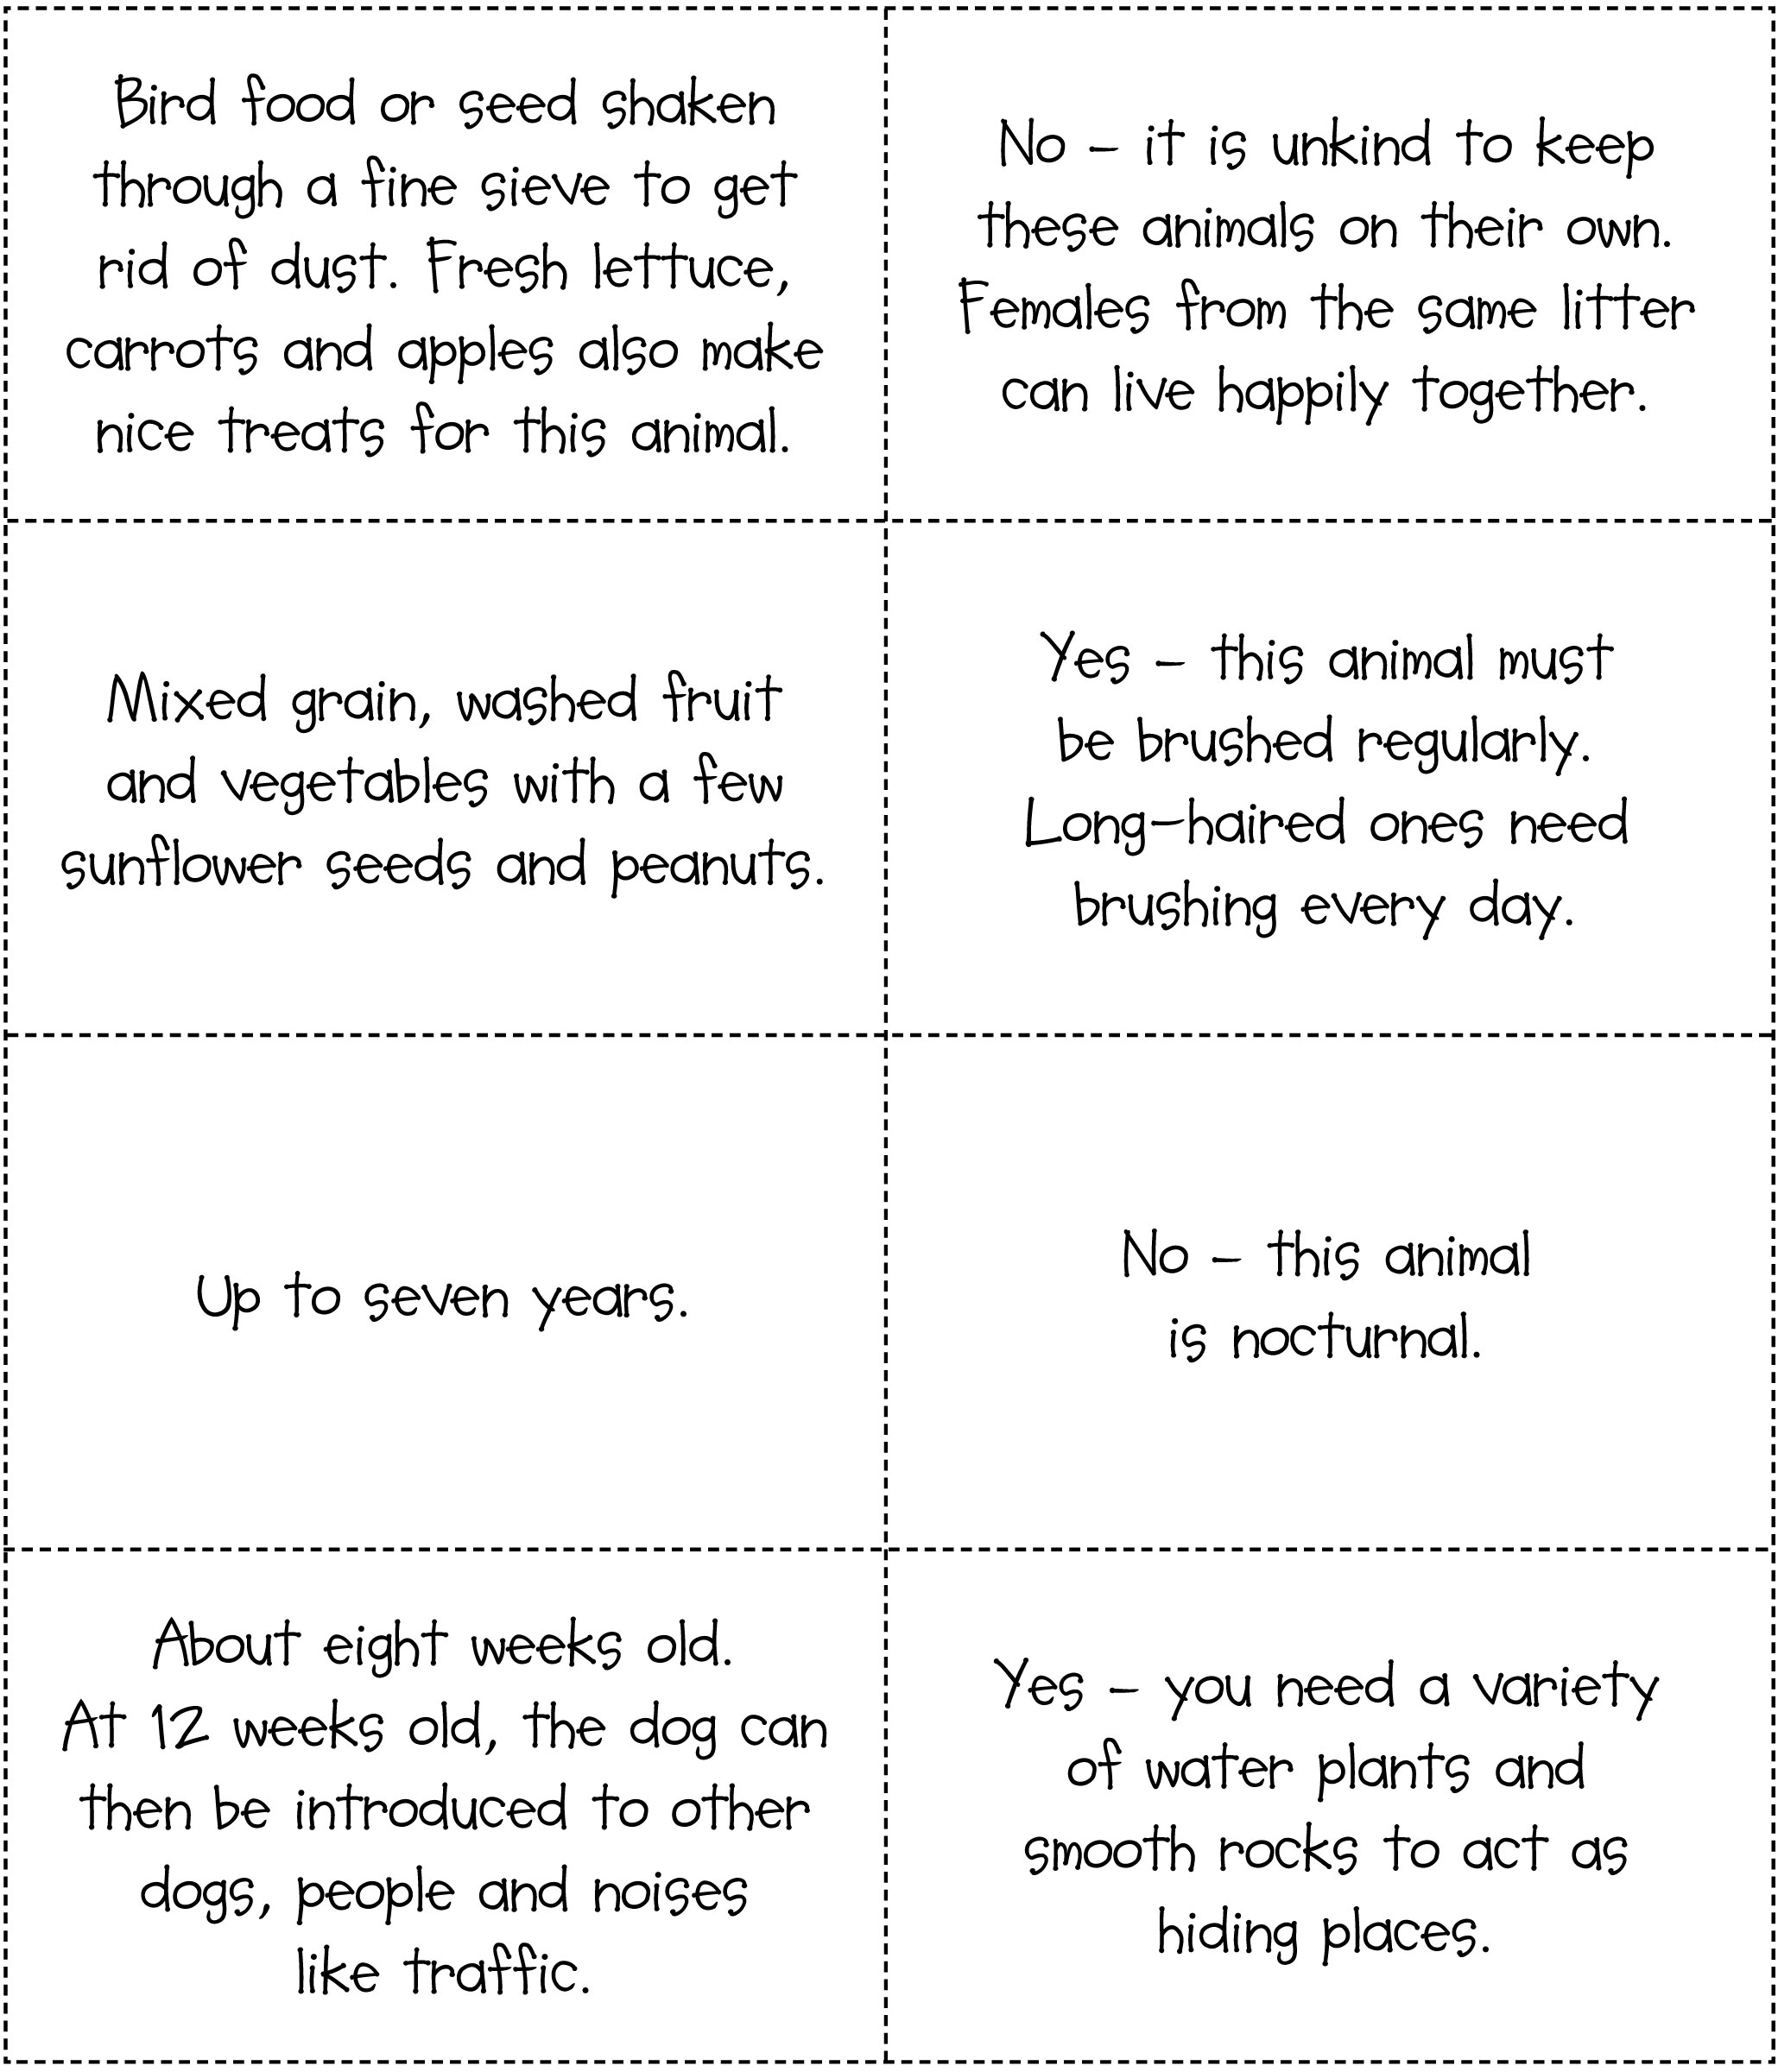
Worksheet - Gyda'r milfeddyg – atebion

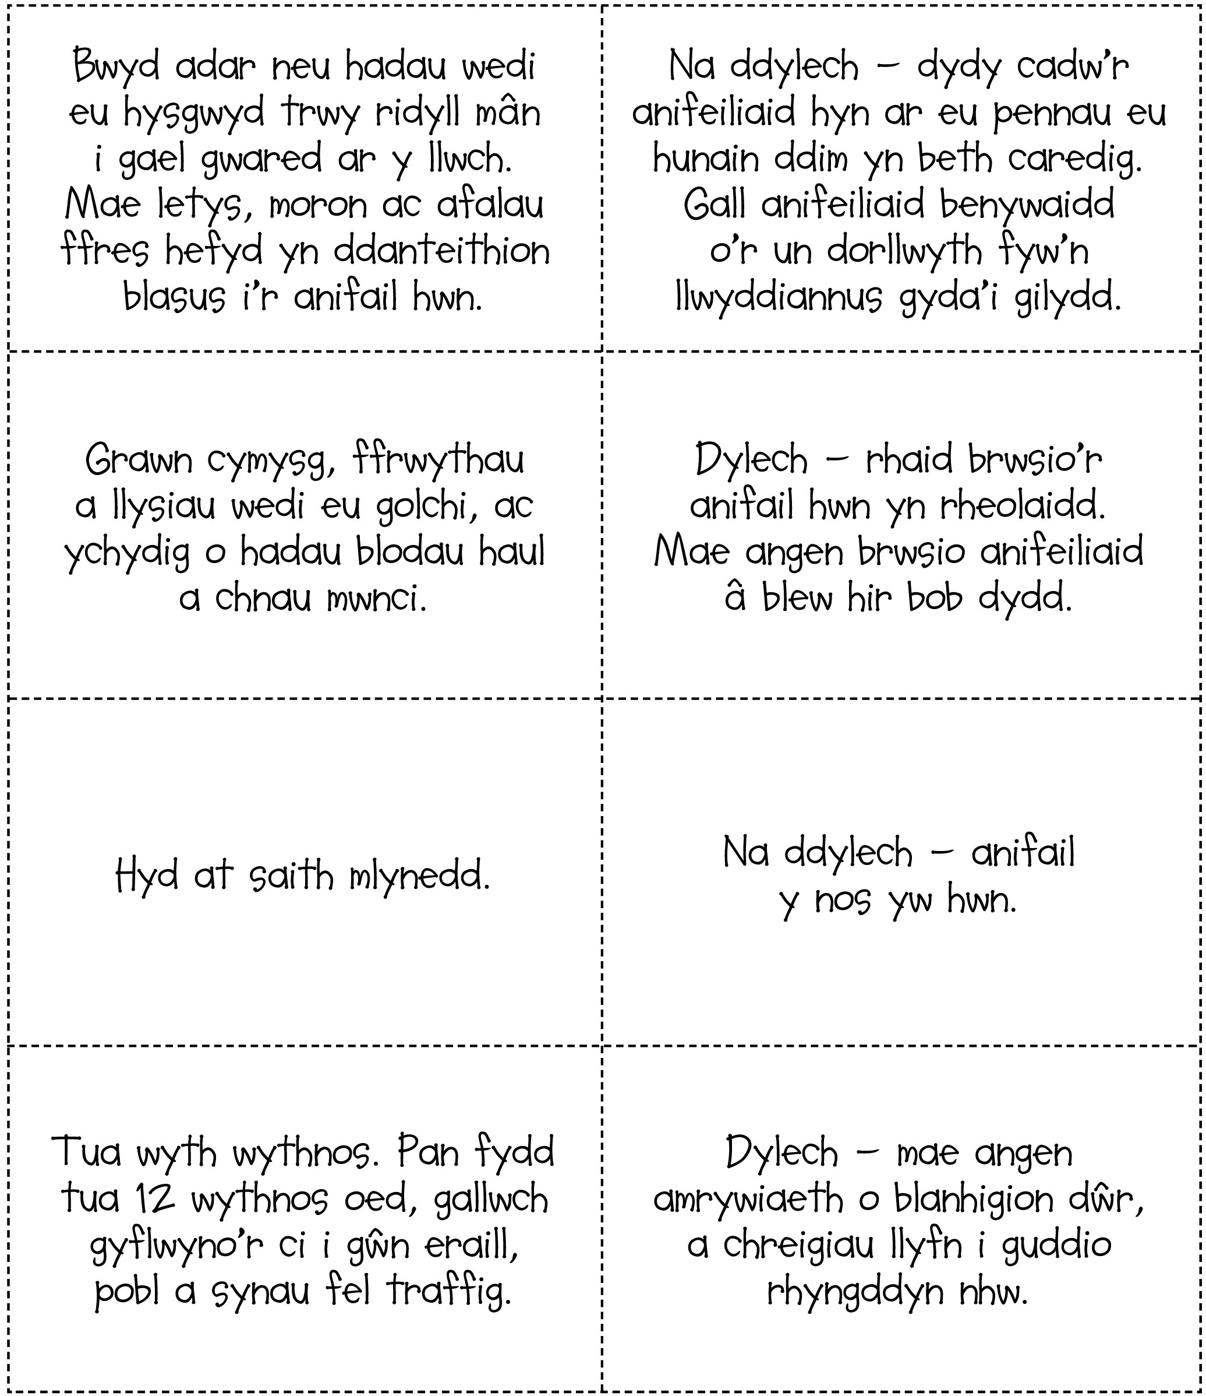
Factsheets - The five freedoms

The five freedoms are like a wish list for animals. The RSPCA believes that anyone who looks after an animal should try to give them the five freedoms:

- Freedom from hunger and thirst
by providing enough fresh water and the right type and amount of food to keep them fit.
- Freedom from discomfort
by making sure that animals have the right type of environment including shelter and somewhere comfortable to rest.
- Freedom from pain, injury and disease
by preventing them from getting ill or injured and by making sure animals are diagnosed and treated rapidly if they do.
- Freedom to express normal behaviour
by making sure animals have enough space, proper facilities and the company of other animals of their own kind.
- Freedom from fear and distress
by making sure their conditions and treatment avoid mental suffering.

Teachers – find out more in the Did you know? section of the lesson resource.
Factsheets - Y pum rhyddid

Mae’r pum rhyddid yn fath o lythyr Siôn Corn i anifeiliaid. Mae’r RSPCA yn credu y dylai pawb sy’n gofalu am anifeiliaid geisio rhoi’r pum rhyddid iddynt:

- Rhyddid rhag newyn a syched
trwy roi digon o ddwˆ r ffres a digon, ond nid gormod, o’r bwyd iawn iddynt i’w cadw’n iach.
- Rhyddid rhag anghysur
trwy wneud yn siwˆ r bod yr anifeiliaid yn cael y math iawn o amgylchedd gan gynnwys cysgod a rhywle cysurus i orffwys.
- Rhyddid rhag poen, anaf a chlefydau
trwy eu hatal rhag mynd yn sâl neu gael eu hanafu a thrwy wneud yn siwˆ r bod anifeiliaid yn cael diagnosis a thriniaeth yn gyflym os yw hynny’n digwydd.
- Rhyddid i ymddwyn yn naturiol
trwy wneud yn siwˆ r bod gan anifeiliaid ddigon o le, cyfleusterau cywir a chwmni anifeiliaid eraill yr un fath â nhw.
- Rhyddid rhag ofn a gofid
trwy wneud yn siwˆ r bod eu hamgylchiadau a’r driniaeth a gânt yn osgoi dioddef meddyliol.

Athrawon – cewch ragor o wybodaeth yn yr adran Wyddech chi? yn adnoddau’r wers.
Teachers' notes - At the vet's

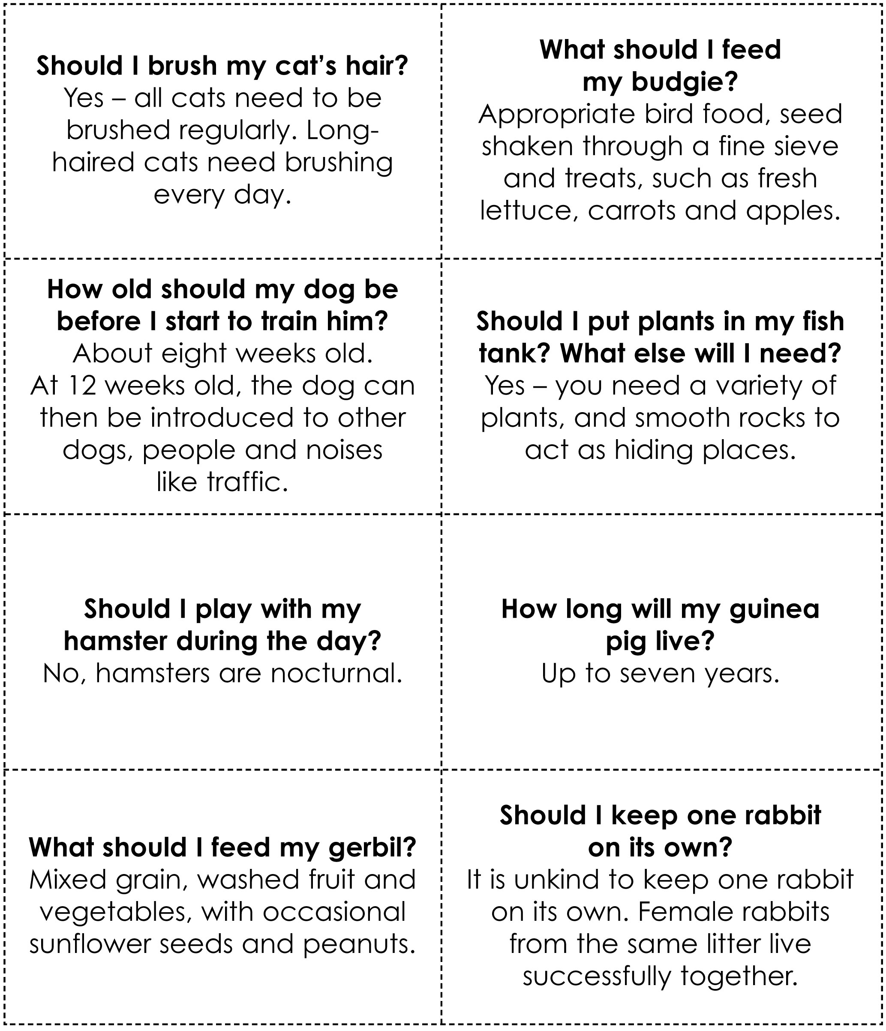
Teachers' notes - Gyda'r milfeddyg



