The aim of this session is to consider the impact of human activity on animals and the environment and to consider ways to minimise this impact. Students will consider a case study of badgers whose habitat is threatened by building development. They will explore views that are not necessarily their own, in addition to expressing their own opinions.

Starter activity
Interpreting data
- Set the scene by giving students a copy of the map of the planned development in Brock Scrub and of the badger enthusiast's diary (see worksheets Map of Brock scrub and factsheet A badger enthusiast's diary in Downloads tab).
- Working in pairs, students should plot the badger sightings on the map. The pairs should also produce a spider diagram of what badgers need. This should help them understand why badgers might live in this area.
- Ask the students to feed back their ideas to the class.
Learning styles: visual, kinaesthetic.

Main activity
Their future in our hands
- Divide the class into eight groups - one for each interested party on the Role play cards (see Downloads tab).
- Give each group a role play card from the worksheet Role play cards. The chairperson also needs the factsheet Living with badgers.
- Give the groups 10 minutes to discuss their stance and to elect one person to represent the group in the debate. This person should note down the thoughts of the group.
- Hold a debate, allowing each representative two minutes to put forward their group's opinion.
- After all viewpoints have been heard the debate can be opened to the floor, but the students must maintain their 'role view'. Allow five minutes for open debate.
Learning styles: auditory, kinaesthetic.

Plenary activity
Voting in motion
- Put up two signs at opposite ends of the room:
- 'I think the development should go ahead'
- 'I don't think the development should go ahead'.
- When the debate is finished, ask the students to stand in a line between the two signs and position themselves according to whether they agree more with one statement than the other - or in the middle if they're unsure.
- Ask individuals along the line to voice their opinions and give the reasons for their decision.
Learning styles: visual, auditory, kinaesthetic.

Differentiation
- Consider allowing students with poor literacy skills to work with more able students who could assist them with the reading task.
- Reduce the number of cards students have to read or invite them to come up with their own arguments to display.

Extension activities
- Students could design an experiment to find out the extent of an individual badger's territory while causing the minimum intrusion to the animal's life. Observation and note-taking should be primary sources of information.
- Students could discuss the best method to discover the layout of underground tunnels and what non-intrusive equipment could be used to do this.
- Students could consider similar situations where human activity affects the habitat of other wild animals such as deer, frogs and otters. They could research those habitats and consider the protection these animals have legally and what measures could be put in place to protect them.

Did you know?
- Badgers live in social groups of five to 12.
- Badgers are crepuscular (active at dawn and dusk).
- A badger’s life-span in the wild is usually about 2 years, but they can live up to 14 years.
- Adult badgers usually weigh between 6kg and 14kg.

Curriculum objectives
Students should learn:
- that living organisms are dependent on the environment and other species for their survival
- that species may be threatened as a result of human activity
- about the impact of human activity on the environment and the species within it.

Animal welfare objectives
Students should learn:
- to understand that badgers are protected by UK legislation
- to recognise that our indigenous species may be put at risk by human activity.

Learning outcomes
At the end of this lesson:
- most students: are aware that human activity can affect the habitats of animals in a variety of ways. They realise that, in England and Wales, the law protects some species and this must be taken into consideration when land development is proposed. They are able to discuss the issues raised, present their ideas, reflect on their opinions and those of others
- some students have not made so much progress and: are aware of some of the ways that human activity can affect the habitats of animals. They understand that different people have different views on the issue of animal welfare
- some students have progressed further and: have a good understanding of the impact of human activity on the habitats of animals. They understand ways in which habits of animals can be tracked, with as little intrusion as possible, to provide information so that reasoned decisions can be made. They discuss the issues raised, present their ideas and reflect on their opinions and those of others.

Vocabulary
affordable bias consultant intrusive mitigation non-intrusive

Useful websites
RSPCA - Campaigns - Back off badgers
RSPCA - Living with badgers information sheet
The Wildlife Trusts
National Assembly for Wales
Badger Trust
Countryside Council for Wales
Natural England
DEFRA
Natural England - local authorities, policy makers and developers
Natural England Advisory leaflets - Badgers

Image – Badger

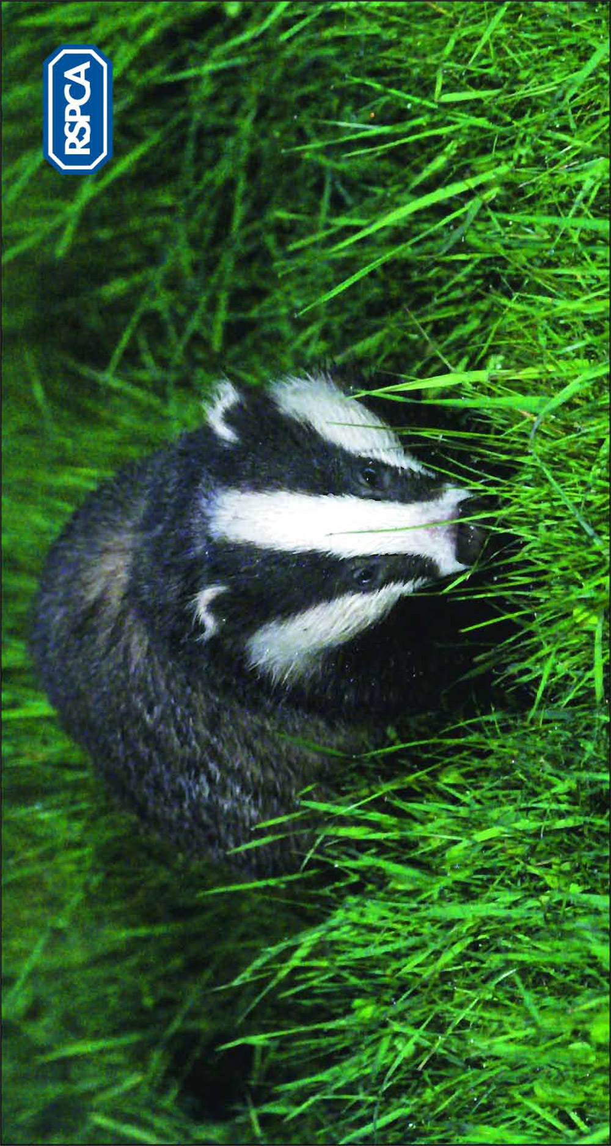
Factsheet – Living with badgers

Badger habitat
Badgers prefer areas of mixed habitat that can provide both food and shelter. Their setts are often in wooded areas or hedgerows on land where the soil is easy to dig and close to pasture. Here they can forage for earthworms - their main food.

Badgers may enter gardens as they move between setts or look for food. They may even set up home in secluded areas in gardens.

Threats
- Traffic accidents are the most common cause of badger deaths in Britain - more than
- 50,000 badgers are killed on roads each year.
- Direct persecution, e.g. illegal killing, illegal digging of their setts and baiting by dogs.
- Habitat loss affecting their setts and/or feeding areas.
- Badgers can carry bovine tuberculosis (bTB) and they have been implicated in the spread of the disease to cattle. As a result, some farmers may kill them illegally. There have been a number of badger-culling strategies undertaken by the government in the past, to try to reduce the incidence of the disease. Recent trials have shown that such culling can make matters worse and that other measures, e.g. more testing of cattle, could be more effective.

Legal protection
Badgers and their setts are legally protected under The Protection of Badgers Act 1992. The Act makes it an offence to:
- kill, injure or take a badger (except under licence)
- cruelly ill-treat a badger
- use certain prohibited firearms
- dig for a badger
- damage or destroy a badger sett, obstruct access to it or disturb a badger in it
- cause a dog to enter a badger sett
- tag or mark any badger (except under licence).

Interfering with badger setts
The Act permits the granting of a licence by Natural England or, in Wales, the Countryside Council for Wales, to ‘interfere’ with a badger sett (block, damage, obstruct access or disturb a badger in a sett) for the purpose of developing land.

Licences to kill or move badgers are only issued under exceptional circumstances to prevent serious damage to land, crops, poultry or other forms of property, or to prevent the spread of disease.

Development
If an occupied badger sett is found on a proposed site for road or housing development, the developers should provide the local planning department with a detailed ecological survey/report. The survey should include: the number of badgers that will be affected or are on the site; the likely impact of the development and mitigation measures; whether the impact is necessary or acceptable and if a licence will be required.

Developers may seek advice from the relevant licence-granting body. They may enlist the help of the local badger group, wildlife trust or ecological consultant to carry out surveys and prepare the report.

Mitigation measures
Mitigation measures, such as providing tunnels under roads, artificial setts, roadside reflectors, badger gates and fencing may also be used to try to reduce the impact that developments have on the local badger population.

Factsheet – A badger enthusiast's diary

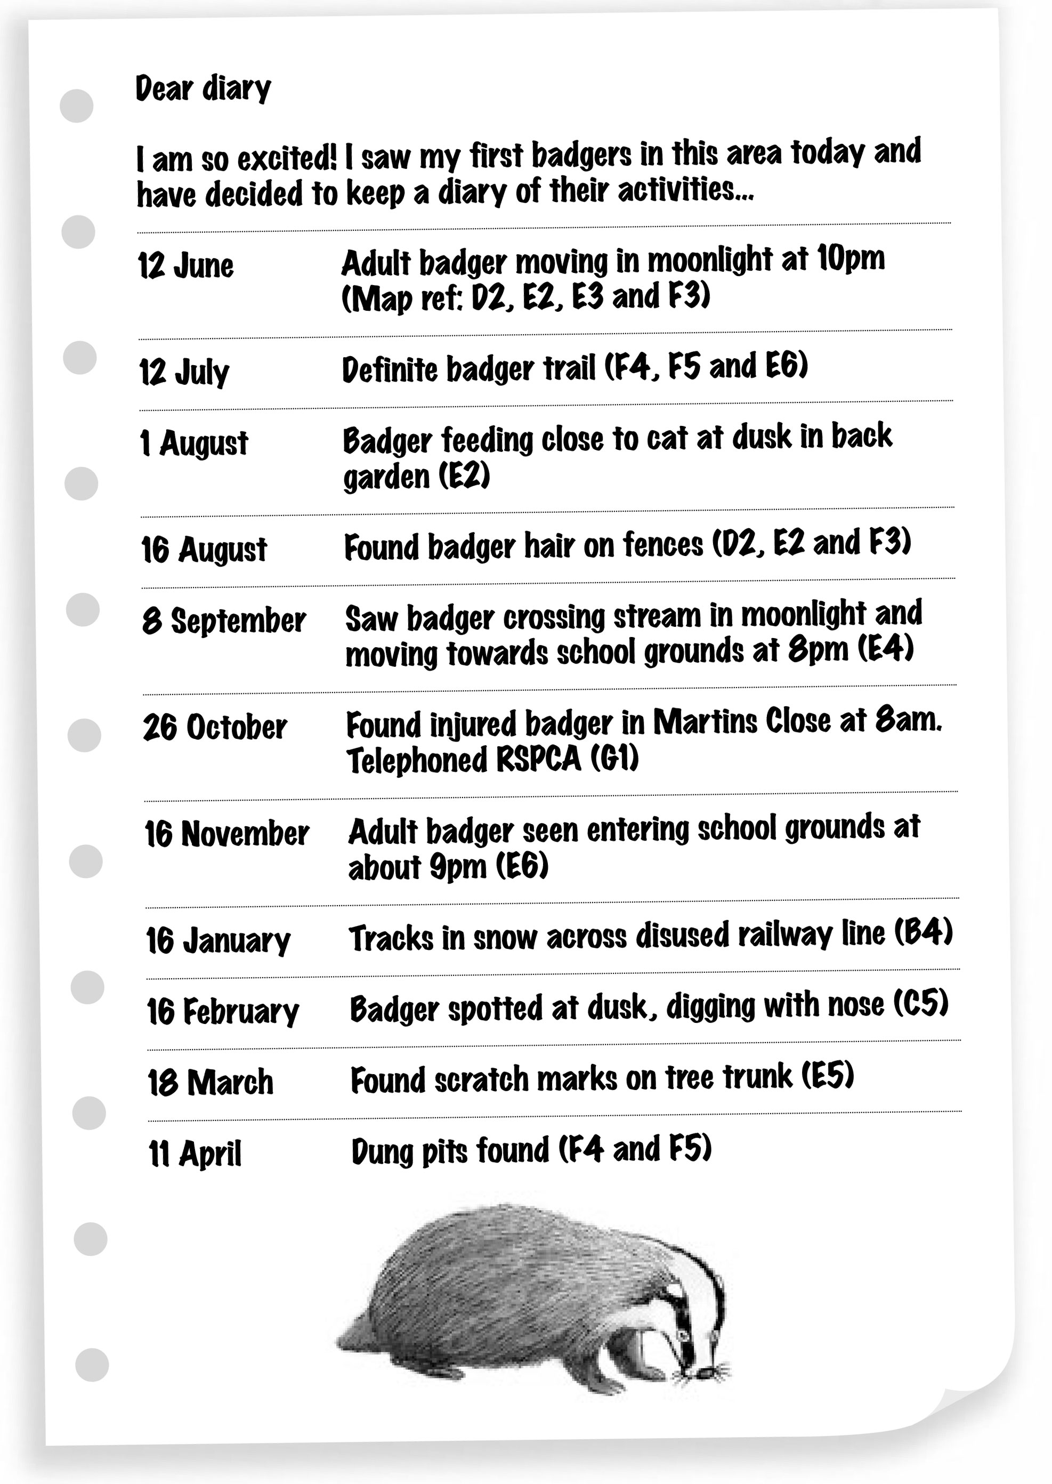
Worksheet – Map of Brock Scrub

Use this map with the Badger enthusiast’s diary to plot the area of any badger activity

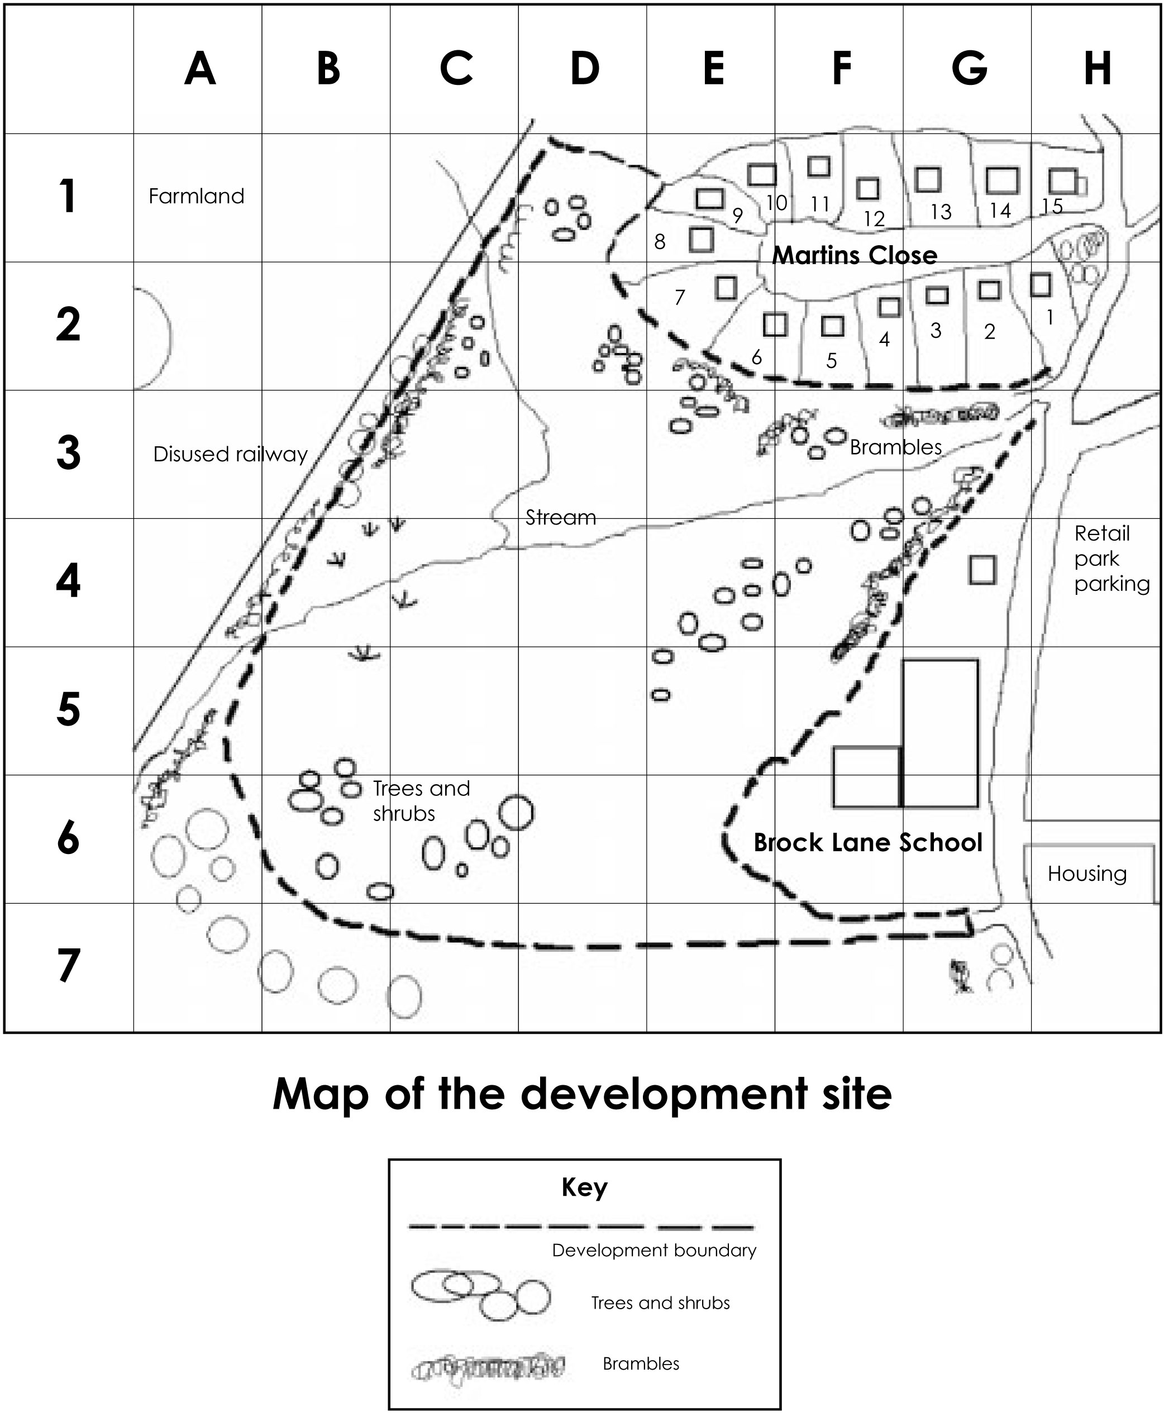

Worksheet – Role play cards

The developer
- Your job is to build new houses and sell them at a profit. You built the houses on Martins Close and would like to continue with your development as you stand to make a good profit.
- You know that there is a shortage of affordable housing in the area.
- You have employed a Wildlife Trust consultant to advise you about your impact on wildlife, and to survey the area to find out where the active badger setts are and what areas the badgers use.
- You know that you would either have to adapt your plans to ensure your development does not affect the badgers using the area or, if you wanted to block off or ‘interfere’ with some of the badger setts, you would need to apply to Natural England for a licence.
- You are willing to implement mitigation measures to help the badgers get around the site after the development, such as providing tunnels under roads, fencing and roadside reflectors where appropriate, and badger gates through fences.

Wildlife Trust consultant
- You work for a Wildlife Trust consultancy and offer professional expertise in ecology, landscape and planning. Profits from your consultancy work go to a Wildlife Trust conservation charity, with the collective aim of protecting wildlife for the future.
- You have been employed by the developer to provide environmental advice, to carry out surveys and, if necessary, to arrange permissions or licences from Natural England or the Countryside Council for Wales.
- You have visited the site and carried out surveys to find out where the badger setts are and whether they are active.
- You want to make sure that adequate provision is made for the badgers if the development does go ahead.
See: www.awtc.co.uk for examples of Wildlife Trust consultancies.

Badger protection group
- You represent a badger protection group that wants to protect the badgers and their habitat.
- Members of the badger protection group are knowledgeable badger enthusiasts, who will provide information, advice and practical help.
- The badger protection group includes some local residents who enjoy seeing the badgers in the neighbourhood and encourage them to feed in their gardens, so they can observe and study them. They object strongly to the proposed housing development plans.
- You want badgers to be protected and their habitat conserved on a local and national level. You have invited an ecological consultant as a guest to your group. He has verified that there is an active badger population at Brock Scrub.
See: www.badger.org.uk for more information about local badger groups and their policy on developments.

Planning committee member
- As councillors, you have been nominated by your political party and approved by the council to sit on the planning committee.
- Your primary role is to listen to all views, ask questions of those making deputations and reach a decision.
- As a member of the committee, you are trusted to be impartial and to make a judgement that is both legally sound and based on evidence that has been presented to you.
- You should also bear in mind that you may be expected to justify your decision to the media and residents, should they question it.

Community representative
- You represent members of the local community who would like to see Brock Scrub managed as a Local Nature Reserve (LNR).
- As a LNR, Brock Scrub would be managed for use by both people and wildlife. It would offer an opportunity for people to study and learn about nature, as well as enjoy it.
- This would also mean that Brock Scrub would be cleaned up and wellmanaged. Signposted access routes, including some disabled access paths, would be created in areas that would not disturb the badgers.
- The LNR could be funded by Natural England’s ‘Wildspaces!’ scheme.
- Local schools and community groups could safely use Brock Scrub to observe wildlife in its natural habitat.
- Local people would have wildlife training and volunteering opportunities.
See: www.english-nature.org.uk for more information about LNRs.

Impartial chairperson
- You have been asked to chair the meeting. Although you are also a local councillor and affiliated to a political party, you must remain impartial.
- You must make sure that every group is allowed five minutes to present their views.
- You will ensure that people listen to the views of others.
- You will be responsible for organising and recording the vote of planning committee members. In the case of a draw, you will have the casting vote.

Neighbouring farmer
- You farm the land on the other side of the disused railway line. At the moment, you do not think that the Brock Scrub badgers come onto your land as you think that Brock Scrub and its neighbouring gardens provide them with a home and food.
- You are concerned about the spread of bovine tuberculosis (bTB) to your cattle. Badgers can carry bTB and some people, including you, believe that badgers are responsible for the spread of this disease between cattle herds.
- You would like badgers to be culled to try to control the spread of bTB.
- If the proposed development went ahead and the badgers were disturbed, you fear that they might move onto your farmland and pose more of a risk to your cattle.

Local councillor
- As a local councillor, you always try to represent the views of the local people in your ward or community.
- This planning application is quite controversial, as it has both support and opposition from local residents. There are two main views:
  - some people want Brock Scrub to be managed for wildlife, so that local people can enjoy the wild area and the badgers’ habitat is protected
  - other people want new homes built, as there’s a shortage of affordable housing in the area. Many people can’t afford to live in their home town.
- All the local people agree that something needs to be done to Brock Scrub to get rid of the fly-tipped rubbish and burnt-out cars, and that good use should be made of the area.

Worksheet – Brock Scrub role play - introduction

Introduction
Known locally as Brock Scrub, this disused land is owned by the local authority and is a mixed habitat of grassland, shrubs and woodland. Local people use the area to walk their dogs, but the area is not looked after well and people have fly-tipped rubbish and abandoned cars.

A developer has approached the local authority and offered to buy the land to build houses, but local community and badger protection groups are campaigning for the area to become a Local Nature Reserve.

The local authority is holding a public consultation to decide the future of Brock Scrub. As part of the planning process, the plans will be discussed at the local authority's planning committee. The developer, interested groups and advisory bodies have been asked to attend a meeting to give their views and discuss the issues.

---------------------------------------------------------------------------------------------------------------
Notes

