In this activity, students will examine how introduced species can affect native species using the example of the squirrel. The session also identifies some important reasons why animals become endangered and analyses some of the measures used to conserve species.

Starter activity
Squirrel profile
Show the students images of both grey and red squirrels (see collection of images Wild animals) and ask the following key questions for each image:
- What are the needs of the animal?
- What is the animal's habitat like?
- How has its body/appearance adapted to survive in its environment?
- Record the students' ideas.
- Compare both squirrels - similarities and differences.
Learning styles: visual, auditory.

Main activity
Squirrel fact quiz
- Ask the students in pairs to name themselves either 'red' or 'grey'.
- Explain that 'red' students will be 'experts' on red squirrels whilst 'grey' students will be experts on grey squirrels.
- Give students their corresponding factsheets The red squirrel or The grey squirrel and allow them a few minutes to read and remember some of the details.
- Without the sheets, in pairs they should complete the worksheet Squirrel quiz to see what key information they remember.
- Revisit the starter activity - what additional information have they discovered?
Competing for resources
- Ask the group:
- How many of them have seen a grey squirrel in the wild?
- How many have seen a red squirrel in the wild?
- Examine some of the reasons why the red squirrel has become endangered (see factsheet The red squirrel).
Culling
- Grey squirrels are a threat to native red squirrels. Some people want to conserve the red squirrel so strongly that they think culling grey squirrels is the answer.
- Discuss some of the main methods used to control the number of grey squirrels, using the factsheet Grey squirrel control.
- Ask the students to consider each method in turn and decide whether they think it is 'Always acceptable', 'Sometimes acceptable' or 'Never acceptable'.
- Explain that the RSPCA would always prefer humane solutions and killing should only be contemplated if there is a serious problem and alternative means are ineffective or impractical.
Protecting the red squirrel
- In small groups, students should read the factsheet Case study: Durnalton and examine the problems facing the red squirrel in the imaginary village of Durnalton.
- Ask the students to consider what solutions they can devise to protect the red squirrel (an optional factsheet Possible solutions is provided to assist the students). Students may find it useful to consider the factsheets Grey squirrel control and Helping the red squirrel.
Learning styles: visual, auditory.

Plenary activity
How did it go?
- Allow each group to feed back their top three ideas for the villagers of Durnalton to use.
- What solutions were the most popular and why?
- Did any individuals disagree with other groups' outcomes?
- Which ideas might be the most suitable and practicable?
Learning styles: auditory.

Differentiation
- Ask the pupils to do their own research on red and grey squirrels, using the headings on the worksheets The red squirrel and The grey squirrel and produce their own quiz.
- Paired work & group work should provide both support and challenge for a variety of abilities.
- A factsheet Possible solutions with focused questions is provided for the Protecting the red squirrel activity.

Extension activities:
Dear MP
- Ask students to write about their own views on the topic of grey squirrel culling/removal. The worksheet Letter template structures the main points needed.
- Allow individuals to read out their written responses.
- Did they think a cull was a reasonable solution?
- Why or why not?
- Do other students agree with their viewpoint?

Did you know?
- The red squirrel is fully protected by the Wildlife and Countryside Act 1981 (as amended).
- Male squirrels are called bucks, female squirrels are called does, and babies are called kits, kittens, nestlings or pups.
- Methods of controlling grey squirrels include: live traps (cage traps), kill traps (spring traps), drey-poking and poisoning using warfarin.
- Only live trapping or shooting can be used in areas where they co-exist with red squirrels.
- Alternative methods of protecting red squirrels also include the enrichment of their habitat, refuge areas and red squirrel feeders.
- It is currently illegal to keep or release grey squirrels.

Curriculum objectives
Students should learn:
- to recognise how animals have adapted specific features suited to their habitat
- how a species of animal may become endangered due to the introduction of non-native species
- to consider the ethical and moral issues that the conservation of a species can raise.

Animal welfare objectives
Students should learn:
- that humans have a responsibility to conserve animals' habitats to ensure their survival
- that any culling of a species to protect another must be thoroughly researched and debated and must be legal and humane
- that every effort should be made to prevent an animal experiencing distress, pain or suffering.

Learning outcomes
At the end of this lesson:
- most students demonstrate knowledge of how animals are adapted to suit their environment, the competition that exists for resources and the risk to native species from introduced species.
- some students have not made so much progress and: describe and identify key features of a species and know where it lives and which other organisms live there.
- some students have progressed further and: debate possible solutions to resolve declining animal populations.

Vocabulary
competition coniferous culling deciduous endangered
evergreen extinct fragmentation habitat
introduced native non-native omnivorous
organism origins parapox virus population species

Useful websites
RSPCA - All about animals - Wildlife
The Wildlife Trusts (TWT)
Natural England
Countryside Council for Wales - Red squirrel conservation plan
Defra - Rural and countryside
Forestry Commission GB
Save our Squirrels
Factsheet – The red squirrel

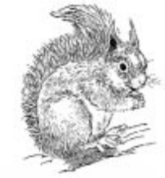
Latin name: Sciurus vulgaris
Body weight: 270-320g
Body length: 18-24cm
Tail length: 14-19.5cm
Appearance:
- Coat is generally a brownish-red colour and is moulted twice a year
- They have ear tufts, which they moult every year in autumn
- Teeth, which grow continuously at about six inches per year, need to be kept healthy by gnawing on tree branches.
Lifespan:
- Up to seven years.
Origins:
- Native to Britain and Europe and across Eurasia to China.
Population in UK:
- About 140,000.
Habitat:
- Live in spherical dreys made from twigs, moss, grass and leaves that are high up in trees
- Sometimes tree holes make good homes
- Found mainly in evergreen and coniferous woodland, especially pine forests. They also occur in deciduous woodland if there are no grey squirrels.
Hibernation:
- Do not hibernate.
Food:
- Predominantly seeds, buds, flowers, shoots, nuts, berries, fruit, fungi, occasionally insects, birds’ eggs and fledglings (baby birds). Red squirrels can’t digest acorns
- Store nuts in autumn, relying on their sense of smell to find them again
- Omnivores.
Breeding:
- Pregnancy lasts 36-42 days
- The female can produce two litters per year with three to four kittens per litter.
Threats:
- Disease, e.g. squirrel pox virus (grey squirrels carry and spread the disease but are not affected themselves)
- Competition for food with larger grey squirrel
- Destruction and fragmentation of habitat
- Predators, e.g. birds of prey, stoats, pine martens, domestic cats
- Starvation/very cold weather
- Road traffic.
Protected species?
- Red squirrels are protected under the Wildlife and Countryside Act 1981.
Factsheet – The grey squirrel

Latin name: Sciurus carolinensis
Body weight: 450-700g
Body length: 24-28cm
Tail length: 19-24cm
Appearance:
- Coat is usually a greyish colour but sometimes with hints of brown and red. They can also be black or white, but this is rare. The underside tends to be whiter and the tail has a white trim. Their coat is moulted twice a year
- Do not have ear tufts
- Teeth, which grow continuously at about six inches per year, need to be kept healthy by gnawing on tree branches.
Lifespan:
- Up to six or seven years, but the average is only about one year.
Origins:
- Introduced to England, Scotland and Wales from the USA and Canada in the 1800s and early 1900s.
Population in UK:
- About 2.5 million.
Habitat:
- Live in spherical dreys made from twigs, moss, grass and leaves high up in trees. Sometimes tree holes make good homes
- Found mainly in broadleaf and deciduous woodland.
Hibernation:
- Do not hibernate.
Food:
- Predominantly seeds, buds, flowers, shoots, nuts, berries, fruit, fungi, occasionally insects, birds’ eggs and fledglings (baby birds) and acorns
- Store nuts in autumn, relying on their sense of smell to find them again
- They are omnivores.
Breeding:
- Pregnancy lasts about 44 days
- Generally, the female produces two litters each year with two to seven kittens per litter.
Threats:
- Pest control
- Food shortage/severe weather
- Predators, e.g. birds of prey, stoats, pine martens and domestic cats
- Road traffic.
Protected species?
- Not protected under the Wildlife and Countryside Act 1981, but they are covered by the Wild Mammals (Protection) Act 1986, which protects all wild mammals from cruelty (mutilation, beating, kicking, impaling, stabbing, etc.).

Factsheet – Grey squirrel control

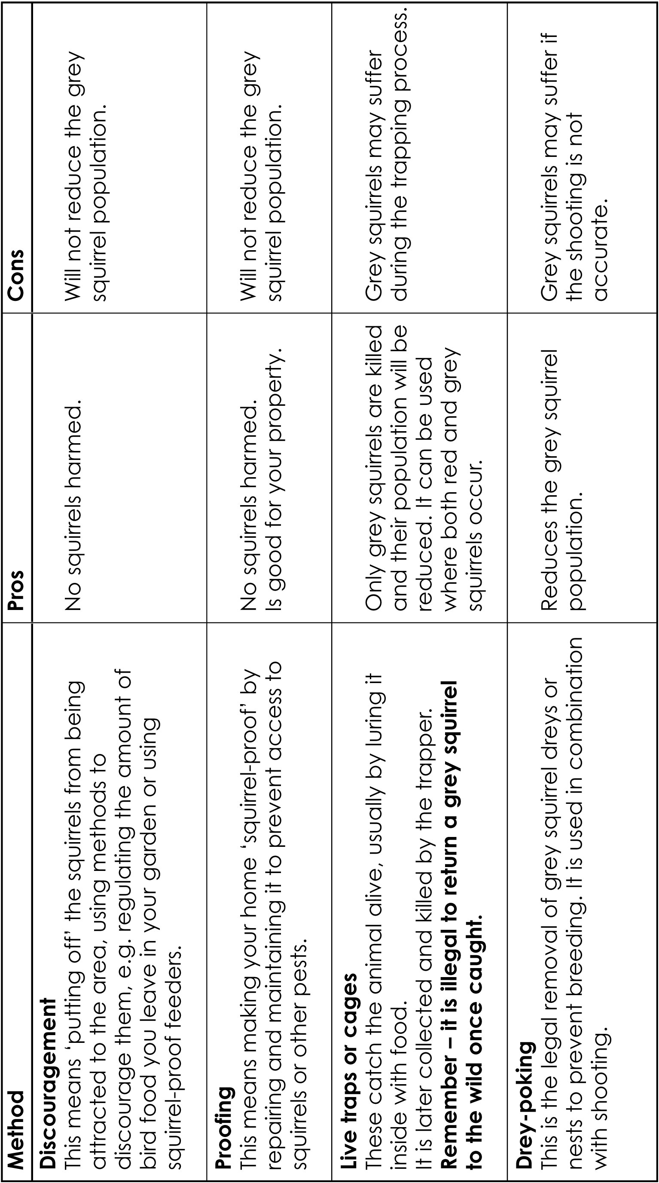
The RSPCA is opposed, in principle, to the taking or killing of wild animals, or the infliction of any suffering upon them. Methods of control and taking should cause minimum pain and distress to individual animals. Wherever possible, non-harmful methods of deterrence should be used. Harmful methods should only be considered if there is a serious problem and alternative means are ineffective or impractical. In this case, control should be carried out legally, precisely targeted and carried out by the most humane method available in the circumstances.

The following methods are used to prevent damage by squirrels or to control the number of grey squirrels.

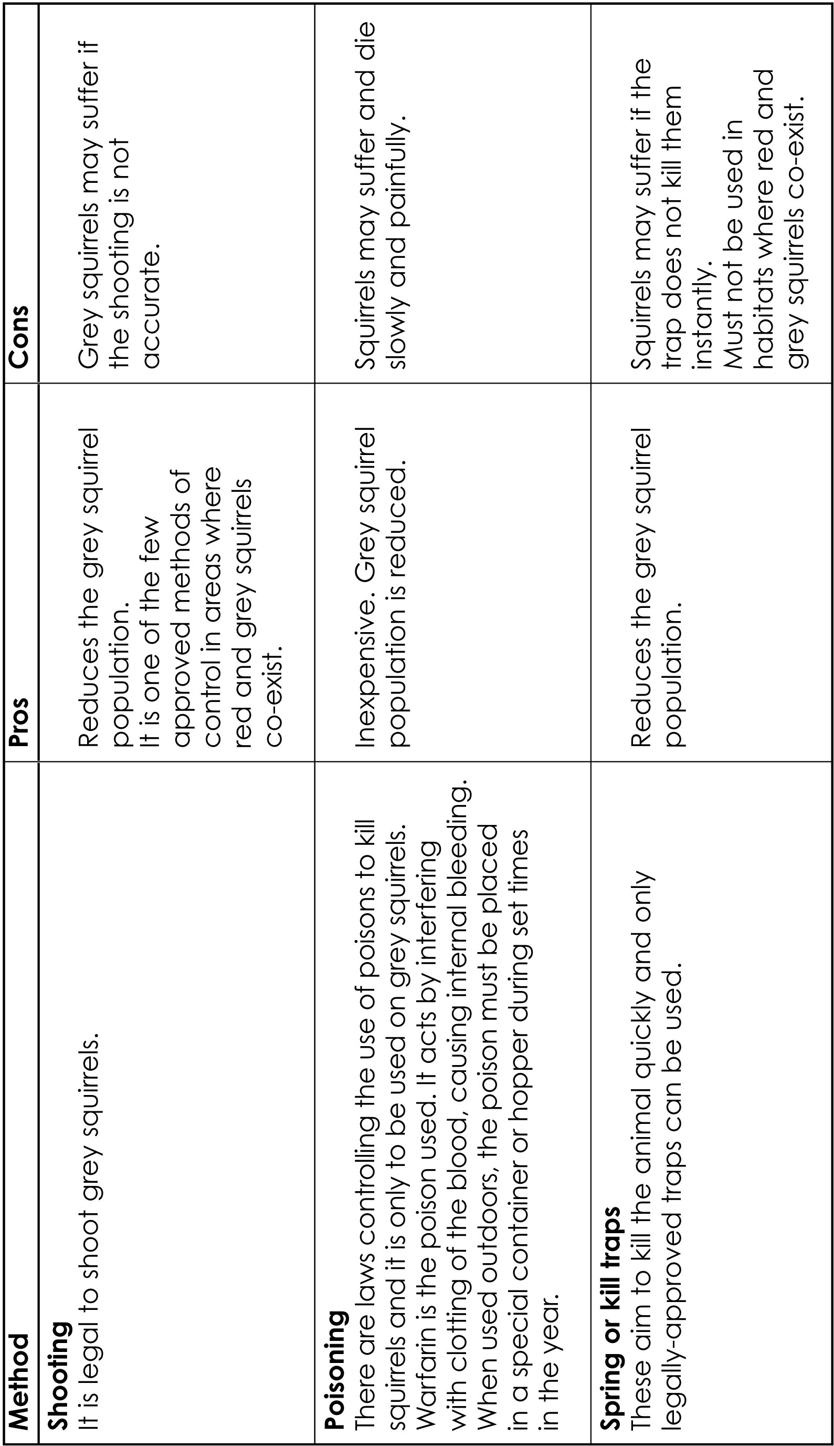
Factsheet – Possible solutions
Creating more habitat or improving existing habitats for red squirrels
- What could you do to attract more red squirrels to the area?
- Could you do this? Should you do this?

Controlling the spread of grey squirrels
- What could you do to discourage more grey squirrels moving into the area?
- What methods of control could you use to reduce the number of grey squirrels now in the area? (e.g. cage traps, spring traps, shooting, drey-poking and poisoning)
- Remember:
  - It is illegal to release a captured grey squirrel into the wild
  - Other animals, including red squirrels, may be at risk.

Preventing destruction or fragmentation of the forest for new buildings and development
- How could your local community get the council to think more carefully about
- giving planning permission?
- How could you make the new residents more aware of the problem?
- What could the new residents do to help the red squirrel?

Reducing the risk of squirrel road kills
- How can you prevent red squirrels getting too close to the roadside?
- How can you make motorists more aware of the presence of red squirrels and slow down?
- Are there ways of helping red squirrels cross the road safely?
Factsheet – Helping the red squirrel

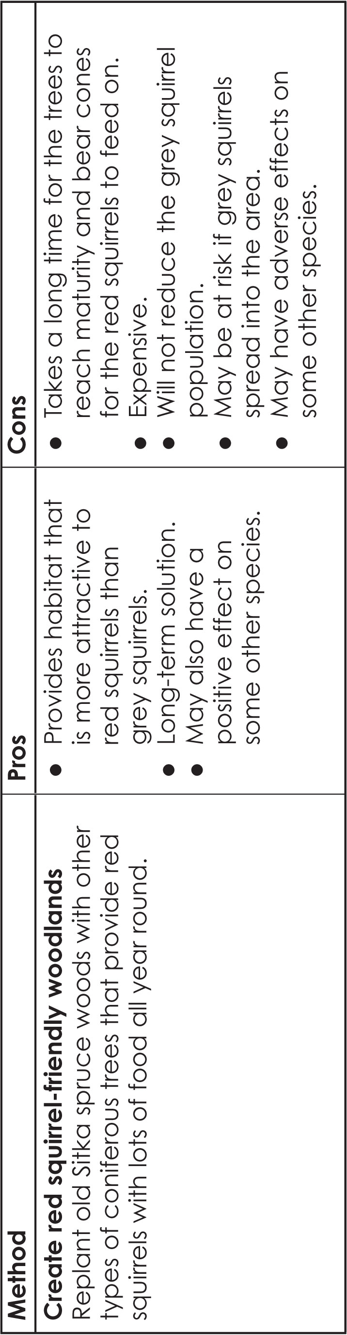
The red squirrel is listed as a priority species in the UK Biodiversity Action Plan (UKBAP), which cites the three main factors for its loss or decline as:
the spread of grey squirrels
disease (squirrel pox virus) carried by grey squirrels
habitat fragmentation.
Deaths on roads have also been highlighted as a threat to red squirrel populations in some areas.
The number of squirrels in a wood generally depends on the size of the wood, the type of trees in a wood, and the capacity of the trees to provide food for either the red or the grey squirrel. Generally, the bigger and more varied the wood, the more squirrels it will support. Both types of squirrel can live in broadleaf and coniferous woods, but greys tend to thrive in broadleaf woods, whereas reds do better than greys in coniferous forests.
The majority of coniferous woods in the UK are Sitka spruce that grow quickly and thrive on poor soil, so they are attractive trees to plant in upland areas. Sitka spruce has smaller cones, which do not provide much food for red squirrels. The best type of trees for red squirrels are those that have large cones and therefore large amounts of food, such as Scots pine, Norway spruce and larch. Additionally, trees do not necessarily produce a very good crop of seed every year, and different types of trees may crop differently in the same year.

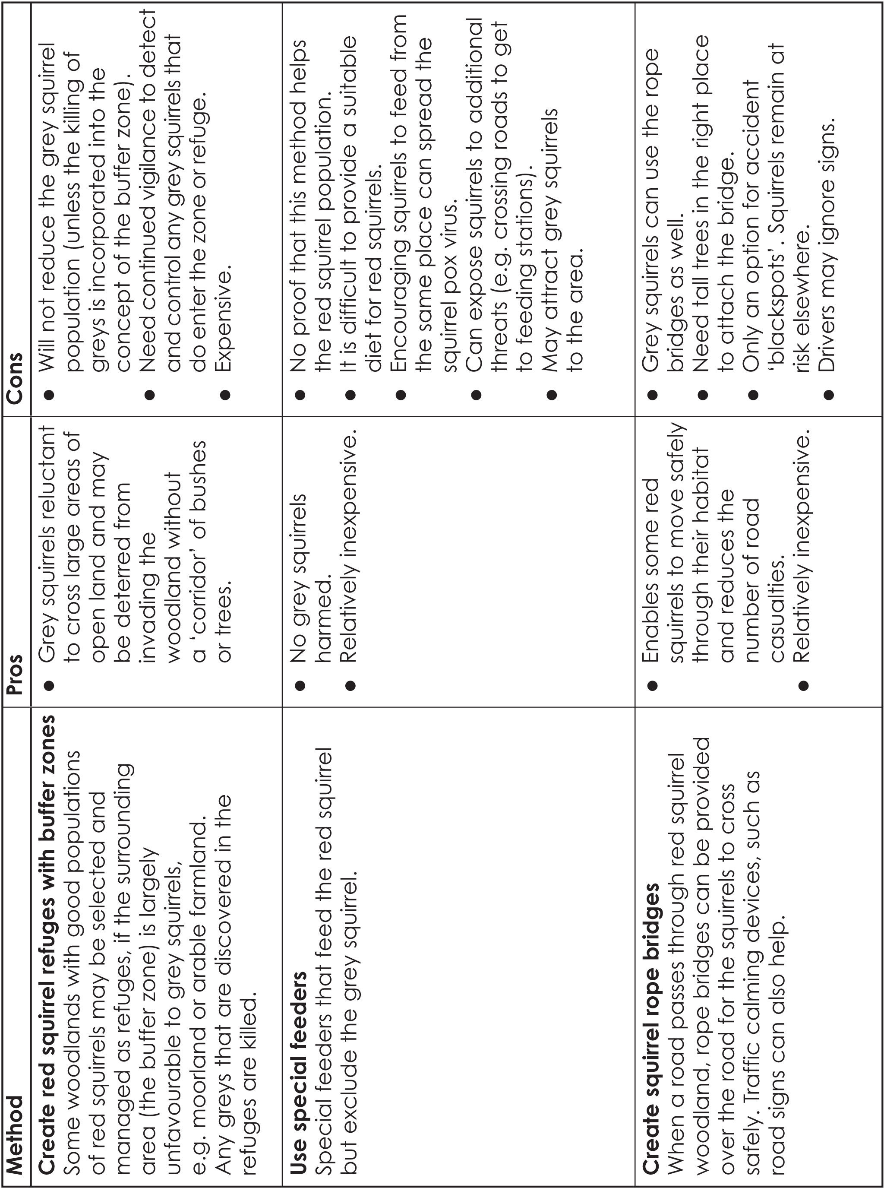

Factsheet – Squirrel quiz
For each question choose either Red squirrel or grey squirrel.
Questions:
- My Latin name is Sciurus vulgaris.
- I originate from America and am not native to the UK.
- I am the largest species of squirrel in the UK.
- I have the longest tail of any squirrel in the UK.
- I have tufts on my ears.
- I am found in pine forest.
- I’m quite bold, and you’ll often see me on the ground as well as in trees.
- I am a victim of, and can die from, the squirrel pox virus.
- I cannot digest acorns.
- I hibernate in winter.

Answers:
- Red squirrel
- Grey squirrel
- Grey squirrel
- Grey squirrel
- Red squirrel
- Red squirrel
- Grey squirrel
- Red squirrel
- Red squirrel
- TRICK QUESTION – squirrels do not hibernate.
Worksheet – The red squirrel

Latin name: ………………………………………
Body weight: ……………………………………….
Body length: ……………………………………….
Tail length: ……………………………………….
Appearance:…………………………………………………………………………………………….………………………………………………………………………………………………………………..………………………………………………………………………………………………………………......................
Lifespan:…………………………………………………………………………………………………………
Origins:………………………………………………………………………………………..………………..
Population in UK:…………………………………………………………………………..…………………
Habitat:………………………………………………………………………………………..……..………………………………………………………………………………………………………………..……………………………………………………………………………………………………………………………………..
Hibernation:…………………………………………………………………………………………………….
Food:………………………………………………………………………………………..………………………………………………………………………………………………………………..………………………………………………………………………………………………………………………………………………..
Breeding:……………………………………………………………………………………………..………………………………………………………………………………………………………………..……………………………………………………………………………………………………………………………………..
Threats:…………………………………………………………………………………..………..………………………………………………………………………………………………………………..…………………………………………………………………………………………………………………………..…………………………………………………………………………………………………………………………………..
Protected species?
……………………………………………………………………………………………..………………………………………………………………………………………………………………..………………………………………………………………………………………………………………………..…………………………
Worksheet – The grey squirrel

Latin name: ………………………………………
Body weight: ……………………………………….
Body length: ……………………………………….
Tail length: ……………………………………….
Appearance:…………………………………………………………………………………………….………………………………………………………………………………………………………………..……………………………………………………………………………………………………………………………….....
Lifespan:…………………………………………………………………………………………………………
Origins:…………………………………………………………………………………………..……………..
Population in UK:………………………………………………………………………………..……………
Habitat:………………………………………………………………………………………..……..………………………………………………………………………………………………………………..……………………………………………………………………………………………………………………………………..
Hibernation:…………………………………………………………………………………………………….
Food:………………………………………………………………………………………..………………………………………………………………………………………………………………..………………………………………………………………………………………………………………………………………………..
Breeding:……………………………………………………………………………………………..………………………………………………………………………………………………………………..……………………………………………………………………………………………………………………………………..
Threats:………………………………………………………………………………..………..………………………………………………………………………………………………………………..…………………………………………………………………………………………………………………………..……………………………………………………………………………………………………………………………………..
Protected species?
……………………………………………………………………………………………..………………………………………………………………………………………………………………..…...…………………………………………………………………………………………………………………….………..…..…………
Worksheet – Case study: Durnalton

Imagine you live in Durnalton, a small village on the edge of a large coniferous forest. For many years, Durnalton has been known for having a healthy population of red squirrels, but recently the numbers have declined.

This could be due to many factors:
- an increased number of grey squirrels in the area
- expanding development of the area for housing
- a new traffic system that allows two roads to dissect the forest.

As a group of citizens keen to protect the red squirrel in your area, you must decide what the best form of action might be to stop this decline.

Make sure you examine the advantages and disadvantages for any solution(s) you decide.

. .
Notes
Worksheet - Letter template
Dear………………………………………………………………………
I am writing this letter to express my opinions relating to culling grey squirrels to conserve red squirrels in Britain.
I think ………………….………….…………………………………………………………………………..…..…..
………………………………………………………………………………………………………..…………………..
The reasons why I feel this way are ………………….………….………………………………………..…..
………………………………………………………………………………………………………..…………………..
……..………………………………………………………………..…………………………………..…………….…
I understand that other people have different views and think………………………….……….…..
…………………………………………………………………………………………………………….……………..
Two reasons why they possibly feel this way are…………………………………………….……….…..
…………………………………………………………………………………………………………….……………..
……..………………………………………………………………..…………………………………….………….…
However, my viewpoint is better because ………………………………..……………….……………..…
…………………………………………………………………………………………………….………….…………..
I think the government should ………………………………………………………….………….…………..
………………………………………………………………………………………………………..…………………..
……..………………………………………………………………..…………………………………..…………….…
Yours faithfully,
………………………………………………………………..

