Equipment
If you prefer to use actual objects, here are two suggested collections you could use:

List 1 List 2
Picture of someone wearing a fur coat Sausages
Dog lead Food bowl
Packaging from a box of painkillers Empty bird feeder
Tin of tuna Meat
Ice cream Leather belt
Fat balls for wild birds Fat balls for garden birds
Shower gel Shower gel with no animal ingredients
Quiche packaging Carton of milk
Milk container Rabbit/hamster water bottle
Leaflet advertising a venue that keeps animals Bird box
Pair of jeans Woollen jumper
Rabbit/hamster water bottle Dog collar
Fishing line and hook

Aims and objectives
- This activity extends the ideas introduced in the Everyday objects activity, but it can work as a standalone session. In it, young people begin to understand the relationship between the role of animals in all our lives and our responsibilities towards them.
- They will explore the concept that:
  - more than one person may be responsible for meeting the needs of an animal
  - even if we have an indirect link with an animal, we can have a sense of responsibility towards it and take action to ensure its welfare.
- It’s important to do the activity Smiley face in the Basic welfare needs and sentience section first.

What to do

- If you have already done the Everyday objects activity in the Role of animals in our lives section, place the objects or pictures you used in it on the table. There’s a reminder of these in List 1 (see What you need in Useful information section), or you can use the activity sheet Everyday objects.
- If you have not yet done the Everyday objects activity, use the objects from List 2 below or the activity sheet What’s the connection?
- Choose one animal group from the activity sheet Animal groups cards (pet animals, wild animals, farm animals or animals used in research) and place the corresponding card on the table.
- Ask the young person to select objects or pictures of objects that relate to the group of animals and to group them around the card.
- Take one of the photographs from the activity sheet Are we connected? – a farmer, for example – and consider whether the person has a connection with the animal group. If they do, place the photo on the table.
- Does that person have a responsibility towards the animals in the group? Consider each of the cards from the activity sheet Statement of actions cards in turn and, if they link to the situation, place them on the table next to the person/people who is/are responsible for that action. Repeat the process for each of the photographs.

Extension activities
- Rank the people in relation to the amount of responsibility they have towards the animals, from lots of responsibility to some.
- Repeat the activity with the other animal groups.
- We have also developed three interactive activities - Was it cruel?, Consequences and Triggers - that help young people think through what happens when people are cruel to animals (see right). However, before you attempt to use these, we suggest that you explore some of the activities in the other sections - What is animal cruelty?, What triggers animals cruelty and how it can be avoided, Consequences of cruelty to animals and The incident.

Activity sheet – Animal groups cards

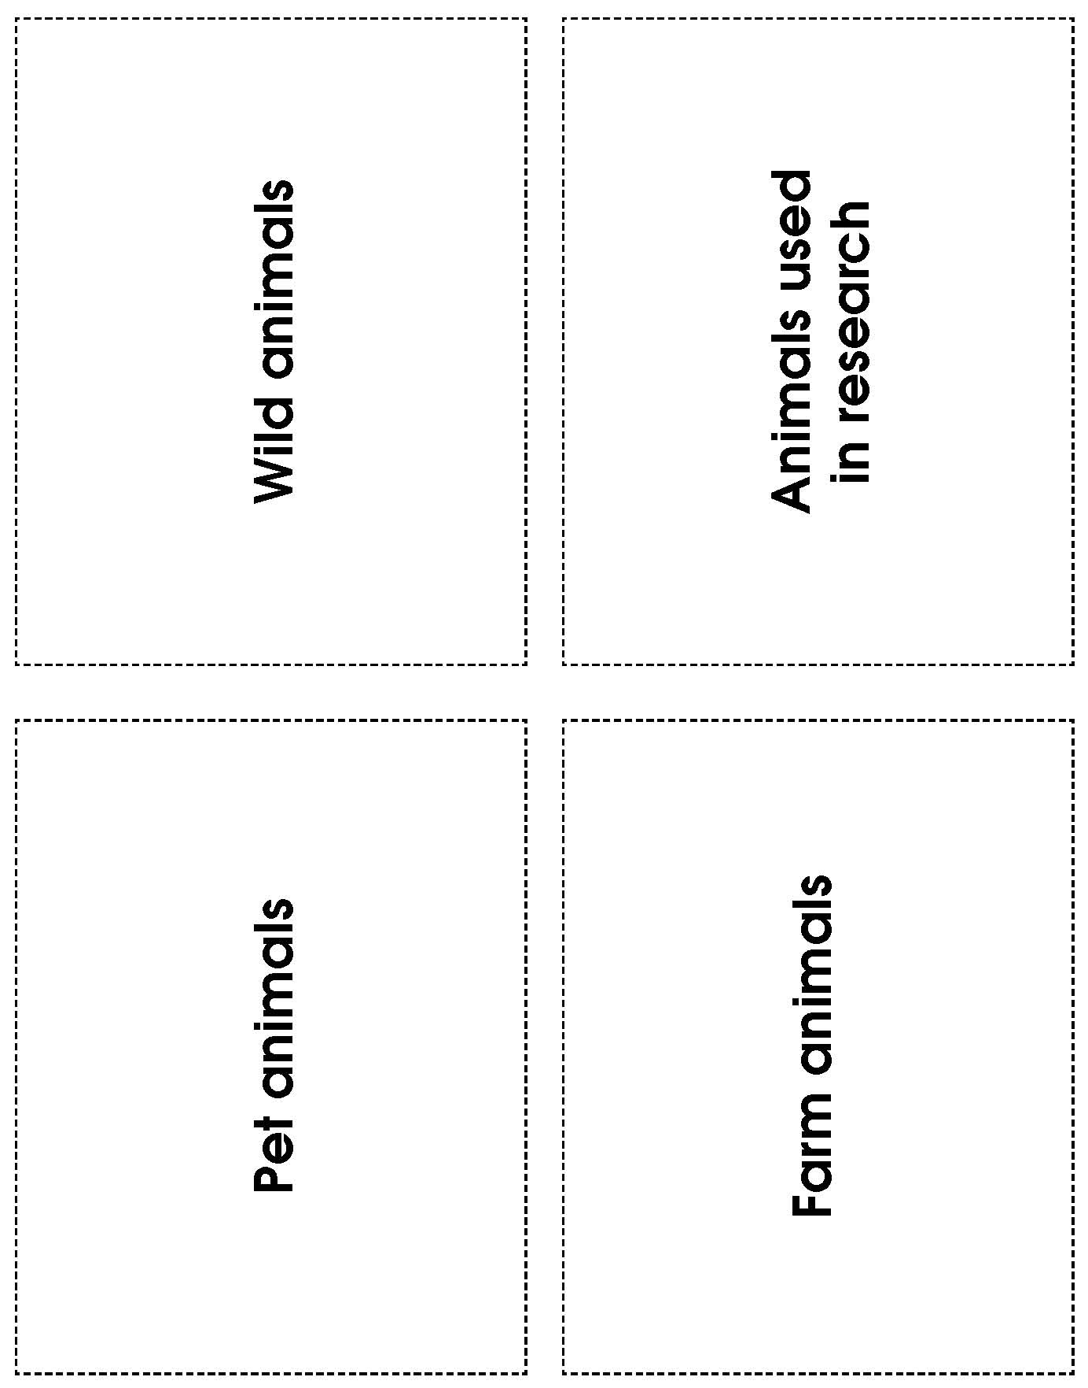

Activity sheet – Statement of actions cards

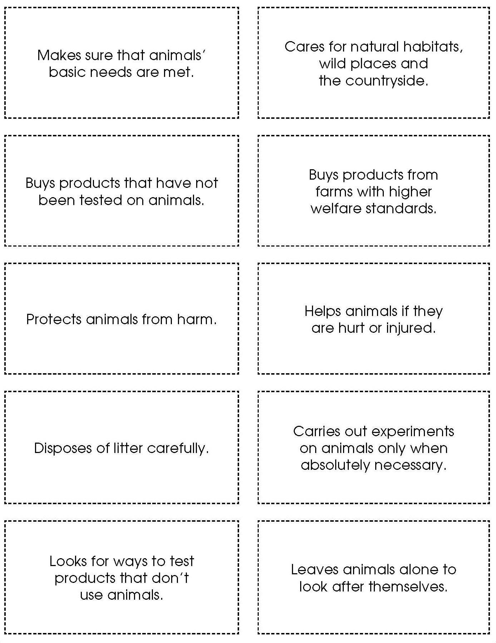

Activity sheet – Are we connected? (1)

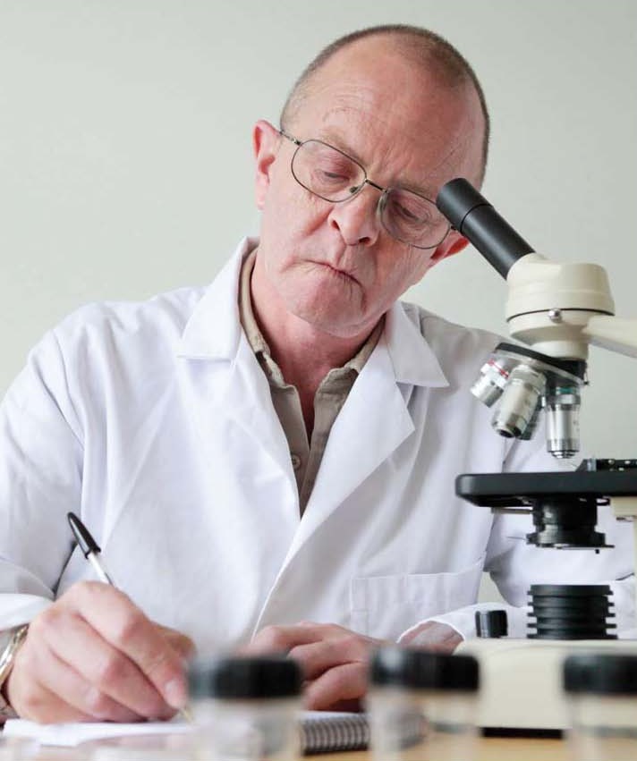

Scientist

Activity sheet – Are we connected? (2)

Adult

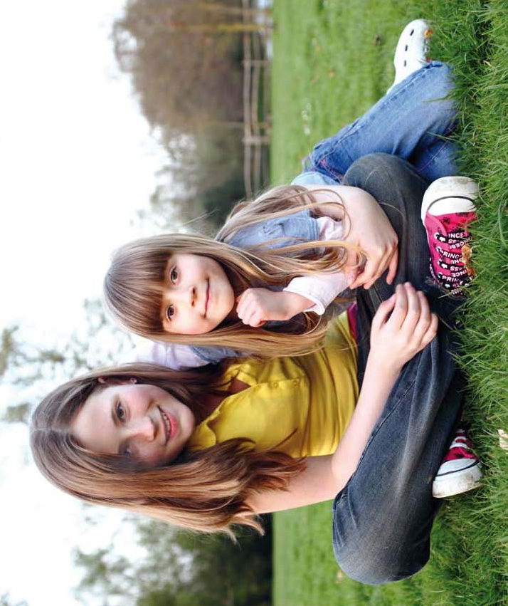
Activity sheet – Are we connected? (3)

Children
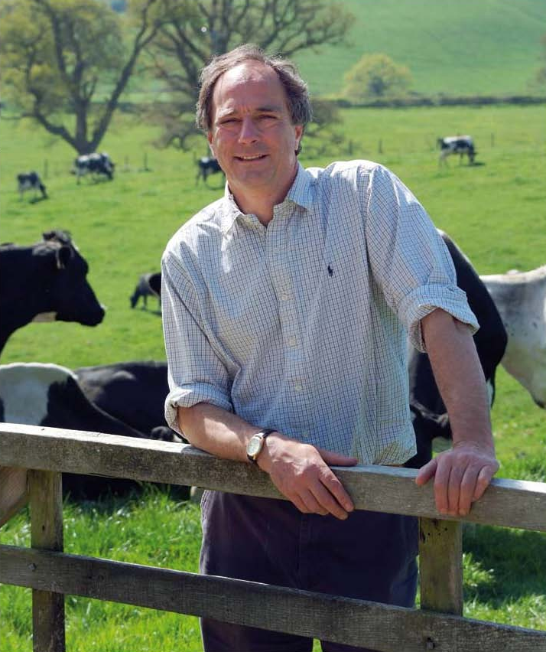

Activity sheet – Are we connected? (4)
Farmer

Activity sheet – Everyday objects (1)
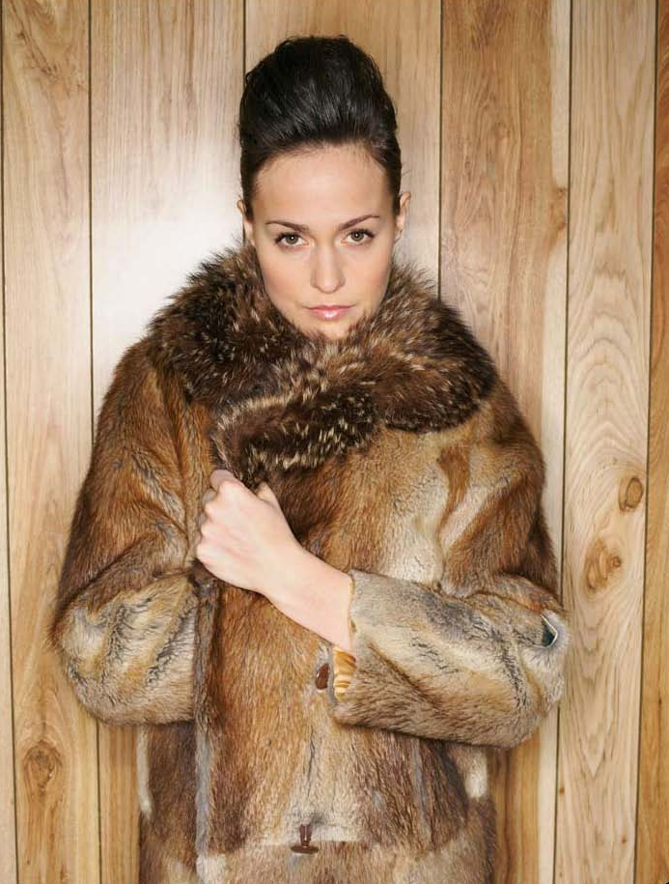
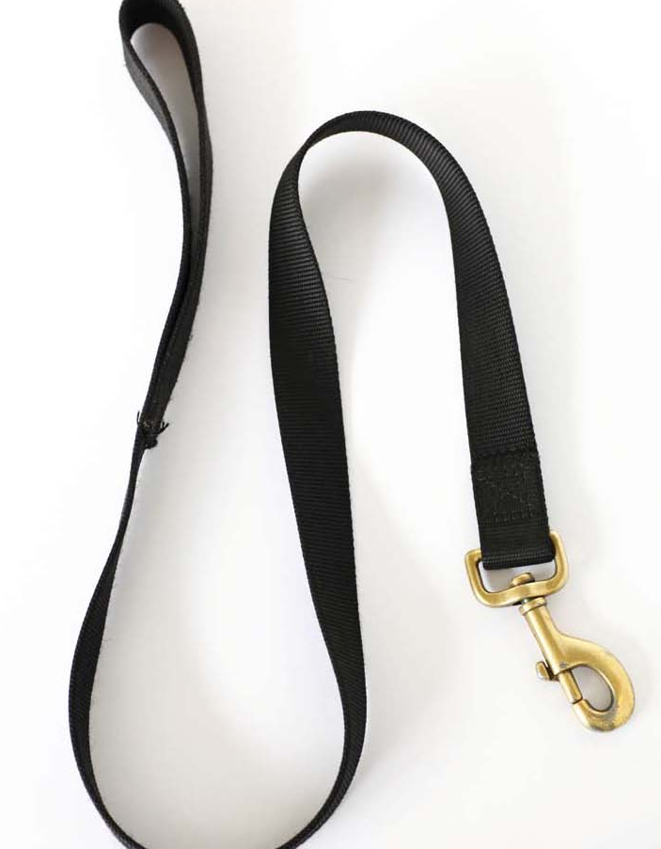
Activity sheet – Everyday objects (2)

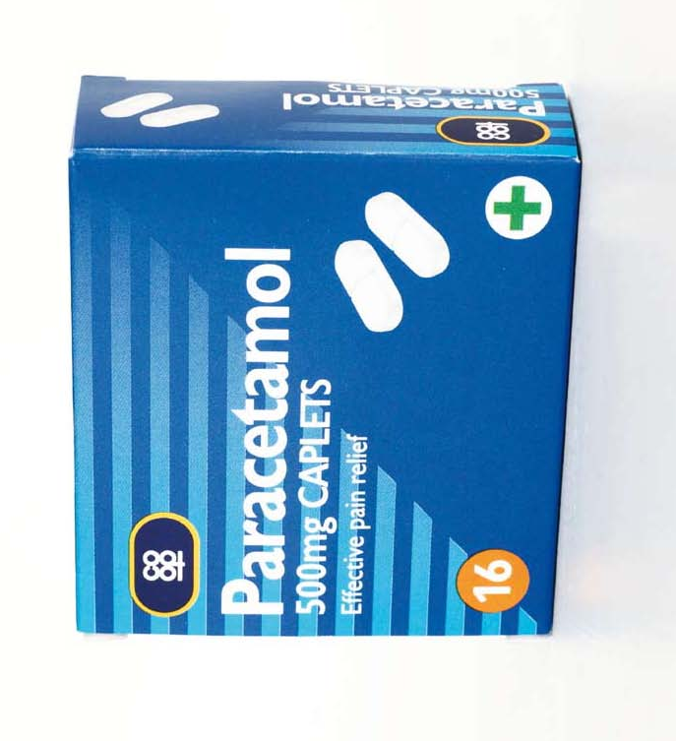
Activity sheet – Everyday objects (3)

Activity sheet – Everyday objects (4)
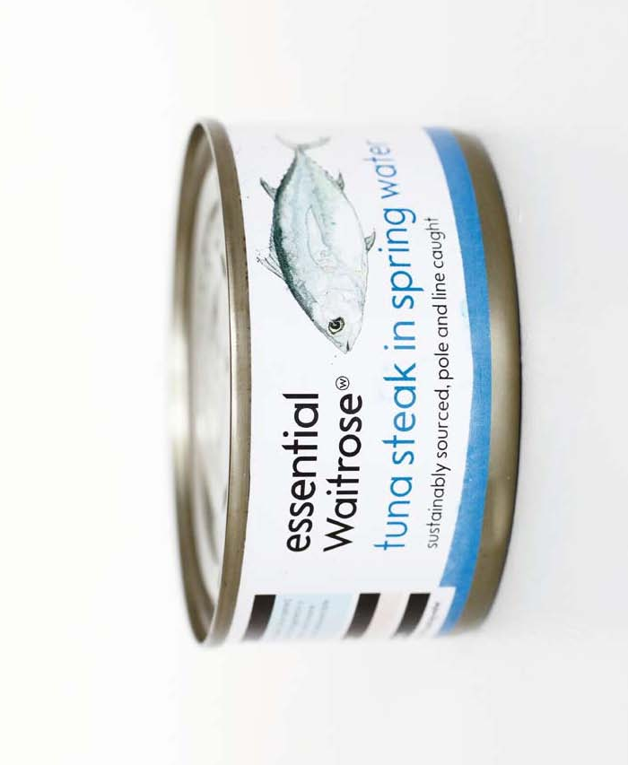

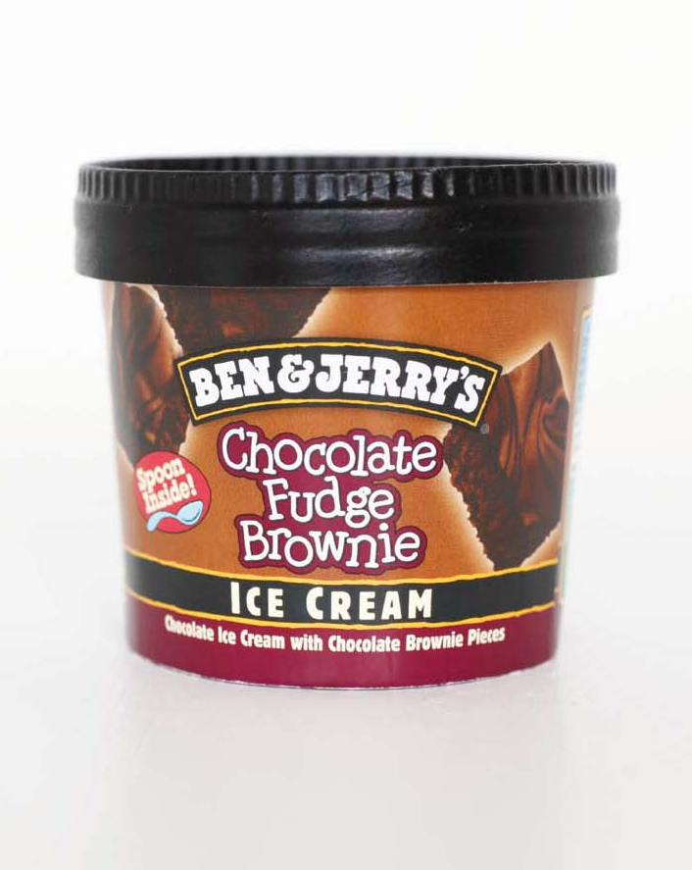
Activity sheet – Everyday objects (5)

Activity sheet – Everyday objects (6)
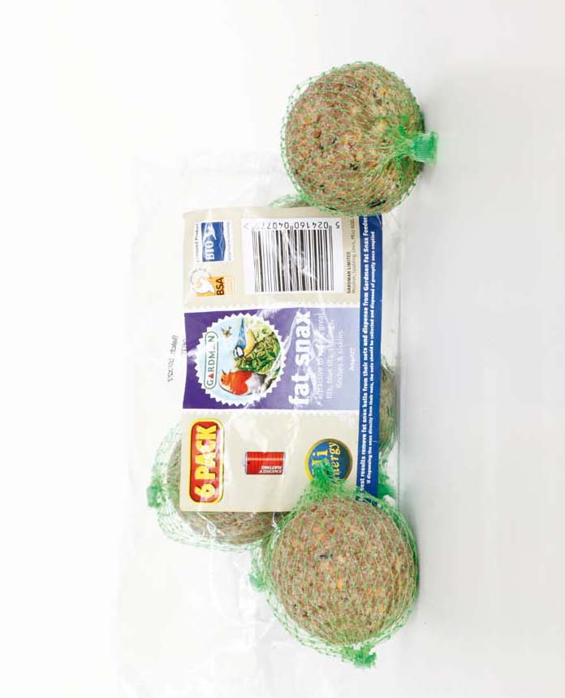

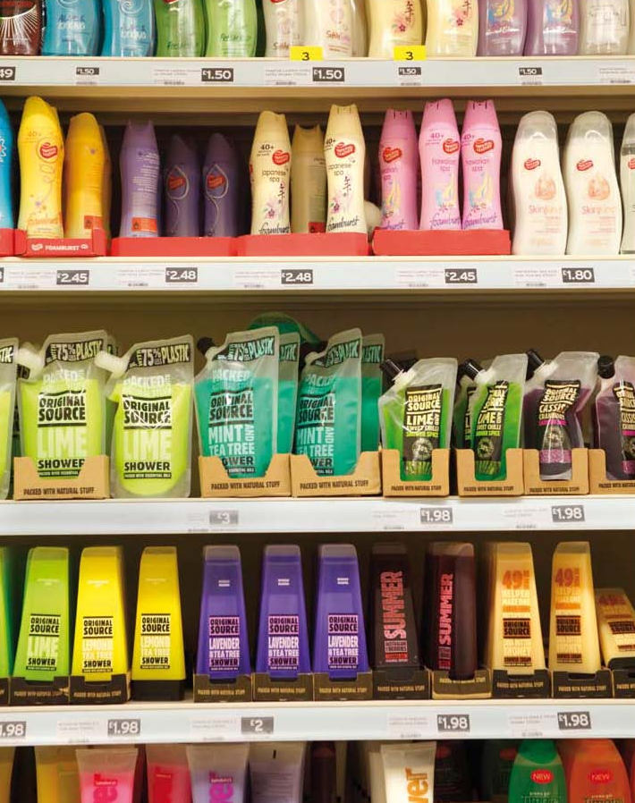
Activity sheet – Everyday objects (7)

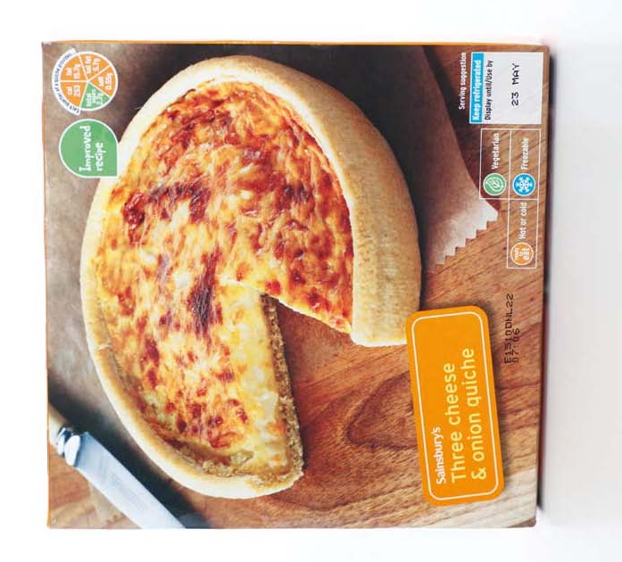
Activity sheet – Everyday objects (8)

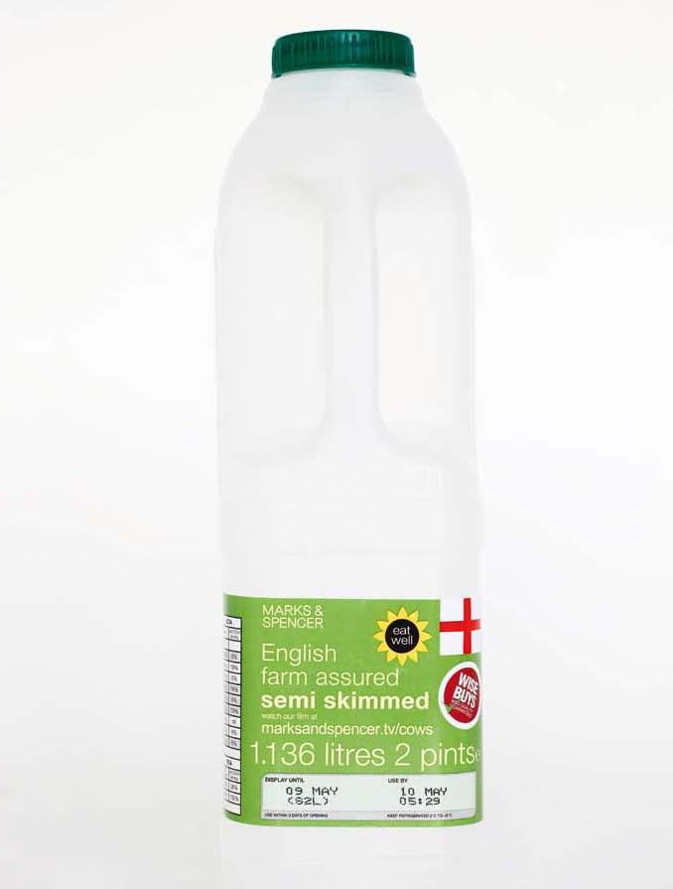
Activity sheet – Everyday objects (9)

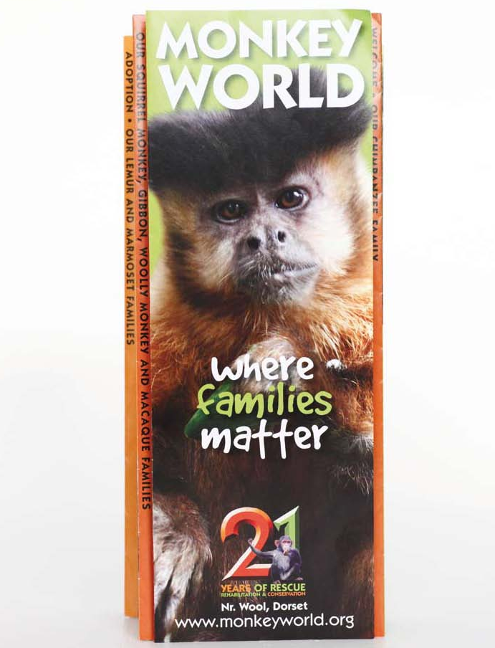
Activity sheet – Everyday objects (10)

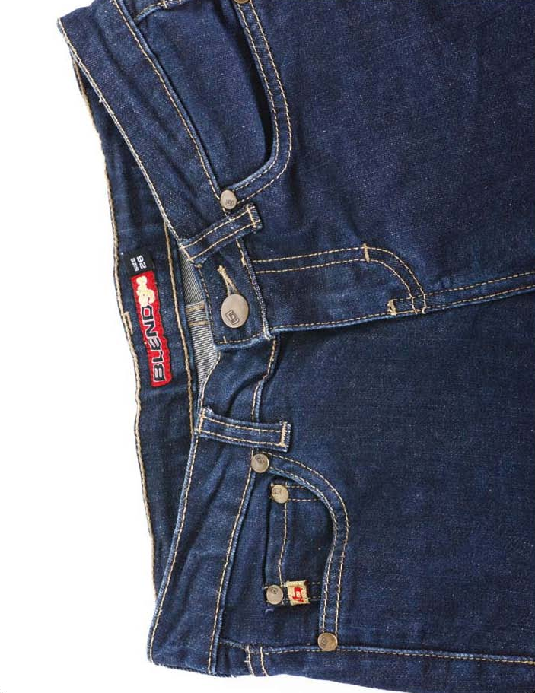
Activity sheet – Everyday objects (11)

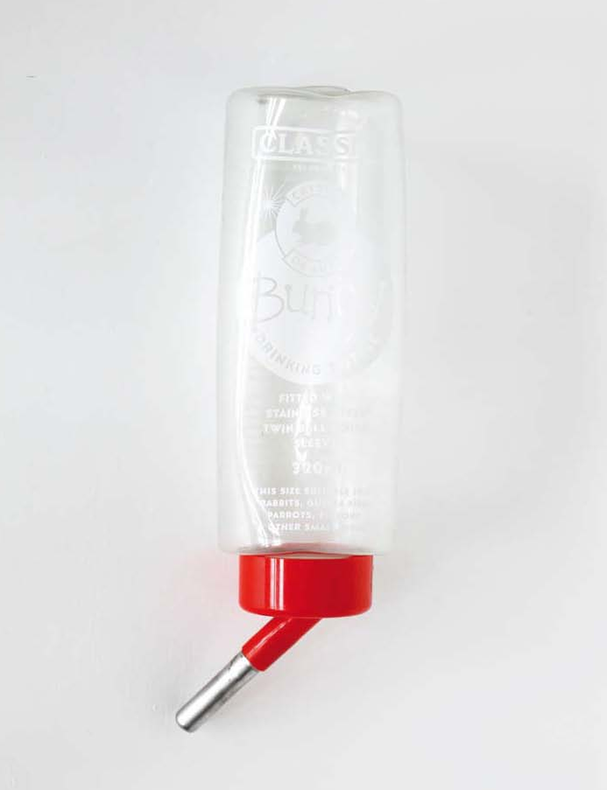
Activity sheet – Everyday objects (12)

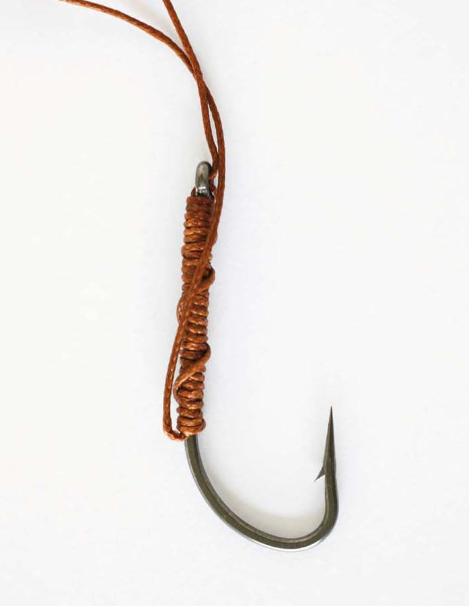
Activity sheet – Everyday objects (13)

Activity sheet – What’s the connection? (1)

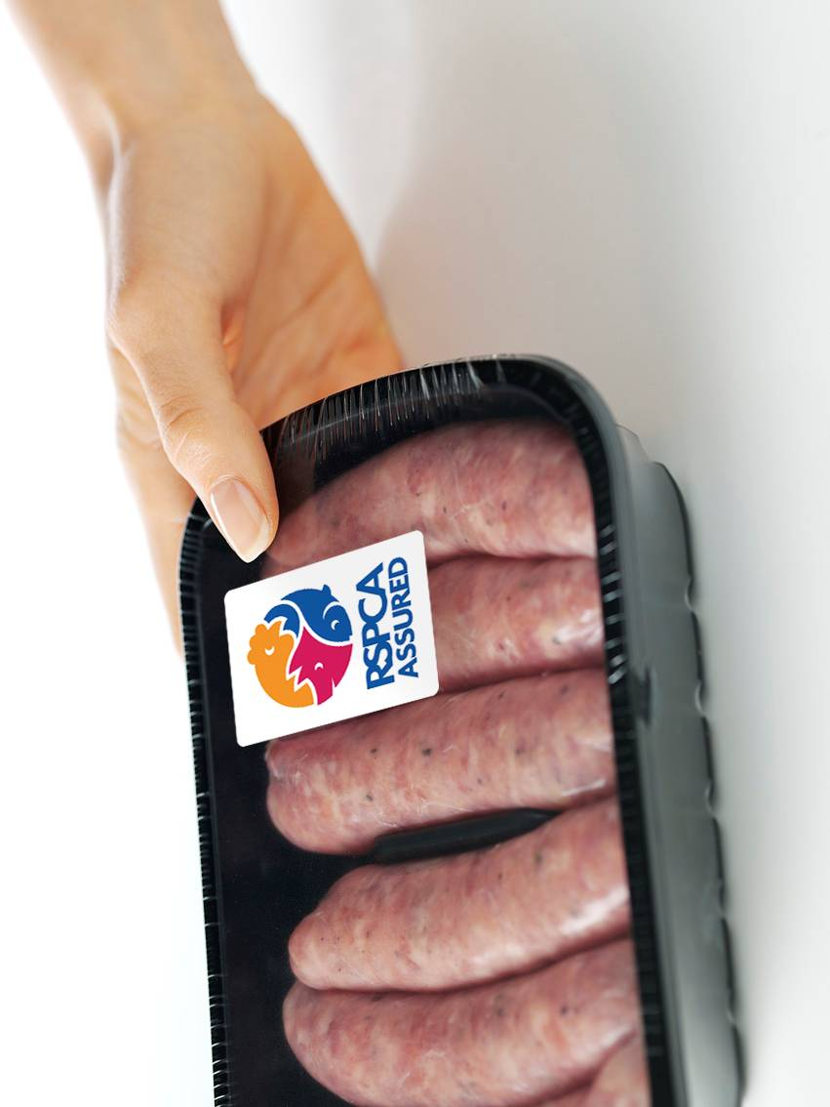

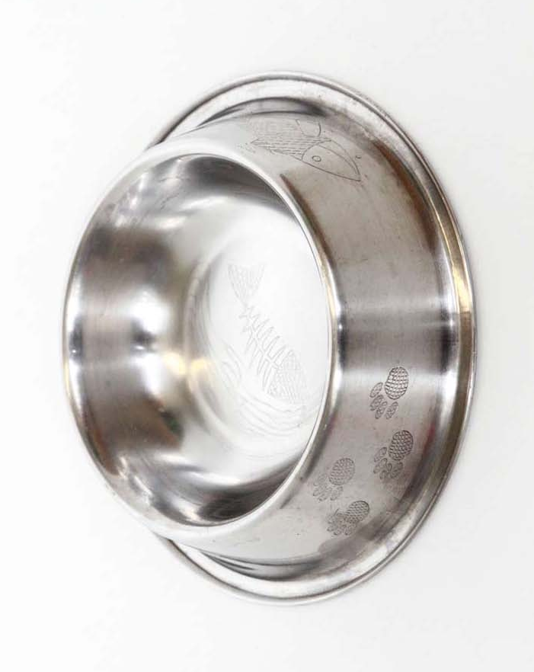
Activity sheet – What’s the connection? (2)

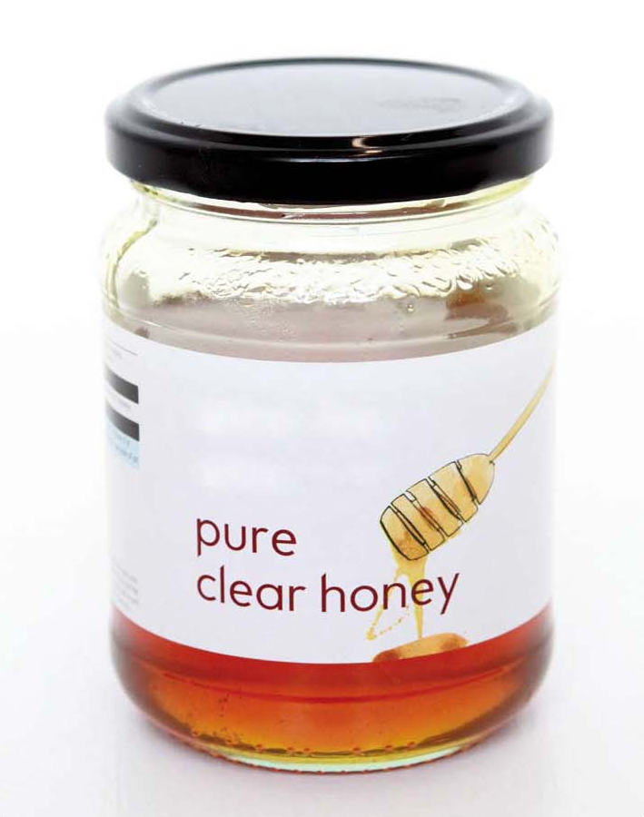
Activity sheet – What’s the connection? (3)

Activity sheet – What’s the connection? (4)

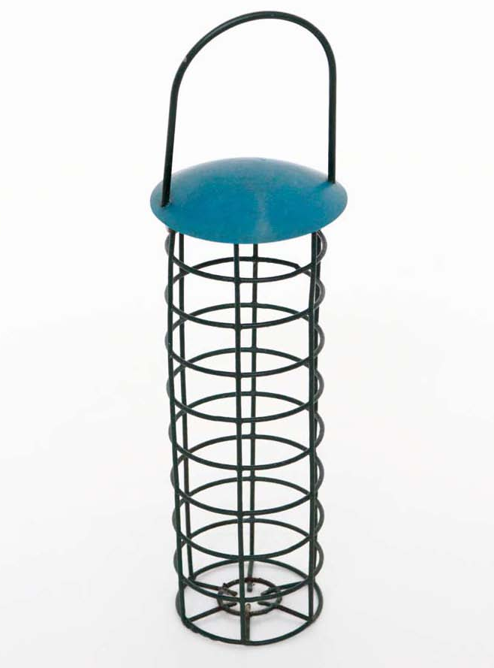

Activity sheet – What’s the connection? (5)
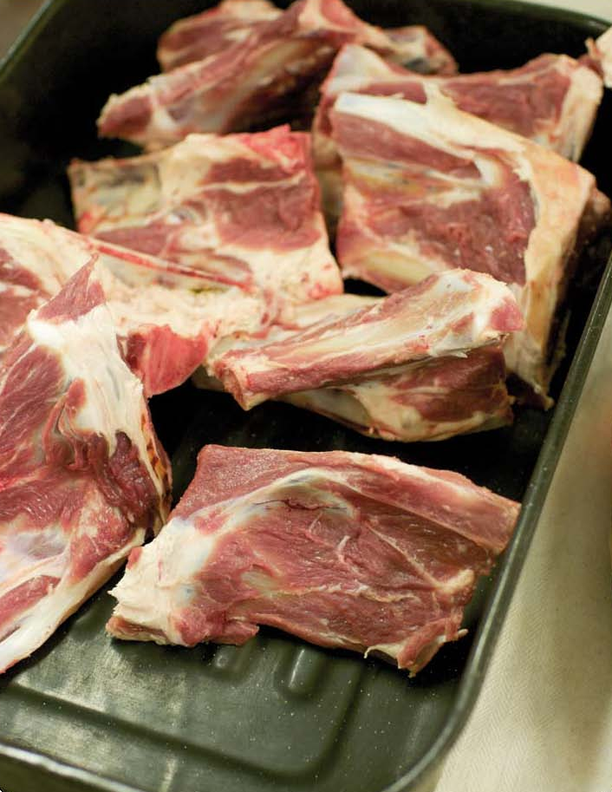
Activity sheet – What’s the connection? (6)

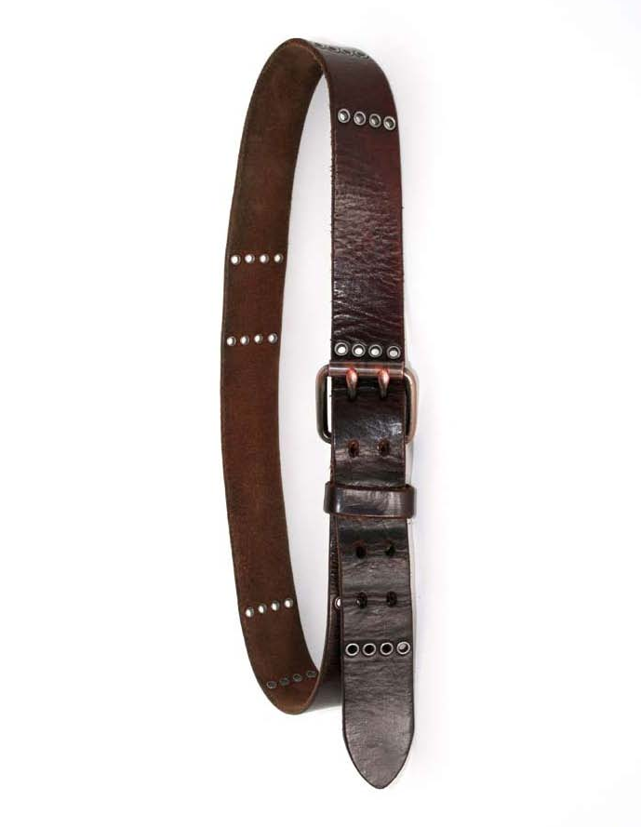
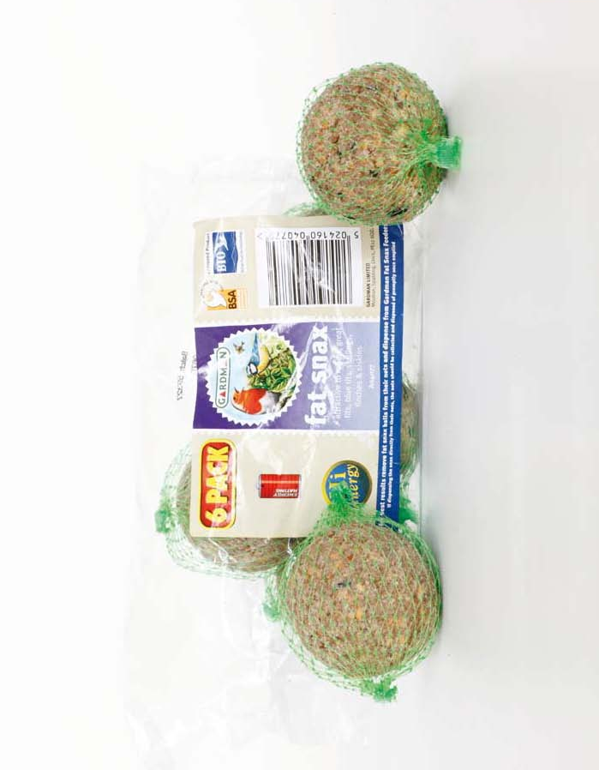
Activity sheet – What’s the connection? (7)

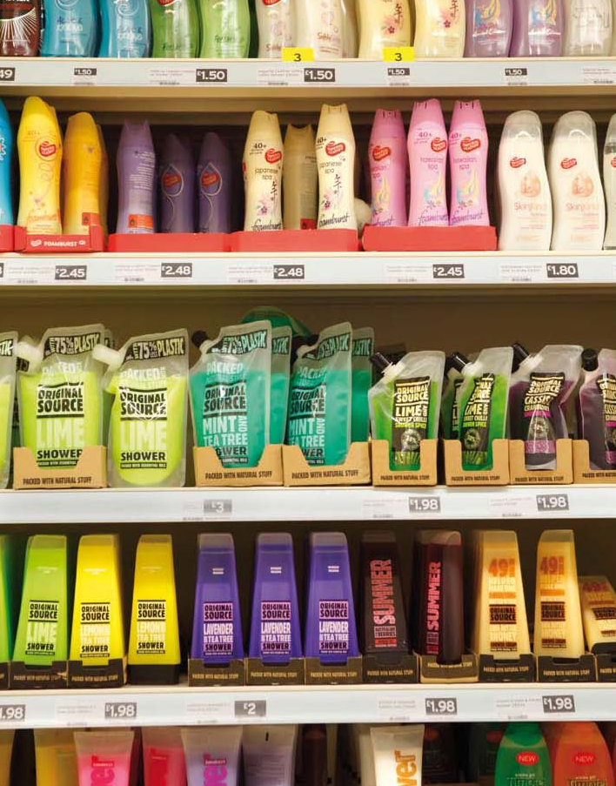
Activity sheet – What’s the connection? (8)

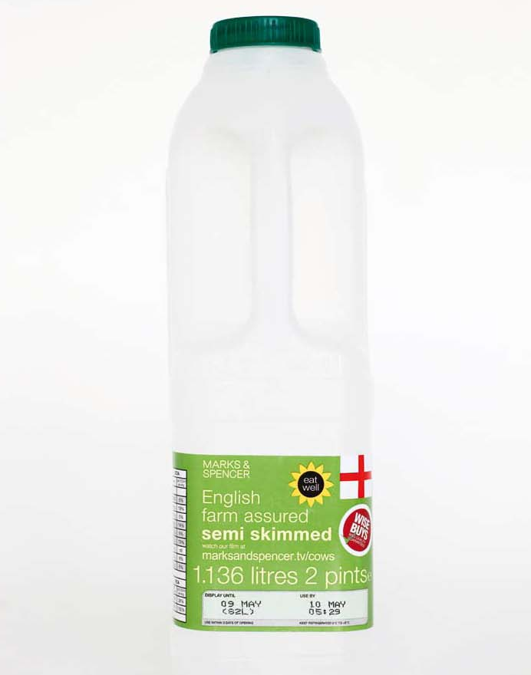
Activity sheet – What’s the connection? (9)

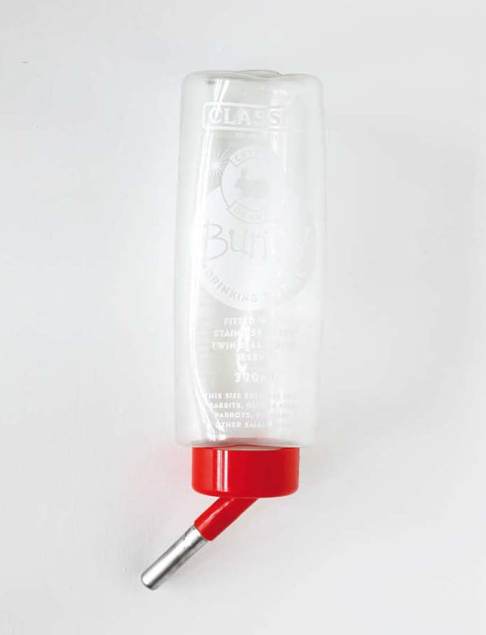
Activity sheet – What’s the connection? (10)

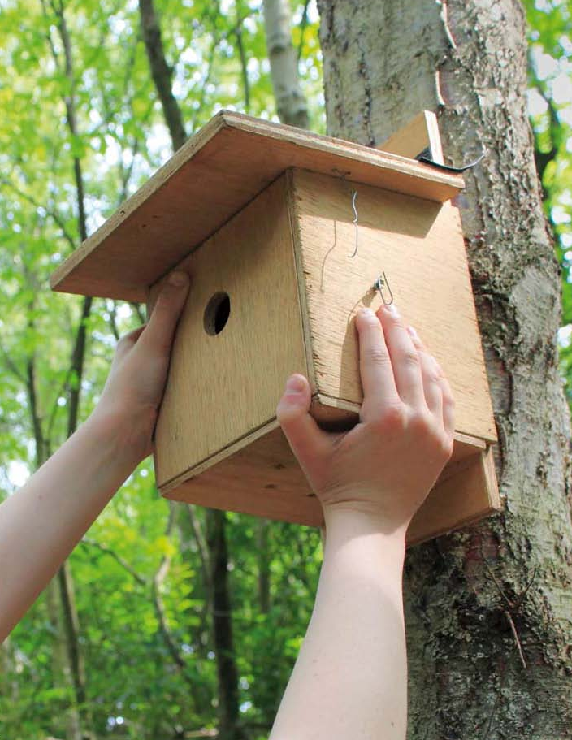
Activity sheet – What’s the connection? (11)

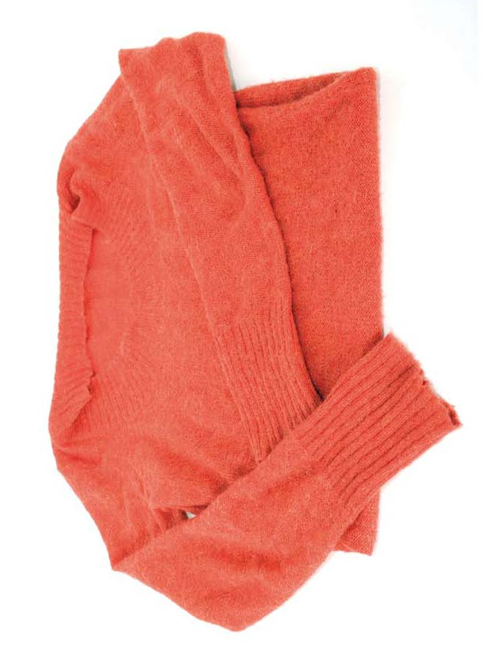
Activity sheet – What’s the connection? (12)

Activity sheet – What’s the connection? (13)



