In this lesson, pupils consider how they can help consumers make informed choices about farm animal products. They look at examples of adverts, labelling and packaging for information as to how the animal has been kept. Posters are produced to highlight the conditions in which the farm animals could have been kept and how consumers can make ethical choices. The lesson A little eggs-tra space could provide some useful background information.

Starter activity
Advert analysis
- Ask pupils to look at the RSPCA Assured adverts from an RSPCA summer campaign (Useful websites).
- Ask the pupils to complete an Advert analysis worksheet for each advert, which encourages them to consider what the adverts tell us about how animals are kept and the methods they use to do this.
- Review the thoughts and ideas from the whole class.
Learning styles: visual, auditory.

Main activity
Poster produce
- Put photographs of a chicken, pig, cow, duck, sheep, hen, turkey and salmon on the walls around the room, and ask pupils to stand by the picture of the farm animal that they would like to research.
- Working in small groups, ask the pupils to research how their chosen farm animal is kept. They can use the factsheets. More factsheets are available in Useful websites.
- Ask the pupils to sort the product labels and packaging according to the farm animal they are researching.
- Can they tell where the meat products have come from and how the animals were kept on farms?
- Ask the groups to produce a poster for their farm animal that will help explain:
- the different ways that the animal may be kept
- the products it produces
- the labels and information that may be found on these products and what they mean.
- Explain that the poster will be displayed in school so that other pupils, teachers, parents/carers, school governors and school visitors will be able to see it.
Learning styles: visual, auditory, kinaesthetic.

Plenary activity
Poster presentations
- Ask the pupils to explain their posters to the rest of the class.
- Display the posters in the classroom and ask the rest of the class to assess them using the worksheet Poster scorecard and to rank them for appearance, persuasion and clarity of information.
Learning styles: visual, auditory, kinaesthetic

Assessment
The pupils' own peer assessment and scoring of the posters in terms of appearance, persuasion and clarity of information.

Differentiation
- Some pupils could concentrate on the way their chosen animal is farmed and choose one label to explain as part of their poster.
- Instead of using the Poster scorecard to assess the posters, the pupils could use the worksheet Three stars and a wish. The pupils write down three good points (stars) for each poster and one thing that they wish they had done to improve the poster.

Extension activities
- Design a survey to find out what other people think of the posters, how effective they are, etc. What changes, if any, would pupils make to their posters as a result of the feedback?
- Explore where else pupils could display these posters. Would they need permission? What would be the advantages/disadvantages of the sites chosen? Ask the school council to consider the source of animal produce served by the school canteen. How ethical is it? Do they want it to change? Can it be changed? What are the consequences of it changing?

Display
To inform a wide audience, display the posters in a public place for view by parents, other teachers, volunteers, governors and visitors.

Did you know?
The RSPCA set up the RSPCA Assured scheme (formerly known as Freedom Food) in 1994 to improve farm animal welfare. RSPCA Assured is a non-profit making charity.
- All farm animals under the RSPCA Assured scheme must be reared according to strict RSPCA welfare standards. These species-specific standards cover each stage of an animal's life, including handling and transportation.
- The RSPCA has developed welfare standards for nine farm animals that are commonly reared for food.
- The RSPCA Assured scheme is concerned solely with animal welfare, while organic schemes focus primarily on environmental sustainability.
- Profitable farmers may be better able to pay for good veterinary care but there may be conflict with animal welfare if the profit is achieved through cutting corners on animal welfare.

Curriculum objectives
Pupils should learn:
- that the life processes common to humans and other animals include nutrition, movement, growth and reproduction
- to research, discuss and debate topical issues, problems and events.

Animal welfare objectives
Pupils should learn:
- that farm animals are sentient creatures
- that, as consumers, we can make informed decisions based on the information presented on the packaging/labels on animal produce
- that farm animals can be kept in a variety of conditions in the UK.

Learning outcomes
At the end of this lesson:
- most pupils will: be able to produce a poster to explain what labels/logos to look for as a consumer and how these impact on animal welfare
- some pupils have not made so much progress and: are able to produce a poster identifying labels/logos that appear on animal produce
- some pupils will have progressed further and will: be able to explain how the design of their poster and/or its positioning could have an effect on increasing consumers' knowledge of labelling and its relationship to animal welfare.

Vocabulary
adjective analysis animal welfare bacon beef broiler (meat chicken)
chicken clarity cow duck free-range
ham lamb organic pig pork salmon
sheep sow stall strapline turkey

Useful websites
RSPCA - All about animals - Farm animals
RSPCA - Dairy cattle information sheet
RSPCA - Farmed duck information
RSPCA - Farming - egg production systems
RSPCA - Meat chicken information sheet
RSPCA - Pig production information sheet
RSPCA - Sheep production information sheet
RSPCA - Turkey production information sheet
RSPCA Assured
RSPCA - Farm animal welfare standards
Compassion in World Farming - Education
FACE - Farming and Countryside Education
Video - What do farm animals need?

Image – RSPCA Assured posters
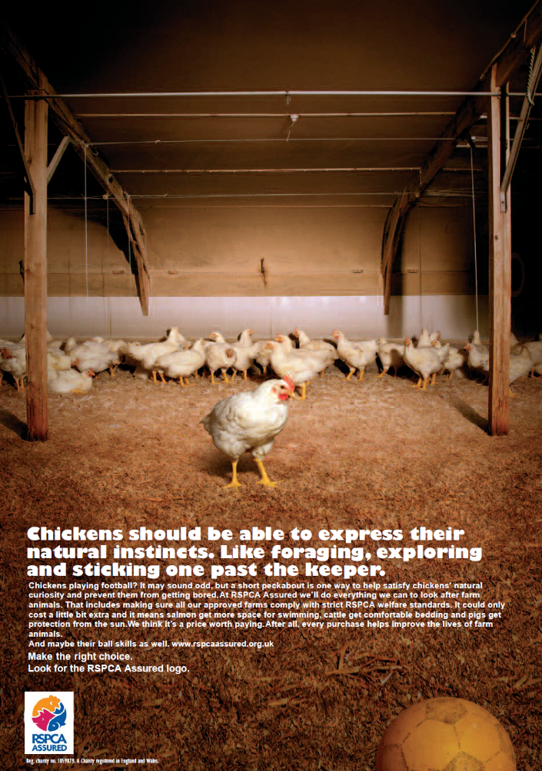
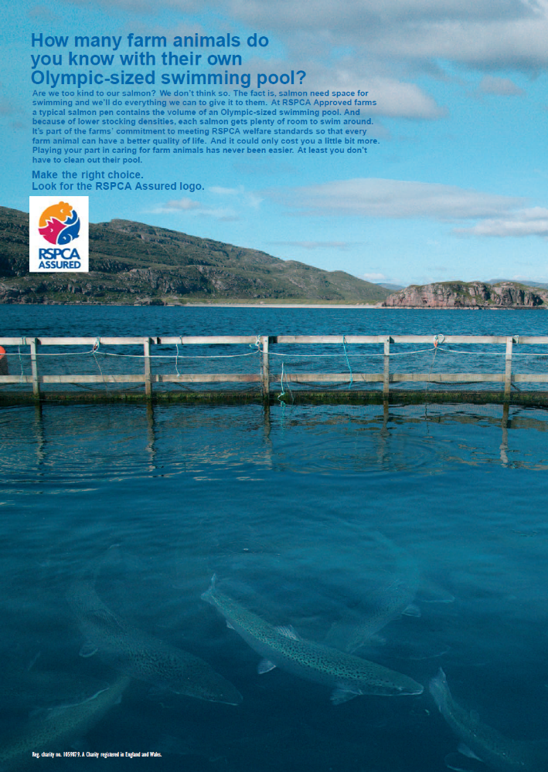

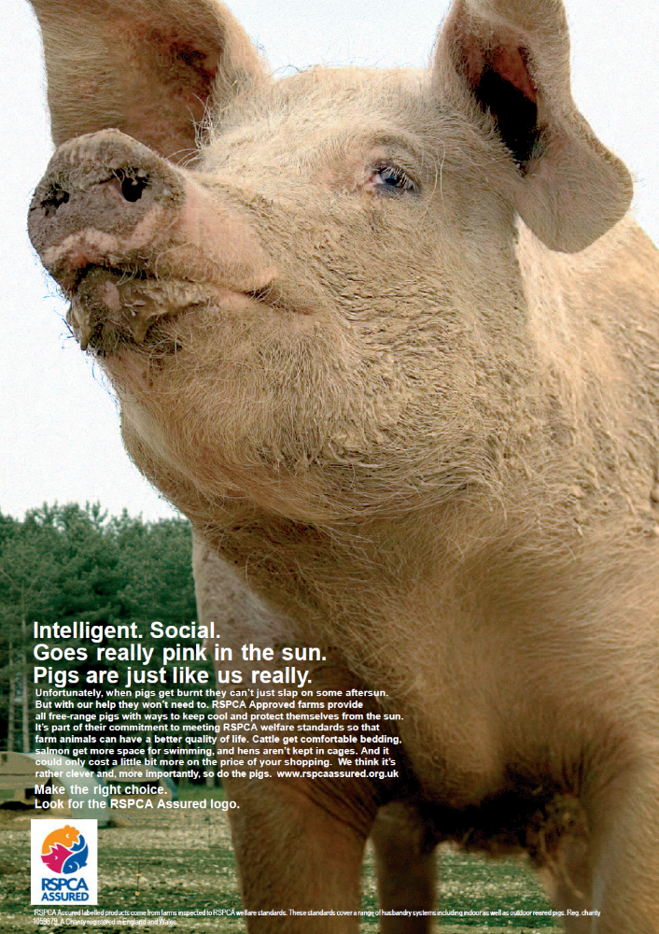
Worksheets – Advert analysis

Questions to think about:
What is the advert about?
- Are there any pictures of animals?
- How do these make you feel?
- Does the advert have a catchy strapline?
- How does this make you feel?
- What adjectives are used in the advert?
- How do these make you feel about the animal(s) in the advert?
- Does the advert make you think about the animal products you eat and what conditions the animals were kept in?
- Are there any logos on the advert?
- Will you remember to look for these logos when you next go shopping?

Strapline: A strapline is a sentence that is used on an advert to help people remember the product or company being advertised.
Worksheets – Poster scorecard

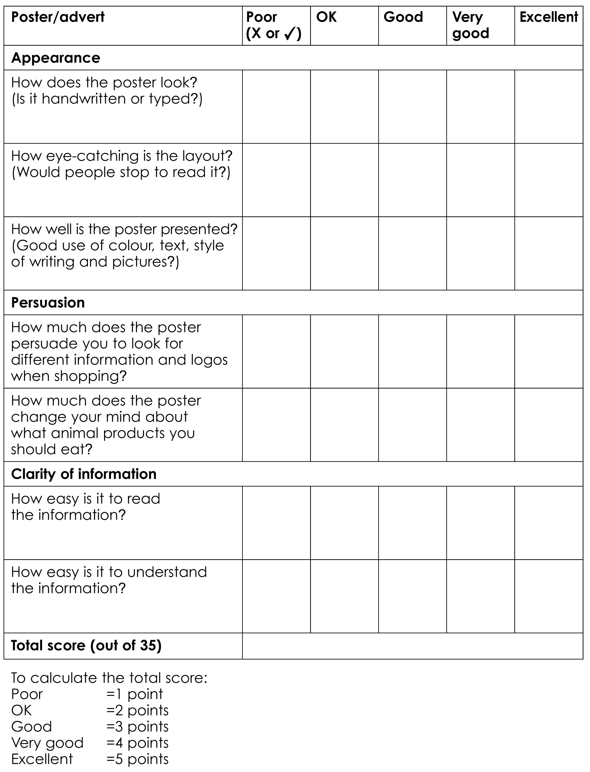

Worksheets – Three stars and a wish



Factsheet – Pig

Name: Pig
Male: Boar Female: Sow or gilt Baby: Piglet

Lifespan: Naturally pigs live for about 10 to 15 years. Pigs bred for their meat are slaughtered at around five to six months.

Natural behaviour: Pigs are very intelligent animals. They still behave like their wild ancestors in many ways:
- they like to explore their environment and look for food by rooting around with their snouts.
- sows like to build a nest in which to give birth to their piglets

How many pigs are there?
Nearly 10 million* are reared in the UK each year - mainly in East Anglia, Eastern Scotland and Yorkshire.

What’s the point of keeping them as farm animals?
For meat - pork, bacon, ham and pork sausages.

How are pigs kept on farms?

Breeding:
About 58 per cent* of pigs reared for meat in the UK are born indoors. Pregnant sows are moved into crates up to a week before they give birth and stay there until the piglets are weaned at around 4 weeks of age. Although the crates are designed to protect the piglets from being rolled on and crushed by the sow, they restrict her movement so she cannot turn around. Over 40 per cent of sows are kept outdoors in fields. They are housed together in groups when pregnant but are then given individual huts with plenty of straw in which to give birth. The sows can leave these huts whenever they want to explore the outdoor area.

Fattening pigs:
Very few pigs are reared outside in fields (around four per cent). Most pigs are reared indoors. This means that, even if the pigs are born on outdoor units, they will spend more than half of their lives indoors. Only three per cent will spend their entire lives outdoors.

Several different types of indoor farms:
A large number of indoor-rearing farms have slatted floors with little or no straw for the pigs to root around in. The slatted floor is uncomfortable for pigs to lie down on and can damage their feet.
Some indoor farms have straw yards so that the pigs can root around, choose a comfortable place to rest and sleep and choose where to go to the toilet.

Did you know?
Pigs can’t sweat, except from the tip of their snout - they cool themselves down by wallowing in mud.
* information correct as of 2015.
Factsheet – Meat chicken

Name: Meat chicken (also known as broiler)
Male: Cockerel Female: Hen Baby: Chick

Lifespan: Naturally about ten years. Chickens bred for meat are slaughtered at about five to six weeks old.

How many broilers are there?
Around 930 million broiler chickens were bred in the UK in 2012.

What’s the point of keeping them as farm animals?
Chicken meat is now the most popular meat in the UK.*

How are the animals kept on farms?
Broiler-breeding farms:
Male and female chickens mate naturally and females lay eggs. The eggs are collected. Fertilised eggs are artificially incubated. When the eggs are hatched, the chicks are moved to rearing farms.

Rearing farms:
Broiler chicks go to rearing farms when they are one day old. Most meat chickens grow up indoors, in large sheds. There are usually around 25,000 in one shed.

Meat chickens are bred to grow very fast. As a result, they may have painful leg problems and heart defects. When a chicken is lame, this means it is not able to walk properly and may have difficulty getting food and water.

Free-range:
A very small percentage of meat chickens are free-range. This means the birds can go outside and have more space to move around.

Organic:
Meat chickens on organic farms are also free-range and are fed organic food. Some farmers may also choose birds that grow more slowly.

RSPCA Assured:
RSPCA Assured chickens may be kept indoors or may be free-range. They have more space than ordinary meat chickens, as well as having straw bales, perches and a clean dry floor. They are also slower growing and are provided with natural light.

Did you know?
In 2010 for the first time, specific legislation relating to meat chicken welfare came into force. It includes stating how much space each bird must have. This is called stocking density.

* information correct as of 2015.
Factsheet – Cattle

Name: Cattle

Male: Bull Female: Cow
Young female: Heifer Young male: Bullock or steer Baby: Calf

Where did they come from?
Descended from aurochs (large, extinct cattle).

Lifespan: 20-30 years naturally. Dairy cattle are usually slaughtered at around five years, beef cattle at 18 months and veal calves at four to five months old.

Special features:
Cattle are herd animals. They naturally live in groups.

How many are there?
1.78 million* dairy cattle and 1.6 million** beef cattle in the UK.

What’s the point of keeping them as farm animals?
Beef cattle for meat - sausages, mince, steak and beef. Dairy cattle for dairy products - milk, cream, cheese and yoghurt.

How are the animals kept on farms?
Dairy cattle:
To produce milk, cows need to give birth to calves. A dairy cow has one calf a year. In total, dairy cows produce 2.25 million calves a year. Some dairy cows now produce over 80 pints of milk a day.*

Beef cattle:
Beef cattle are bred to grow big and muscular. There have been some problems with selectively-bred cattle, including female animals experiencing difficulties at the time of giving birth (calving)

Both dairy and beef cattle usually spend spring and summer out in the fields and are housed in winter. Many of the housing that dairy herds are kept in can be uncomfortable for them. Some beef cattle housing may have slatted floors with no straw for the animals to lie down on.

Did you know?
About 40 per cent of the beef we eat is a by-product of the dairy industry - calves that are not needed or dairy cows at the end of their milk-producing lives.

* information correct as of 2014.
**information correct as of 2013

Factsheet – Laying hen

Name: Laying hen (only females lay eggs!)

Lifespan: Naturally about seven to nine years. On laying hen farms, they are usually kept for about 18 months, when the number of eggs they produce starts to decrease.

Natural behaviour – hens need to:
- stretch their wings and clean them by dustbathing
- scratch and peck for food
- exercise – they need to move around
- make nests to lay their eggs in.

How many are there?
There are around 36 million laying hens in the UK.*

What’s the point of keeping them as farm animals?
For eggs.

How are they kept on farms?
Rearing:
Just after hatching and until around 15-18 weeks old, young female chickens, known as pullets, are kept on rearing farms. These are usually large barns with places to scratch around and dustbathe. Many have perches and some have an outdoor area. Pullets being reared for caged egg farms may be reared in cages. Just before they begin to lay eggs, pullets are moved to a laying farm.

Laying hen systems
Battery:
Hens live in a cage with less space each than the size of an A4 piece of paper. Birds can’t flap their wings or move around properly and so find it difficult to exercise or move away from other more aggressive hens. Conventional or barren battery cages were banned in Europe from 1 January 2012 but ‘enriched’ cages are still permitted. These are still battery cages. About 51 per cent of eggs produced in the UK are still produced using hens kept in cages.*

Barn eggs:
The hens are kept indoors but can move freely around the building. They have places to dustbathe, scratch, nest and perch. About three per cent of eggs from laying hens in the UK are produced using this system.*

Free-range:
Hens are kept in barns but can also go outside during the day. Each hen should have a minimum of four square metres outside and access to shade and shelter. They can scratch and peck on outside ground.
About 46 per cent of eggs from laying hens in the UK are produced using this system.*

Did you know?
Hens are strongly motivated to gain access to a suitable nest site in which to lay their eggs and will perform complex pre-laying behaviours. Provision of a nest area has been identified as a very important welfare need.

* information correct as of 2013.

Image – chicken

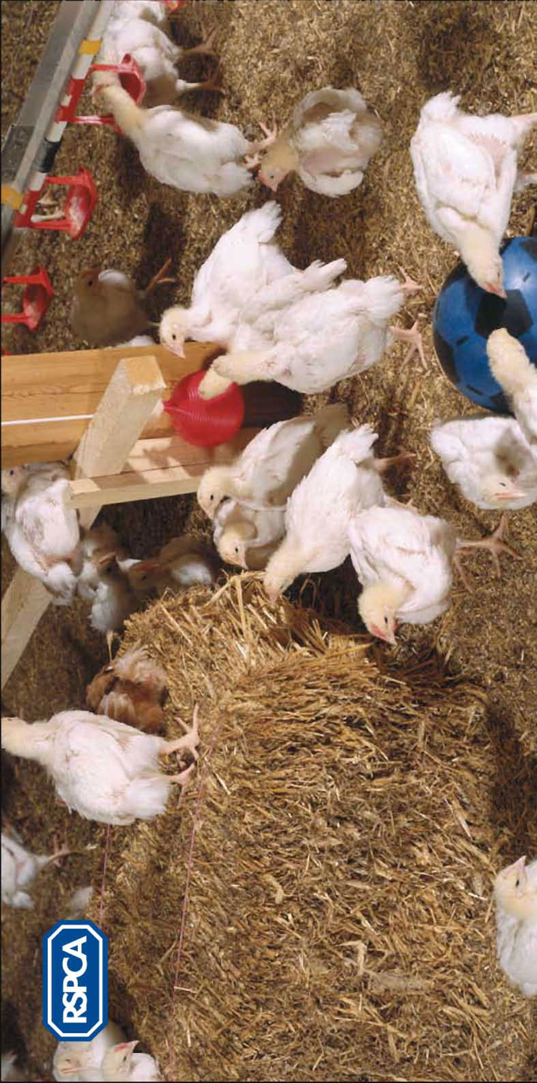
Image – pig

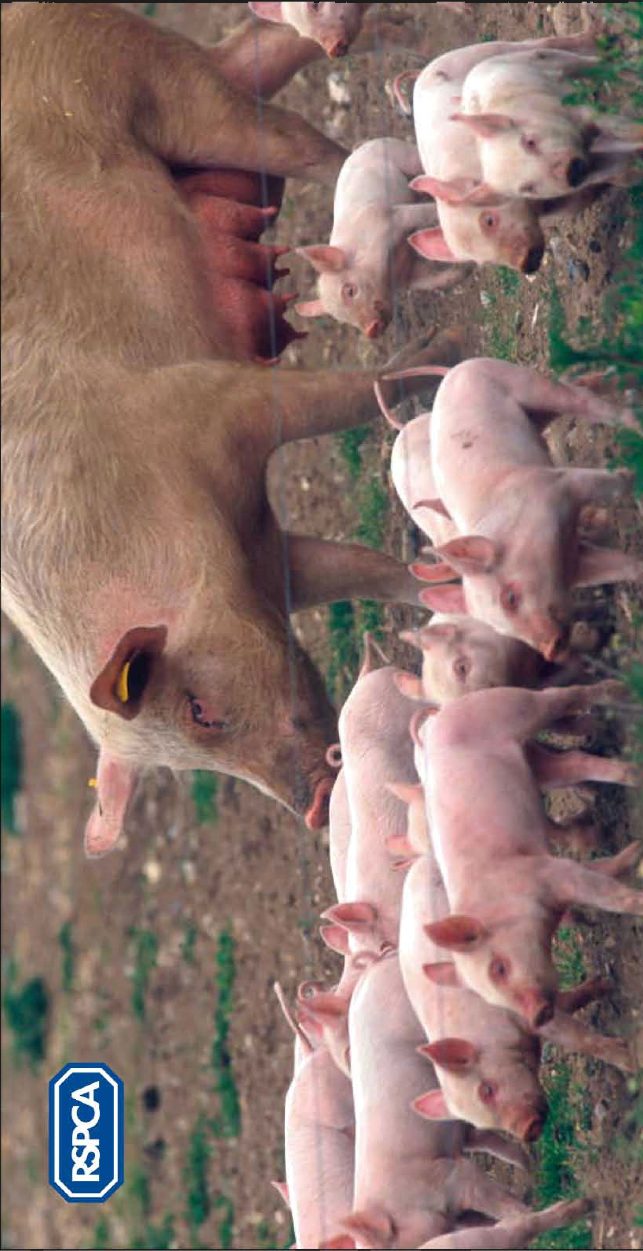
Image – cow

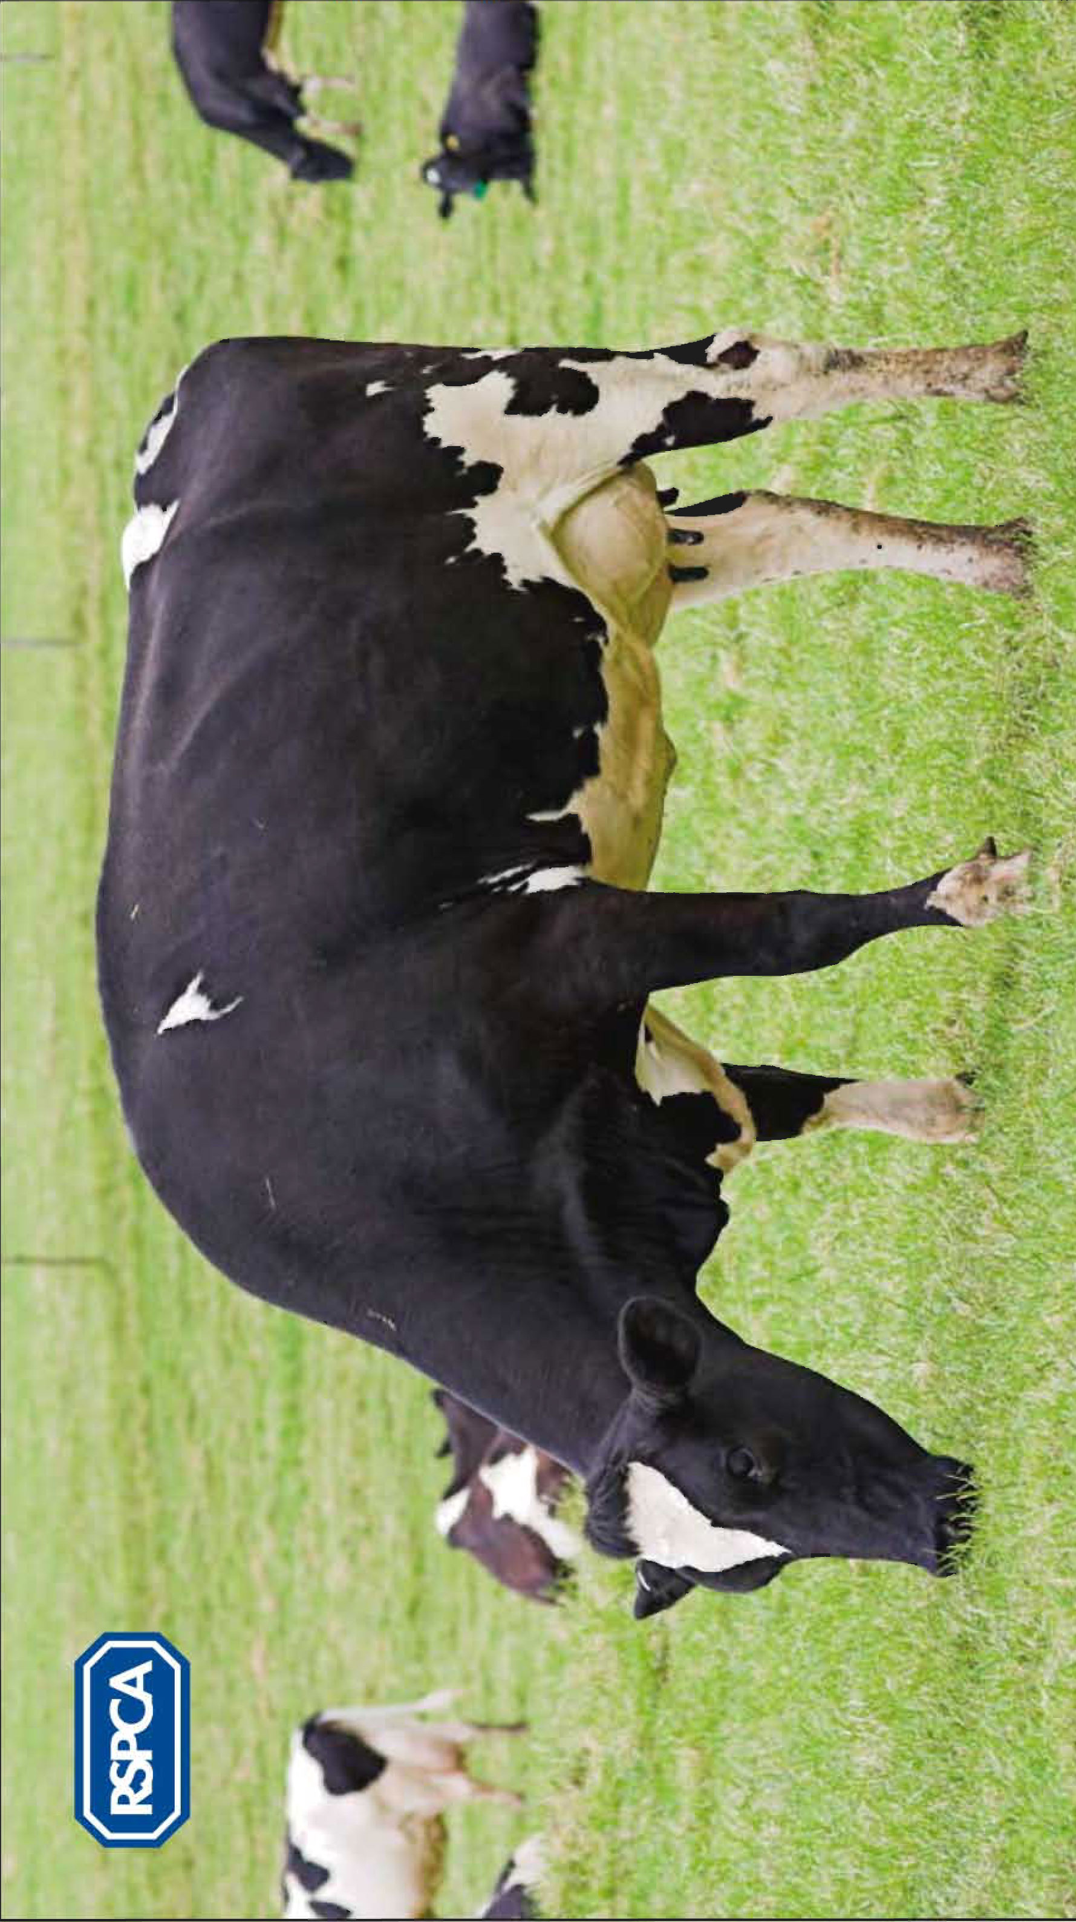
Image – sheep

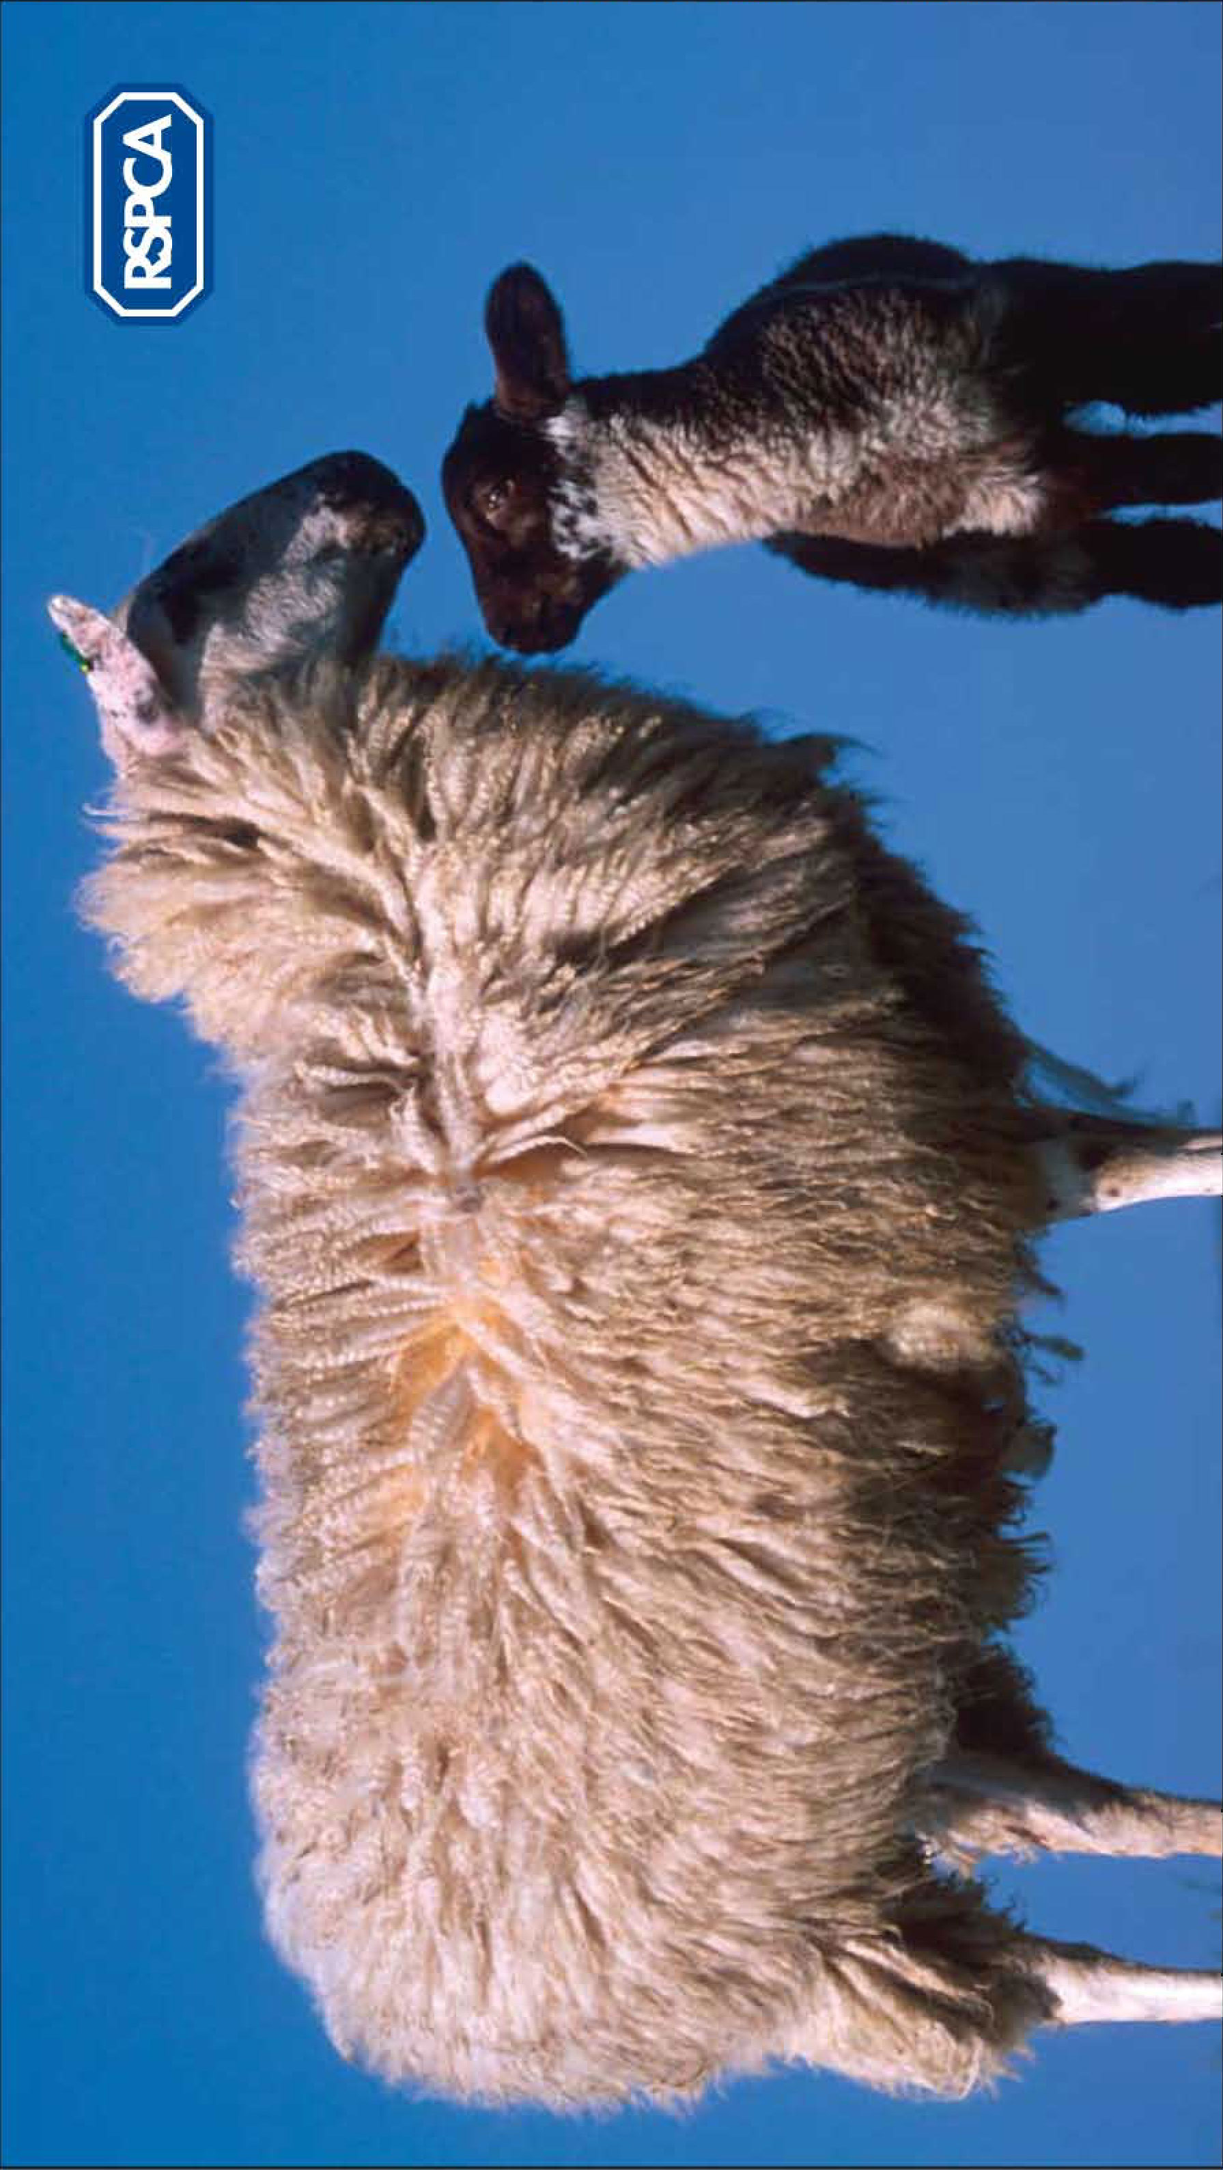
Image – hen

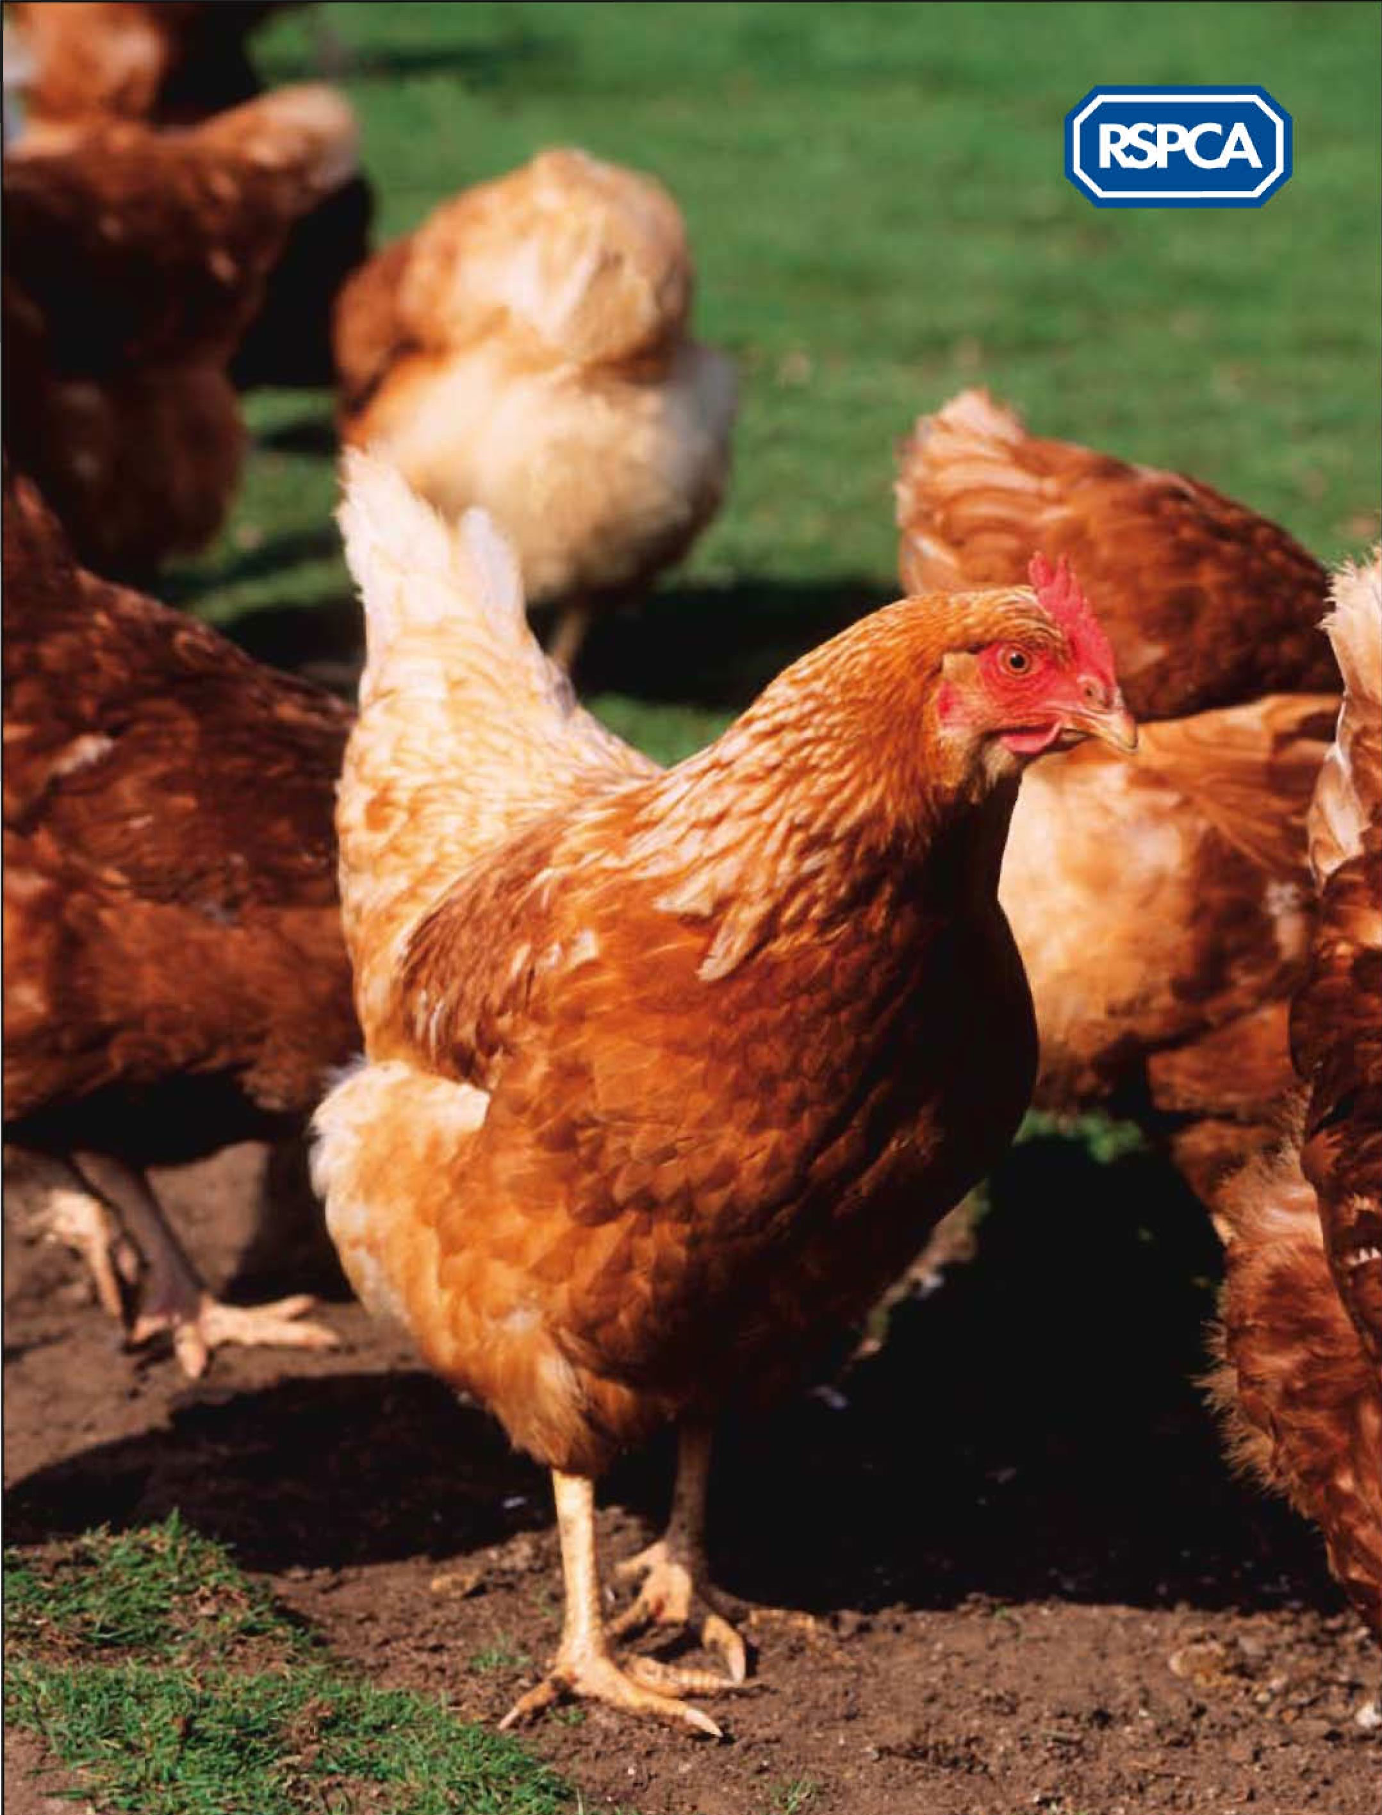
Image – turkey

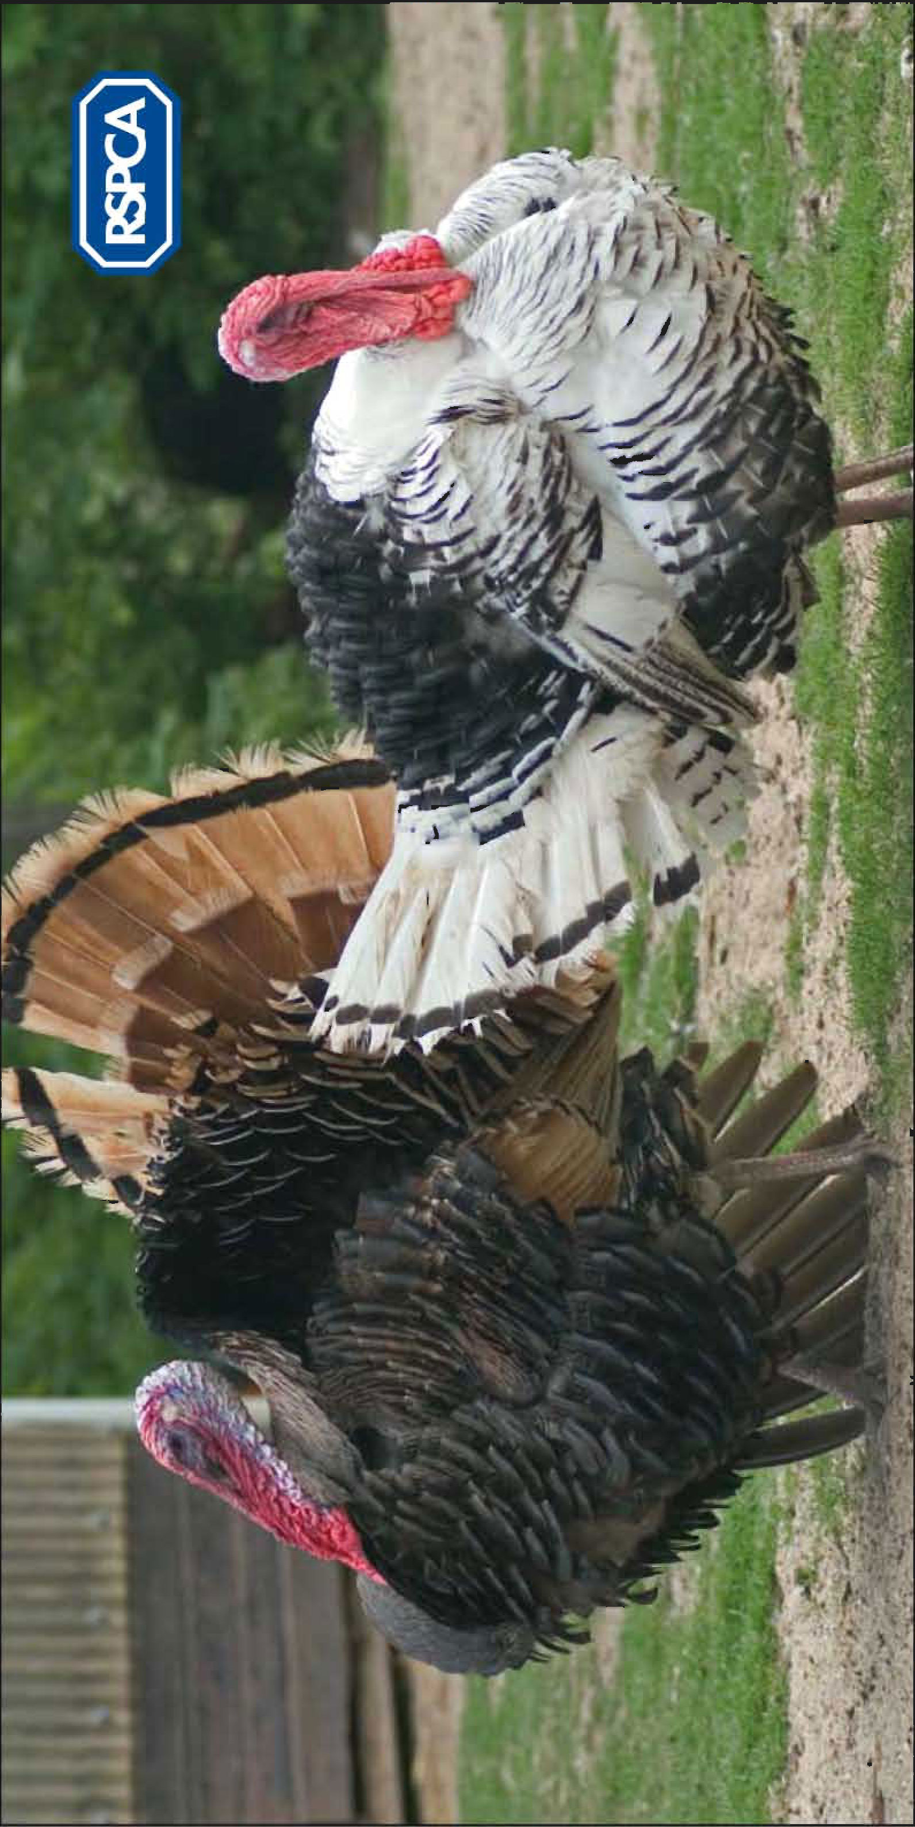
Image – duck

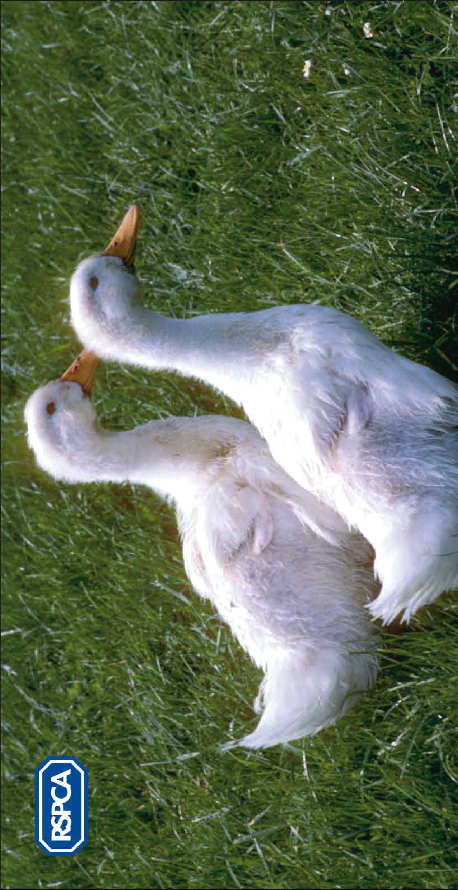
Image – salmon



