In this lesson students will examine the welfare and ethical issues concerned with rearing chickens for meat as an example of selective breeding and intensive farming. It should ideally be followed by Designing a chicken welfare experiment .

Starter activity
What do you know?
- Using photos to illustrate, explain the objectives of the lesson. Invite the students to find out what they know about chicken meat production through a short quiz (see worksheet Chicken quiz).
- Read out the questions and ask the students to record their answers on paper or, if appropriate, put up signs with the letters A,B and C in the corners of the room and invite them to vote with their feet.
- Reveal the answers (see factsheet Chicken quiz - answers) as appropriate and discuss.
Learning styles: visual, auditory, kinaesthetic.

Main activity
What are the welfare concerns?
- Distribute the worksheet Do meat chickens suffer? (1) and read through with the class. This repeats and reinforces some of the facts they have already come across in the quiz and clearly describes the animal welfare concerns associated with this practice. Invite questions to clarify any vocabulary.
- The students should underline the key points. They then discuss where each point fits in the Welfare concerns flowchart and write them in. When completed, they will have a summary of the concerns the RSPCA has about meat chicken welfare. This activity is differentiated, see Differentiation section below.
Considering the issues
- Discuss the completed flowchart using the points outlined in the teachers' notes (see Downloads tab).
Who can change this?
- Explain that, because of concerns about the welfare of chickens, the RSPCA tries to influence how chickens are reared, such as:
- Liaising with retailers and producers, educating the public and running advertising campaigns
- A UK farm assurance and food labelling scheme called RSPCA Assured
- Campaigning and lobbying to get laws changed to improve standards of welfare.
- Ask the class who else they think has (or could have) influence over the way chickens are reared. Record their answers on a board or flipchart (start with the RSPCA - others are listed in the teachers' notes).
Learning styles: visual, auditory.

Plenary activity
What can we do?
- Ask the students to discuss their role as consumers and members of the public. They can:
- Choose RSPCA Assured or free-range labelled products when they shop. The more we buy/ask for these products, the more shops and supermarkets will stock them
- Support campaigns run by the RSPCA and other animal welfare organisations by signing petitions, writing to their MP or lobbying (see Useful websites tab).
Learning styles: visual, auditory.

Differentiation
- On version 2 of the worksheet Do meat chickens suffer?, the students pick out the underlined words/phrases, decide where they fit into the Welfare concerns flowchart and write them into the boxes.
- On version 3 the students should cut out the boxes, discuss and decide where they fit in the chart and then stick them all down.
- For less able students, some of the boxes could be filled in before they start cutting and sticking.

Extension activities
- The follow-up questions (see worksheet What can we do about it?) will help to prepare the students for a discussion or, when used as homework, will consolidate the knowledge.
- Further extension work could include comparing the welfare standards of different methods of meat chicken-rearing. The students could be directed to find out exactly what is meant by an 'organic' and a 'free-range' chicken. This can be done by research on the Internet.

Did you know?
- The RSPCA's definition of 'intensive farming' is a system of farming livestock in which the management of the animals hinders the performance of normal behaviours to such an extent that welfare is compromised.
- Around 90 per cent of chickens are reared for their meat to minimum welfare standards, which allow each chicken less space than a sheet of A4 paper. That's less space than is allowed for egg-laying hens that are kept in cages.
- Chickens on RSPCA Assured-assessed farms are given items to enrich their environment such as perches, straw bales and even footballs to play with to keep them active.
- The RSPCA Assured scheme is concerned primarily with animal welfare, while organic schemes focus primarily on environmental sustainability.
- For tips and advice on writing to politicians, you can order the leaflet Make every word count from the Publications section of the RSPCA website.

Curriculum objectives
Students should learn:
- that intensive farming and selective breeding may raise ethical issues concerning animal welfare.

Animal welfare objectives
Students should learn:
- about the welfare issues surrounding farmed chickens
- that they, as consumers, can affect the way in which animals are farmed.

Learning outcomes
At the end of this session:
- most students: have a good understanding of the welfare concerns associated with meat chicken (broiler) rearing as an example of an intensive farming method. They will have raised and discussed some associated ethical issues. They will be able to identify the individuals and groups who can influence the welfare of the chickens either directly or indirectly by influencing the legislation that regulates this method
- some students have not made so much progress and: will be aware of the welfare concerns associated with broiler rearing and will have discussed the issues raised and listened to others' opinions
- some students have progressed further and: will understand the difference between indoor, free-range and organic rearing of chickens. They will recall and describe the organisations responsible for the regulation of intensive farming.

Vocabulary
broiler dehydration farming RSPCA Assured free-range
intensive organic starvation syndrome

Useful websites
RSPCA - All about animals - Farm animals
RSPCA - Publications
RSPCA - Meat chicken information sheet
RSPCA Assured
RSPCA report: 'Everyone's a winner'
Compassion in World Farming - Education
Write To Them
FACE - Farming and Countryside Education
Defra - Welfare of meat chickens and breeding chickens
RSPCA - Campaigns - Working for a better deal for chickens

Images – Farming
Meat chickens – standard indoor-reared chickens, 31-day-old flock
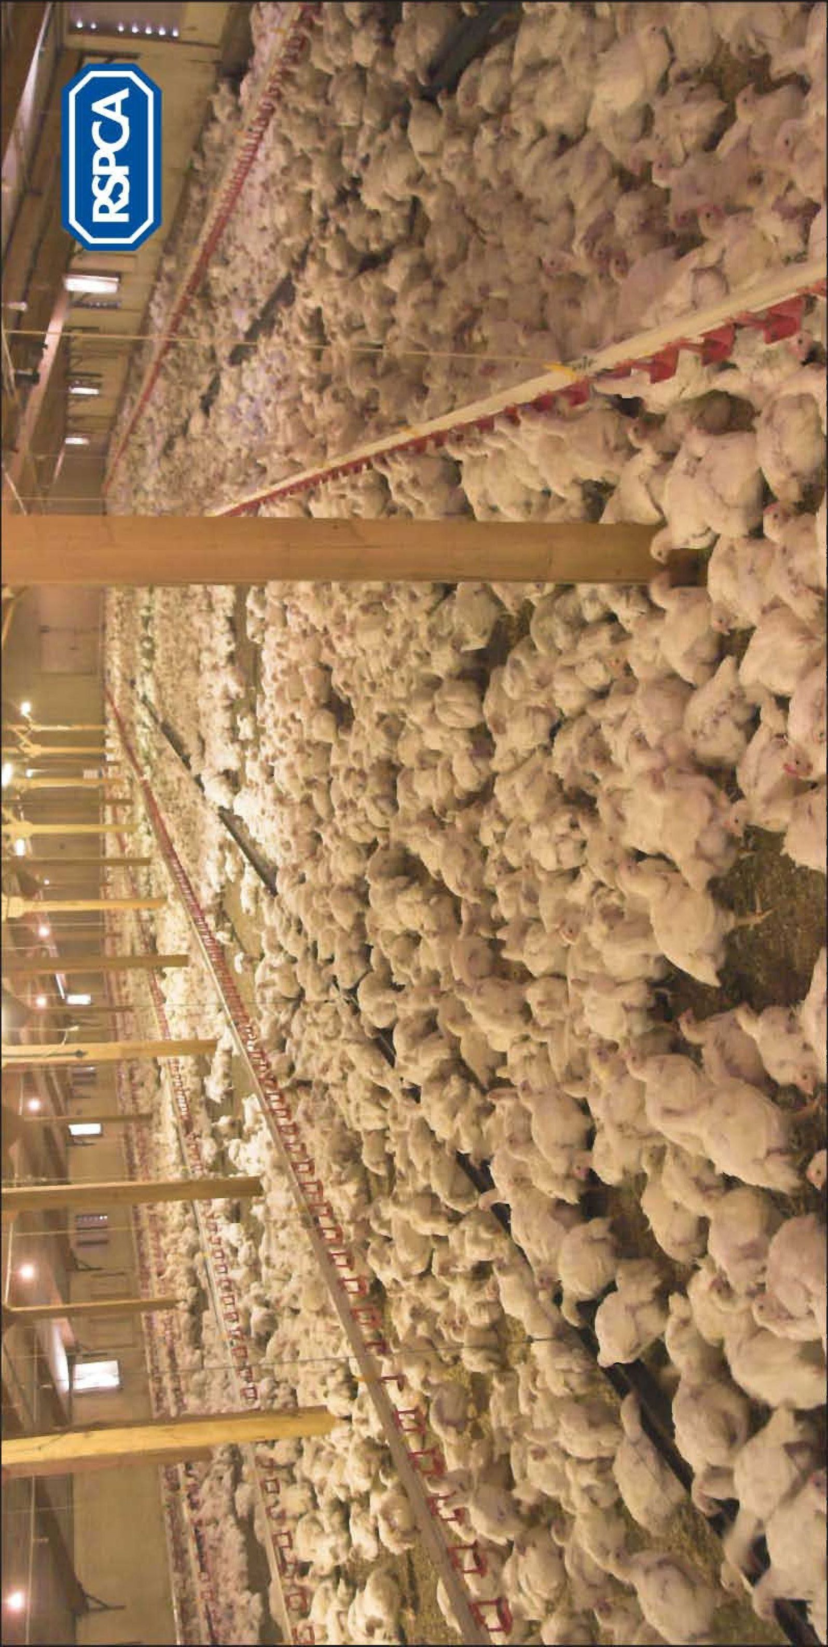
Laying hen and meat chicken growth comparison
After only 45 days the meant chicken (right) is significantly larger than the laying hen (left).

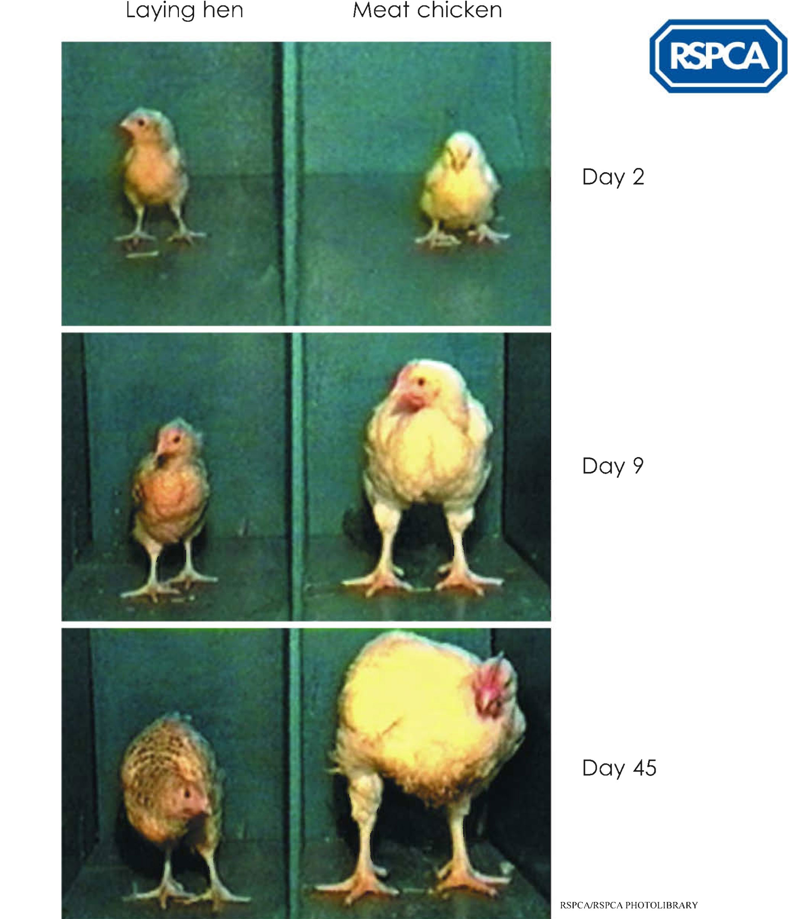
Meat chickens
Indoor broiler system – single chicken lying on straw and incapable of standing.

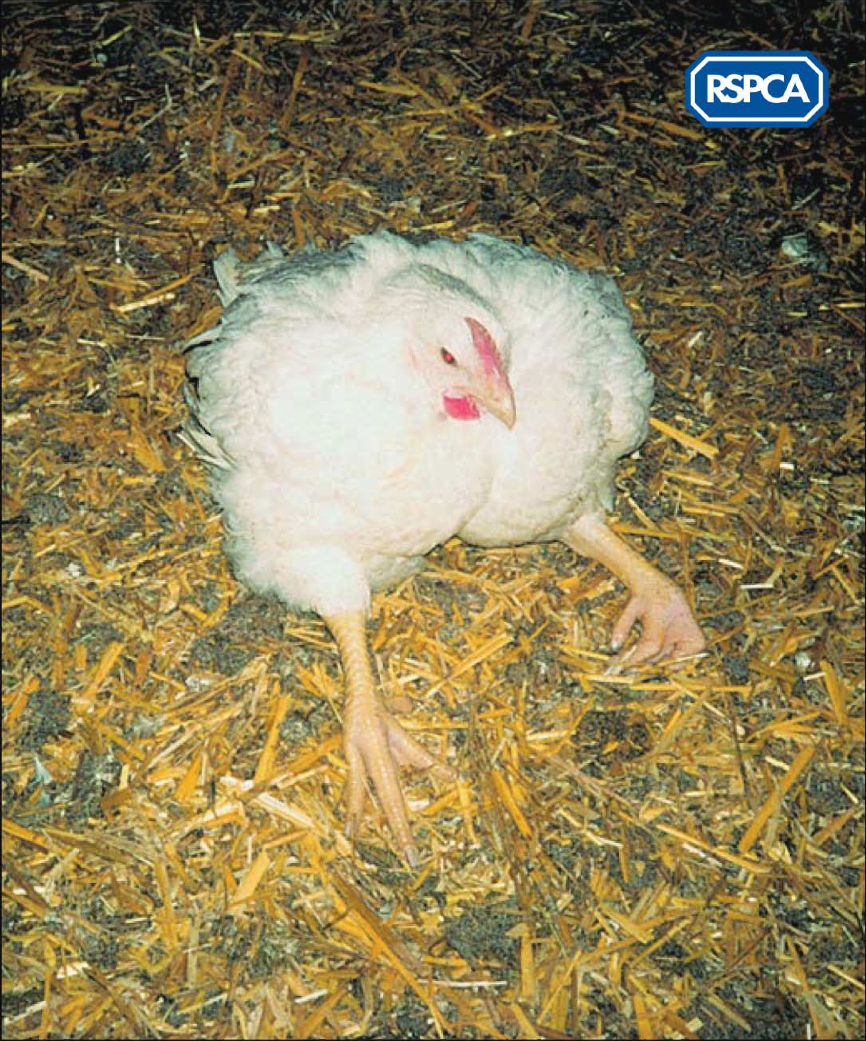

Meat chicken
Chicken with hock burns purchased in UK supermarket.

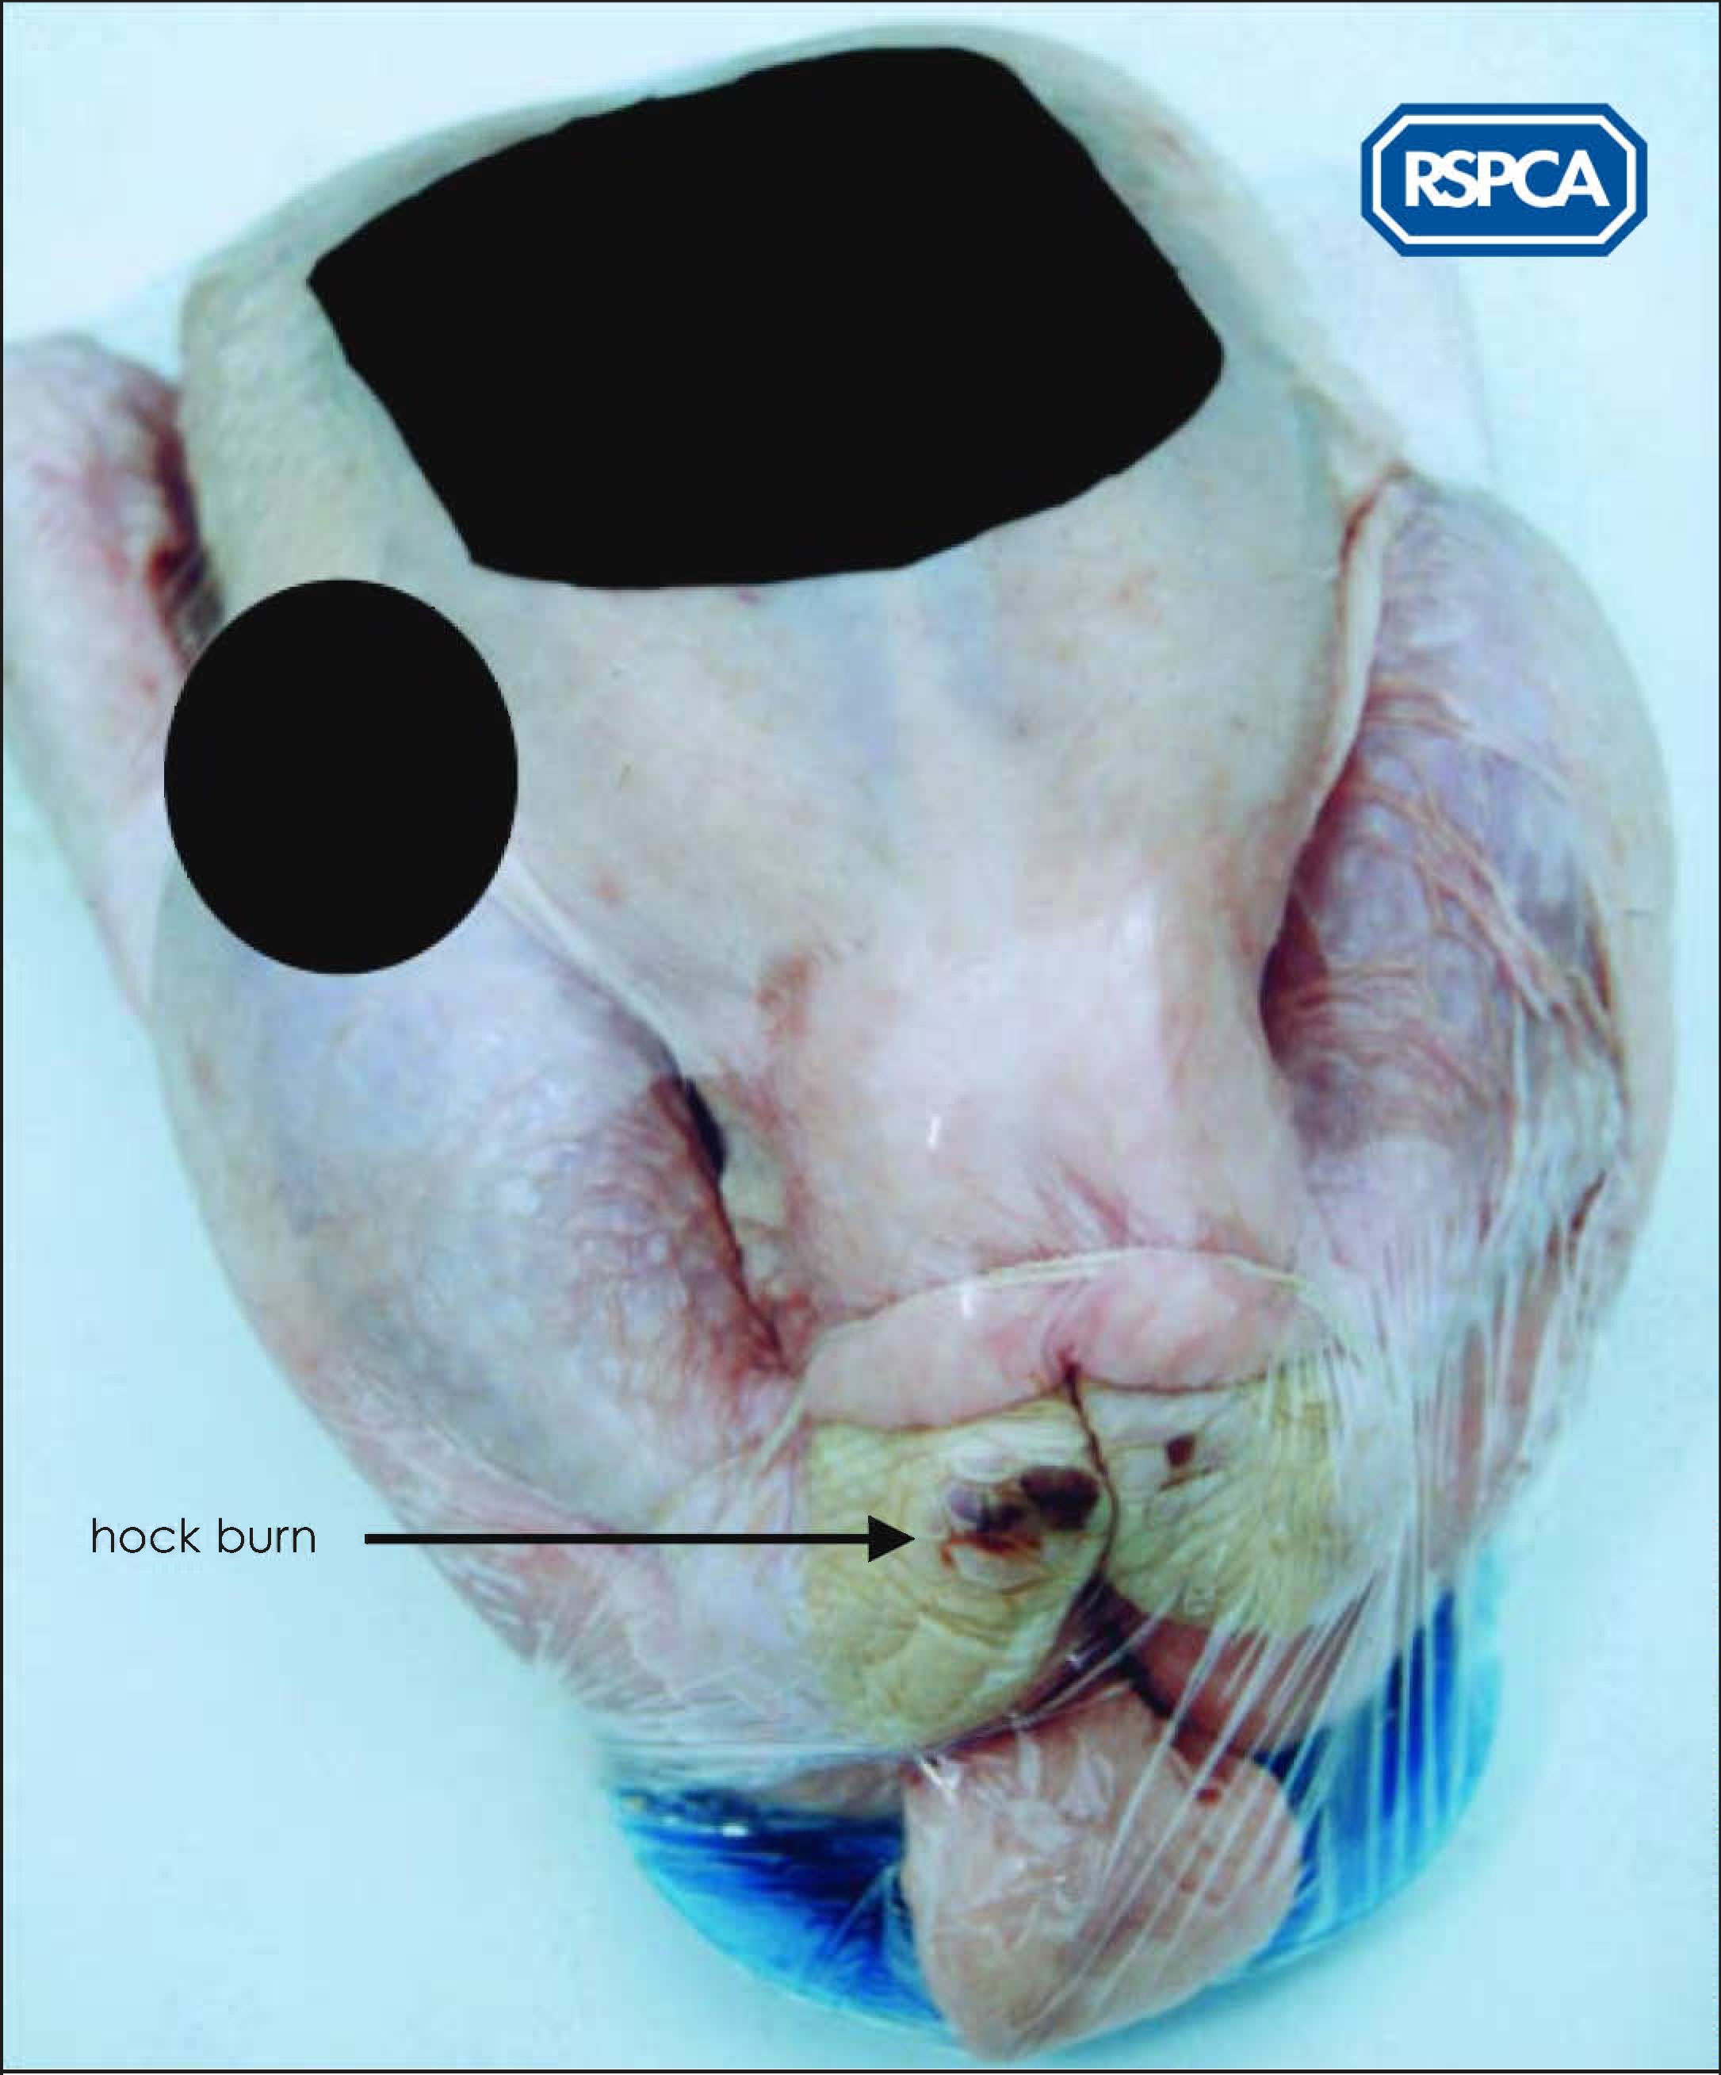
Image – RSPCA Assured logo

Worksheet – Chicken quiz

Q1. Meat chickens can be reared in sheds about the size of a small football field.
How many birds do you think can be kept in such a large shed at one time?
- 25
- 2,500
- 25,000

Q2. How many chickens were reared for meat in the UK in 2012?
- 93 million
- 930 million
- 9,300 million

Q3. On average, how many chickens are slaughtered every second in the UK?
- 5
- 29
- 98

Q4. Meat chickens can be selectively bred to grow fast. What is the average time between them first hatching to appearing on the supermarket shelf?
- 5 – 6 weeks
- 5 – 6 months
- 12 – 18 months

Q5. On average, how many kg of chicken does each person in the UK consume per year?
- 230kg
- 23kg
- 2.3kg

Q6. What percentage of meat eaten in the UK is chicken?
- 10 per cent
- 40 per cent
- 70 per cent

Q7. What percentage of chickens reared for meat in the UK are free-range and/or organic?
- 2.5 per cent
- 10 per cent
- 25 per cent

Q8. How many chickens die prematurely each day?
- 1,000
- 10,000
- 100,000

Answers: 1. C, 2. B, 3. B, 4. A, 5. B, 6. B, 7. A, 8. C
Worksheet – Do meat chickens suffer? 1

Below are some extracts from the RSPCA report ‘Everyone’s a winner’, which is about the farming of chickens for meat.

Your task is to underline the key welfare points that you think the RSPCA is concerned about and copy the words/sentences into the Welfare concerns flowchart.

If you get them all in the right places you will have a summary of the RSPCA’s concerns.

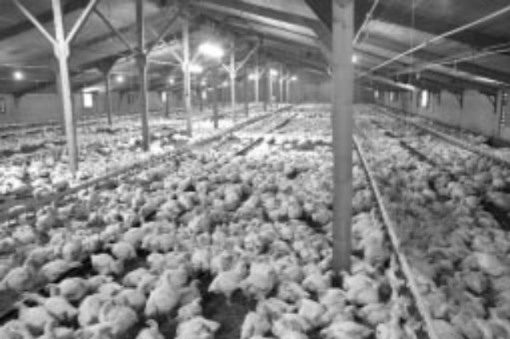

About 930 million meat chickens were slaughtered for food in the UK in 2005 - that’s 29 chickens every second. Most of these meat chickens or ‘broilers’ are selectively bred to grow fast, from hatching to supermarket shelves in little over a month. This rapid growth may lead to heart failure (sudden death syndrome), and if the chickens don’t die they may suffer from a heart condition (ascites), which can lead to death from starvation and dehydration. Fast growth rate can also lead to leg problems such as lameness. Lame chickens cannot reach the feed and water stations in the sheds so they too can die of starvation and dehydration.

Around 98 per cent of chickens in the UK are reared in large closed buildings, where the temperature and lighting are controlled. Depending on its size, a shed can hold up to 25,000 birds. The light in the sheds may be kept very dim, and the chickens can develop eye problems.

The amount of space provided per bird is called the ‘stocking density’. A high stocking density (or small amount of space per bird) combined with an unstimulating (boring) environment where there is very little to do means that the chickens become less active. Also, when they are crowded, the chickens may find it difficult to sleep properly.

Reduced activity coupled with poor litter conditions (a lot of droppings) can mean that birds get skin infections and burns to their feet and legs, caused by the ammonia in their droppings. Having lots of birds in a small area can also increase the chance of them suffering from heat stress in hot weather, and they can get scratched.

Worksheet – Do meat chickens suffer? 2

Below are some extracts from the RSPCA report ‘Everyone’s a winner’, which is about the farming of chickens for meat.

Your task is to copy the underlined words/sentences into the boxes of the Welfare concerns flowchart.

If you get them all in the right places you will have a summary of the RSPCA’s concerns.

About 930 million meat chickens were slaughtered for food in the UK in 2012 - that’s 29 chickens every second. Most of these meat chickens or ‘broilers’ are selectively bred to grow fast, from hatching to supermarket shelves in little over a month. This rapid growth may lead to heart failure (sudden death syndrome), and if the chickens don’t die they may suffer from a heart condition (ascites), which can lead to death from starvation and dehydration. Fast growth rate can also lead to leg problems such as lameness. Lame chickens cannot reach the feed and water stations in the sheds so they too can die of starvation and dehydration.

Around 98 per cent of chickens in the UK are reared in large closed buildings, where the temperature and lighting are controlled. Depending on its size, a shed can hold up to 25,000 birds. The light in the sheds may be kept very dim, and the chickens can develop eye problems.

The amount of space provided per bird is called the ‘stocking density’. A high stocking density (or small amount of space per bird) combined with an unstimulating (boring) environment where there is very little to do means that the chickens become less active. Also, when they are crowded, the chickens may find it difficult to sleep properly.

Reduced activity coupled with poor litter conditions (a lot of droppings) can mean that birds get skin infections and burns to their feet and legs, caused by the ammonia in their droppings. Having lots of birds in a small area can also increase the chance of them suffering from heat stress in hot weather, and they can get scratched.

Worksheet – Do meat chickens suffer? 3

Below are the facts that fit into the Welfare concerns flowchart.
You have to cut each box out carefully and decide where it goes in the flowchart.
It’s a good idea to position all the boxes before you start sticking them down.

Here’s a clue to get you started:
Fast growth rate (at the top of the chart) leads to heart condition which leads to death by starvation and dehydration. The effect is poor welfare (at the bottom of the chart).

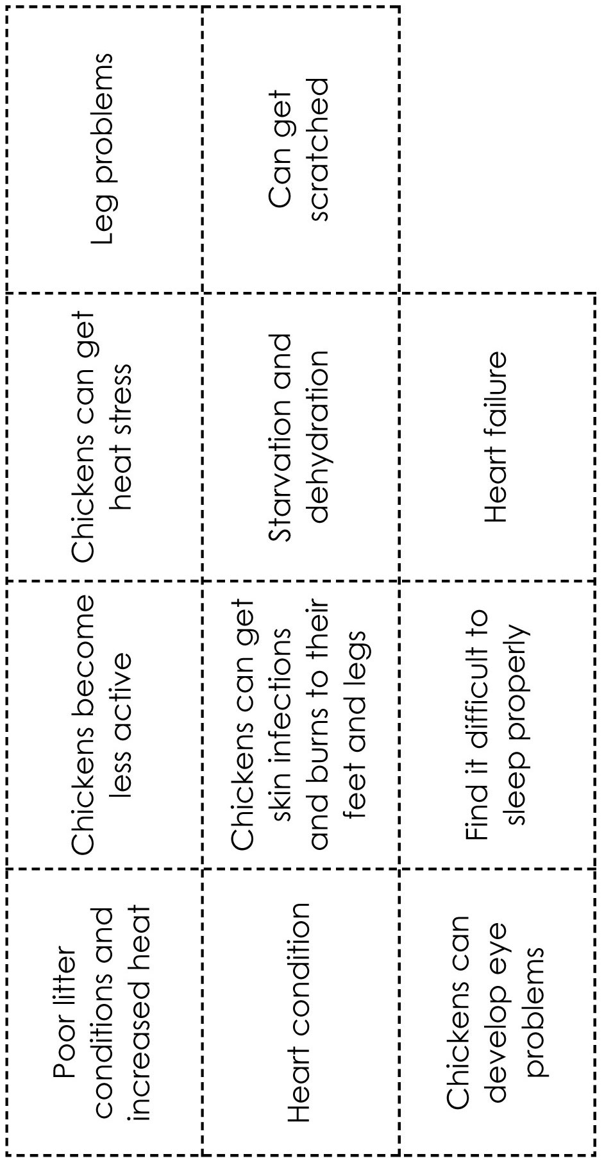
Worksheet – Welfare concerns flowchart

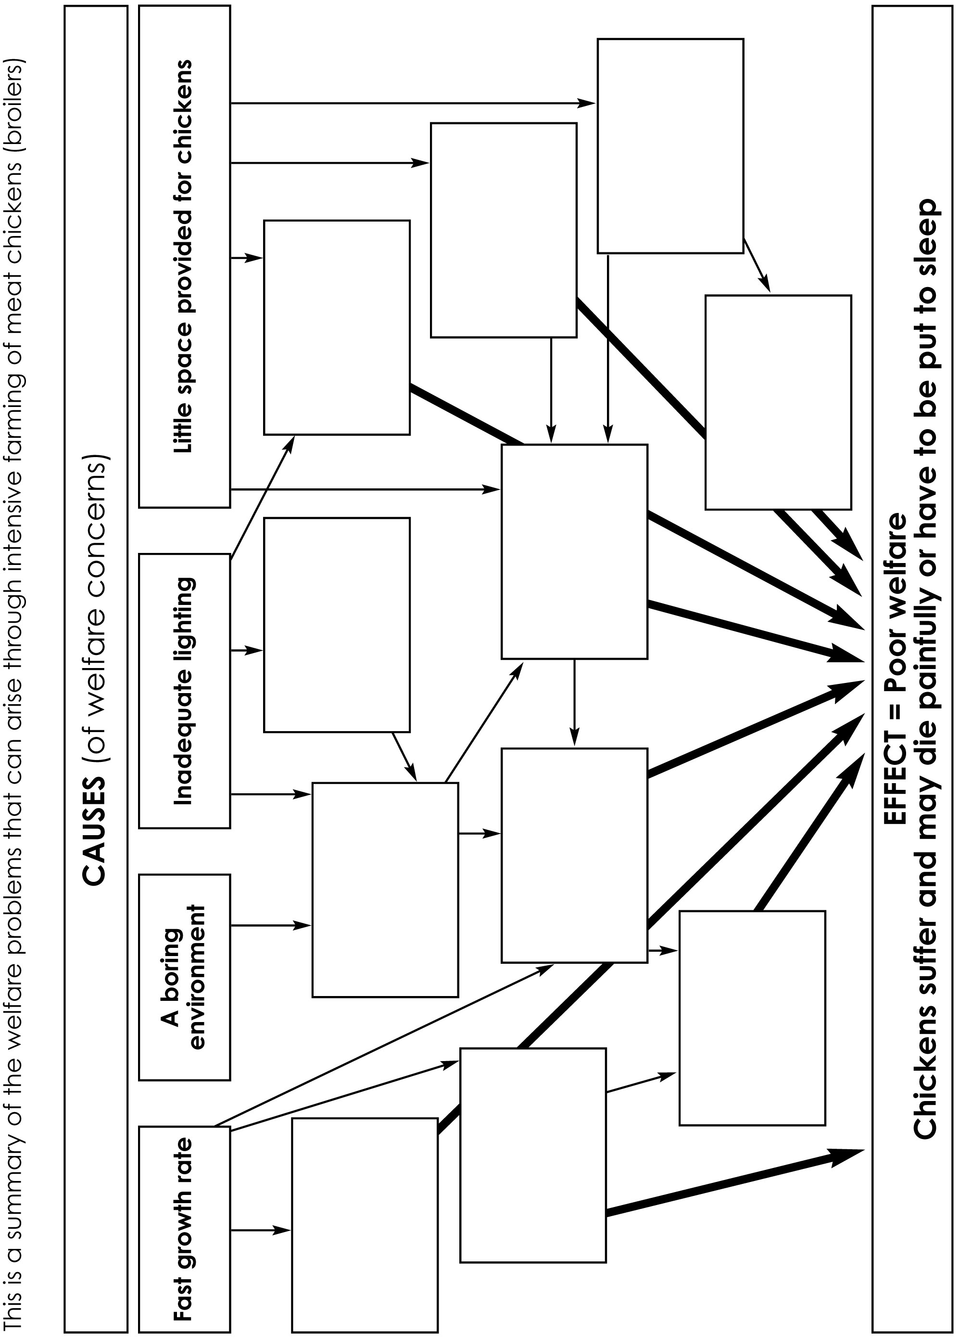
Worksheet – Welfare concerns flowchart answers

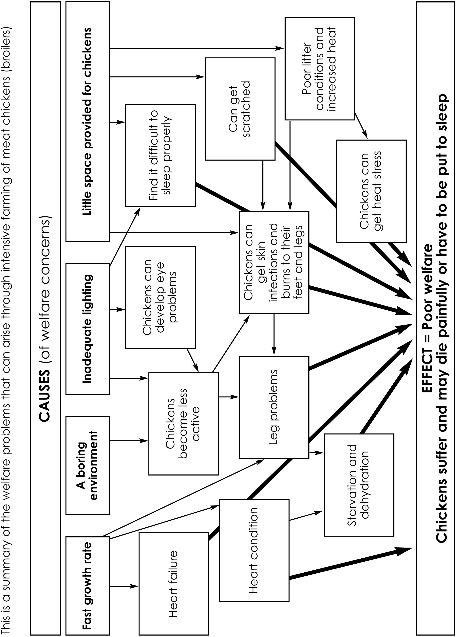
Factsheet – ‘What can we do about it?’ Questions

You can find the answers to questions 1-5 in the worksheets Do meat chickens suffer? and Welfare concerns flowchart. Discuss your answer to question 6 with your partner or group.

- What are the four main welfare concerns the RSPCA has about meat chickens raised indoors?
- List three reasons why the chickens are likely to experience discomfort or pain
- List two reasons why the chickens might be stressed
- What are the three consequences of the chickens being kept in poor lighting?
- Why can leg problems lead to death by starvation and dehydration?
- Who could influence the way chickens are kept in the future, and how could they do this?

‘What can we do about it?’ Answers

- What are the four main welfare concerns the RSPCA has about meat chickens raised indoors?
  - Fast growth rate
  - An unstimulating (boring) environment
  - Inadequate lighting
  - Little space provided for chickens
- List three reasons why the chickens are likely to experience discomfort or pain
  - Fast growth rate can lead to heart failure or a heart condition
  - Fast growth rate can lead to leg problems such as lameness
  - The birds can get skin infections and burns to their feet and legs caused by poor litter conditions
- List two reasons why the chickens might be stressed
  - When they are crowded, the birds may get scratched and may find it difficult to sleep properly
  - Having many birds in a small area can increase the chance of them suffering from heat stress
- What are the three consequences of the chickens being kept in poor lighting?
  - Chickens can develop eye problems
  - Chickens become less active
  - Chickens can get skin infections and burns to their feet and legs
- Why can leg problems lead to death by starvation and dehydration?
  - Because lame chickens cannot reach the feed and water stations in the shed.
- Who could influence the way chickens are kept in the future, and how could they do this?
  - Consumers and members of the public can ask supermarkets and shops to stock RSPCA Assured or free-range labelled products. They can support campaigns run by the RSPCA and other animal welfare organisations by signing petitions, writing to their MP or lobbying.

Find out more about meat chickens and how you can improve their lives by visiting www.rspca.org.uk/farmanimals
Teachers' notes – Do they suffer?

Starter activity:
The facts contained in this quiz should stimulate discussion. To make the activity more kinaesthetic, the students can then be invited to guess the answers by voting with their feet. This has the advantage that no one can opt out of answering!

Main activity:
Points for discussion:
- Encourage the class to describe the ways in which the welfare of meat chickens is compromised.
- Consider why the chickens are reared in this manner and who is responsible.
- For example, to get cheap food and maximise profits. At this point, the students may feel that the farmers are completely responsible. It is important to impress upon them that farmers using these methods are within the law. Ask them to think about who makes the laws. Who else might be able to influence the chickens’ welfare, e.g. retailers who supply the meat and consumers who buy the meat (supply and demand)?
- Simple changes could be introduced to improve welfare. Can the class think of some, e.g. lowering the stocking density, putting straw bales into the sheds that the birds can roost on, providing bright ‘daylight’ periods so the chickens can see better and suitable dark periods so the chickens can rest better.
- What might be the consequences of doing this for the farmer - and the consumer, e.g. small improvements in conditions can lead to big improvements in the welfare of the chickens and might not necessarily lead to lower profits for the farmer or increased cost for the consumer.

Plenary:
To explain more about how the RSPCA is trying to improve the welfare of meat chickens.
- The RSPCA has set up a UK farm assurance and food labelling scheme called RSPCA Assured, dedicated to improving welfare standards for farm animals. The RSPCA Assured logo (see Useful websites section) is assurance that products have come from animals reared on farms assessed to the RSPCA’s strict welfare standards by trained farm assessors.
- The RSPCA organises campaigns to inform the public about its concerns and to lobby central government to change laws to improve standards of welfare for meat chickens and other farm animals.

Your list ‘Who else has influence over the way chickens are reared?’ should include:
- The RSPCA (via farm livestock inspections, RSPCA Assured and campaigning)
- Farmers
- Supermarkets
- Central government (through changing welfare laws)
- Defra and the Food Standards Agency
- Local licensing authorities
- Consumers
- European Union

