In this lesson students will examine the reasons for selective breeding of chickens for meat and learn how extreme selection for specific traits can cause unnecessary suffering to the chicken. Ideally, they should have completed the lesson Intensive farming and selective breeding - an ethical debate beforehand.

Starter activity
What do they look like?
- Ask the students to suggest the ideal characteristics to breed into chickens reared for meat from both the farmer's and the supermarket's point of view. This can be done orally or by drawing and annotating a picture of an ideal meat chicken.
- Share ideas and record them on the board. Suggestions include:
- big, with large leg and breast muscles
- non-aggressive
- tasty meat
- tender meat
- fast-growing.
- Explain that chickens have been selectively bred over many generations to have these characteristics. Fact: the modern meat chicken is bred to grow to slaughter weight in just over a month.
- What problems could this very fast growth rate cause the chickens? For example, deformed legs due to them not being able to support such large bodies and other health problems including heart failure.
- Using photos, show the comparison between growth of a meat chicken and an egg-laying hen and the resultant leg deformities.
- Explain that the RSPCA is concerned about the fact that chickens can suffer as a result of this selective breeding. However, before trying to get laws changed to stop this extreme level of selection, the RSPCA needs proof of suffering. The Society commissions scientists to carry out experiments to obtain this evidence.
Learning styles: visual, auditory.

Main activity
Getting the evidence (an experimental design exercise)
- Students imagine that they are RSPCA research scientists. They are trying to collect evidence that meat chickens suffer pain because of their leg deformities.
- Distribute the factsheet Getting the evidence and read through the instructions. Students need to understand that they must plan a method that will not cause the chickens any extra unnecessary suffering.
Learning styles: visual, auditory.

Plenary activity
What did we find?
- Distribute the information about lameness and pain taken from the RSPCA report Paying the price.
- Ask students to compare the experiment described in the report with their own design.
- Ask the students to comment on the welfare issues raised. Revisit ideal characteristics. What characteristics would an animal welfare scientist like to include? Are there any chickens that fulfil these characteristics?
- How can they, as consumers, help to prevent chickens suffering in the future? Show them the factsheet RSPCA Assured logo. By choosing to buy products that display this label, they can be assured that the meat comes from farms that are working to higher welfare standards. (For more detail see the session Do they suffer?).
Learning styles: visual, auditory.

Assessment
The experiments the students design can be added to a portfolio of evidence for the 'Investigative science' aspect of their course.

Extension activities
Ask the students to consider how selective breeding could be used to improve the welfare of chickens.

Did you know?
- Meat chickens (also referred to as broilers) are by far the most numerous of farm animals produced for meat in the UK.
- The modern broiler has been selectively bred to grow at a very rapid rate; from hatching to slaughter weight (2.2kg) in just 37 days. This rapid growth can cause them a variety of health problems such as heart failure and lameness.
- Chickens on RSPCA Assured-assessed farms are given items to enrich their environment such as perches, straw bales and even footballs to play with to keep them active.

Curriculum objectives
Students should learn:
- how scientific methodology can be used to assess the welfare of animals
- to describe how productivity can be improved by using selective breeding
- that selective breeding involves selecting parents with desired traits, crossing them, selecting from their offspring and then repeating the process over several generations.

Animal welfare objectives
Students should learn:
- about the welfare issues surrounding farmed chickens
- that they, as consumers, can affect the way in which animals are farmed.

Learning outcomes
At the end of this lesson:
- most students: have learned about or recapped the process of selective breeding and understand that it is done to increase productivity of farm animals. They realise, however, that for the majority of meat chickens the breeding has caused unnecessary suffering to many of the animals involved. They design an experiment to get evidence of this, which could be used in a campaign to try to improve the animals' welfare
- some students have not made so much progress and: are aware that selective breeding may cause suffering to meat chickens and that science can be used to try and prove this
- some students have progressed further and: understand that the future welfare of meat chickens could be improved. They understand that public opinion and consumer choice can influence decision-making about how these animals are reared.

Vocabulary
ammonia broiler productivity selective breeding welfare

Useful websites
RSPCA - All about animals - Farm animals
RSPCA - Meat chicken information sheet
RSPCA Assured
RSPCA report: 'Everyone's a winner'
Compassion in World Farming - Education
FACE - Farming and Countryside Education
Defra - Welfare of meat chickens and breeding chickens
RSPCA - Campaigns - Working for a better deal for chickens
Images – Farming
Meat chickens – standard indoor-reared chickens, 31-day-old flock
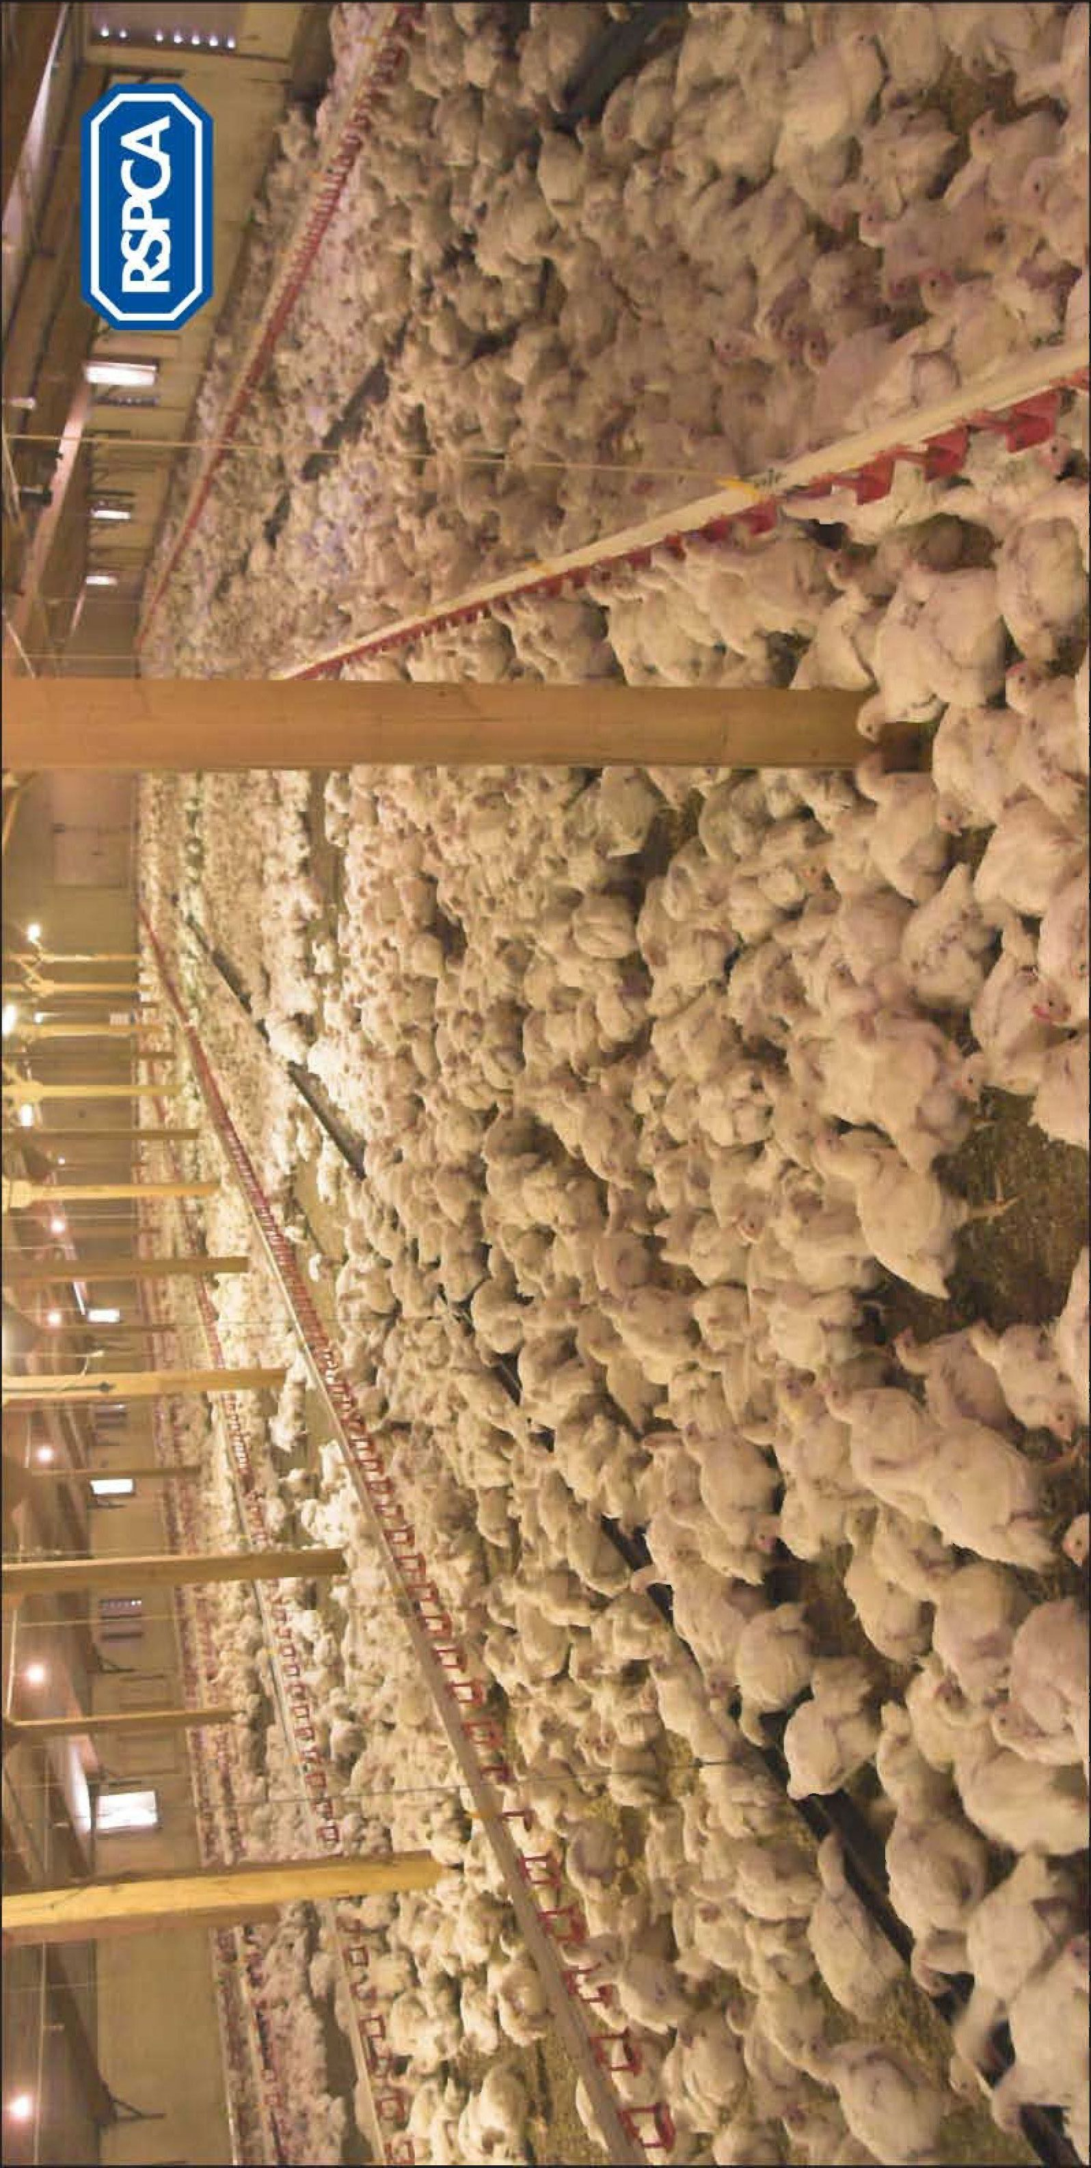
Laying hen and meat chicken growth comparison
After only 45 days the meant chicken (right) is significantly larger than the laying hen (left).

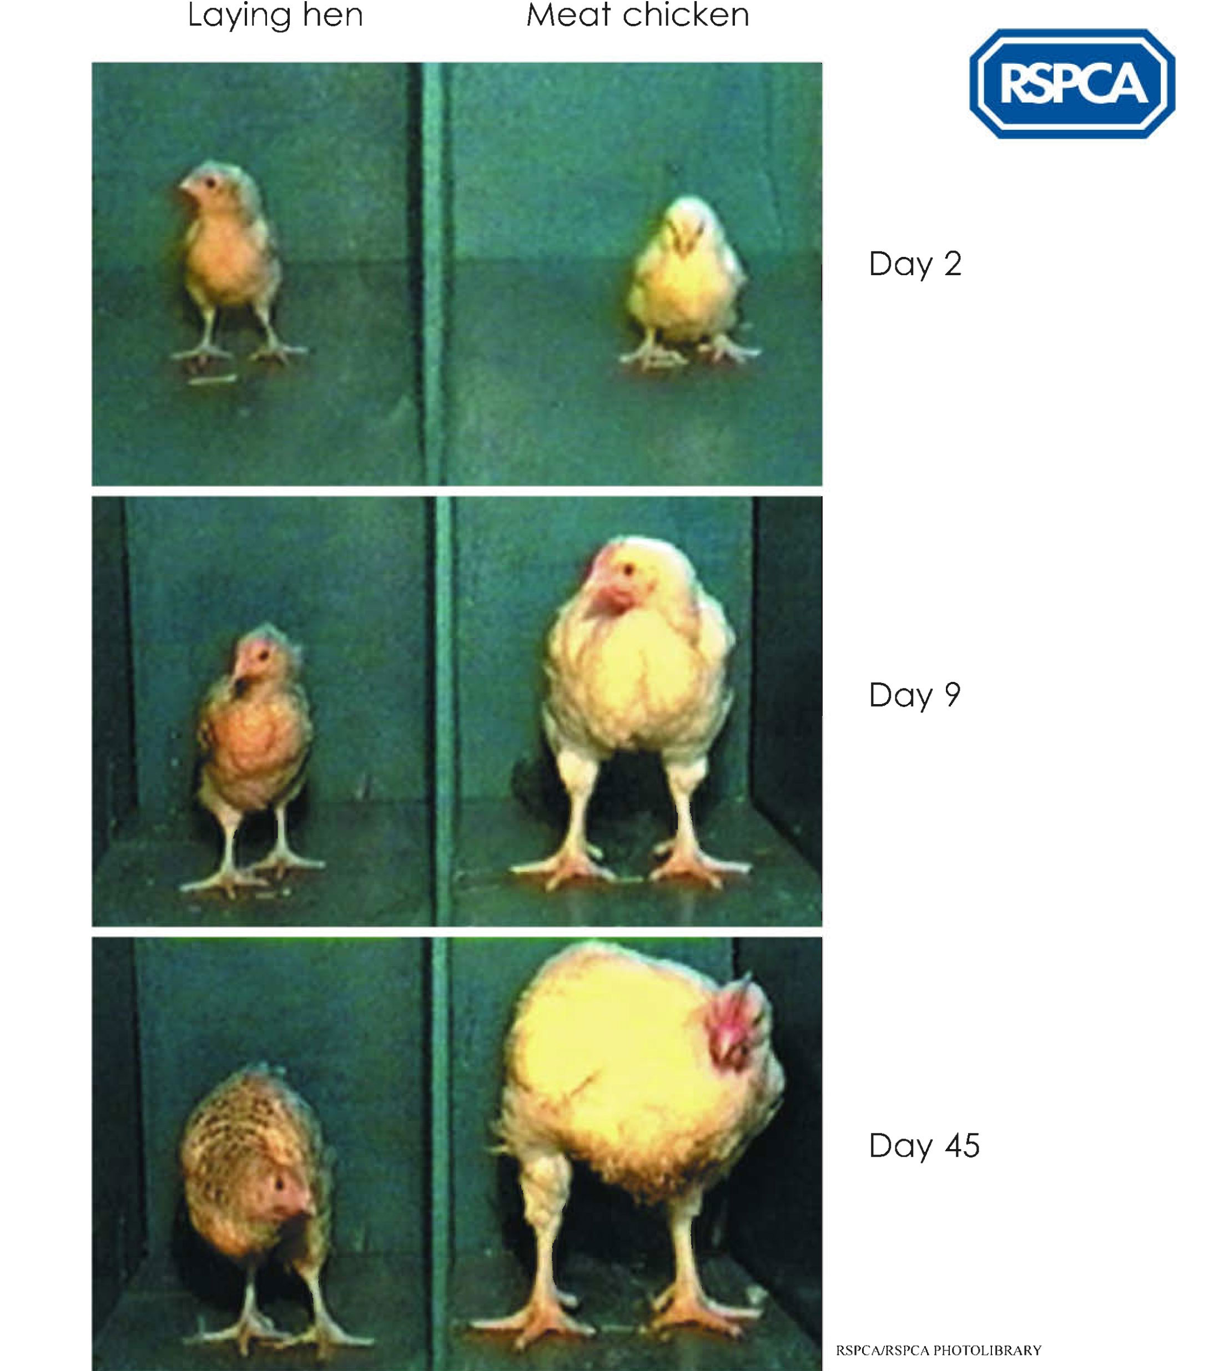
Meat chickens
Indoor broiler system – single chicken lying on straw and incapable of standing.

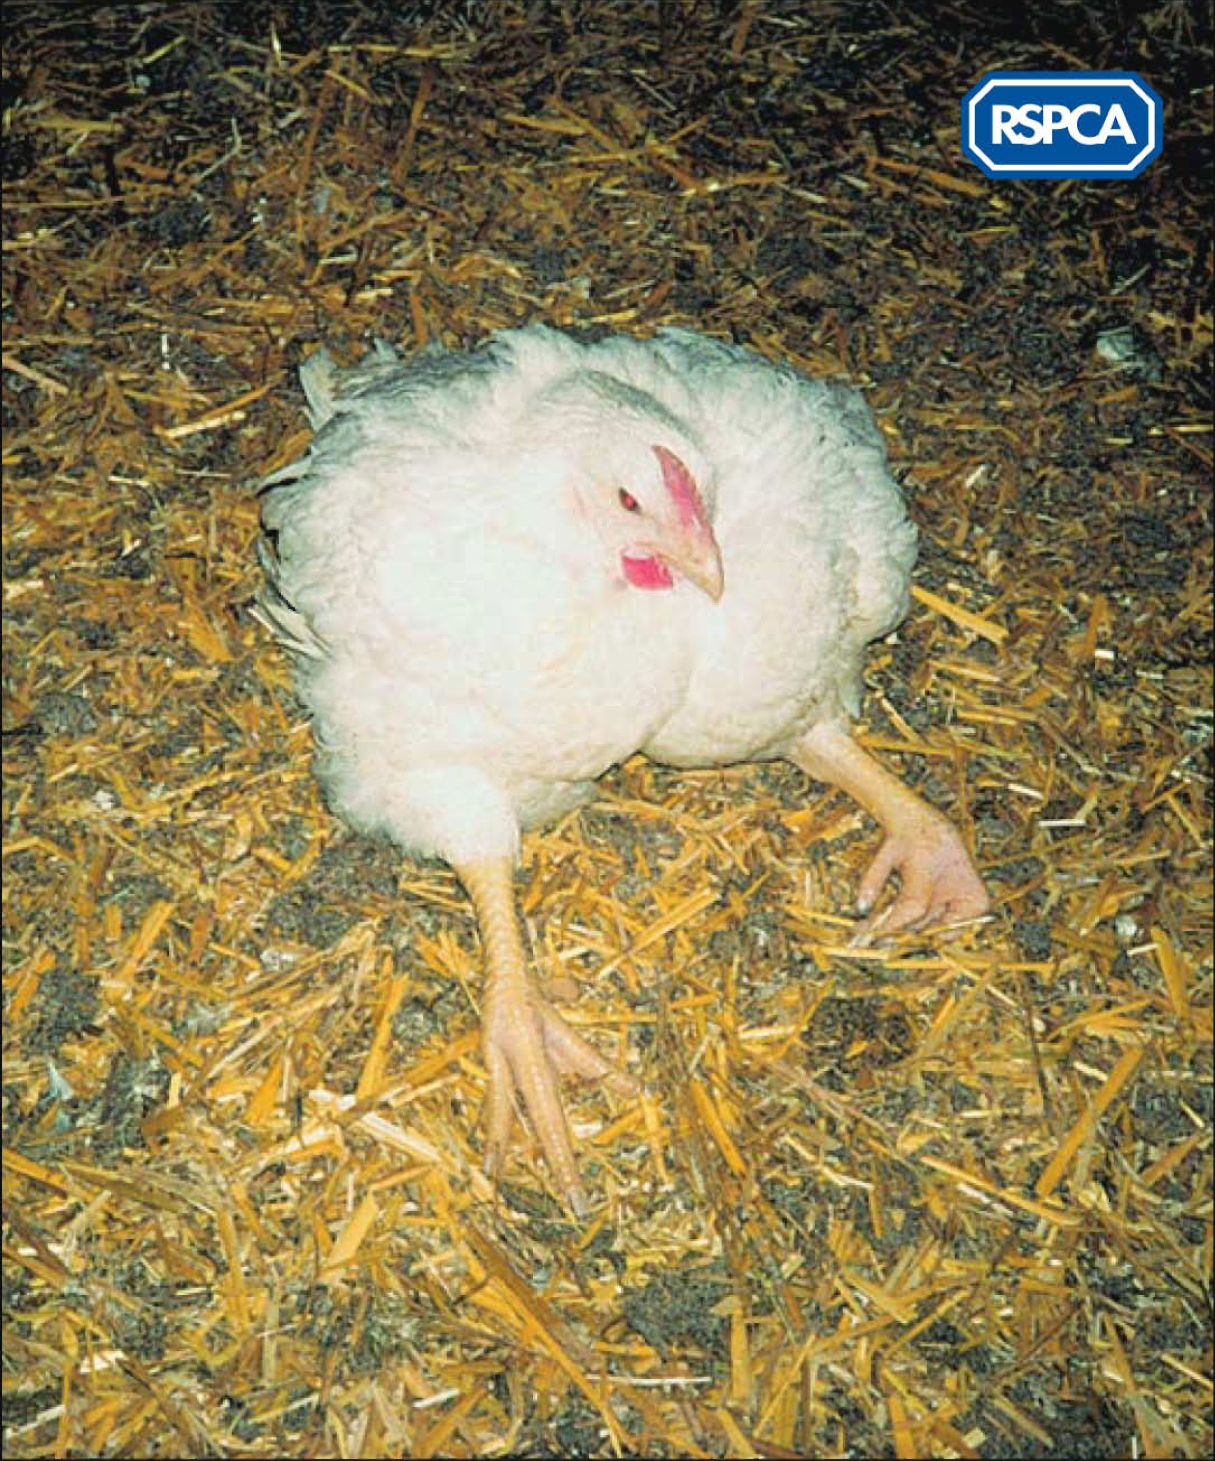

Meat chicken
Chicken with hock burns purchased in UK supermarket.

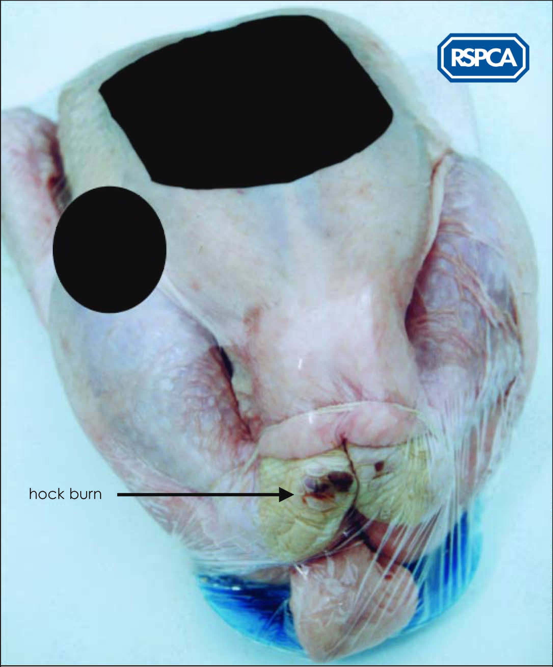
Image – RSPCA Assured logo


Factsheets – Getting the evidence (1)

Chickens for meat production (broilers) are selectively bred to grow very rapidly. As a consequence, the chickens can develop leg deformities, which may mean that it is painful for them to walk around.

The University of Bristol has developed the following method for measuring lameness (e.g. leg deformities) by assessing the walking ability of meat chickens:

Gait scoring
Walking ability is divided into six standardised categories, from completely normal to unable to walk.

Gait score 0 bird walks normally
Gait score 1 bird has a slight gait defect
Gait score 2 bird has a definite and identifiable gait defect but this does
not affect its ability to move
Gait score 3 bird has a definite and identifiable gait defect which affects
its ability to move
Gait score 4 bird has a severe gait defect and can only walk with difficulty
Gait score 5 bird is incapable of walking

Source: RSPCA report: ‘Behind closed doors’ (2001)

The task
Your job is to imagine that you are a scientist working on a project for the RSPCA. The Society has asked you to design an experiment to test the following hypothesis:

‘Meat chickens suffer from leg pain’

To do the experiment you have:
- 200 selectively bred broilers
- some normal chicken feed
- some chicken feed containing painkiller
- a large barn in which to work.

Factsheets – Getting the evidence (2)

1 Plan out your experiment
- Write your method in bullet steps.
- Make sure your test is fair. Think carefully about what chickens you are going to compare. Describe which variable you are changing (the independent variable, the one under investigation) and what variable(s) you must control (keep the same).
- Describe what you are going to measure (the dependent variable). How many times will you need to repeat the measurements to make sure you have reliable evidence?
- Most importantly, please ensure that your method is ‘chicken-friendly’. You must not try to hurt the chickens deliberately.

2 The results
- Draw a table into which you would input your raw results.
- Describe how you would process these results. Include any calculations you would do and why.
- Draw a table and plan a graph for your final results.

3 Your conclusions:
- Predict what you think the results might be and explain why.
- Describe any further work you think you would like to do, given more time and resources.
Factsheet – Page taken from RSPCA report: Paying the price



