Aims and objectives
To encourage responsible attitudes towards the care and welfare of rabbits.

You will need
- Role-play clothes
- Toy rabbits for pet shop role-play

Introduction
- What animal am I? Slowly reveal the picture of rabbits (see image in Downloads tab). Can they guess what animal this is? Use a show of hands to see how many pupils have a pet rabbit in their family. Talk about the different things the rabbit needs.
- Play the Rabbit quiz and ask pupils questions from the activity sheet. If they think it is true, they can make ‘rabbit ears’ with their hands. If they think it is false, they fold their arms. Share each of the answers and discuss.

Main issues and problems
- Role-play a typical scene in a pet shop where the child pesters the parent to buy a rabbit (see activity sheet Pet shop pestering). Choose a pupil to pretend to be the parent and use dressing-up clothes to help them with their role. The teacher pretends to be the child who really wants a rabbit. Role-play going to a shop and seeing a cute rabbit that the child really wants. Demonstrate how a child will pester their parents while in the shop (see help sheet). After each ‘pester’ the ‘adult’ is going to say “no!” (The pupil could hold up a big card with ‘no’ on it to encourage the other pupils to say no too).
- Explain that sometimes people will buy a cute rabbit, just like the one in the pet shop today, and even with the best intentions some people don’t look after their rabbits. Reveal pictures of rabbits whose welfare needs are not being met (see Images of rabbits with welfare problems) The first two images show unsuitable environments (see notes under ‘Environment’ in teachers’ notes Animals' basic needs: Rabbits) and the third image shows a mother rabbit with lots of kittens (see notes on neutering under ‘Health and welfare’ section in teachers’ notes). Discuss with pupils why the rabbits are not healthy or happy, referring to rabbits’ needs as discussed earlier.
- Explain to the pupils that sometimes people who own rabbits don’t want them any more and let them go in the wild. Discuss why this isn’t a good idea. Abandoning a rabbit in the wild could make it hard for the rabbit to find the shelter, food and companionship that it needs. (See teacher’s notes Animals’ basic needs: Rabbits for more information.)
- Tell the pupils that, on average, 400 rabbits a month are rescued, collected or seized by RSPCA inspectors because they are not looked after properly, they are neglected, or treated cruelly, or they are abandoned. Depending on age of the pupils, the teacher or pupils can work out how many rabbits would be collected in a week, etc.

What can we do?
- Enlarge the factsheet The five welfare needs to use as a checklist for the things that rabbits need to be healthy and happy. If pupils have their own rabbits, this checklist will help them think about their rabbits’ needs.
- Watch the happy bunnies video. Ask the pupils to suggest some of the things they have learnt about what rabbits like to do.
- Hop and stop! Think before you get a rabbit. Some pupils may be interested in owning their own rabbit(s) following the assembly. Encourage them to think responsibly and remind them how long rabbits can live for and what this responsibility entails. Direct them to the RSPCA website for more information on caring for rabbits.
Teachers’ Notes – Animals' basic needs: Rabbits

Environment
Make sure your rabbit has a suitable place to live
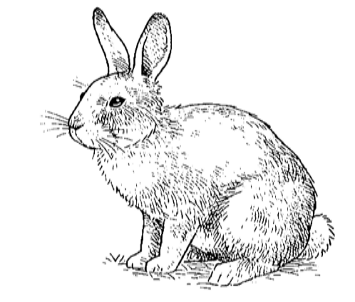
Things you should do:
- Provide your rabbit with a secure living environment that is large enough for it to exercise in and stand up fully on its back legs.
- You should provide both a large exercise area and a secure shelter where your rabbit can rest, feel safe and is protected from predators and extremes of weather and temperature. Ensure all areas of your rabbit’s environment are well ventilated, dry and draught-free.
- Make sure your rabbit has constant access to safe hiding places where it can escape if it feels afraid.
- Allow your rabbit to exercise regularly.
- Provide enough bedding to keep your rabbit warm. Bedding should be safe for your rabbit to eat, e.g. dust-free straw or hay.
- Give your rabbit regular access to a suitable place where it can go to the toilet, separate to where it eats and sleeps.
- Clean the housing and toilet areas regularly.
- If you are going away, try to find someone to care for, and meet all your rabbit’s welfare needs within its familiar home. If boarding your rabbit, try to ease the move by keeping grouped rabbits together and taking familiar items, such as toys, along too.
- When you transport your rabbit make sure it is comfortable and safe at all times. Putting familiar smelling items in the carrier and the new environment can help make your rabbit feel at ease.
- Ensure the size and temperature of any place you leave your rabbit (including your vehicle) is appropriate.
- Make sure that where your rabbit lives is safe, secure and free from hazards.

Diet
Make sure your rabbit has a healthy diet
Things you should do:
- Provide fresh clean drinking water at all times. Check the water supply twice a day. Make sure water doesn’t freeze if your rabbit is outdoors in winter.
- Good quality hay and/or grass should make up the majority of your rabbit’s diet and should be available at all times
- You can feed a small amount of commercial rabbit pellets or cereal mix, but hay and/or grass are much more important. If pellets or mix are provided, follow the manufacturer’s instructions. Don’t keep topping the bowl up as this may result in it not eating enough hay and/or grass. Growing, pregnant, nursing or underweight rabbits may need a larger portion of pellets or mix. Your vet or a rabbit nutritionist will be able to advise you about how to provide the best diet for your rabbit.
- Find out which plants are safe to feed your rabbit. Offer safe, washed leafy greens or weeds every day.
- Do not feed lawnmower clippings as these can upset your rabbit’s digestive system and make it ill.
- Only give root vegetables like carrots, or fruit, in small amounts as a treat. Don’t feed any other treats as these may harm your rabbit.
- Adjust how much you feed your rabbit to make sure it does not become underweight or overweight.
- Don’t make any sudden changes to your rabbit’s diet as this could upset its digestive system and make it very ill.
- Monitor the amount your rabbit eats and drinks. If your rabbit’s eating or drinking habits change, the number of droppings gets less or stops, or there are soft droppings sticking to its back end, talk to your vet straight away as it could be seriously ill. Read more about rabbit health and welfare.

Behaviour
Make sure your rabbit is able to behave normally
Things you should do:
- Make sure your rabbit can access all the things that it needs (space, food, water, safe hiding places, companion rabbit(s), toilet area(s) and toys) at all times.
- Provide your rabbit with safe toys to play with and chew, and regular opportunities to play with people or other friendly rabbits.
- Make sure your rabbit has constant access to safe hiding places where it can escape if it feels afraid.
- Make sure your rabbit has opportunities to exercise every day to stay fit and healthy.
- Provide your rabbit with suitable materials that allow digging behaviour and areas to mark its territory with chin secretions, urine and droppings.
- Be observant. If your rabbit’s behaviour changes or it shows regular signs of stress or fear, seek advice from a vet or a clinical animal behaviourist.
- Never shout at or punish your rabbit, it is very unlikely to understand and can become more nervous or scared. If your rabbit’s behaviour becomes an ongoing problem, seek expert advice.

Company
Make sure your rabbit has appropriate company
Things you should do:
- Keep your rabbit with at least one other friendly rabbit, unless advised otherwise by a vet or clinical animal behaviourist. A good combination is a neutered male and a neutered female, or neutered littermates of the same sex.
- Get your rabbit neutered, unless it is intended for breeding and provisions have been made to care for both parents and offspring.
- Handle your rabbit every day from an early age. Rabbits which live indoors can see humans as important companions. If your rabbit has to be kept on its own for some reason you must provide it with companionship by interacting with it every day.
- Make sure your rabbit has places it can go to get away from companions if it wants to and that there are enough resources (e.g. shelter, food, water, hiding places) for all your rabbits at all times.
- Introduce new rabbits gradually and under supervision, preferably in a space that is new to both rabbits. Seek advice from a clinical animal behaviourist if you are unsure or have problems.
- When you are away make sure your rabbit is cared for by a responsible person.
- Never leave your rabbit unsupervised with another animal or person who may (deliberately or accidentally) harm or frighten it. Never leave your rabbit unsupervised with a cat or dog, even if you know they are good friends.

Health and welfare
Make sure your rabbit is protected from pain, suffering, injury and disease
Things you should do:
- Get your rabbit neutered, unless it is intended for breeding and provisions have been made to care for both parents and offspring. Before allowing rabbits to breed, seek the advice of your vet to ensure they are suitable for breeding in terms of their health and personalities.
- Before deciding to buy a rabbit, make sure you find out what health and behaviour problems it has, or may be prone to, how it has been bred and how it has been cared for. Always check with a vet if you are unsure about anything.
- Feeding your rabbit a correct diet of mainly hay and/or grass will help prevent a lot of common diseases such as dental and gut disease. Check that your rabbit is eating every day and that it is passing plenty of dry droppings. If your rabbit’s eating or drinking habits change or the number of droppings gets less or stops, talk to your vet straight away as it could be seriously ill.
- Check your rabbit for signs of illness or injury every day, and make sure this is done by someone else if you are away. In warm weather you should check the fur and skin around your rabbit’s rear end and tail area twice a day, as urine staining or droppings that are stuck will attract flies, which can lay eggs and cause ‘flystrike’, which is often fatal.
- Consult a vet immediately if you suspect that your rabbit is in pain, ill or injured.
- Front teeth and nails should be checked at least once a week as these can grow quickly. Only a vet should correct overgrown or misaligned teeth.
- Take your rabbit for a routine health check at your vets at least once each year.
- Get your rabbit vaccinated regularly against myxomatosis and Viral Haemmorhagic Disease (VHD), as advised by your vet.
- Prevent your rabbit having contact with wild rabbits or areas where wild rabbits have been.
- Give your rabbit treatment for external and internal parasites (e.g. fleas and worms) as necessary, as advised by your vet.
- Only use medicines that have been specifically recommended for your rabbit by a vet. Some medicines used for other animals can be very dangerous to rabbits.
- Ensure your rabbit’s coat is kept in good condition by grooming it regularly. If you are unsure how to groom it properly seek advice from a pet care specialist.
- Make sure your rabbit can be identified, ideally via a microchip (ask your vet for advice), so it can be treated quickly if injured or returned to you if lost.
- Consider taking out pet insurance to ensure your rabbit is covered if it needs veterinary treatment.
- Never leave your rabbit unsupervised with another animal or person who may (deliberately or accidentally) harm or frighten it. Never leave your rabbit unsupervised with a cat or dog, even if you know they are good friends.

Pet owners now have a legal responsibility to meet the five welfare needs of their pet. This sheet provides further information about the specific needs of rabbits. However it is important to note that there is no one ‘perfect’ way to care for all rabbits because every rabbit and every situation is different. It is up to the owner how they look after their rabbit, but they must take reasonable steps to ensure that all its needs are met.

For more information visit www.rspca.org.uk/rabbits
Image – Rabbits with welfare problems

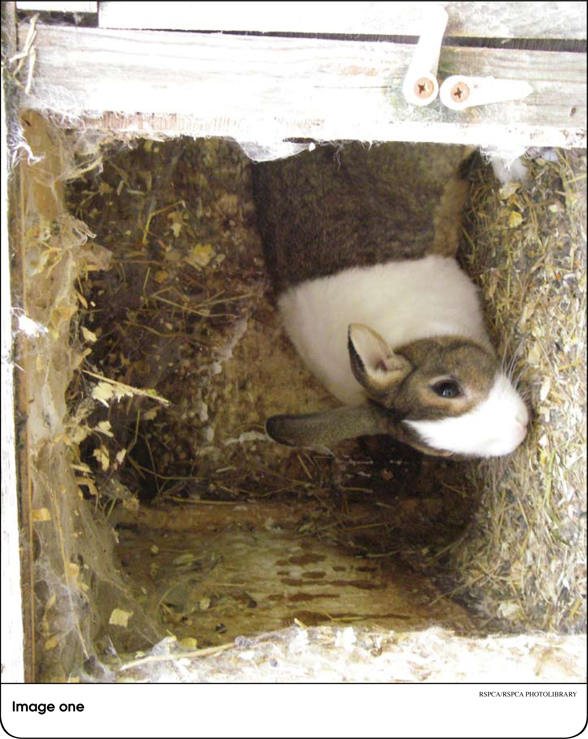

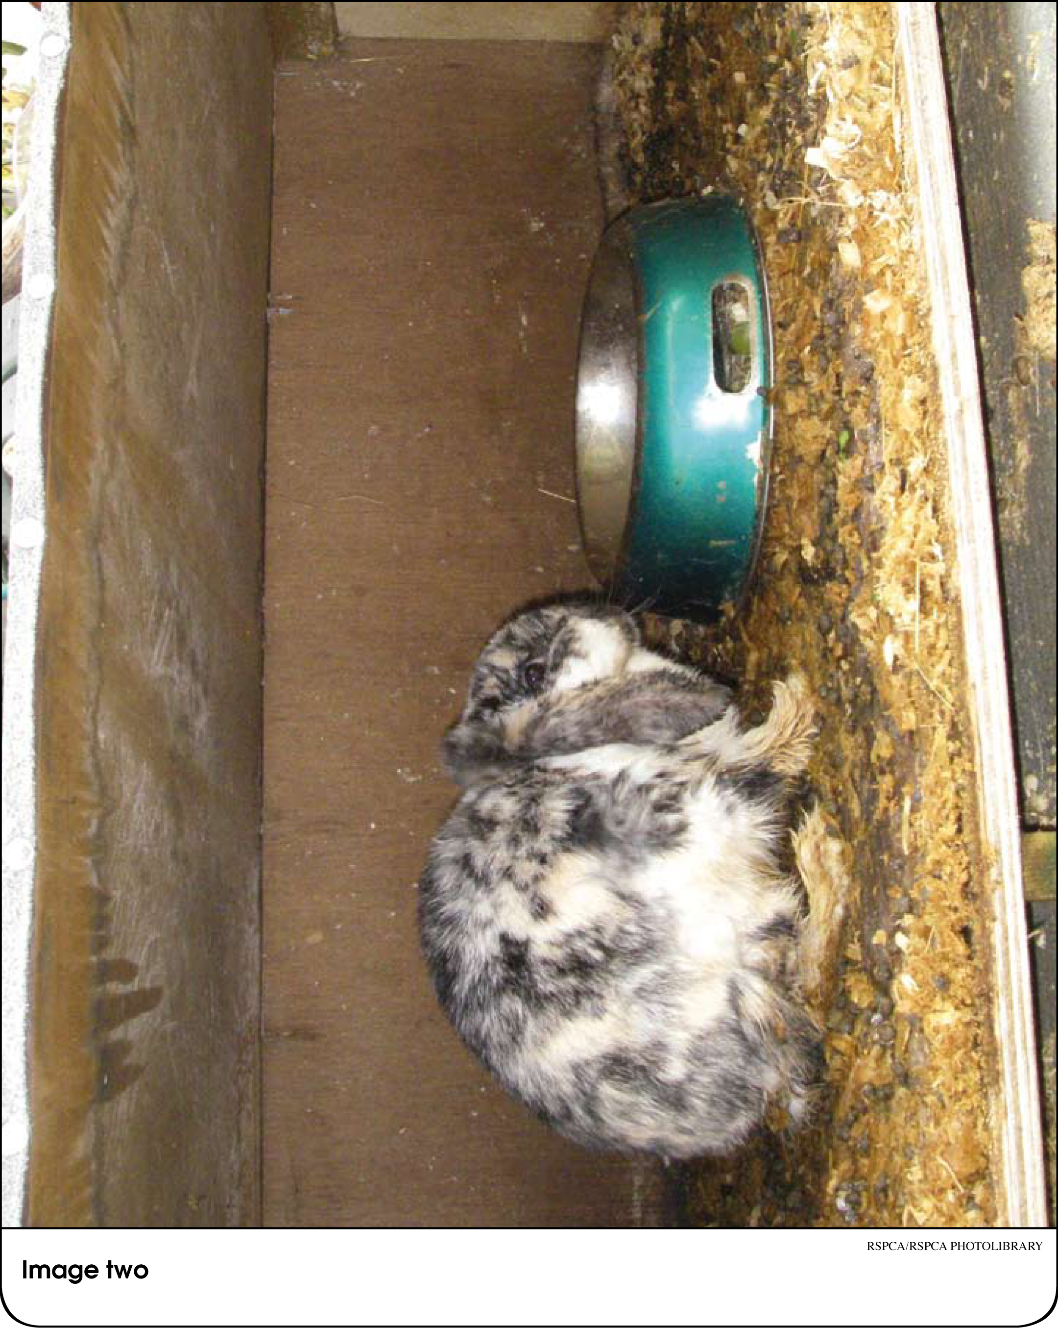

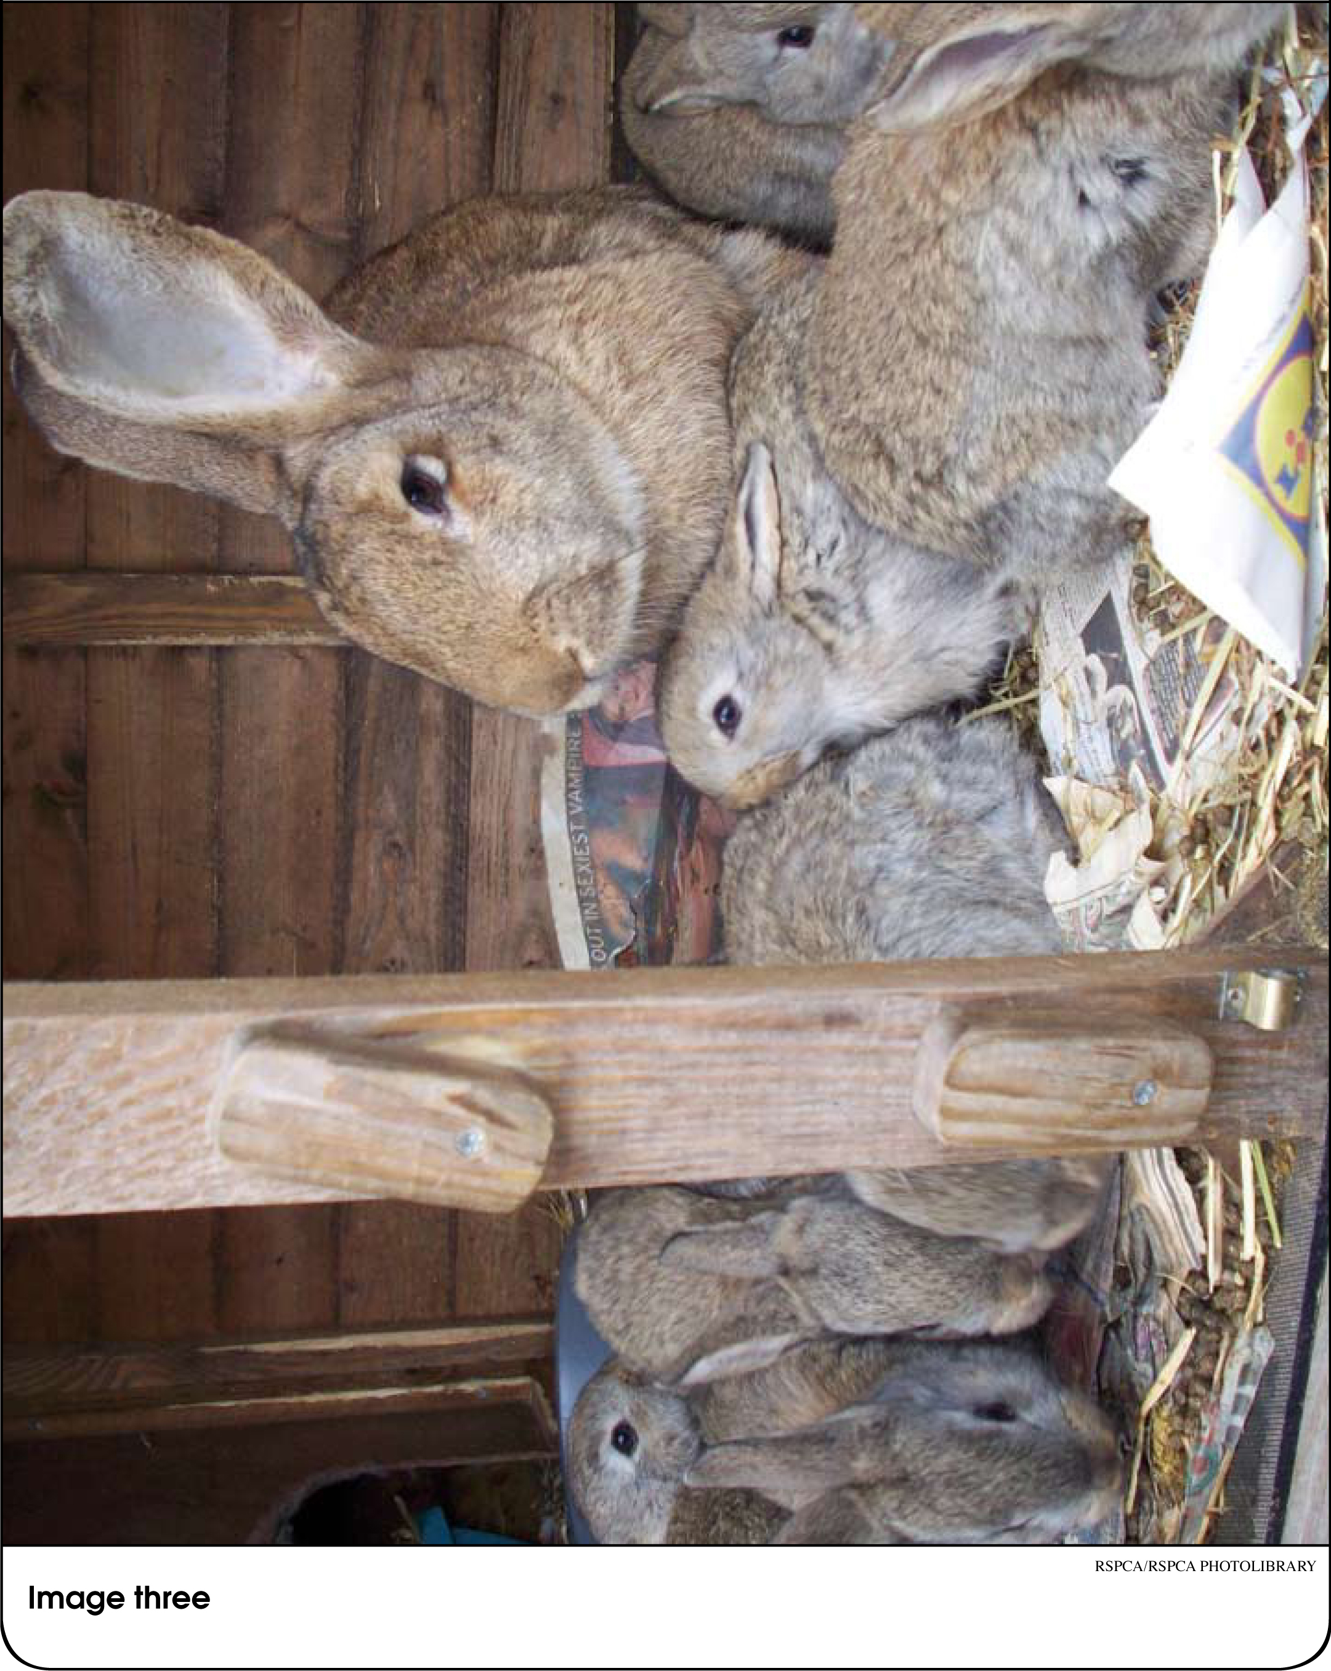

Image – Rabbits (to slowly reveal at beginning)

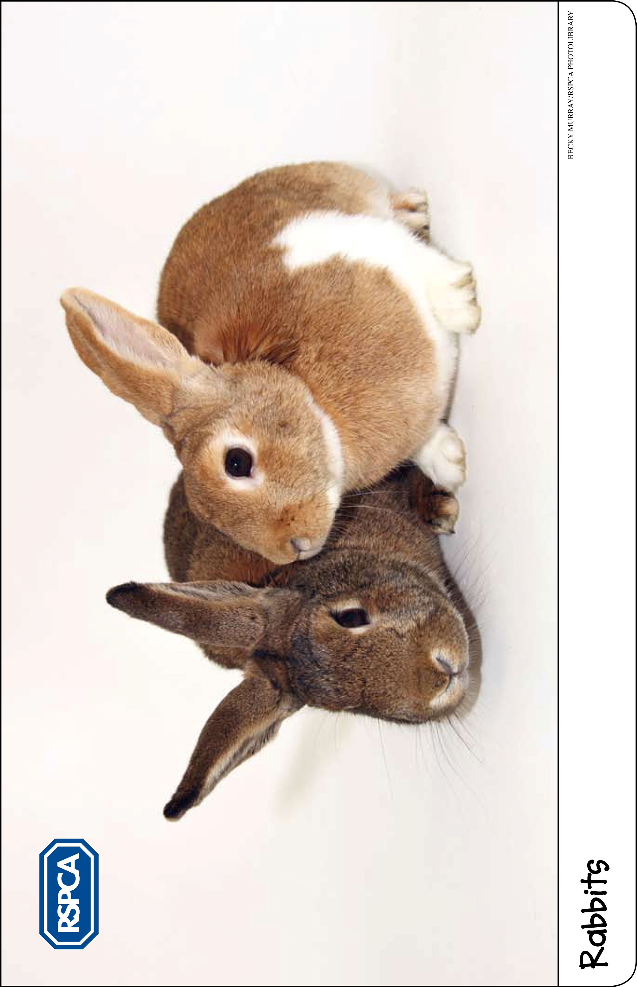
Activity Sheet – Rabbit quiz: True or False?

  - Rabbits like to stand up on their back legs.
TRUE – Rabbits like to stretch up and see what’s going on around them, so their homes should let them stand up without their ears touching the roof.

  - Rabbits like to eat mostly carrots.
FALSE – Rabbits like carrots but should only be given them in very small amounts now and again as a treat as they are high in sugar. They need to eat lots of hay and grass.
  - Rabbits like their owners to spend time with them.
TRUE – Rabbits like their owners to sit quietly with them at ground level and to gently stroke them.
  - Rabbits like to live on their own.
FALSE – Most rabbits get bored and lonely if kept on their own. They normally like to be kept with another friendly (neutered) rabbit. Rabbits and guinea pigs should not be kept together as they have different needs.
  - Rabbits like to keep healthy by riding a bike.
FALSE – Rabbits can’t ride a bike, but they do need to be able to exercise every day to stay fit and healthy. Did you know that rabbits have long, powerful hind legs that allow them to achieve speeds of up to 50 miles per hour for short bursts?
  - When rabbits are ill they should be taken to a vet.
TRUE – Rabbits should be taken to see the vet when they are ill. They also need to see the vet for regular health checks, at least once a year.
Activity Sheet – Pet shop pestering

Some examples of what children might say to their parents include:

Please, please, please!
I’ve been really good today!
I’ll pay for it with my pocket money.
I’ll look after it all by myself.
My friend has one.
Everyone else has got a pet.
Factsheet – The five welfare needs
The Animal Welfare Act 2006 requires anyone who owns or looks after an animal to provide everything that the animal needs to be happy and healthy. These needs can be described as:


A suitable place to live
Animals should have the right type of home, including shelter, enough space, and somewhere comfortable to rest and hide.


A healthy diet
Animals should have access to fresh, clean water all the time and should be given the right type and amount of food to keep them fit and healthy.


The ability to behave normally
Animals should have enough space and the right kind of facilities to allow them to behave normally.


The company he or she needs
Animals should be given appropriate company. Some animals should have company and some should be kept on their own.


To stay healthy
Animals should be protected from pain, suffering, injury and disease and should be treated by a vet if they are sick or injured.

