Equipment
Scissors
A variety of everyday objects relating to pet, farm and wild animals and animals used in research. You could also use the pictures in the activity sheet Everyday objects. Here are some suggestions, but feel free to add or replace objects:

- Picture of someone wearing a fur coat
- Leaflet advertising a venue that keeps animals, such as a zoo, aquarium, urban farm
- Tin of tuna
- Milk carton/container
- Item of clothing, such as a pair of jeans
- Packaging from a box of painkillers
- Packaging from a food product that contains eggs as an ingredient, such as cake or ice cream
- Rabbit/hamster water bottle
- Packet of wild bird food/fat ball
- Hair product or shower gel that has/has not been tested on animals
- Fishing line or hook
- Dog lead

Aims and objectives
- This activity is just one part of a range of resources addressing the needs of young people who have been involved, or who are at risk of being involved, in cruelty to animals. Our online assessment tool Developing a suitable intervention programme (Word 17KB) will help you create individualised intervention programmes from these resources.
- The young person will realise during these activities that:
  - animals have an impact on everyone in some way
  - we all interact with animals throughout our lives.

What to do

Gathering first thoughts
- Print and cut out labels from the activity sheet Are animals part of my life?
- Ask the young person to think about how much animals are a part of his/her day-to-day life, and to choose a card from the sheet – are they a large part, some part or a small part?
Making the connection
- Put onto the table a selection of everyday objects that are connected with animals in some way (there is a list of suggested objects in the What you need section, but you might want to create your own collection, depending on what’s appropriate for the young person you are working with) – or use the pictures from the activity sheet Everyday objects.
- Ask the young person to select the objects they think are connected with animals, and to explain the connection.
- Look at any objects left over, and discuss how they also relate to animals. The facilitators' notes Everyday objects (answers) explain the connections.
How does my life connect with animals?
- Print and cut out the labels from the activity sheet How does my life connect with animals?. The young person can put simple drawings of people or names in the blank boxes, representing ‘Me’, ‘Both of us’, ‘People I know’ and ‘Other people’.
- Put all the objects on the table again.
- Ask the young person to take the label ‘Me’ and put around it all the objects or pictures of objects that relate to his or her life in particular, such as wearing jeans, taking painkillers, having a pet. You could also put your own name on a blank label and choose items that relate to your life. Put any things that relate to both your lives around a label marked ‘Both of us’.
- Look at any objects that are left and discuss whether they relate to the lives of anyone the young person knows. Gather them around a label marked ‘People I know’.
- If there are any objects left, discuss whether they connect to society in general, and put them around the ‘Other people’ label.
Final thoughts
Revisit the Gathering first thoughts activity and see whether the young person’s perception has changed.
- The ideas introduced in this activity are developed in the activity Categorising animals in the Who is responsible? section.
- We have also developed three interactive activities - Was it cruel?, Consequences and Triggers - that help young people think through what happens when people are cruel to animals (see right). However, before you attempt to use these, we suggest that you explore some of the activities in the other sections - What is animal cruelty?, What triggers animals cruelty and how it can be avoided, Consequences of cruelty to animals and The incident.

Activity sheet – Are animals part of my life?

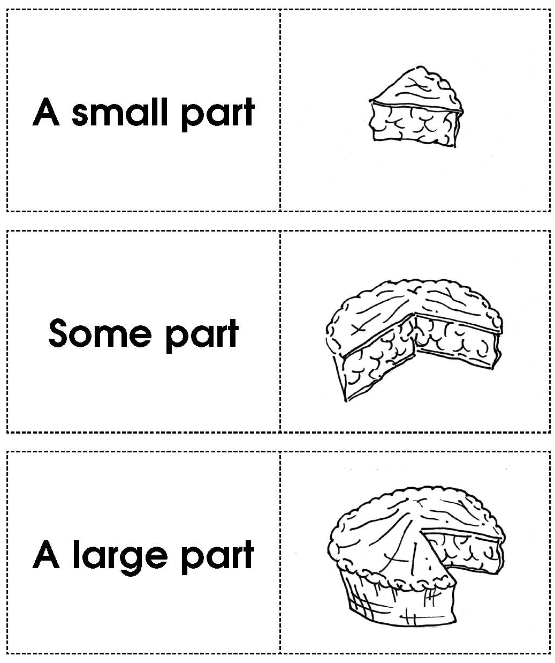

Activity sheet – Everyday objects (1)

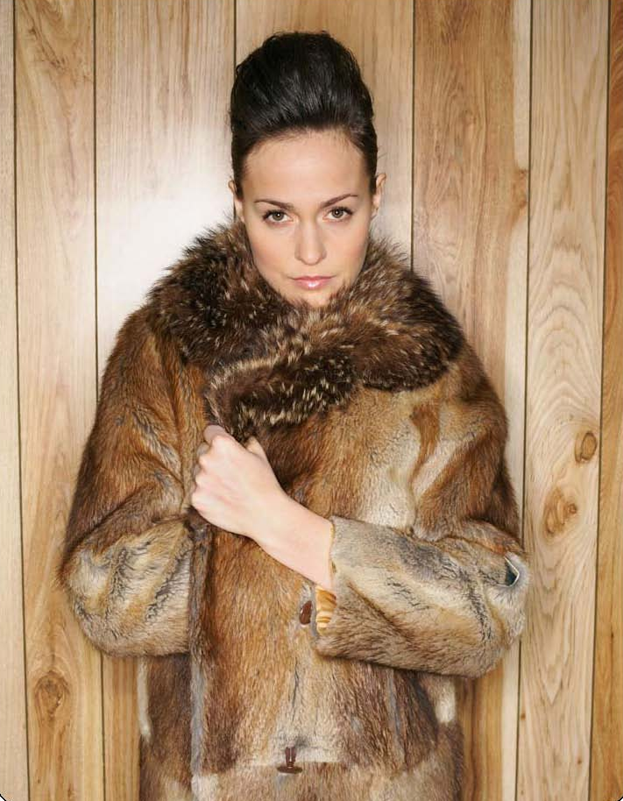

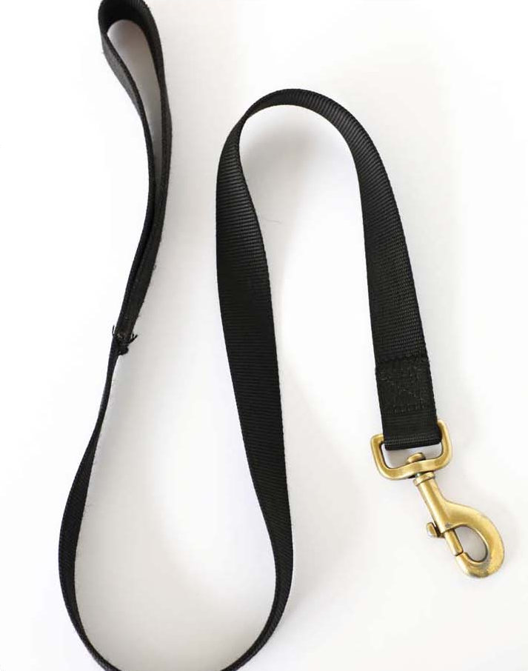
Activity sheet – Everyday objects (2)

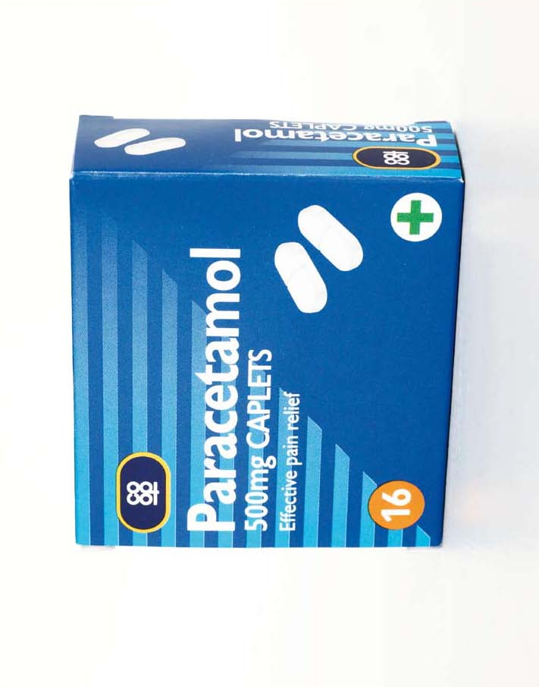
Activity sheet – Everyday objects (3)

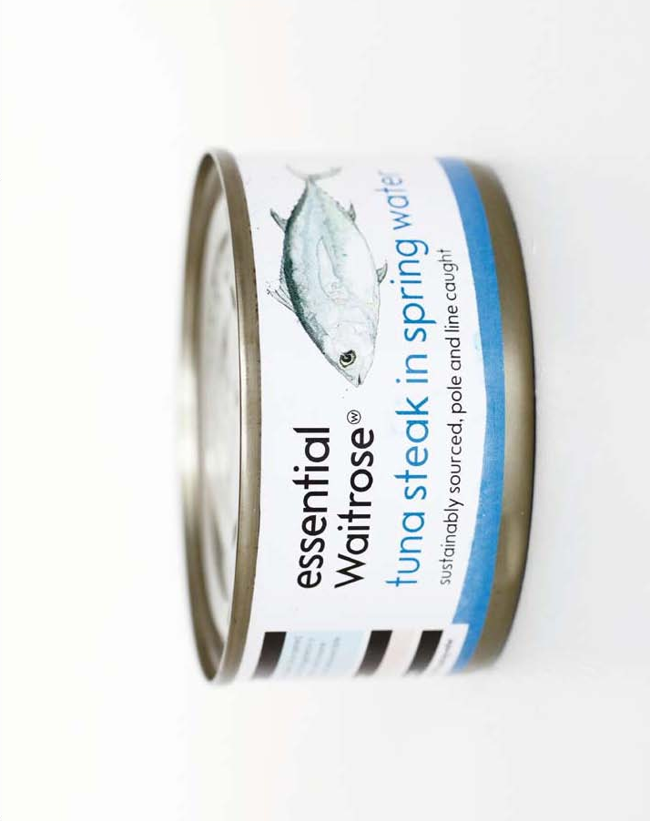
Activity sheet – Everyday objects (4)

Activity sheet – Everyday objects (6)

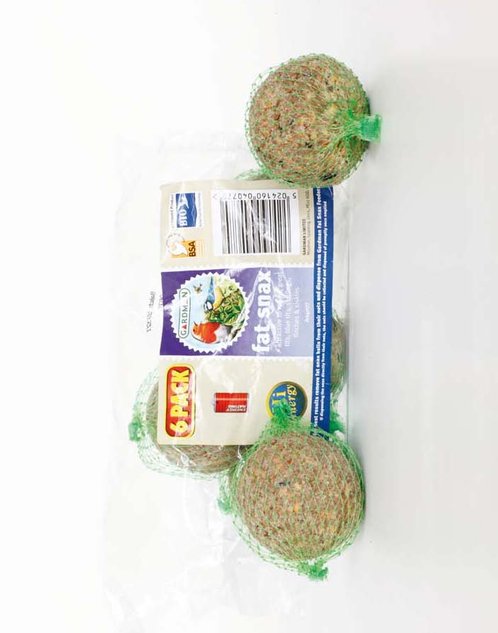

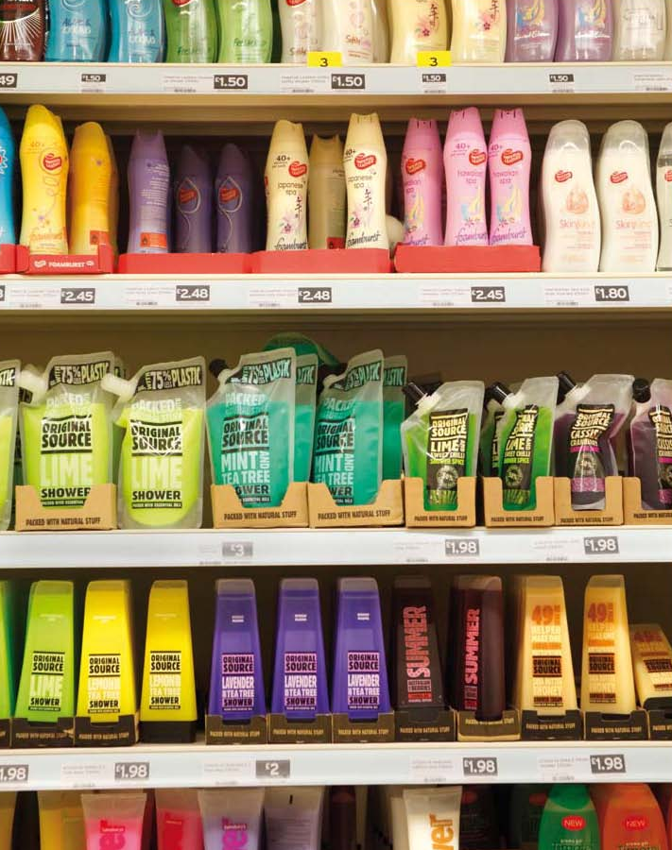
Activity sheet – Everyday objects (7)

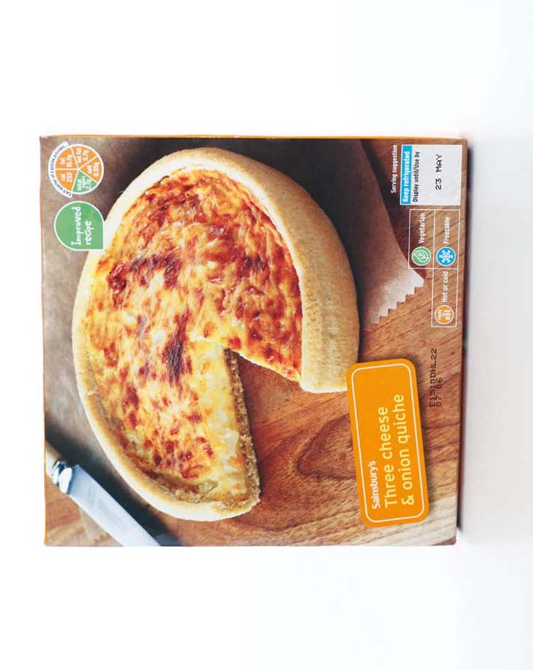
Activity sheet – Everyday objects (8)

Activity sheet – Everyday objects (9)

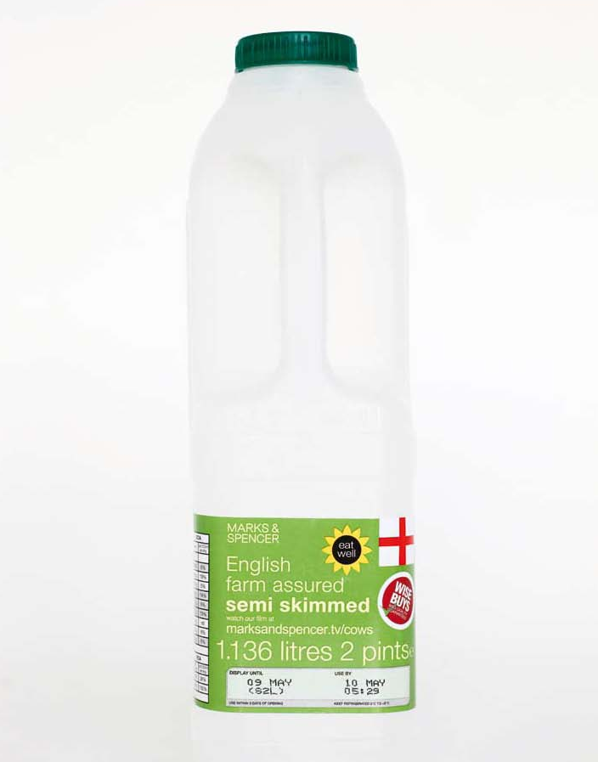

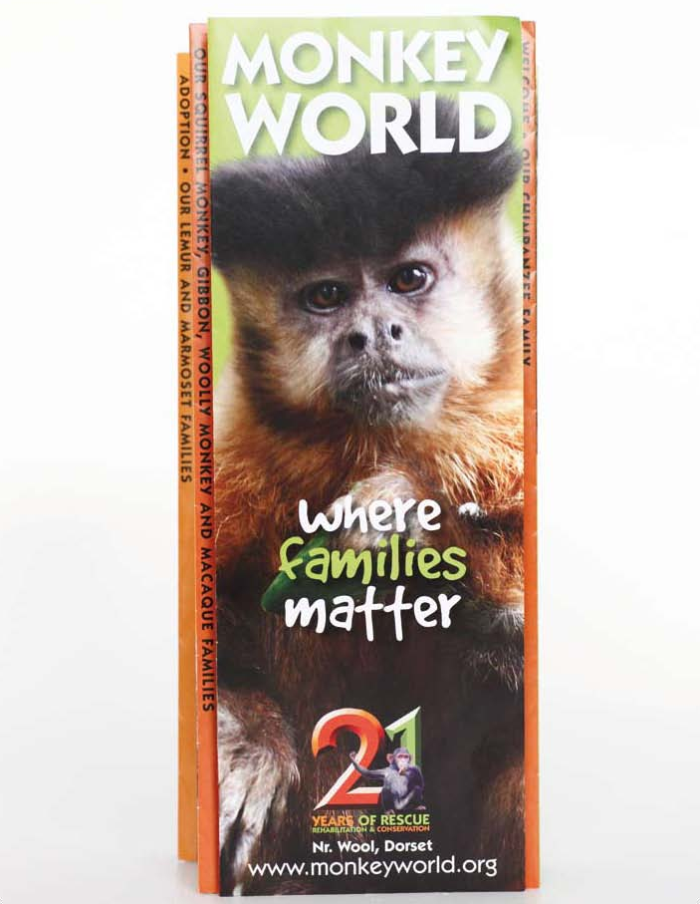
Activity sheet – Everyday objects (10)

Activity sheet – Everyday objects (11)
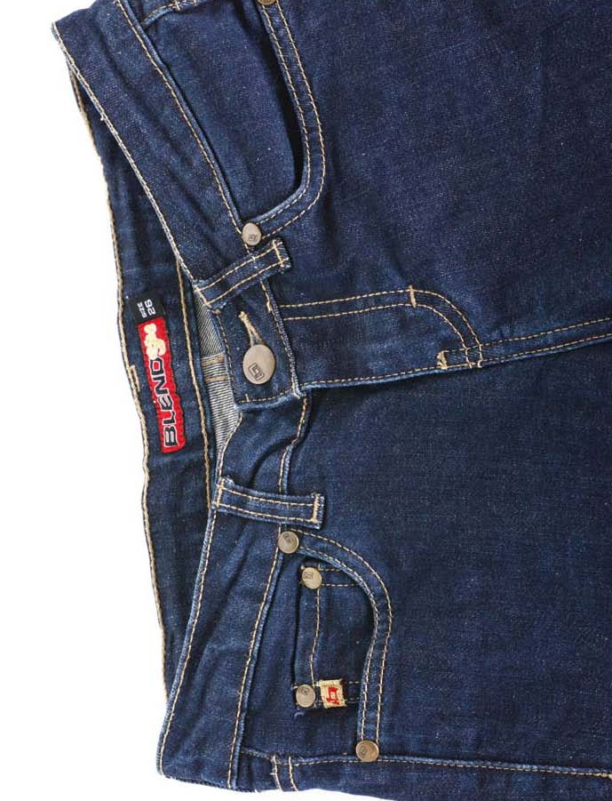

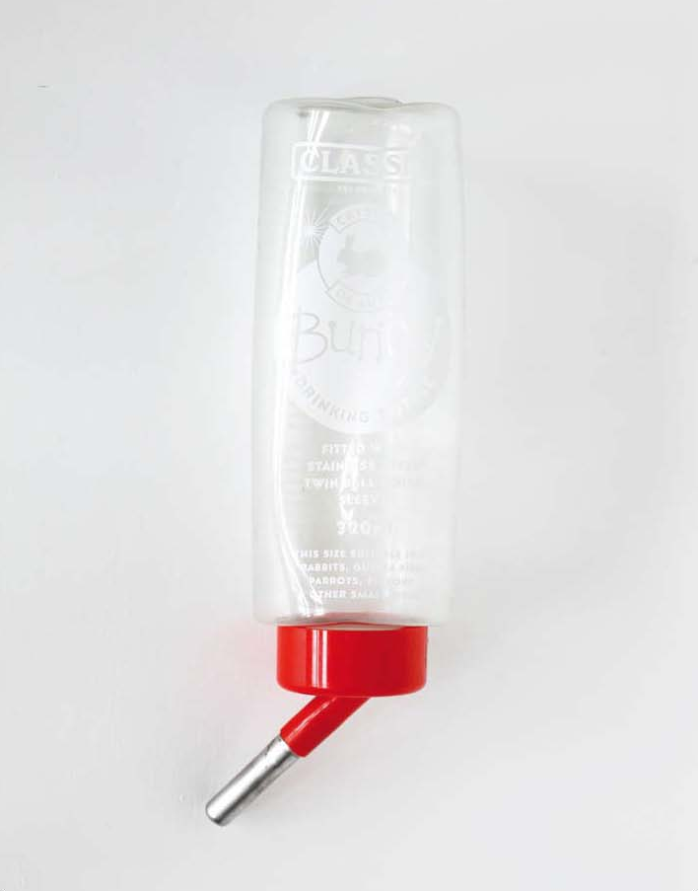
Activity sheet – Everyday objects (12)

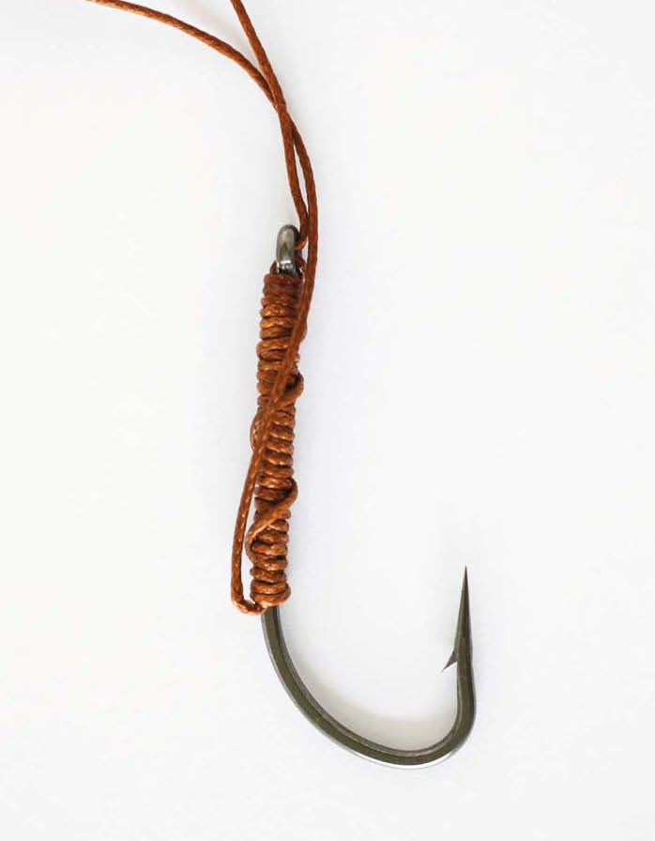
Activity sheet – Everyday objects (13)

Activity sheet – How does my life connect with animals?

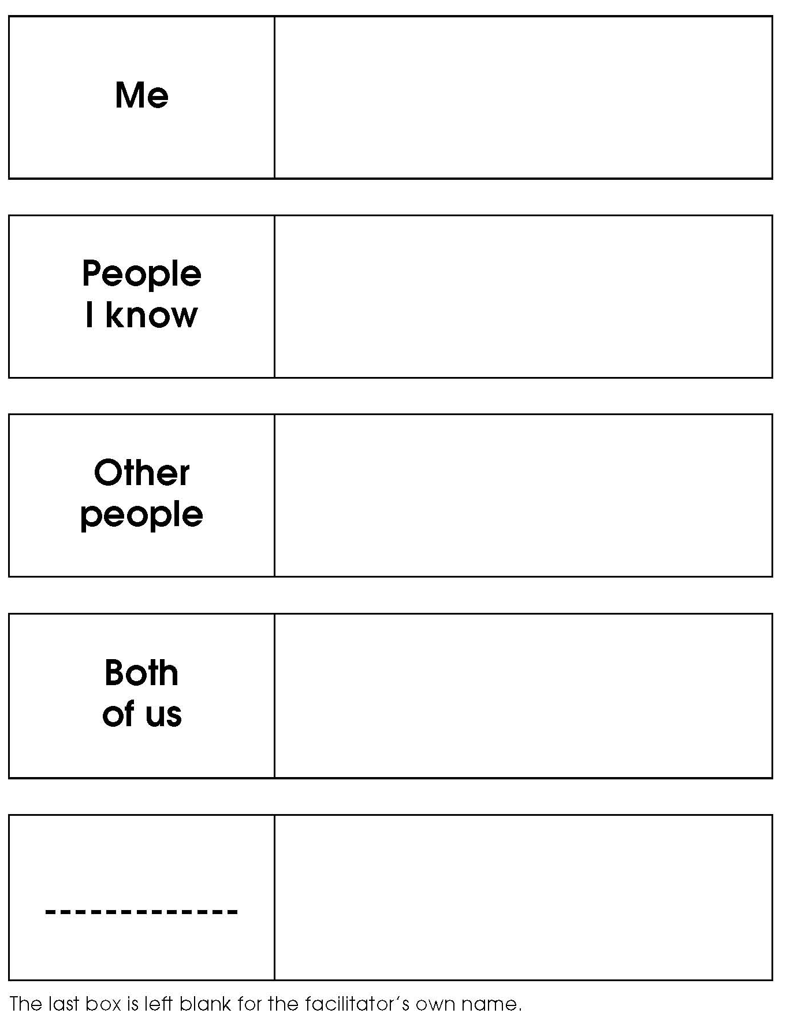

Facilitators’ notes – Everyday objects (answers) (1)

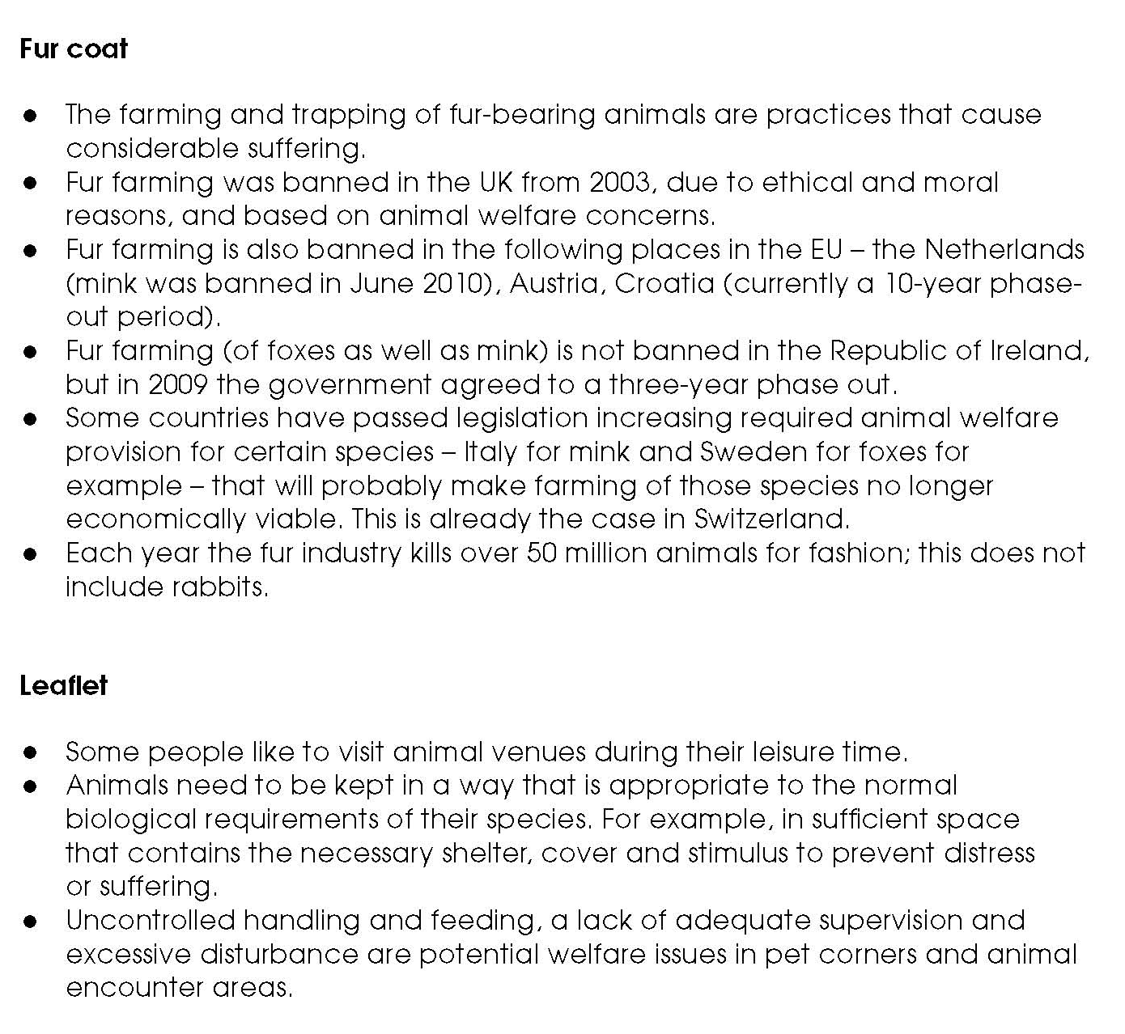

Facilitators’ notes – Everyday objects (answers) (2)

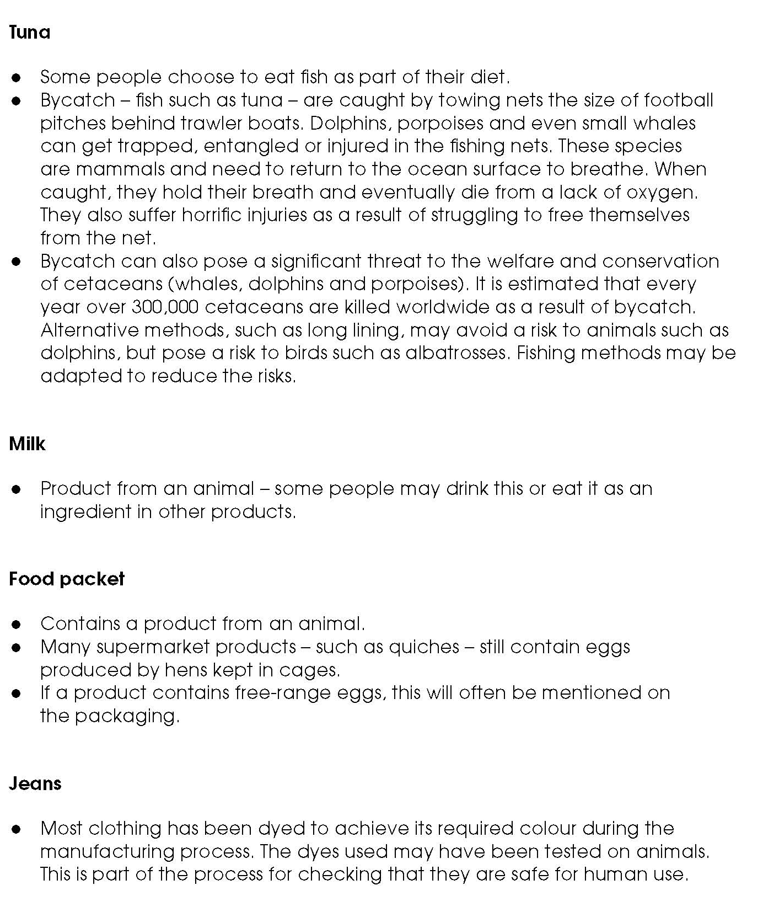

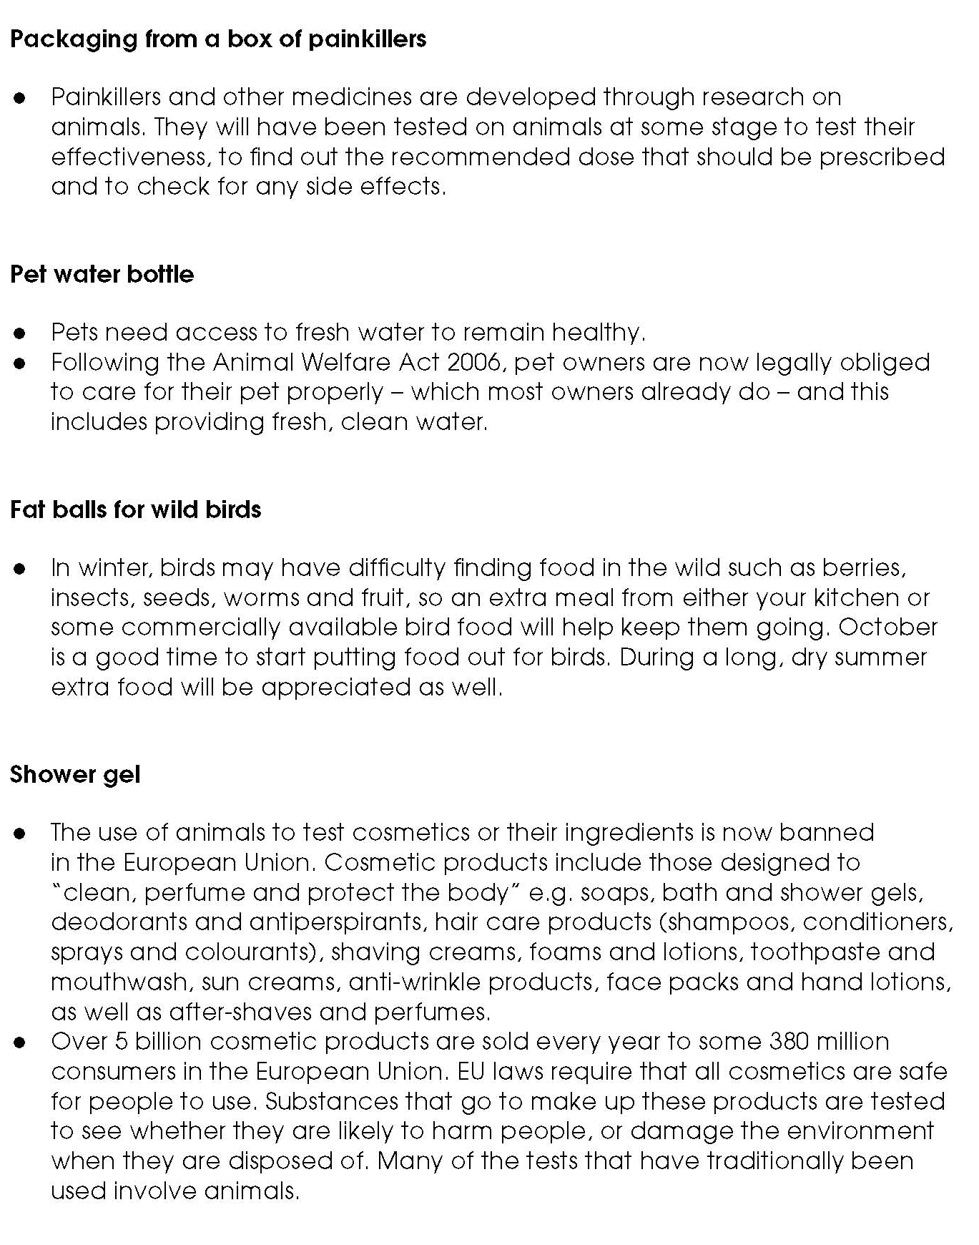
Facilitators’ notes – Everyday objects (answers) (3)

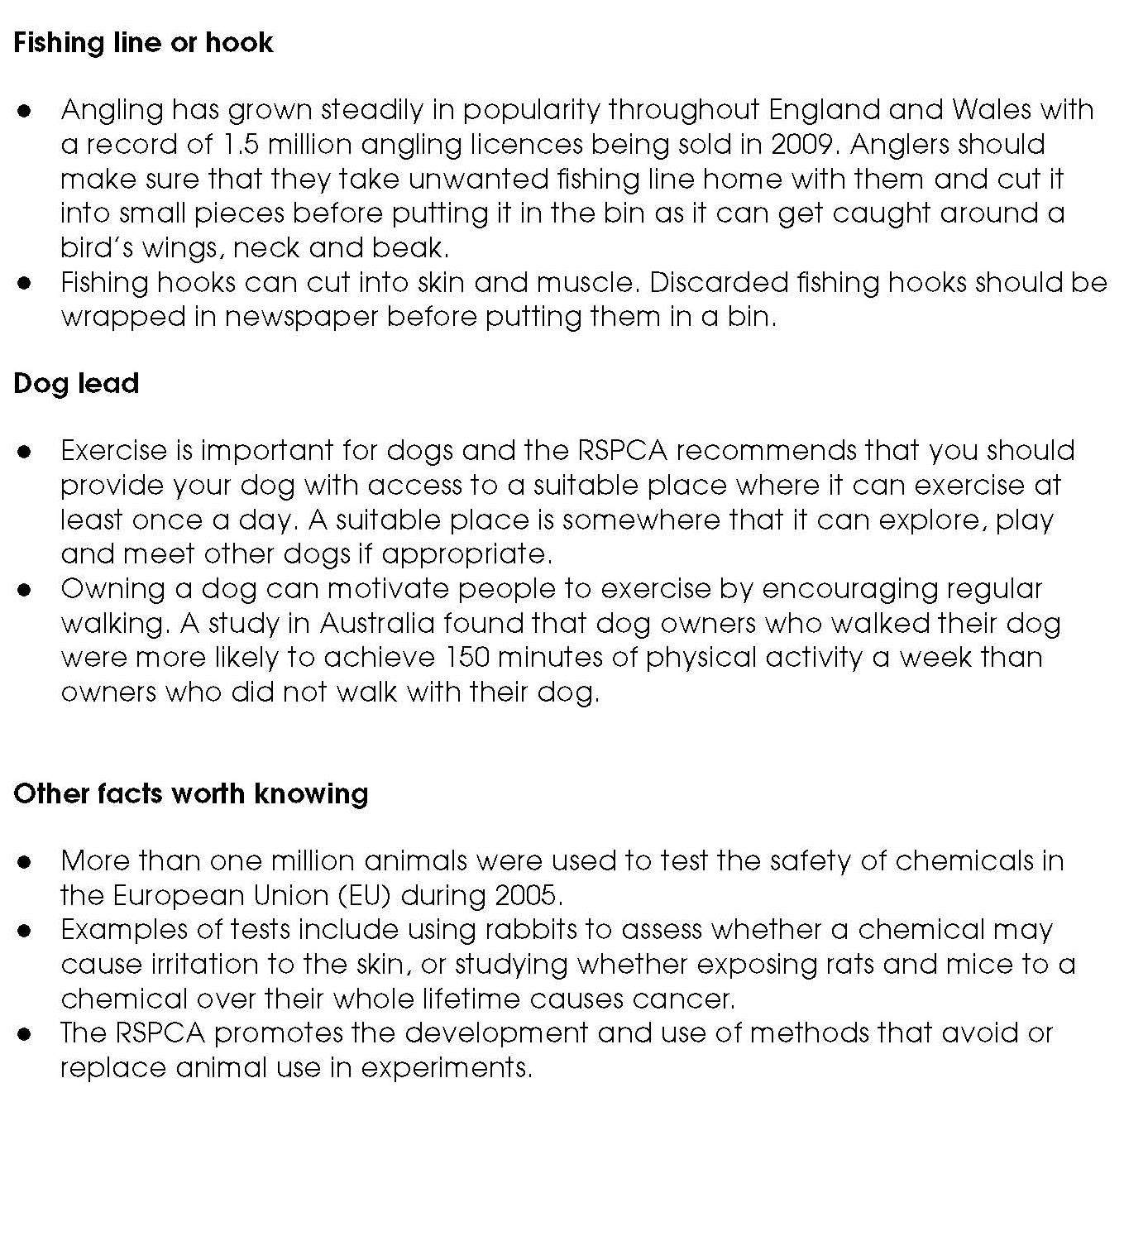
Facilitators’ notes – Everyday objects (answers) (4)

