Aims and objectives
- This activity is just one part of a range of resources addressing the needs of young people who have been involved, or who are at risk of being involved, in cruelty to animals. Our online assessment tool Developing a suitable intervention programme (Word 17KB) will help you create individualised intervention programmes from these resources.
- The young person will realise during these activities that:
  - animals have an impact on everyone in some way
  - we all interact with animals throughout our lives.

What to do

- Choose some photos from the activity sheet How do animals help us? and ask the young person to put them in a timeline from past to present.
- Ask them to choose two to four photos (encouraging a selection of historical and modern-day uses) and to say what they think about the following points.
  - What job the animal is doing and how it is helping people.
  - Why they think that particular type of animal has been chosen to do that particular job, and why other types of animals may not be as suitable. Does the animal have any special skills or qualities?
  - Whether the animal is still used in that way or whether people have found another way to do that job using new technology, for example.
  - If we still use the animal to do that job today, why has new technology not replaced it?
  - How would people’s lives be affected if that animal weren’t available to do that job? How would their quality of life be affected?
  - Can they think of any alternative ways we might be able to do the same job without using animals?
- If they have already completed the Everyday objects activity, ask them to think back to the issues it raised – that animals interact with and affect our lives on a day-to-day basis (The objects/photos from that activity could be used as a reminder).
- If they haven’t done the Everyday objects activity, just ask the question: “Can you think of any other ways animals affect our lives or ways in which people use animals?”. Encourage them to think about the following.
  - Animals used for food and products – farm animals
  - Animals used for companionship or leisure – pets
  - Animals used to test medicines and products for human use – research animals
  - Animals as part of an ecosystem or food chain, or part of nature – wild animals
  - Animals used in sport – the RSPCA believes that ‘sport’ does not justify the causing of suffering to birds and other animals.
- Ask the young person to watch the short film about how dogs are used by the military. Our four-legged heroes is found in the Useful websites tab. Ask them to think about the following things and discuss them after the film.
  - What does the military use dogs for in places where they are working? For example, in Afghanistan.
  - Why do they use dogs instead of other technology?
  - What do you notice about the relationship between the dog and the handler?
  - What is the impact of using the dogs in combat zones such as Afghanistan?
  - What would happen if dogs like Charlie and Jirka didn’t exist?

- Ask them to think about what would happen if the following animals disappeared. You don’t need to discuss all the animals if you don’t want to. Use the facilitators’ notes (listed below) to help in your discussion.
  - How are cows useful?
  - How are bees useful?
  - How are dogs useful?
- Ask the young person to consider how they would be affected if animals no longer existed. It may be helpful to think about this in terms of the RSPCA’s areas of concern:
  - pets (companion animals)
  - wildlife
  - farm animals
  - animals used in research.
- It may also help to refer back to the objects/photos in the Everyday objects activity. Encourage them to think about the things they would no longer have, or be able to do that they enjoy. They might also be able to think about how people they know might also be affected, and other people in general.
- Finally, you may wish to ask the question: “Are animals important?”.
- We recommend that you complete the Everyday objects activity in this section before completing this one. A useful follow up to this activity is Ground rules for farm animals and/or Taking responsibility, which are both in the Who is responsible? section.
- You can choose which photos to use from the activity sheet How do animals help us? Your choice should be based on your knowledge of the young person you are working with. Choose the photos you think they will engage with the most. You can also add any of your own photos that you have found on the internet or ask them to bring in their own picture of an animal helping someone they know, if this would be appropriate.

Activity sheet – How do animals help us? (1)

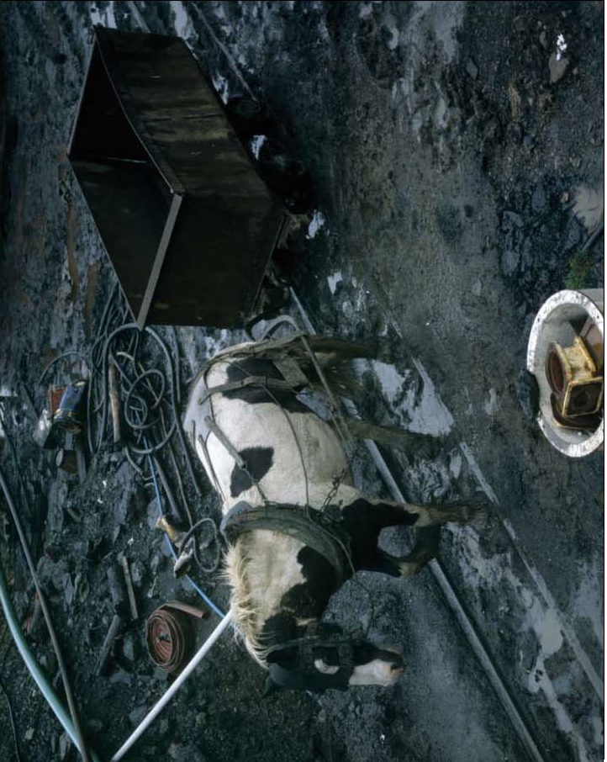

Activity sheet – How do animals help us? (2)

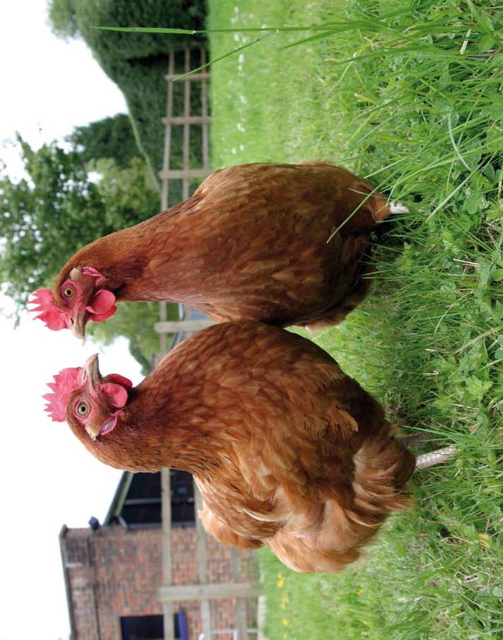
Activity sheet – How do animals help us? (3)
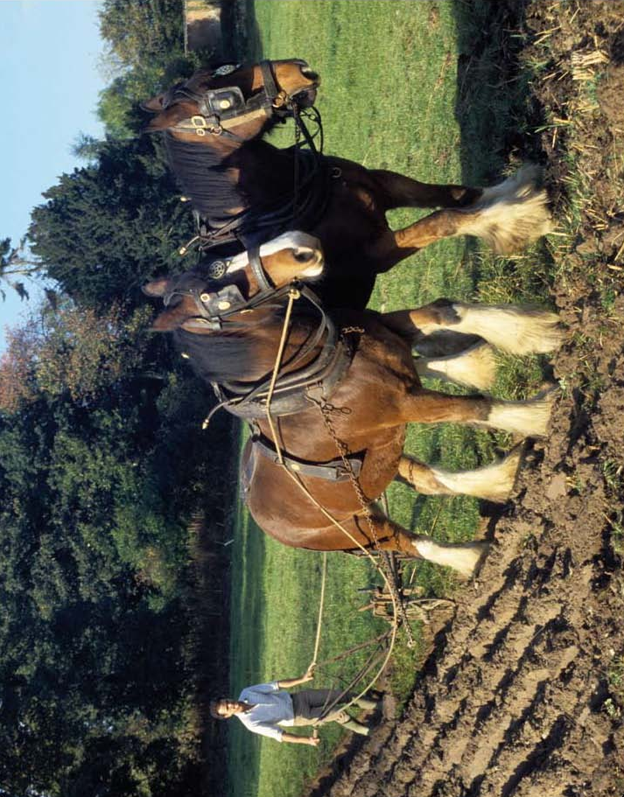

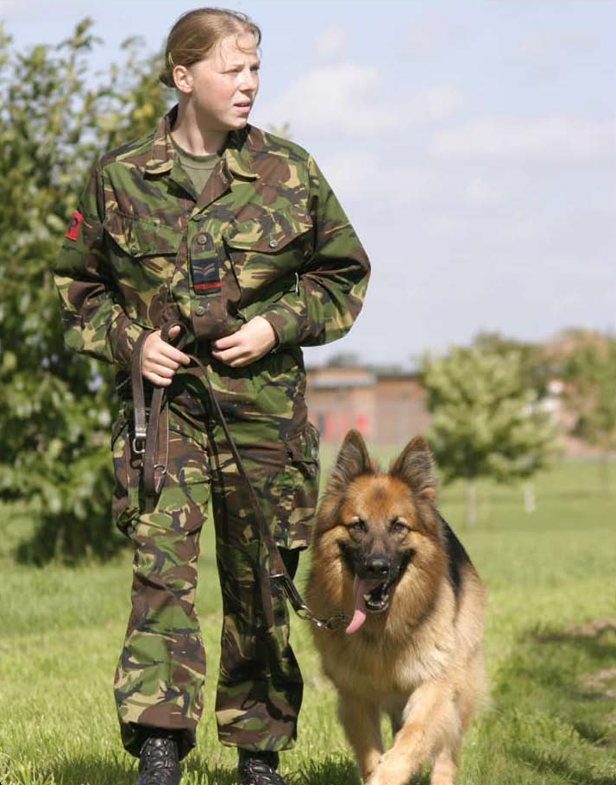
Activity sheet – How do animals help us? (4)

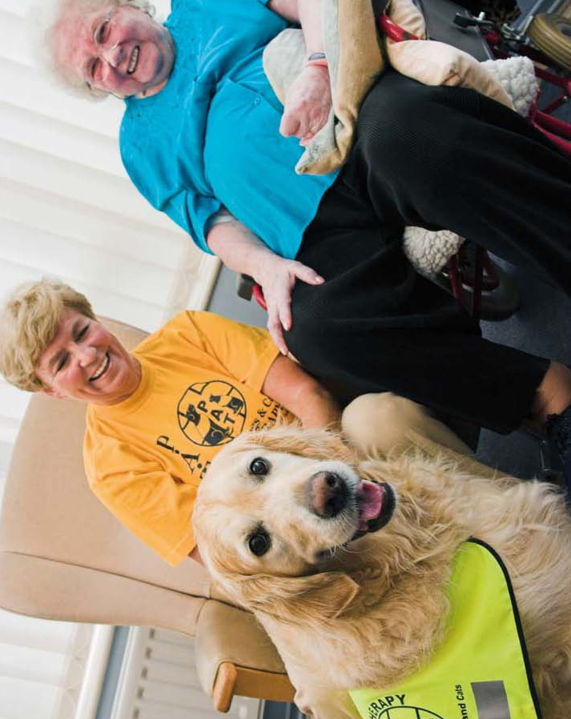
Activity sheet – How do animals help us? (5)

Activity sheet – How do animals help us? (6)

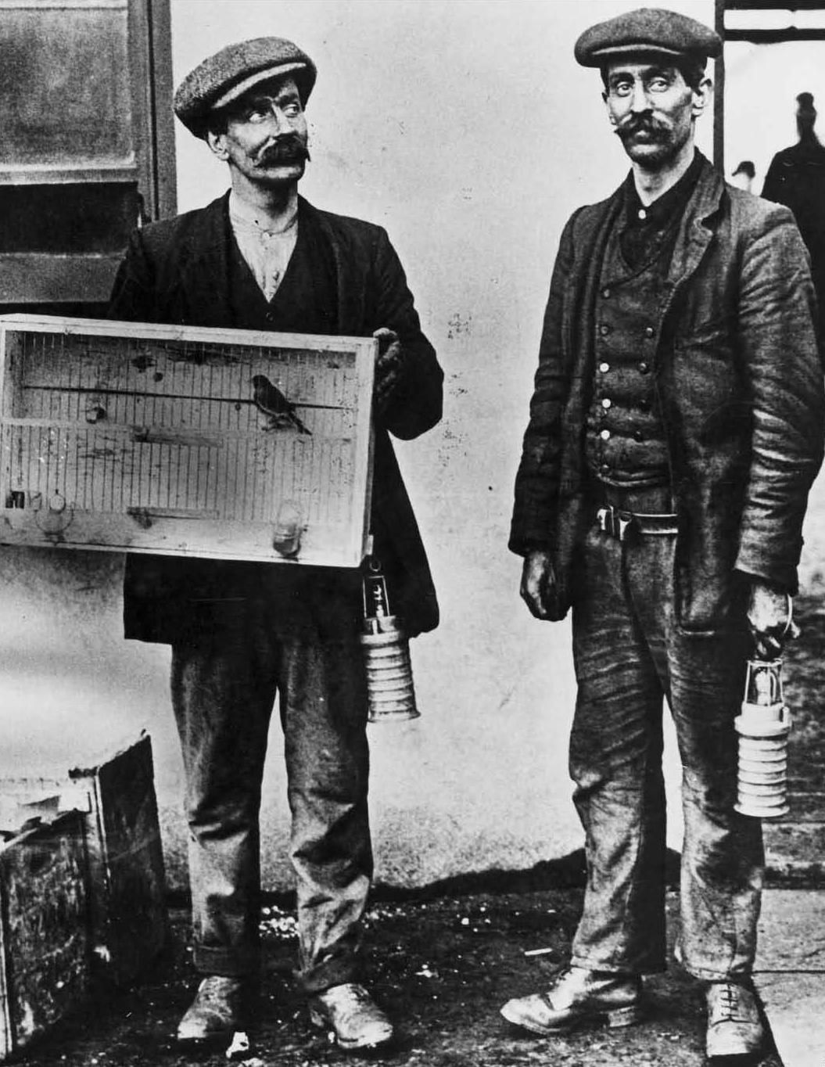

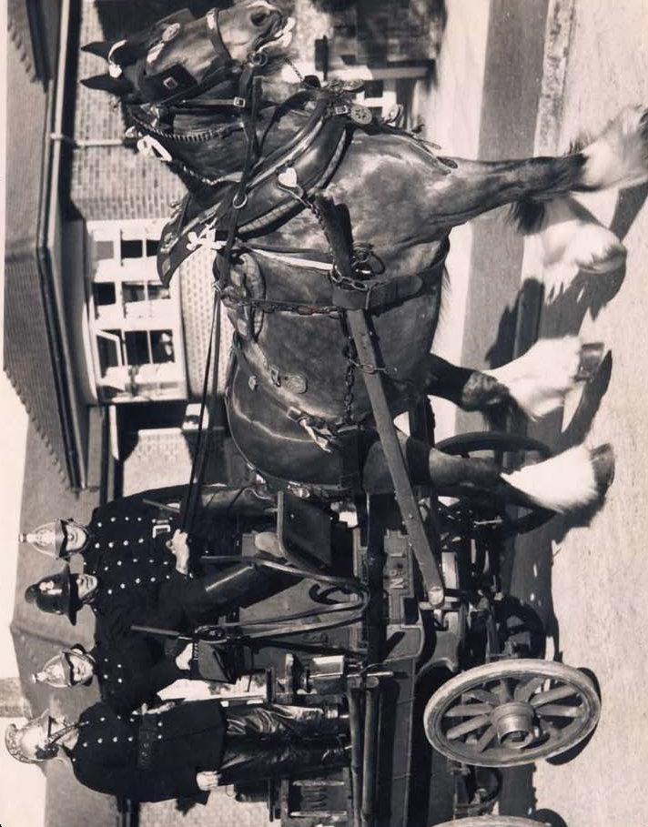
Activity sheet – How do animals help us? (7)

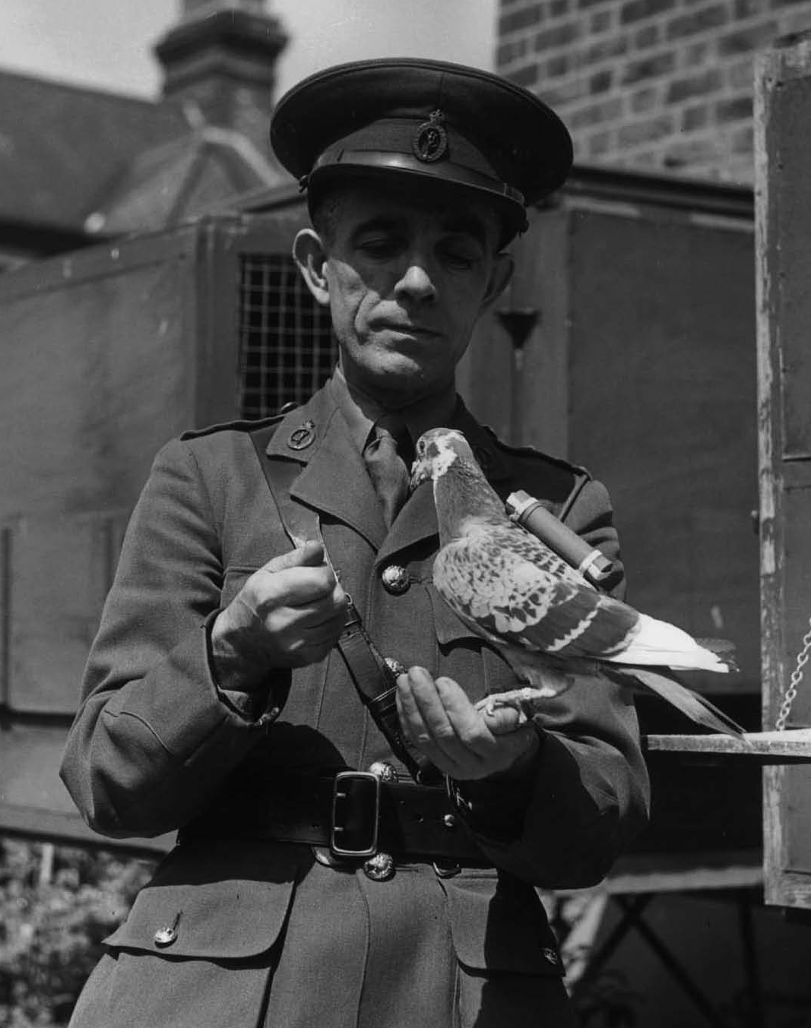
Activity sheet – How do animals help us? (8)

Facilitators’ notes – How are bees useful?

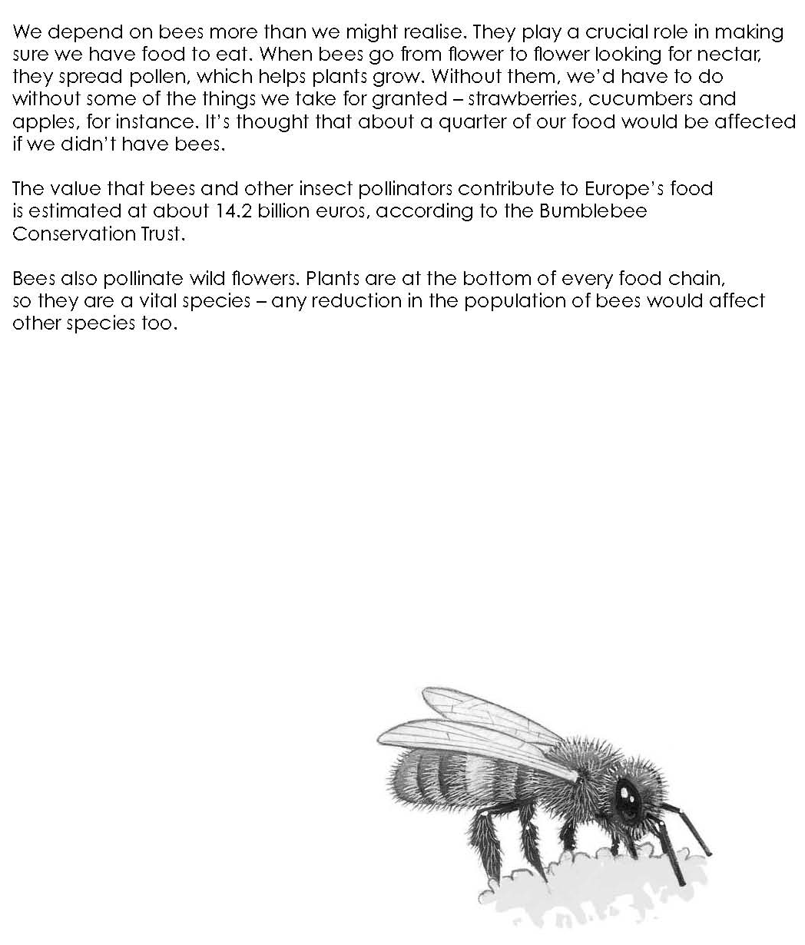

Facilitators’ notes – How are dogs useful? (1)

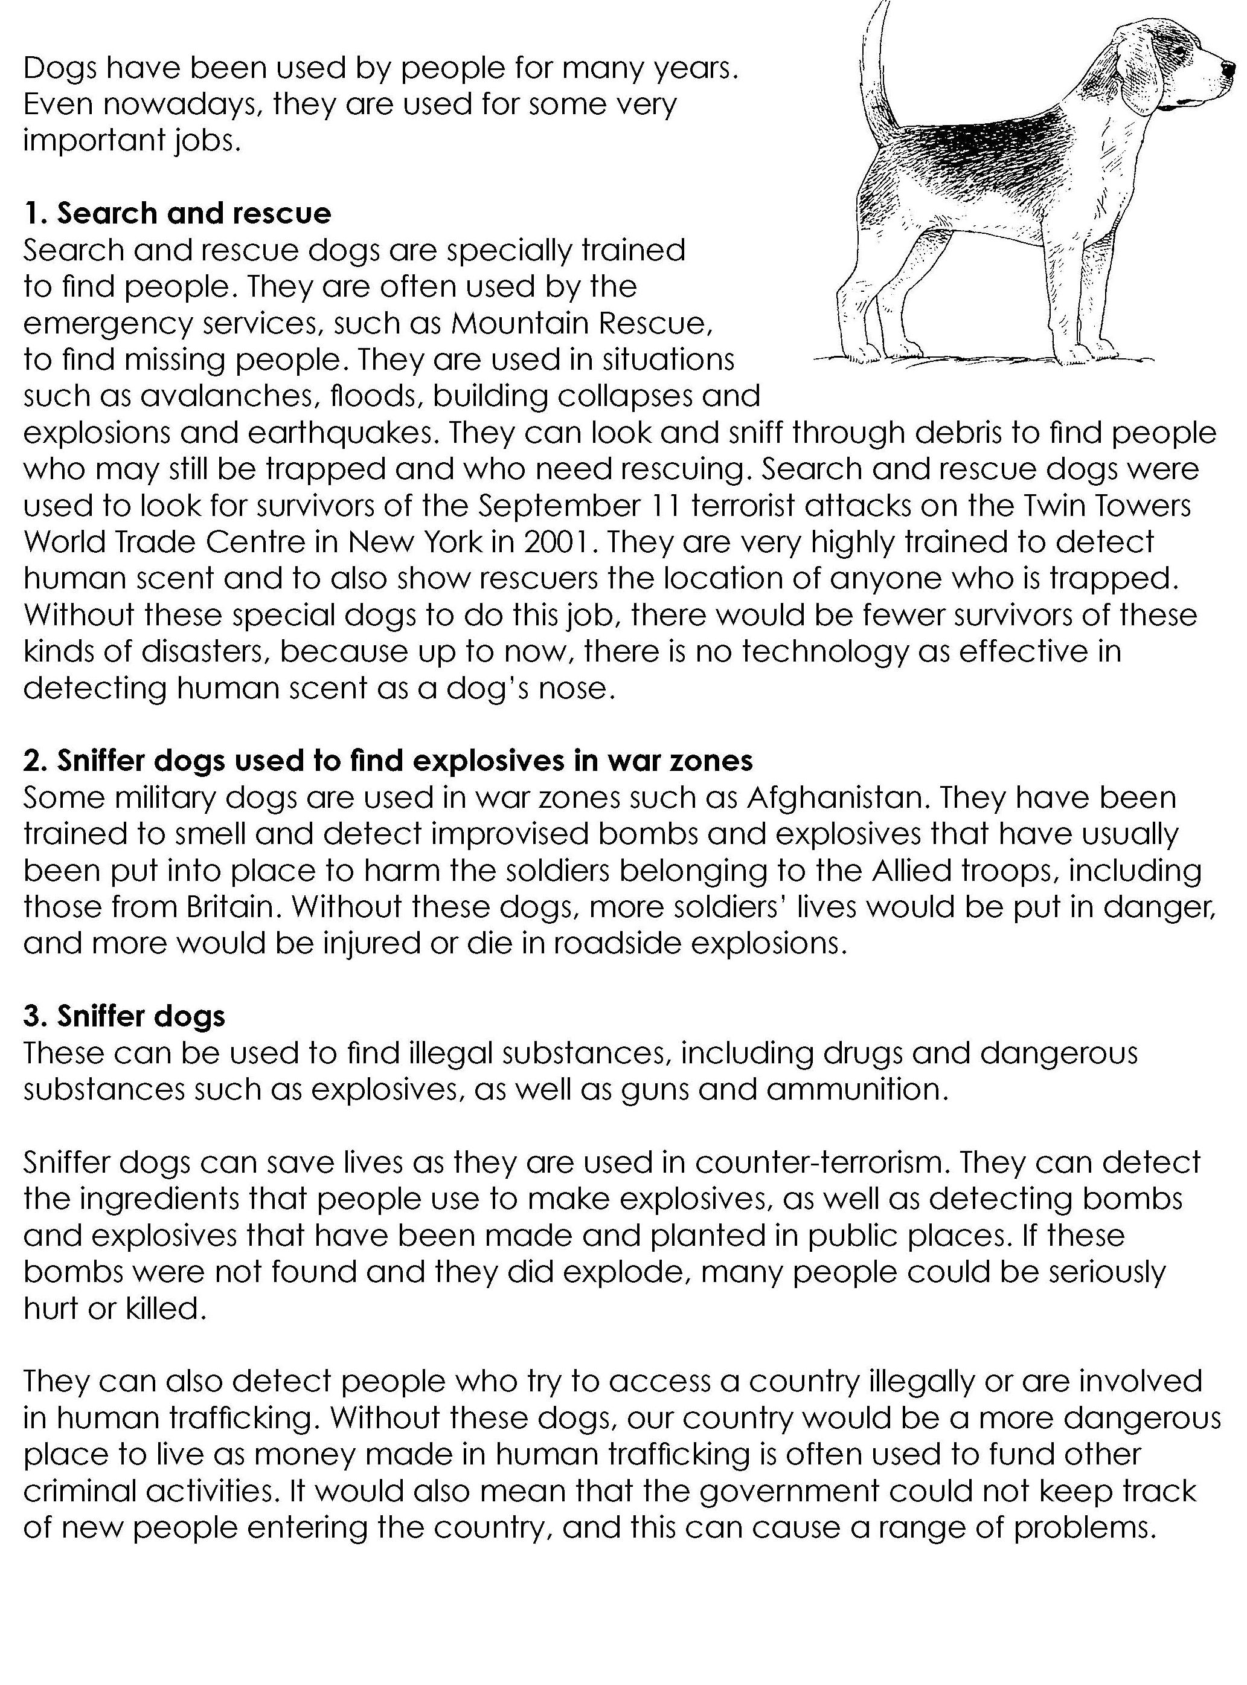
Facilitators’ notes – How are dogs useful? (2)

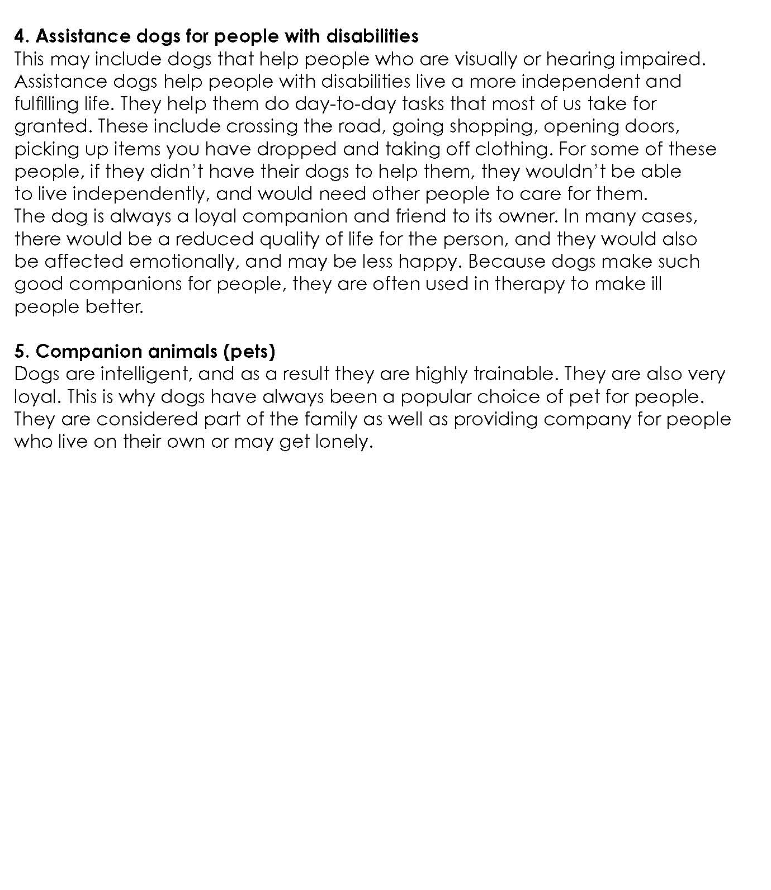

Facilitators’ notes – How are cows useful?



