Aims and objectives
- This activity is just one part of a range of resources addressing the needs of young people who have been involved, or who are at risk of being involved, in cruelty to animals. Our online assessment tool Developing a suitable intervention programme (Word 17KB) will help you create individualised intervention programmes from these resources.
- In this group of activities, young people develop an understanding that cruelty means causing suffering, either because of something you have done, or something you have omitted to do. They will learn how to identify suffering in relation to specific cases and relate this back to the five freedoms.

Before you do this activity, it would be best to do some activities from the Basic welfare needs and sentience section, particularly the Smiley face activity.

What to do

- Look at the activity sheet Which of the five freedoms are missing? Ask the young person to complete the sentences – you can check these against the facilitators’ notes Which of the five freedoms are missing? (answers). Cut out the five freedoms.
- Explain that you will be focusing on what cruelty is, not whether it is against the law or not. Almost all the illustrations in the activity sheet What is wrong? show a situation where a law is being broken, but you should try to focus attention on the actual suffering of the animal, rather than this.
- Using a selection of the illustrations from the activity sheet What is wrong?, look at each in turn and discuss what it shows. Some are trickier than others. Try to use a range of pictures, including some of intentional cruelty and some that show neglect. Take care in choosing the pictures – some may not be suitable, or may be upsetting, for some young people.
- Ask the young person to decide why the animal may be suffering in each picture and to place the appropriate missing freedom next to that picture, using the cut-out five freedoms. Use the facilitators’ notes What is wrong? (answers) to aid your discussions.
- Try to gently encourage the understanding that all the animals are suffering, and that they are all victims of cruelty.

Extension activities
- Ask the young person to arrange the pictures into two groups, one showing pictures where the cruelty was intentional, and one where it was through neglect.
- Look again at the freedoms the animals are missing. Suggest that all are suffering because of cruelty. Whether or not it was intentional is irrelevant to the animal.
- Before you do this activity, we suggest you run activities from the Basic welfare needs and sentience section. You can choose either to do both activities, or just one or the other.
- The Animal Welfare Act became law in 2007. It gave pet owners, and people who have responsibility for pet and working animals, a legal duty of care to provide five welfare needs for their animals.
- The five needs in the Act only apply to pet animals, but we aspire to these needs being met for all animals, so we refer to the five freedoms throughout this activity. The five freedoms are very similar to the five welfare needs in the Animal Welfare Act.
- A good follow-up activity is in Animals and the law, which looks at what laws have been broken in a set of illustrations.
- To complement the ideas in this session, we have developed three interactive activities - Was it cruel?, Consequences and Triggers - that help young people think through what happens when people are cruel to animals. To access each of them, click on the titles, right.

Activity sheet – Which of the five freedoms are missing?

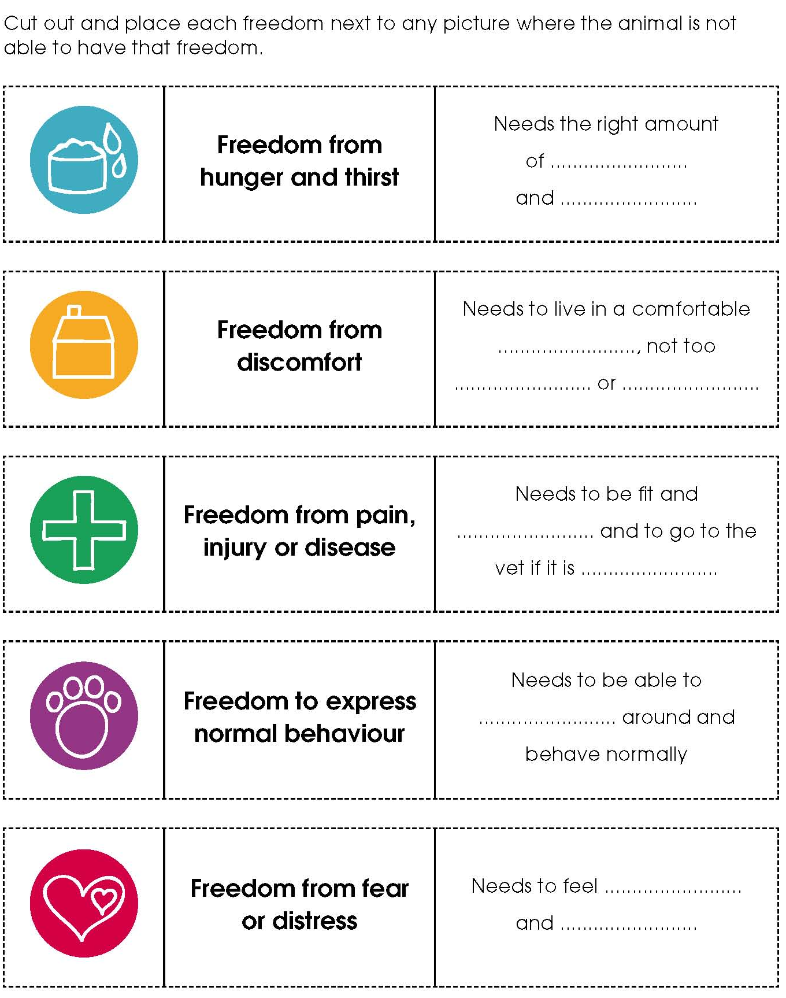
Activity sheet – What is wrong? (1)

Rabbit hutch
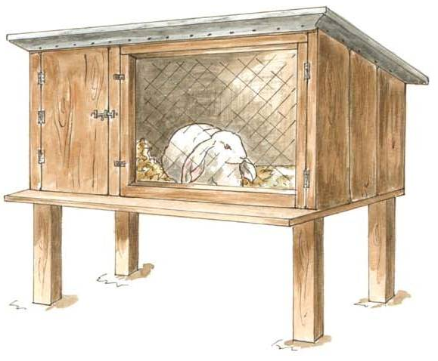

Cat with a firework

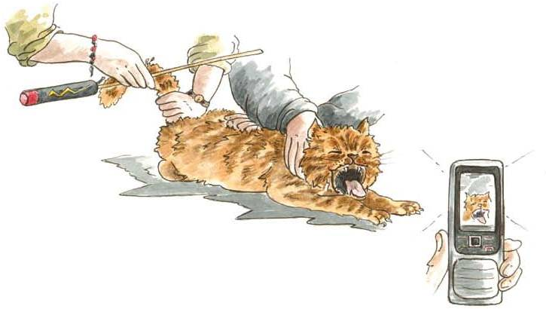
Activity sheet – What is wrong? (2)

Guinea pig in a run

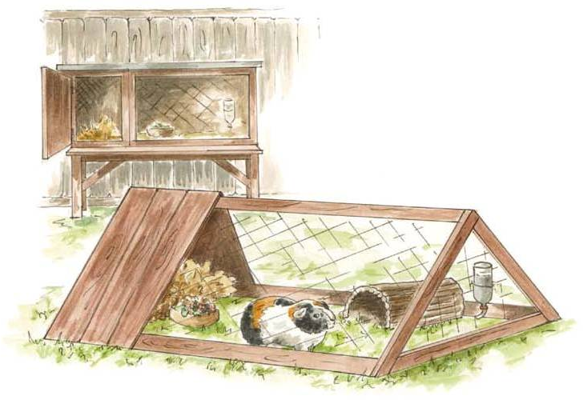

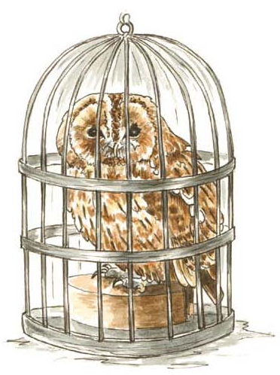
Owl in a small cage

Activity sheet – What is wrong? (3)

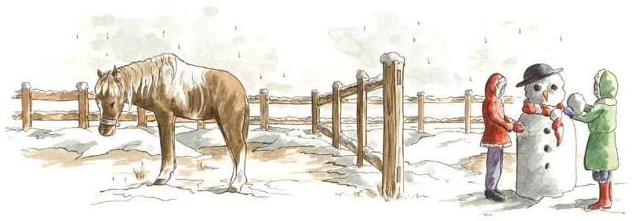
Horse in a field

Dog in a yard
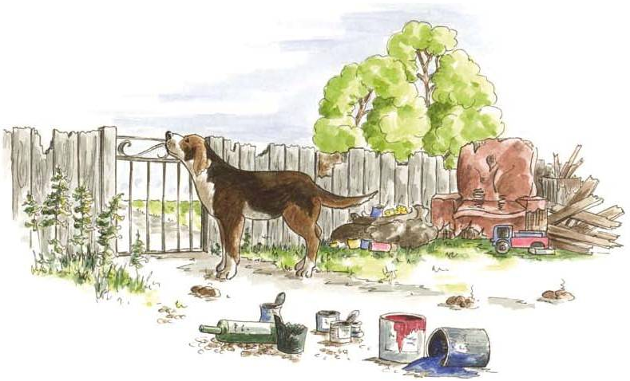

Activity sheet – What is wrong? (4)

Caged hens
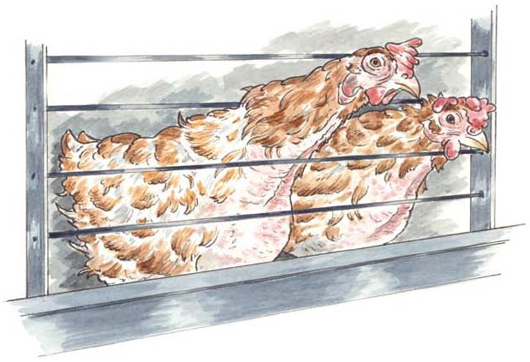

Boys inciting a fight between dogs

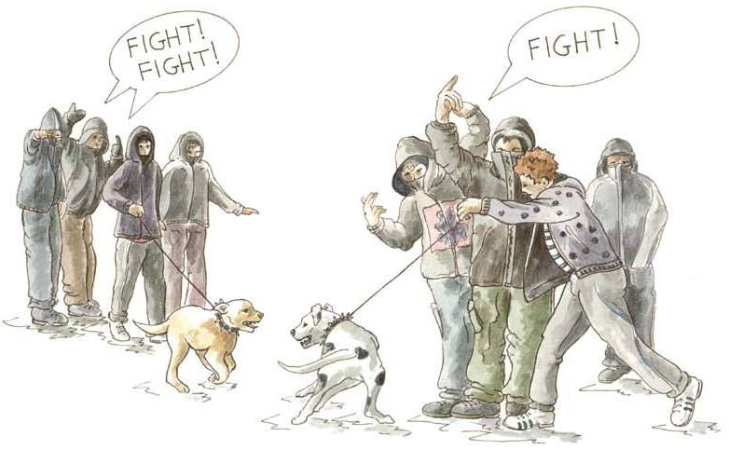
Activity sheet – What is wrong? (5)
Obese dog
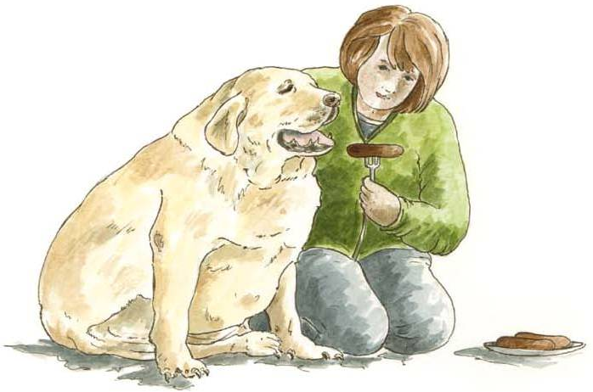

Dog that’s been scratching
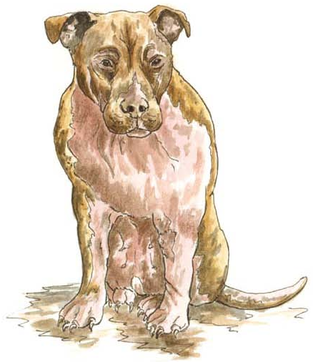

Activity sheet – What is wrong? (6)

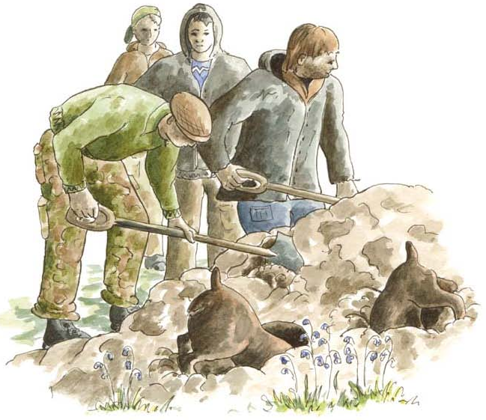
People digging out a badger sett

Cows in a transport truck
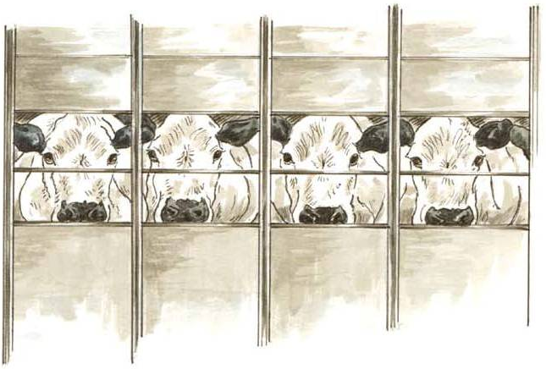
Activity sheet – What is wrong? (7)

A dog chasing sheep

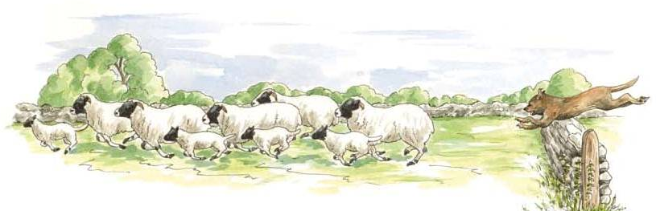

Fish in a bowl

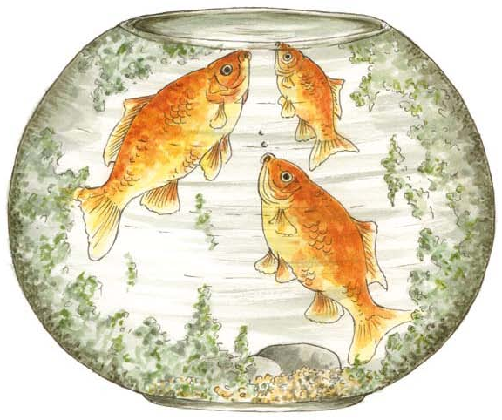

Activity sheet – What is wrong? (8)
Dog in a car
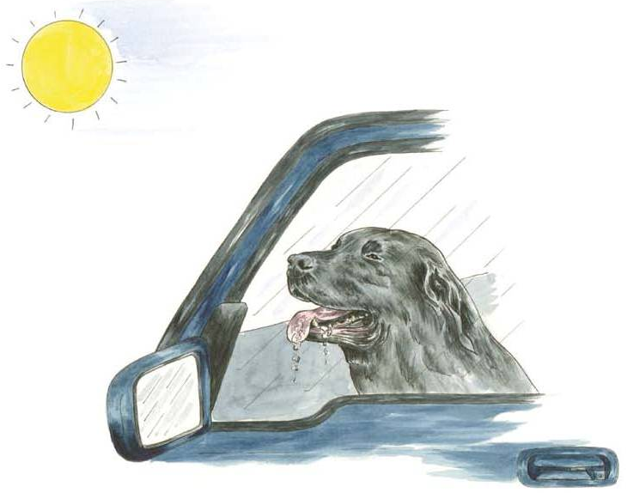

Pet owner feeding her dog chocolate
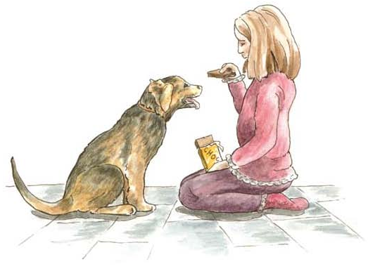

Fact sheet – Which of the five freedoms are missing? (answers)

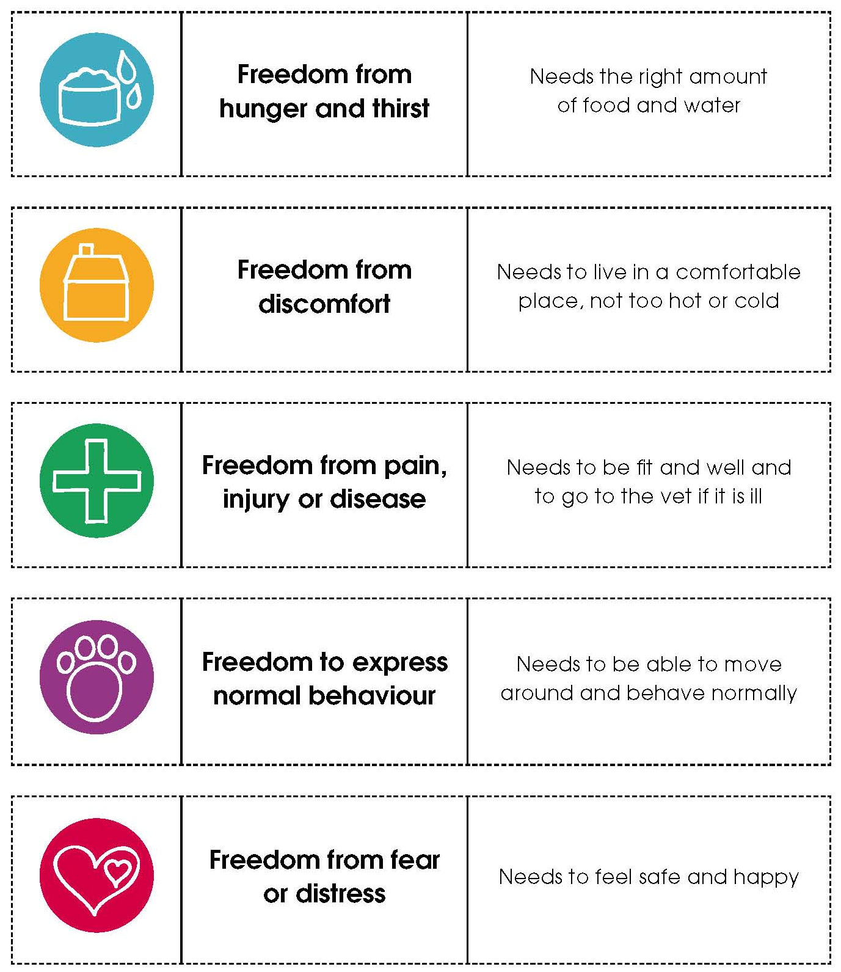

Facilitators’ notes – What is wrong? (answers) (1)

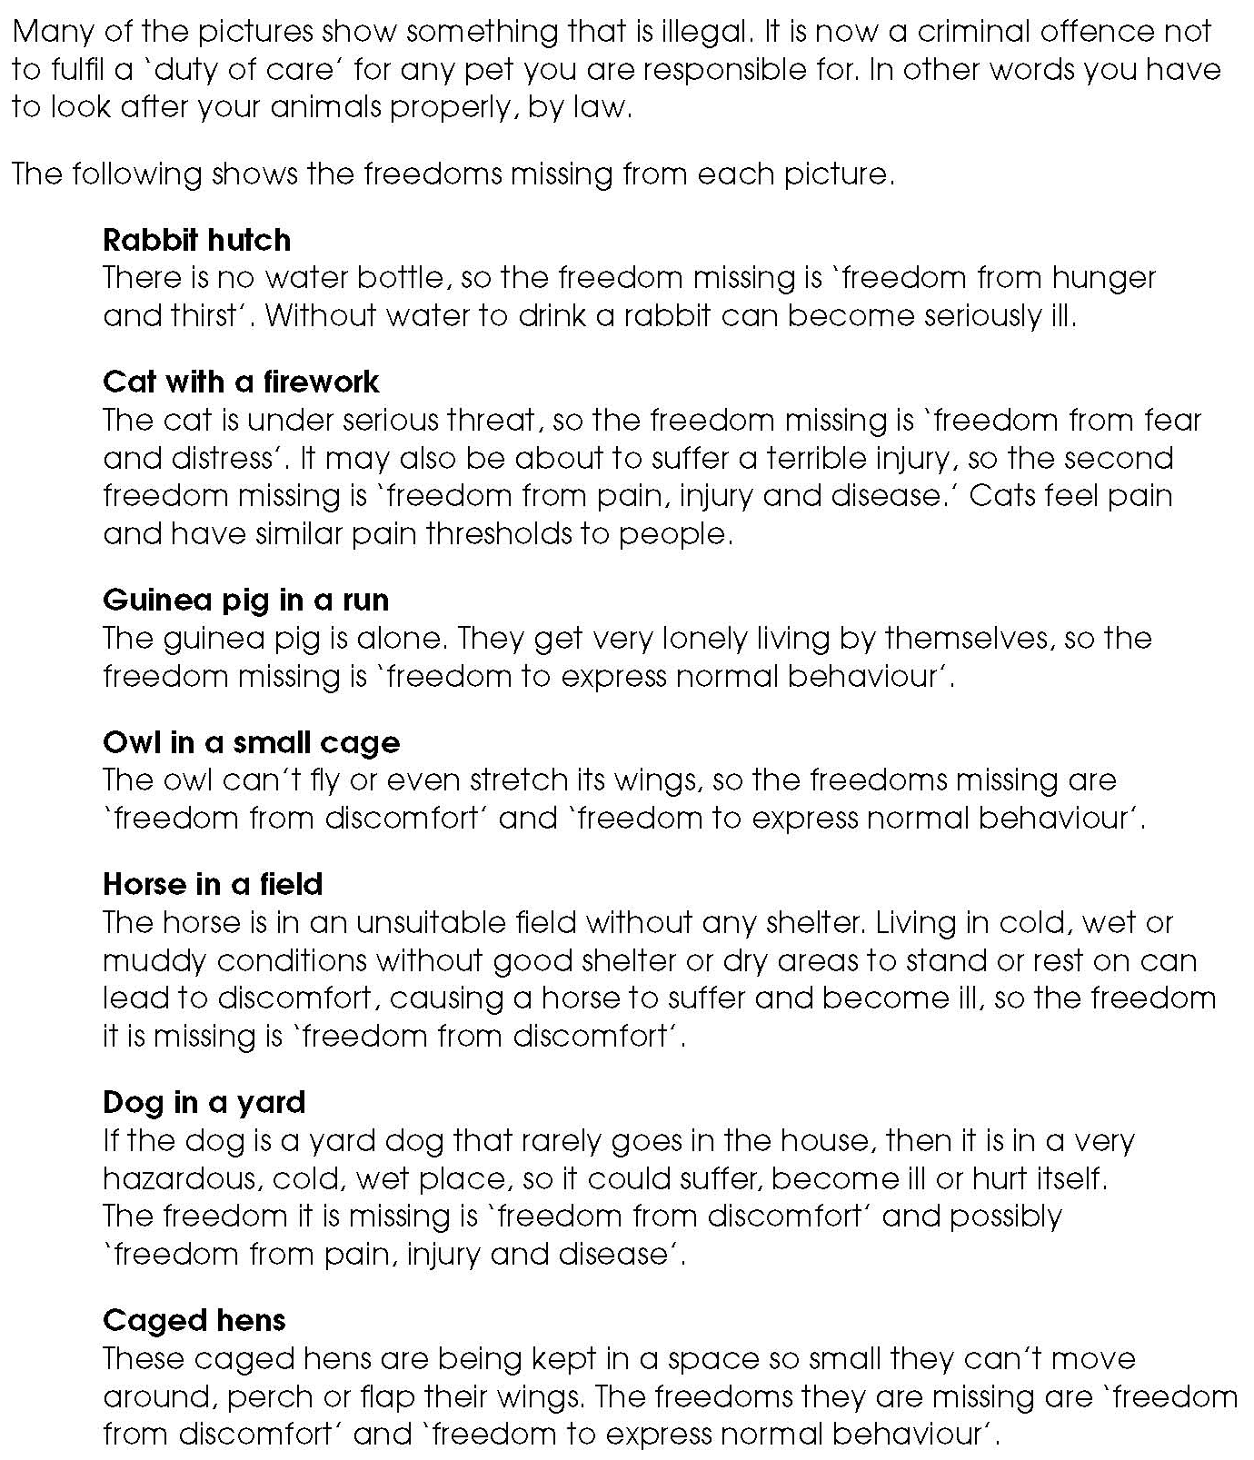

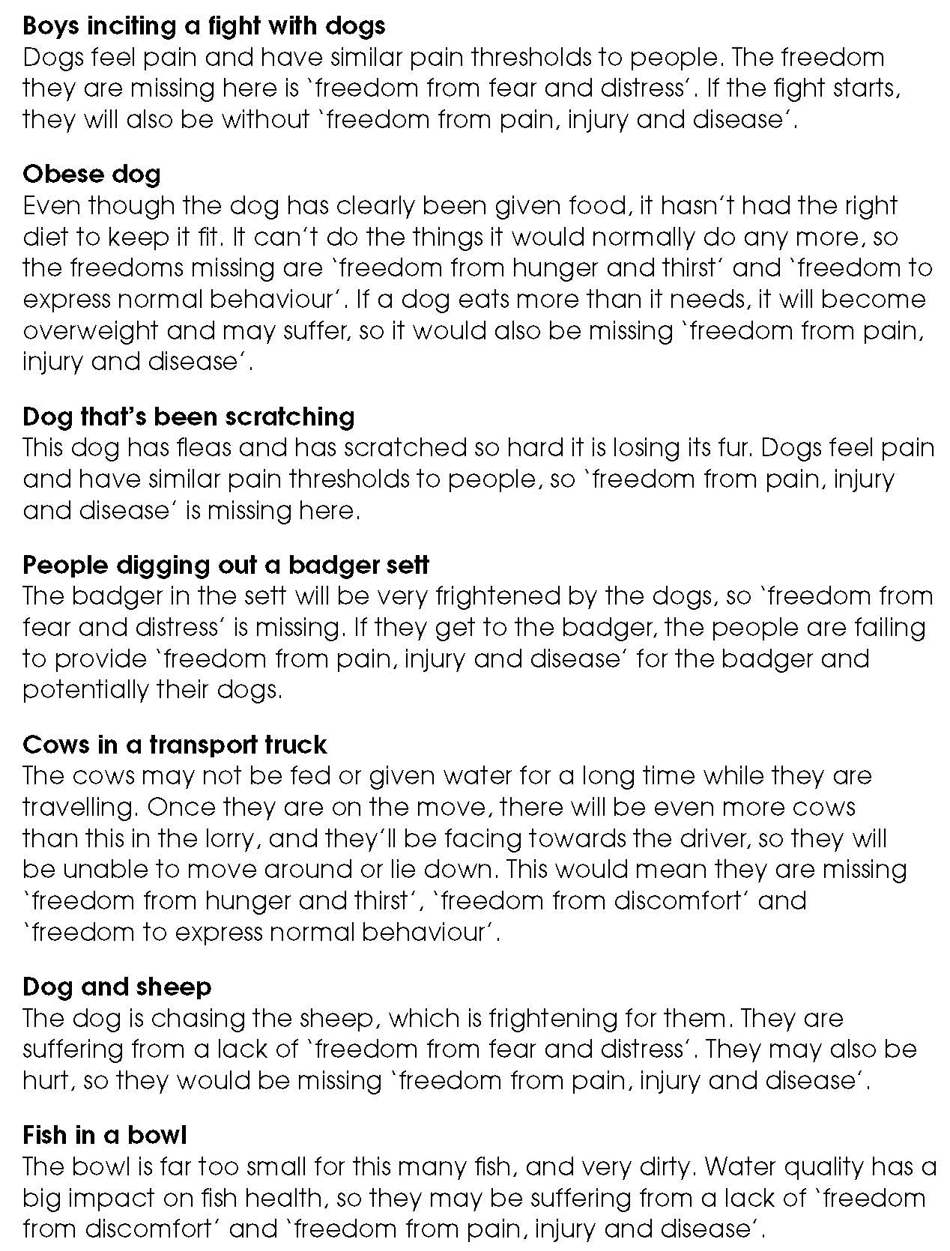
Facilitators’ notes – What is wrong? (answers) (2)

Facilitators’ notes – What is wrong? (answers) (3)


