Aims and objectives
- In this activity, young people have the opportunity to share their opinions about animals. For example, they can explore:
  - what situations they feel are right or wrong
  - how animals affect their lives
  - the level of responsibility they feel towards different types of animals.
- Young people will be able to:
  - discuss their opinions about a range of issues relating to animals
  - have any negative views gently challenged.

Although this can be a standalone activity, it can also provide the information you need to use our online assessment tool Developing a suitable intervention programme (Word 17KB), which will help you develop individualised intervention programmes.

What to do

- Ask the young person to cut out the different opinions and decide which they agree/disagree with or are unsure about.
- Gently challenge any negative or stereotypical views. You may wish to introduce the five freedoms at this point and explain that the RSPCA believes that anyone responsible for looking after animals should try to give them the five freedoms. Refer to the factsheet The five freedoms for information.
- You can use this activity to help you judge how to use the online assessment tool Developing a suitable intervention programme (Word 17KB). The assessment will direct you to the activities best suited to the needs of the individual you are working with.
- After working with your young person for the time specified for them, you might like to look at these statements again, to gauge whether the work has changed any of their opinions.
- A central theme running through all these resources is the concept of the five freedoms. We hope that by introducing this to the young people in the Basic needs section and then reinforcing it in a number of other sections, we will provide them with a code of conduct to apply to every situation in which they encounter animals. The five freedoms are very similar to the duty of care criteria mentioned in the Animal Welfare Act.
- We have also developed three interactive activities - Was it cruel?, Consequences and Triggers - that help young people think through what happens when people are cruel to animals. However, before you attempt to use these, we suggest that you explore some of the activities in the other sections - What is animal cruelty?, What triggers animal cruelty and how it can be avoided, Consequences of cruelty to animals and The incident.

Useful websites
RSPCA – All about animals

Fact sheet – The five freedoms

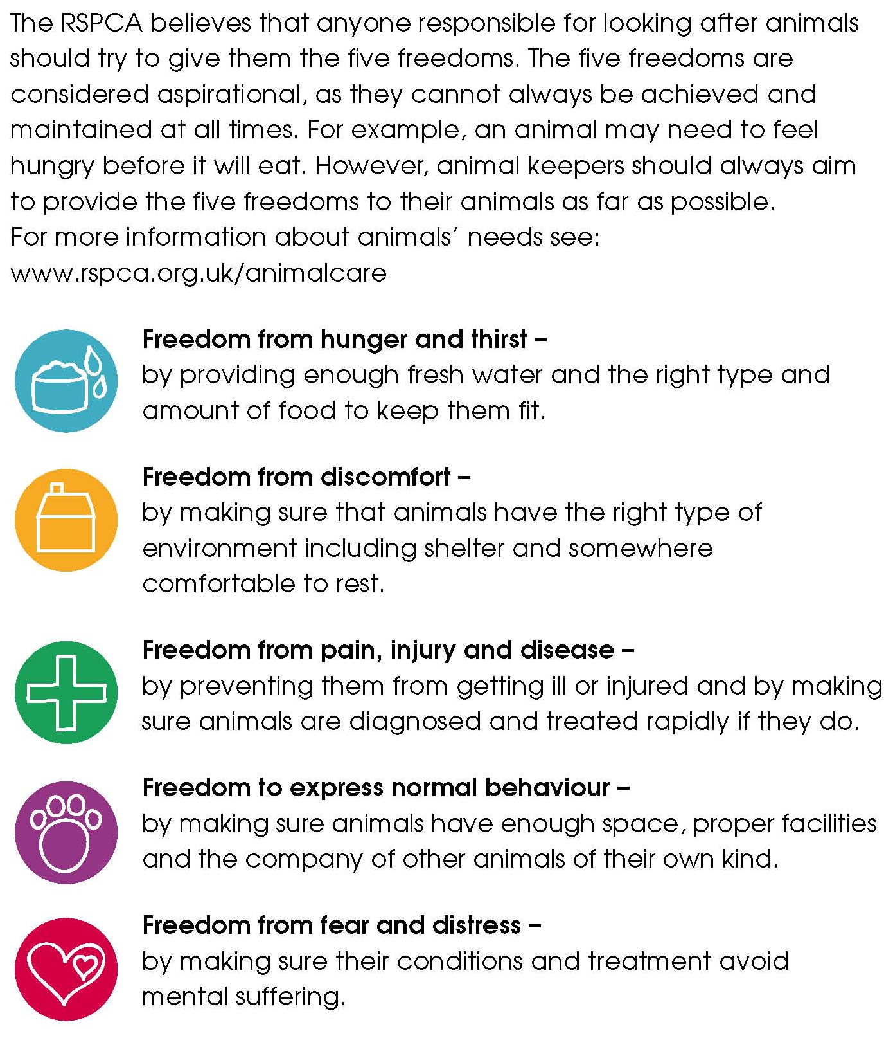

Activity sheet – What’s your view about animals? (1)

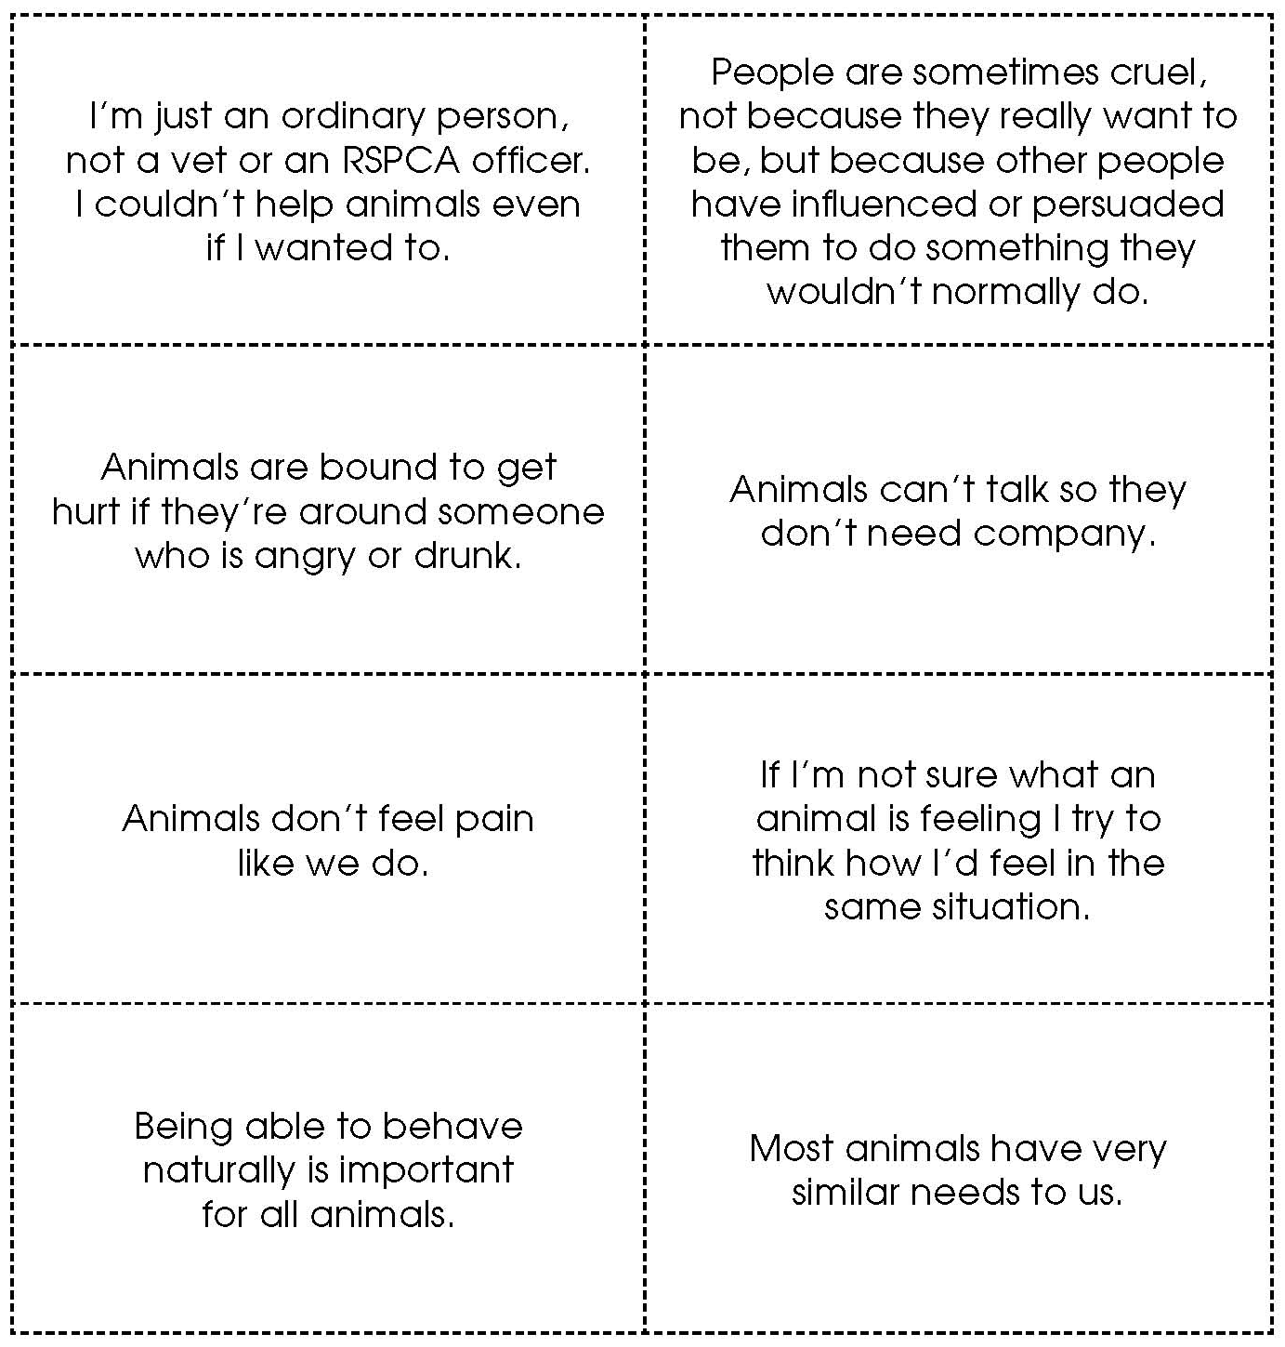

Activity sheet – What’s your view about animals? (2)

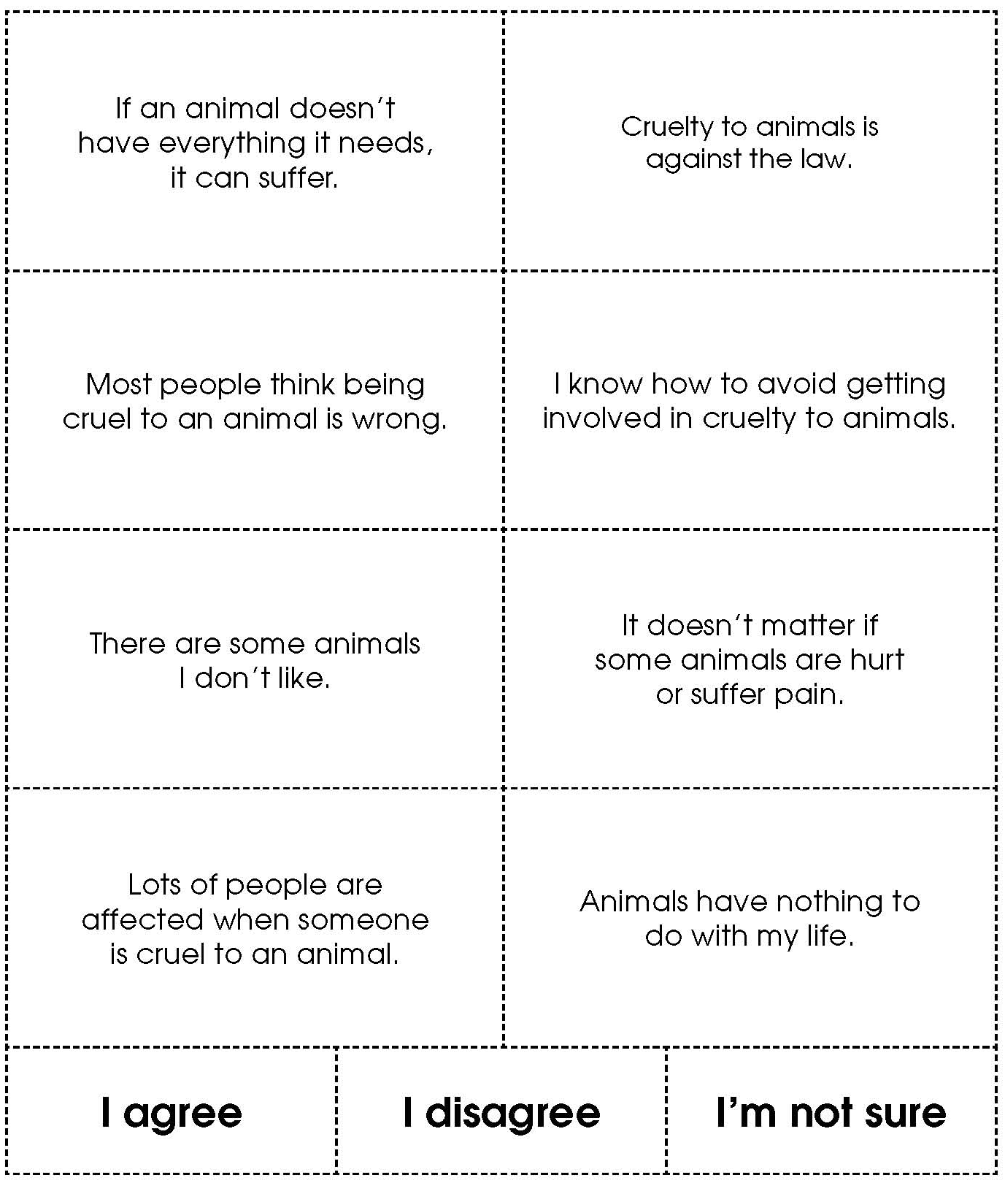

Activity sheet – What’s your view about pet animals?

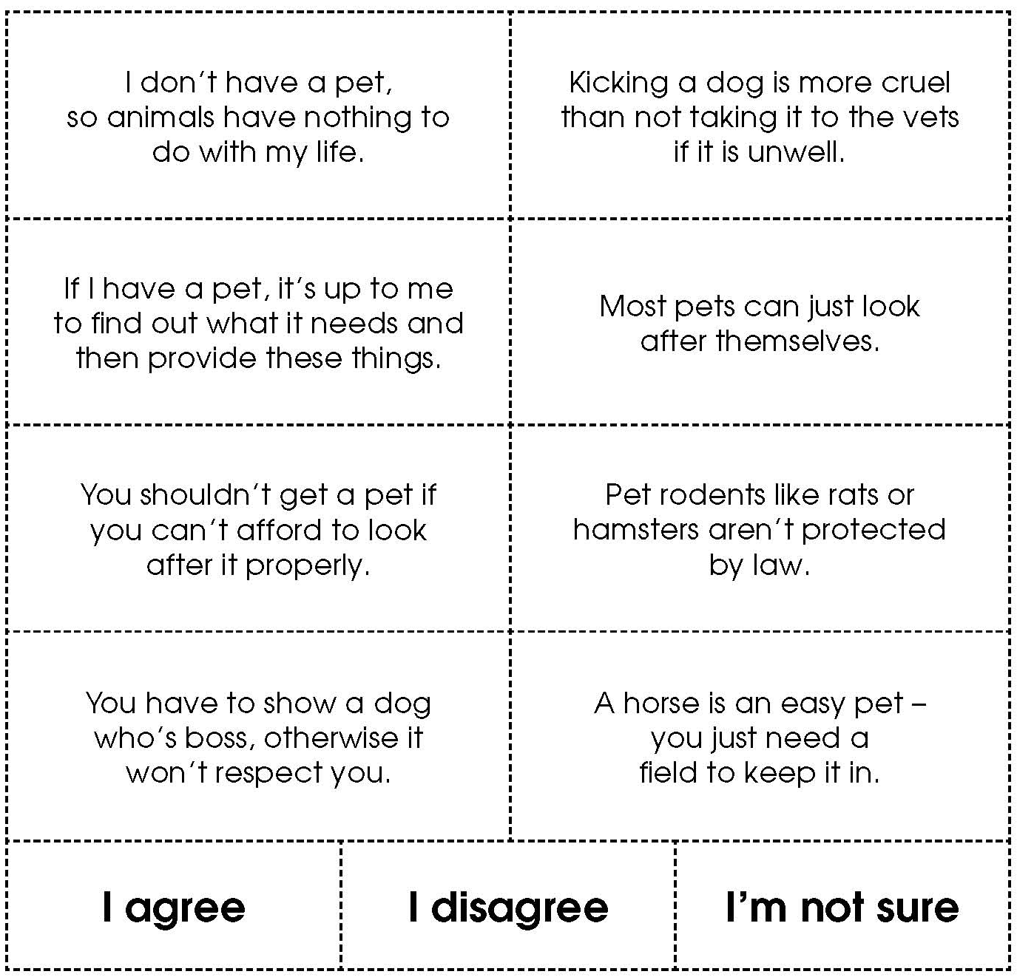

Activity sheet – What’s your view about wild animals?

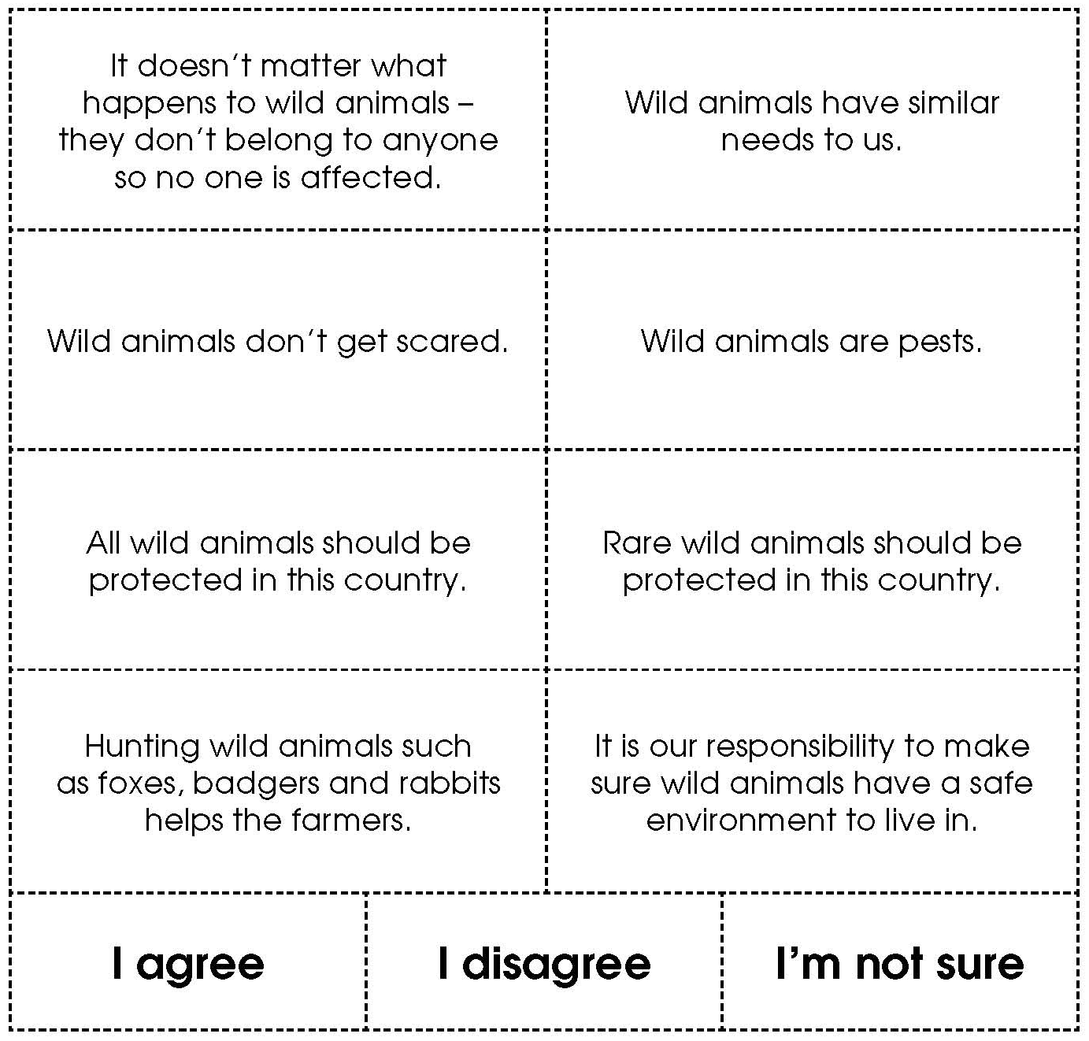

Activity sheet – What’s your view about farm animals?



