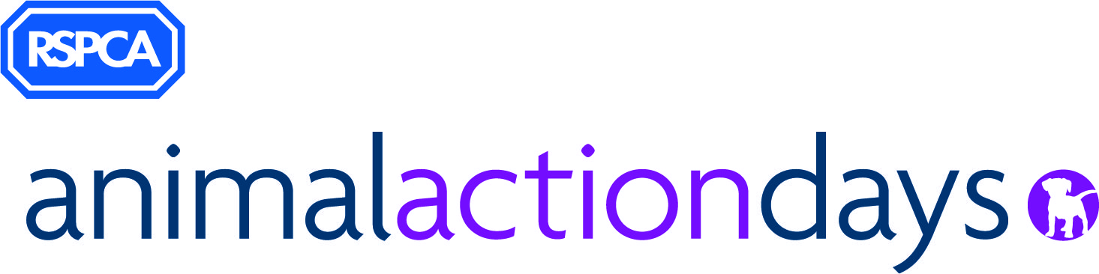

Generation Kind Animal Action Project for Care Experienced Children

Consent and Referral Form

Thank you for your interest in the RSPCA’s Animal Action Project which is a project designed for care experienced young people. Please only complete this form if you have the appropriate and proper authority to make this referral and share the young person’s personal data.

We see education as the way in which we can increase positive attitudes and interactions with animals, reduce the number of animals being harmed or neglected, keep young people safe around animals, both in the home and outdoors, and increase the sustainability of placements.

Data Protection Statement: The information that is provided on this form will only be used for the purposes as set out. By completing this form, you consent to the RSPCA processing your data and retaining it for a period of 36 months. You have the right to withdraw your consent at any time, you can do this by contacting aadconsent@rspca.org.uk. Information about how we use your personal data is set out in our privacy notice, available at: www.rspca.org.uk/utilities/privacy

Once completed, please send this form, securely, back to:
kate.oregan@rspca.org.uk By the 12th March 2020.

If you have any queries, or wish to discuss a referral, please contact us at: kate.oregan@rspca.org.uk

It would be helpful if you refer families who you know are available on the 8th and 9th April. (We are currently planning for 8.4.2020 to be for children aged 5-11, and the 9.4.2020 to be for children aged 11-16, but this may change depending on the volume of referrals within each age range.)

Referral

Your Details (details of the person making the referral):
Name: |  | Agency/Organisation:
Job Title: |  | Contact Email:
Contact Phone:

Young Person’s Details

Name: |  | Age: |  | Gender:

Who will be accompanying the young person?

Name: |  | Email: |  | Phone:

Photography Statement: It is important that young people feel happy with the things that they achieve at the Animal Action Day and have photos and films of their special moments. However, it is important to be aware of child protection and safeguarding issues when taking photos or filming at such events. We have decided that we will not take photos that identify the young people in attendance, but we may take photos where they may be undertaking tasks, these photos will only include hands, backs of heads and activities being undertaken. If carers would like to take pictures of their young people on the day, we would request that they ensure there are no other young people around at that time.

Are you happy with us capturing photos as explained above? Yes / No

Additional Information
There may be some opportunities for children to attend additional sessions which would take place in school holidays or at the weekends.

Would the carer and young person be interested in attending further sessions if available? | Yes / No | Would the carer and young person be prepared to complete a short pre-session evaluation and provide feedback during and after the project. | Yes / No

About the young person
1. Why would you like to nominate the young person to take part in the Animal Action Project?
2. Are there any animals in the home, and what is the young person’s behaviour towards them?
3. Have there been any reports of inappropriate behaviour towards animals? Please provide details.
4. Are there any additional needs (SEND) for which we would need to offer provision for? Please provide details.

I ______________________________, confirm that I have the right and authority to provide the information about the young person and give consent to participate in the Animal Action Programme.

