Aims and objectives
- This activity is just one part of a range of resources addressing the needs of young people who have been involved, or who are at risk of being involved, in cruelty to animals. Our online assessment tool Developing a suitable intervention programme (Word 17KB) will help you create individualised intervention programmes from these resources.
- In this activity, young people develop ground rules for owning and visiting pets, to ensure they are safe and well.
- Young people will develop the understanding that:
  - people who have pets must give them everything they need to be happy and healthy
  - when we come into contact with someone else’s pet animals, we must behave in a way that does not scare or harm them
  - society expects us all to be responsible for pet animals.
- You will need to do the Smiley face activity from the Basic welfare needs and sentience section beforehand.
- It is also important to do this activity before going on to The Visit activity in this section if your visit is connected with pet animals.

What to do

- Explain that this activity will help the young person explore what is acceptable and what is unacceptable behaviour when caring for pets, or being around other people’s pets. Anyone who owns a pet must provide what they need.
- You can see the basic animal welfare needs listed in the factsheet The five freedoms. When we visit other people’s pets there are certain ways to behave, to avoid scaring or harming them.
Ground rules for pet owners
- Explain that the young person is going to develop some ground rules or a code of conduct for pet owners. Help them to complete the activity sheet Five freedoms ground rules for pets. They need to record at least one rule for each of the five freedoms with words or pictures. You can use the factsheet The five freedoms to help.
- An example of a ground rule might be:
  - Always make sure your pet has clean water to drink all of the time.

Ground rules for visiting pet animals
- Explain that the young person is going to develop some ground rules or a code of conduct for how to behave when visiting other people’s pets. Emphasise the positives, by encouraging the young person to discuss things they CAN do rather than what they CAN’T do. For example:
  - Talk quietly around pets, rather than Don’t shout
  - Be gentle, rather than Don’t hit pets.
- You or the young person should keep a record of the code of conduct for future reference. You may want to use it for The Visit activity, which is also in this section.
- Before you do this activity, we suggest you run some of the activities in the Basic needs and sentience section first. You can choose to either do both activities 2 and 3, or just one or the other. You must do this activity before going on to do The Visit activity in this section.
- A central theme running through all these resources is the concept of the five freedoms. We hope that by introducing this to the young people in the Basic needs section and then reinforcing it in a number of other sections, we will provide them with a code of conduct to apply to every situation in which they encounter animals. The five freedoms are very similar to the duty of care criteria mentioned in the Animal Welfare Act.
- We have also developed three interactive activities - Was it cruel?, Consequences and Triggers - that help young people think through what happens when people are cruel to animals (see right). However, before you attempt to use these, we suggest that you explore some of the activities in the other sections - What is animal cruelty?, What triggers animals cruelty and how it can be avoided, Consequences of cruelty to animals and The incident.

Activity sheet – Five freedoms ground rules for pets

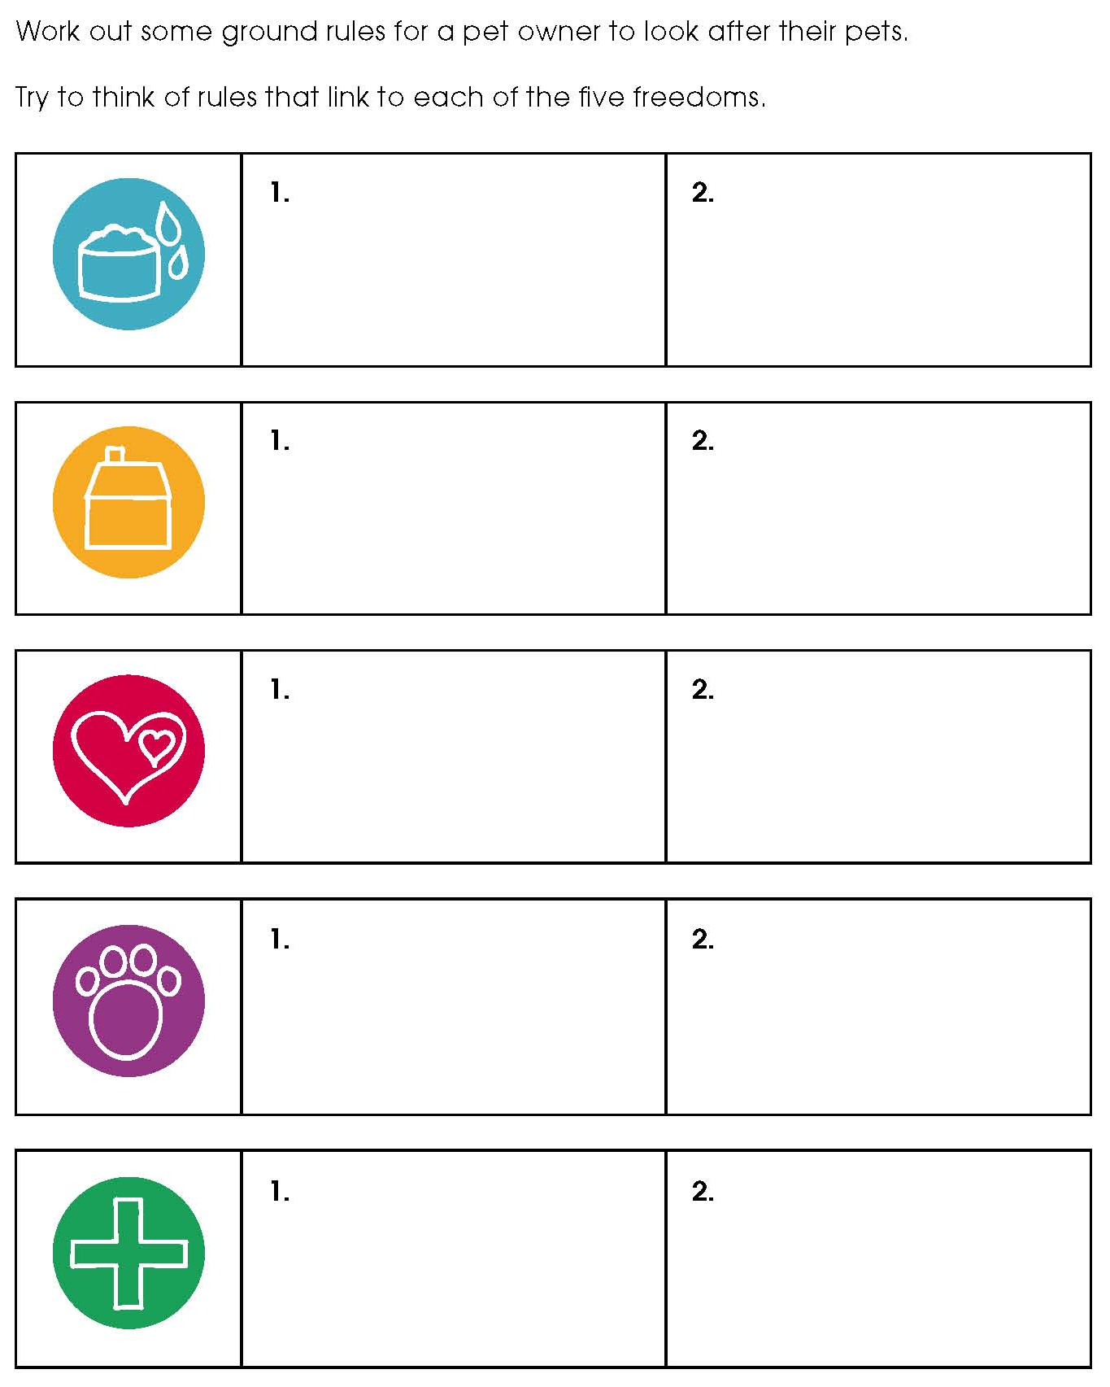
Fact sheet – the five freedoms

