Aims and objectives
- This activity is just one part of a range of resources addressing the needs of young people who have been involved, or who are at risk of being involved, in cruelty to animals. Our online assessment tool Developing a suitable intervention programme (Word 17KB) will help you create individualised intervention programmes from these resources.
- There are three activities from The incident section that should be completed beforehand: Revisiting the incident, What triggers cruelty? and Consequences of my actions.
- In this activity, the young person explores how they can avoid reoffending by managing some of the triggers identified in the activity Revisiting the incident. They complete an action plan to help them avoid reoffending and think about positive goals for themselves.
The young person:
- increases their awareness of the strategies they can use to manage their own trigger factors and prevent reoffending
- examines how the incident might have evolved differently, if these strategies had been used at the time of the incident
- creates an action plan to help them avoid offending behaviour in the future
- records any positive future goals.

What to do

- Tell the young person that it is important for them to learn from what has happened. Explain that part of your role is to help them avoid reoffending in the future.
- Explain that one way that this can be done is by giving them coping strategies to help them deal with similar situations and feelings in the future. If they can identify what they think contributed to and caused the incident in the first place, they can start to think about ways in which these situations can be avoided and ways of managing strong feelings. This will make them much better at managing their behaviour.
- Using your storyboard cartoon or models from the session Revisiting the incident, ask the young person to think again about what triggered the incident. You may need to use the activity sheet Human feelings cards again. Ask them to put one of the warning sign pictures from the activity sheet Warning sign symbols next to the part of their story where a key event, or key decision was made. Examine one trigger at a time. For each trigger, ask them to then think about how they could have coped differently in that situation or avoided those triggers or risk factors. Some suggestions may be grouped under the following headings.
  - Avoiding the situation arising
  - Avoiding a particular group or individual
  - Managing any strong feelings they have discussed with you
  - Handling conflict
  - Re-education and victim awareness
Note: the RSPCA believes the youth justice professional working with the young person is in the best position to offer advice about the sorts of coping strategies available to them.
- Record each trigger or risk factor as well as the relevant coping strategy on the activity sheet Action plan. You may also decide to organise some additional intervention work or arrange for the young person to attend a course or some training. This can also be recorded on the action plan.
- Ask the young person to think back to other times when they may have been involved in animal cruelty. Explain that they can trust you, and you need to know, to help them avoid reoffending in the future. Ask them what happened, and if there were similar or different trigger points. Add these to the action plan if appropriate.
- Have a discussion with the young person about which of their targets will be easy or difficult to achieve. Explain that some of them may be quite difficult, but it is important to work hard to avoid further involvement in cruelty. Ask the young person why it is important to stop any other cruelty events from occurring.
- Now, while looking at their storyboard or model from earlier in the session, ask the young person to present how the incident would have evolved differently if they had used some of these strategies. They could storyboard, model or just talk about an alternative ending to their story, with a positive outcome.

Extension activities

- On the activity sheet What have I got to lose?, ask the young person to write or draw the risk factors or triggers on the steps going up to the top of the diving board. On the top of the diving board, ask them to write or draw all the things they would lose if they climbed up the ladder to the top. Say that by working their way up through the risk factors using the ladder, they would cause themselves and all the things on the diving board to fall down into the water.
- This activity will only be effective if the young person accepts their involvement in the incident.
- We suggest you complete the activity Revisiting the incident beforehand.
- To complement the ideas in this session, we have developed three interactive activities - Was it cruel?, Consequences and Triggers - that help young people think through what happens when people are cruel to animals.

Activity sheet – Human feelings cards

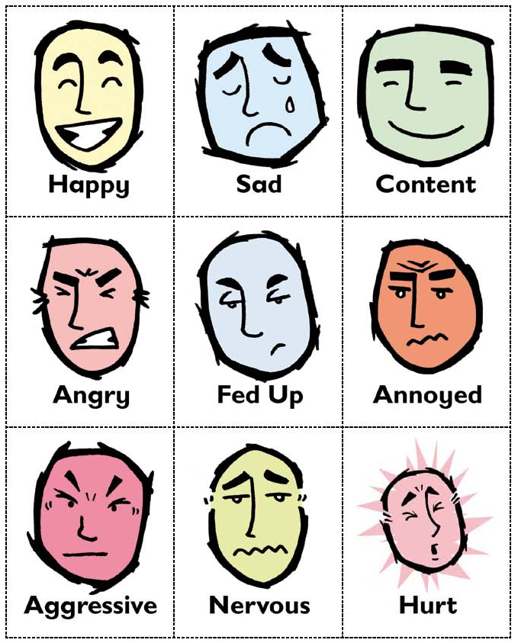

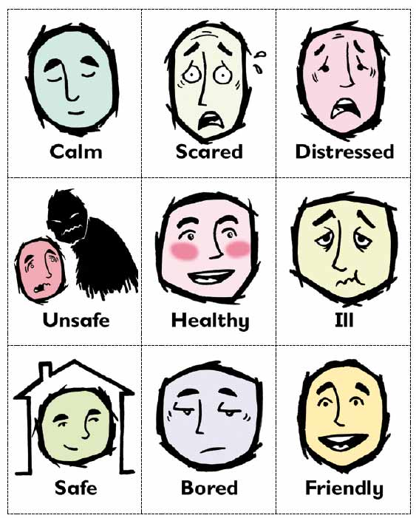

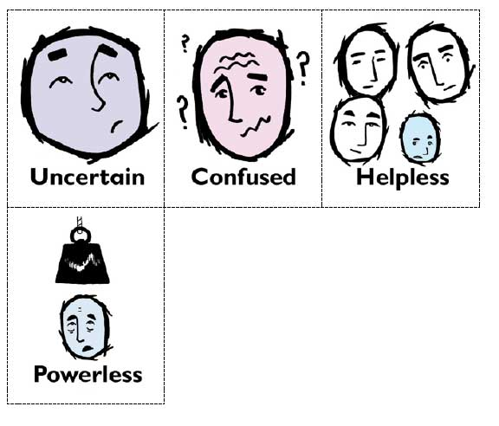

Activity sheet – Warning sign symbols

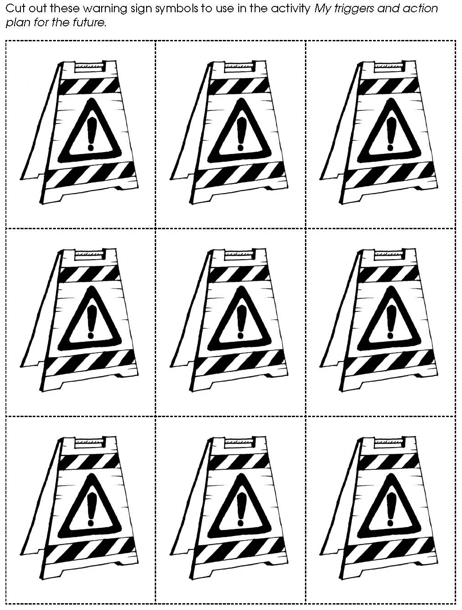

Activity sheet – Action plan

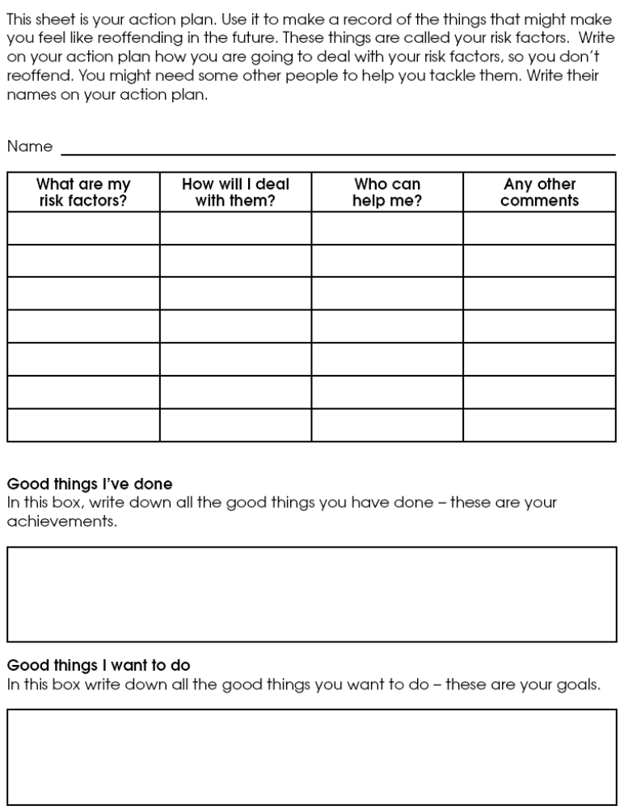

Activity sheet – What have I got to lose?



