Aims and objectives

This activity is just one part of a range of resources addressing the needs of young people who have been involved, or who are at risk of being involved, in cruelty to animals. Our assessment tool Developing a suitable intervention programme (Word 17KB) will help you create individualised intervention programmes from these resources.

In this activity, the young person will discover that animals and humans have the same basic needs.

It’s essential to do this activity before doing the activity Feelings in this section. The Smiley face activity is important in helping young people develop empathy for animals, and may encourage positive human/animal interactions. We recommend that it is part of every young person’s programme.

What to do
Animal/human needs
- Ask the young person to draw a simple, smiley face – this will represent him or herself.
- Ask him or her to think about what they need to make them happy and healthy, and to write each need around the smiley face, using a coloured felt pen. If you prefer, you can use the word/picture cards from the activity sheet What we need, and group them around the face. In the discussion, relate each suggestion to the young person’s everyday life. For example, we need food, so ask them what they like to eat.
- Look at each suggestion and ask the young person to think how they’d feel if they had to live without it. Would it be possible? If they say yes, cross that idea out, so you are left with just the basic human needs.
- Place the picture of a dog from the activity sheet Animals over the smiley face.
- Look at each basic need in turn and ask whether the dog needs it too. Use a different-coloured pen to tick those it does need and put a cross by those it doesn’t need. For example, does it need water? Does it need exercise? Use the information on dogs in the facilitators' notes Animals’ basic needs: Dogs to support your discussion.
- Discuss the connection between the basic needs of humans and dogs. Did you cross out many things? What did you discover? What similarities are there between the basic needs of humans and dogs? Does an animal need anything that a human doesn’t?
Comparing animal needs
- One by one, put pictures of other animals from the activity sheet Animals over the smiley face and think about the needs of each in turn. You could include a cat, rabbit, hedgehog, swan, sheep, laying hen. See the series of facilitators' notes Animals’ basic needs for information about the basic needs of each animal.
- Discuss the connection between the basic needs of the animals. What similarities are there between them? Are there any differences? Who is responsible for meeting their needs? You could agree that pet owners are responsible for pets and farmers for farm animals, while wild animals are good at meeting their own needs. Refer to the section Who is responsible? to explore this idea more fully.
- Explain to the young person that the RSPCA believes the basic welfare of all animals must take into account the five freedoms. These are:
- Freedom from hunger and thirst
- Freedom from discomfort
- Freedom from pain, injury or disease
- Freedom to express normal behaviour
- Freedom from fear and distress.
- Ask them to consider how similar these are to the basic needs they identified for all animals. Are there any they didn’t consider? The factsheet The five freedoms provides more information.

Extension activities
- Cut out the symbols and statements from the factsheet Remembering the five freedoms (answers). Mix them up on the table and ask the young person to match the logos with the correct definitions.
- Ask the young person to complete the activity sheet Remembering the five freedoms from memory.

The five freedoms
- A central theme running through all these resources is the concept of the five freedoms. We hope that by introducing this to the young people in the Basic needs section and then reinforcing it in a number of other sections, that we will provide them with a code of conduct to apply to every situation in which they encounter animals. The five freedoms are very similar to the duty of care criteria mentioned in the Animal Welfare Act.
- For more detailed information about pets, wild and farm animals visit the All about animals section of the RSPCA website.
- We have also developed three interactive activities - Was it cruel?, Consequences and Triggers - that help young people think through what happens when people are cruel to animals (see right). However, before you attempt to use these, we suggest that you explore some of the activities in the other sections - What is animal cruelty?, What triggers animals cruelty and how it can be avoided, Consequences of cruelty to animals and The incident.

Useful websites
RSPCA – All about animals

Activity sheet – Animals
©Andrew Forsyth/RSPCA Photolibrary
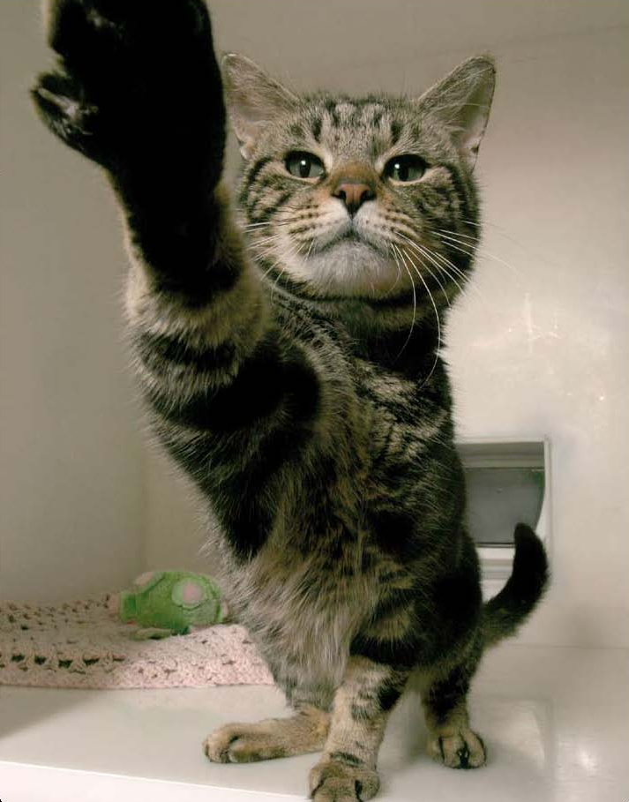

Activity sheet – Animals

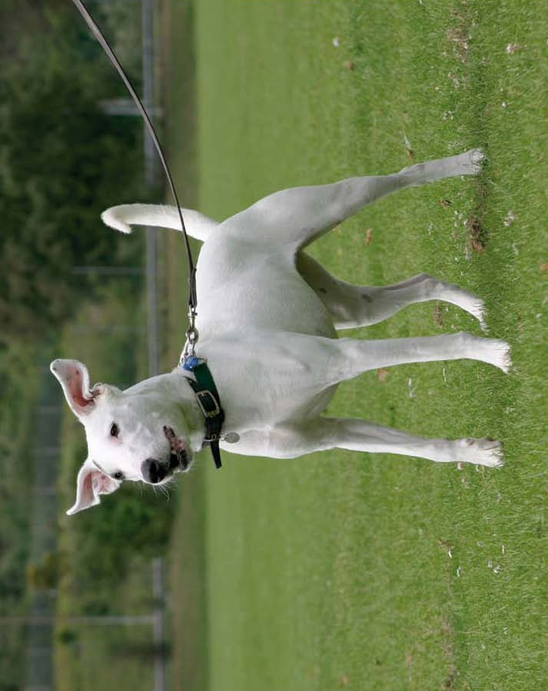
©Andrew Forsyth/RSPCA Photolibrary
Activity sheet – Animals

©Andrew Forsyth/RSPCA Photolibrary
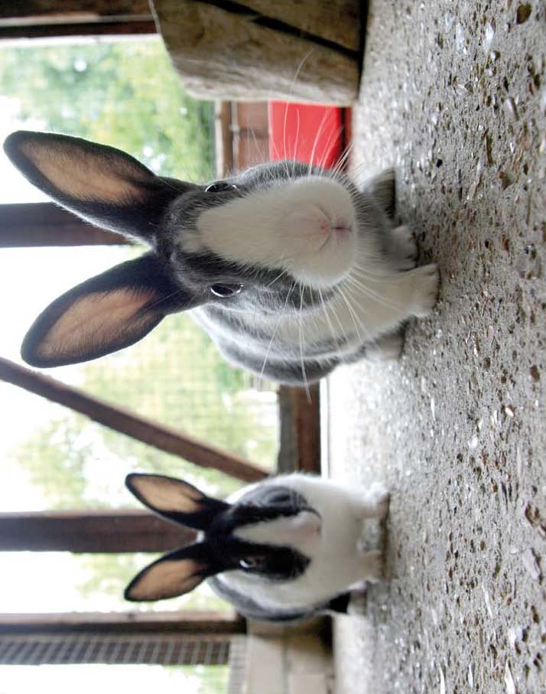
Activity sheet – Animals

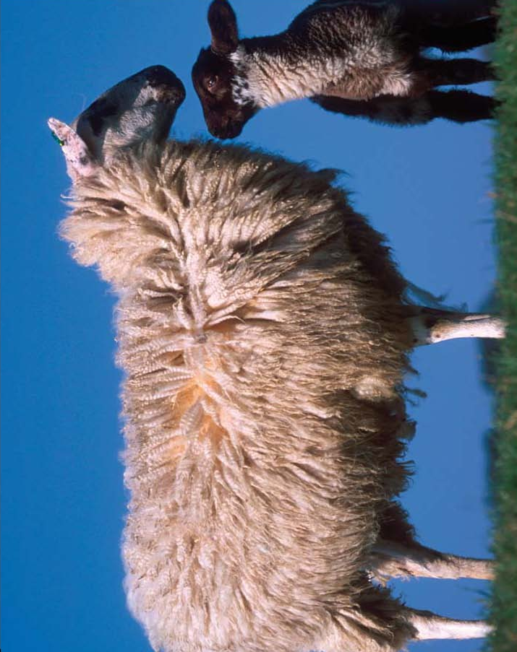
©Andrew Forsyth/RSPCA Photolibrary
Activity sheet – Animals

©Andrew Forsyth/RSPCA Photolibrary
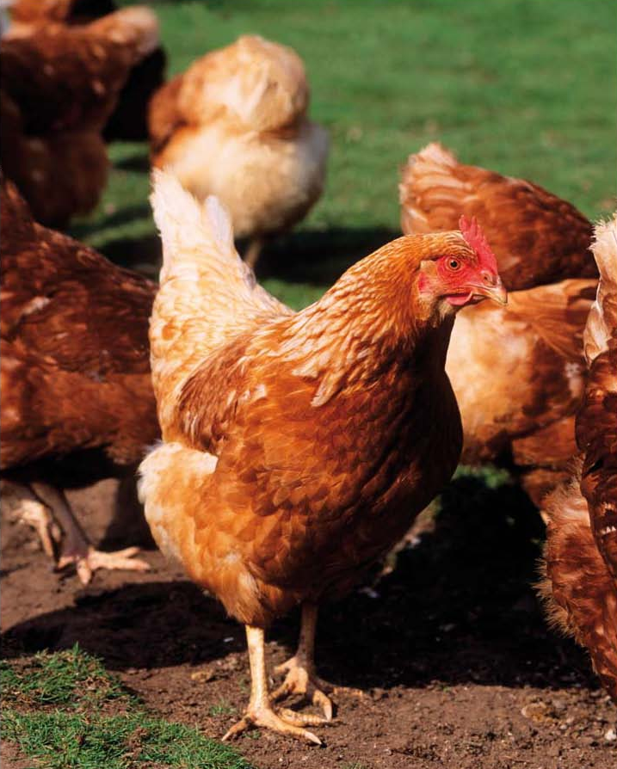
Activity sheet – Animals

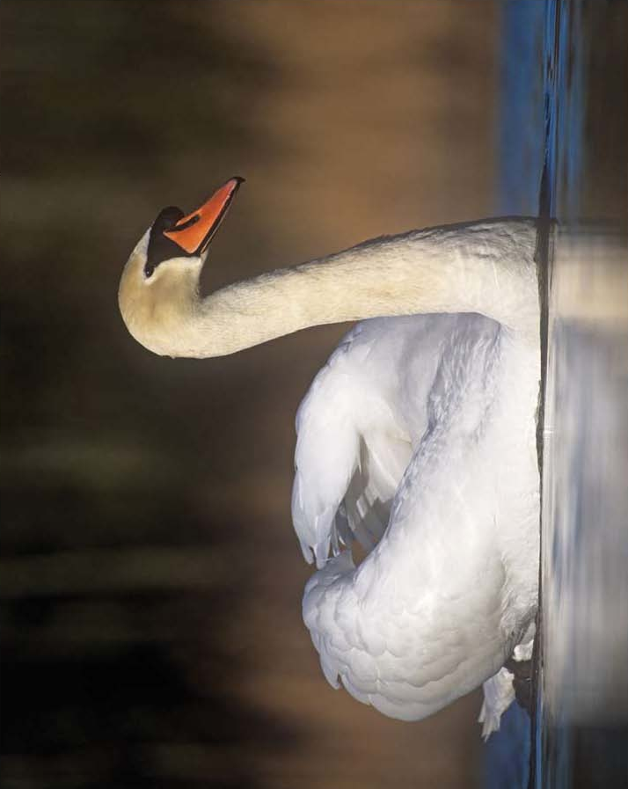
©Andrew Forsyth/RSPCA Photolibrary

Activity sheet – Animals
©Andrew Forsyth/RSPCA Photolibrary
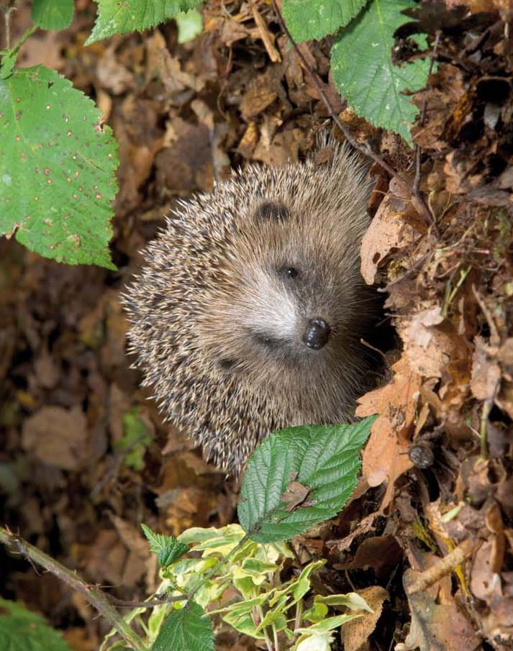
Activity sheet – What we need (1)

Food | 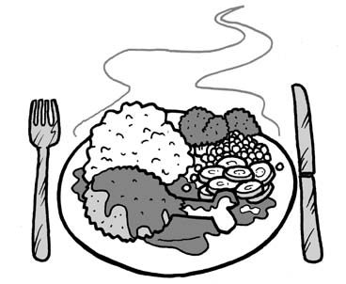
Water | 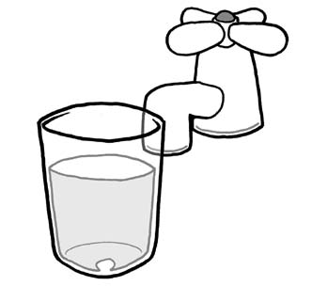
Love and care | 
Exercise | 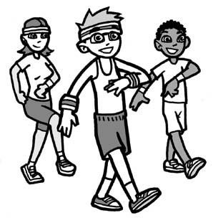

Activity sheet – What we need (2)

Somewhere to live | 
Medical care | 
Friends | 

Activity sheet – The five freedoms
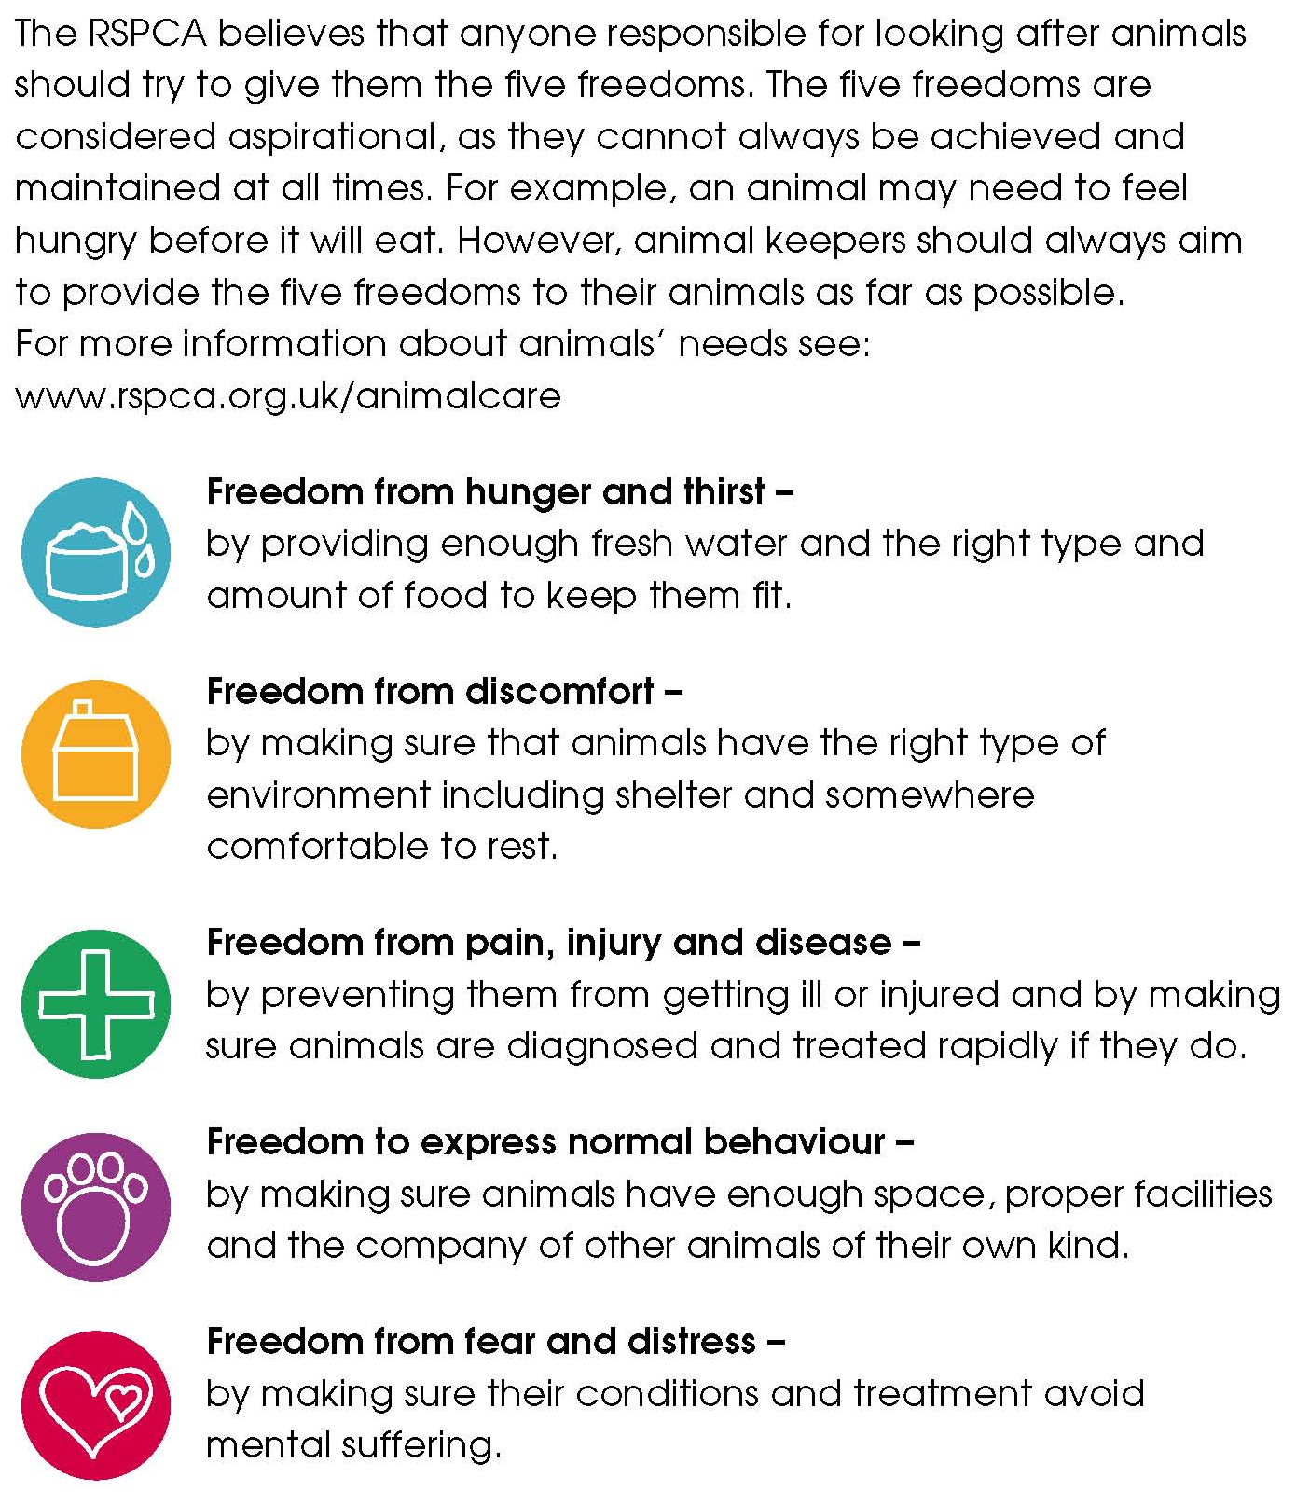

Activity sheet – Remembering the five freedoms (1)
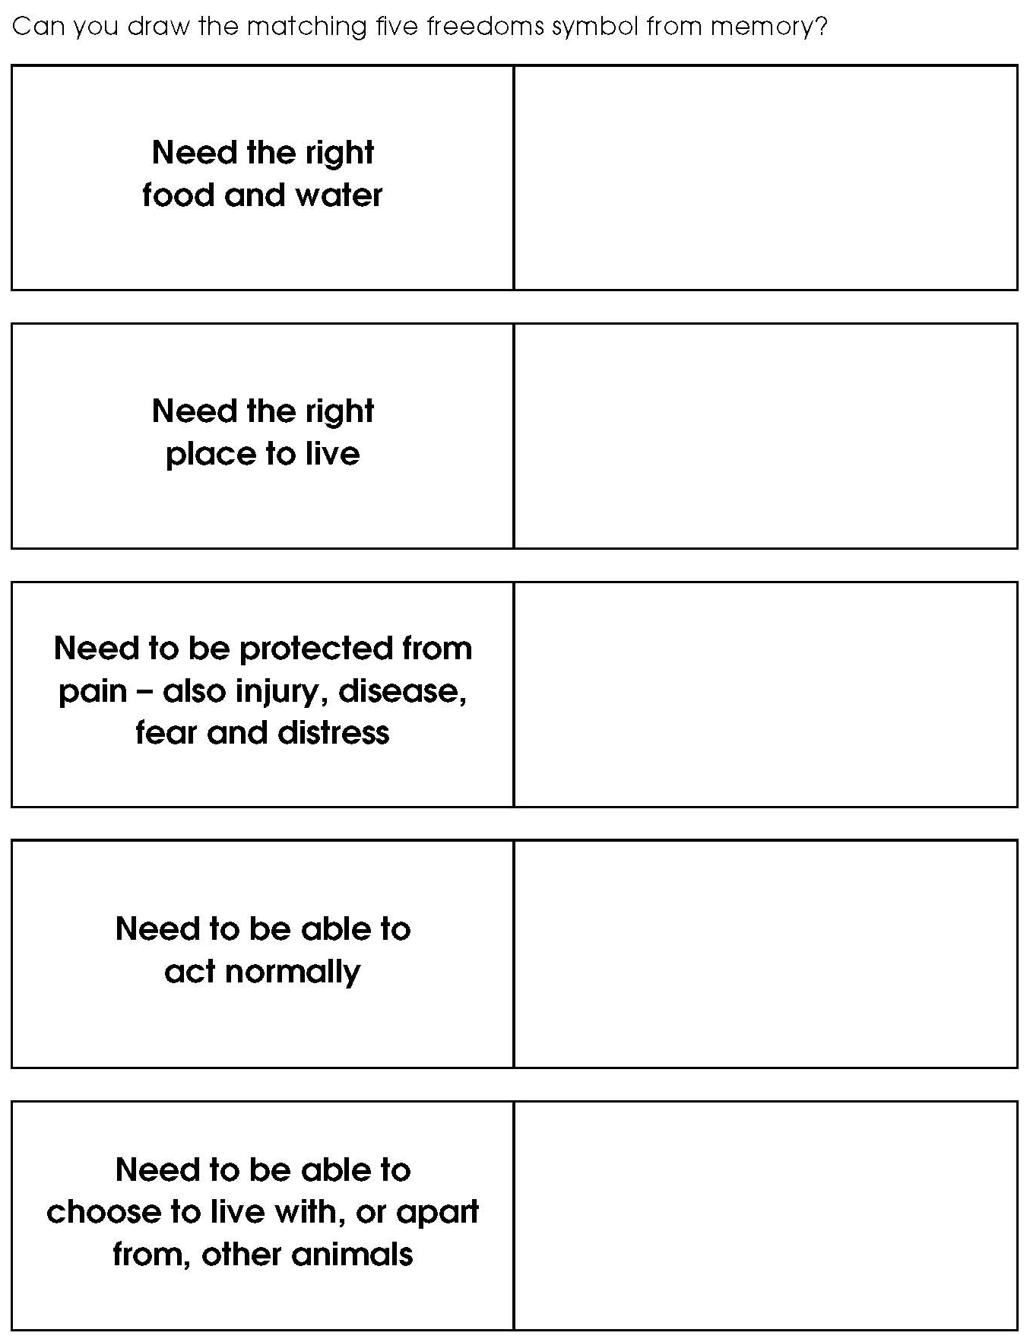
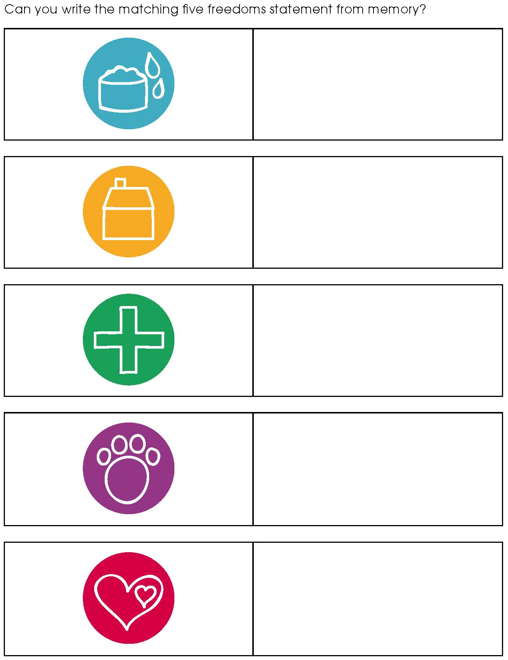
Activity sheet – Remembering the five freedoms (2)

Factsheet – The five freedoms
Factsheet – Remembering the five freedoms (answers)

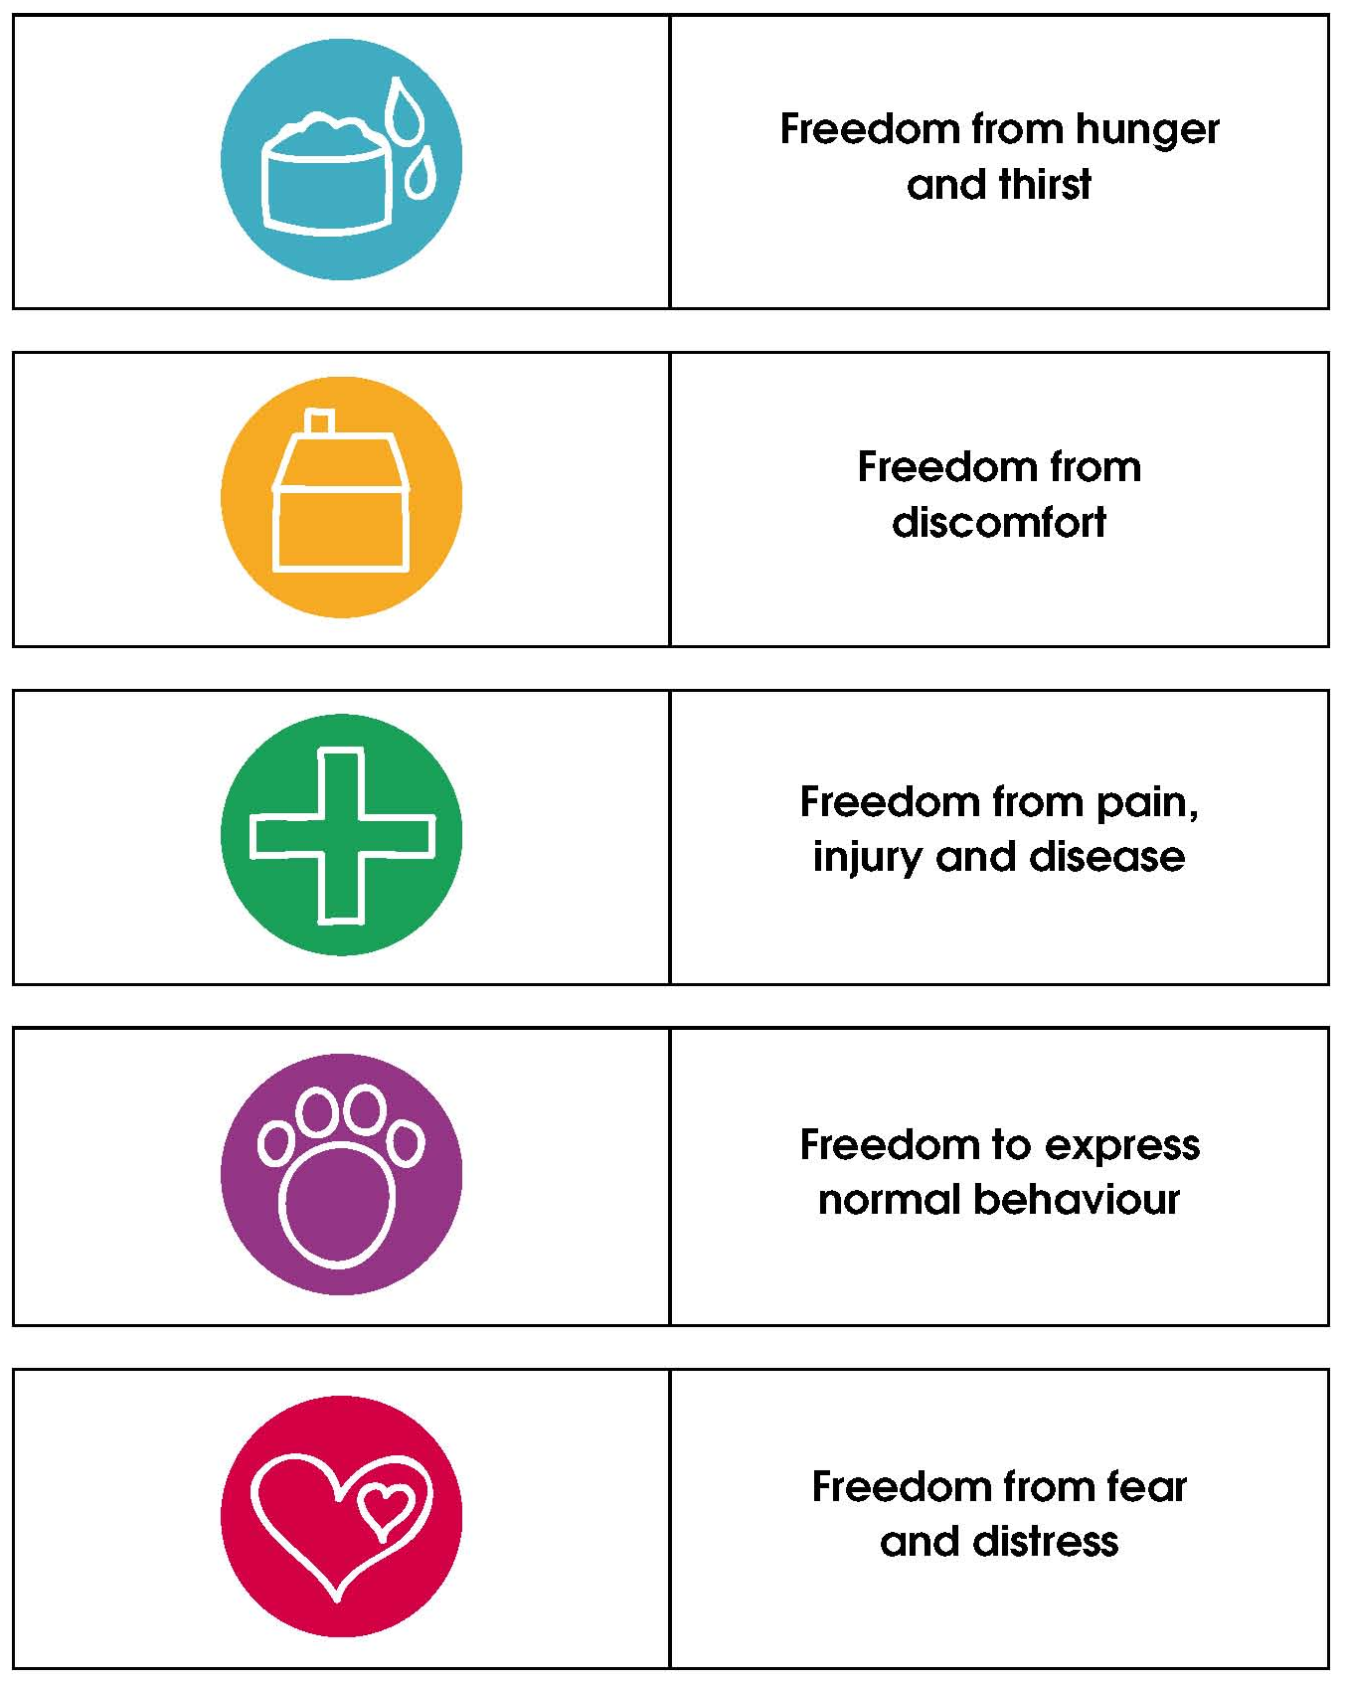

Facilitators notes – Animals’ basic needs: Cats (1)

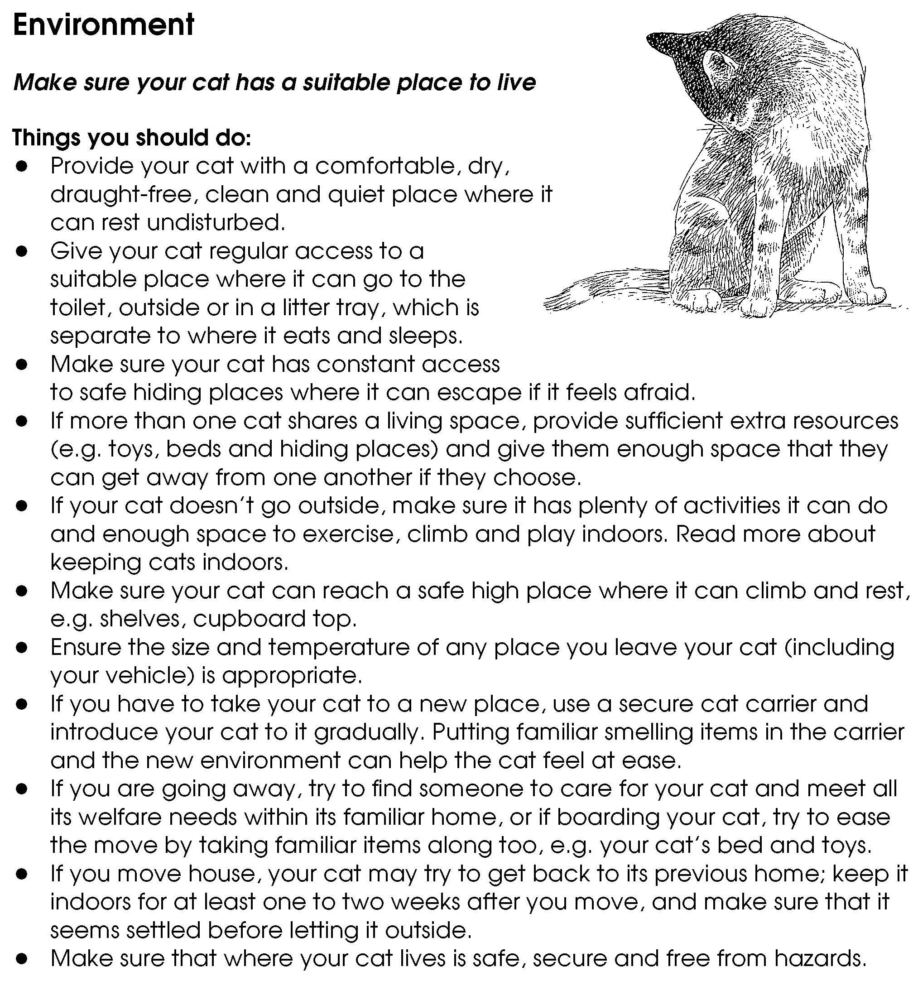

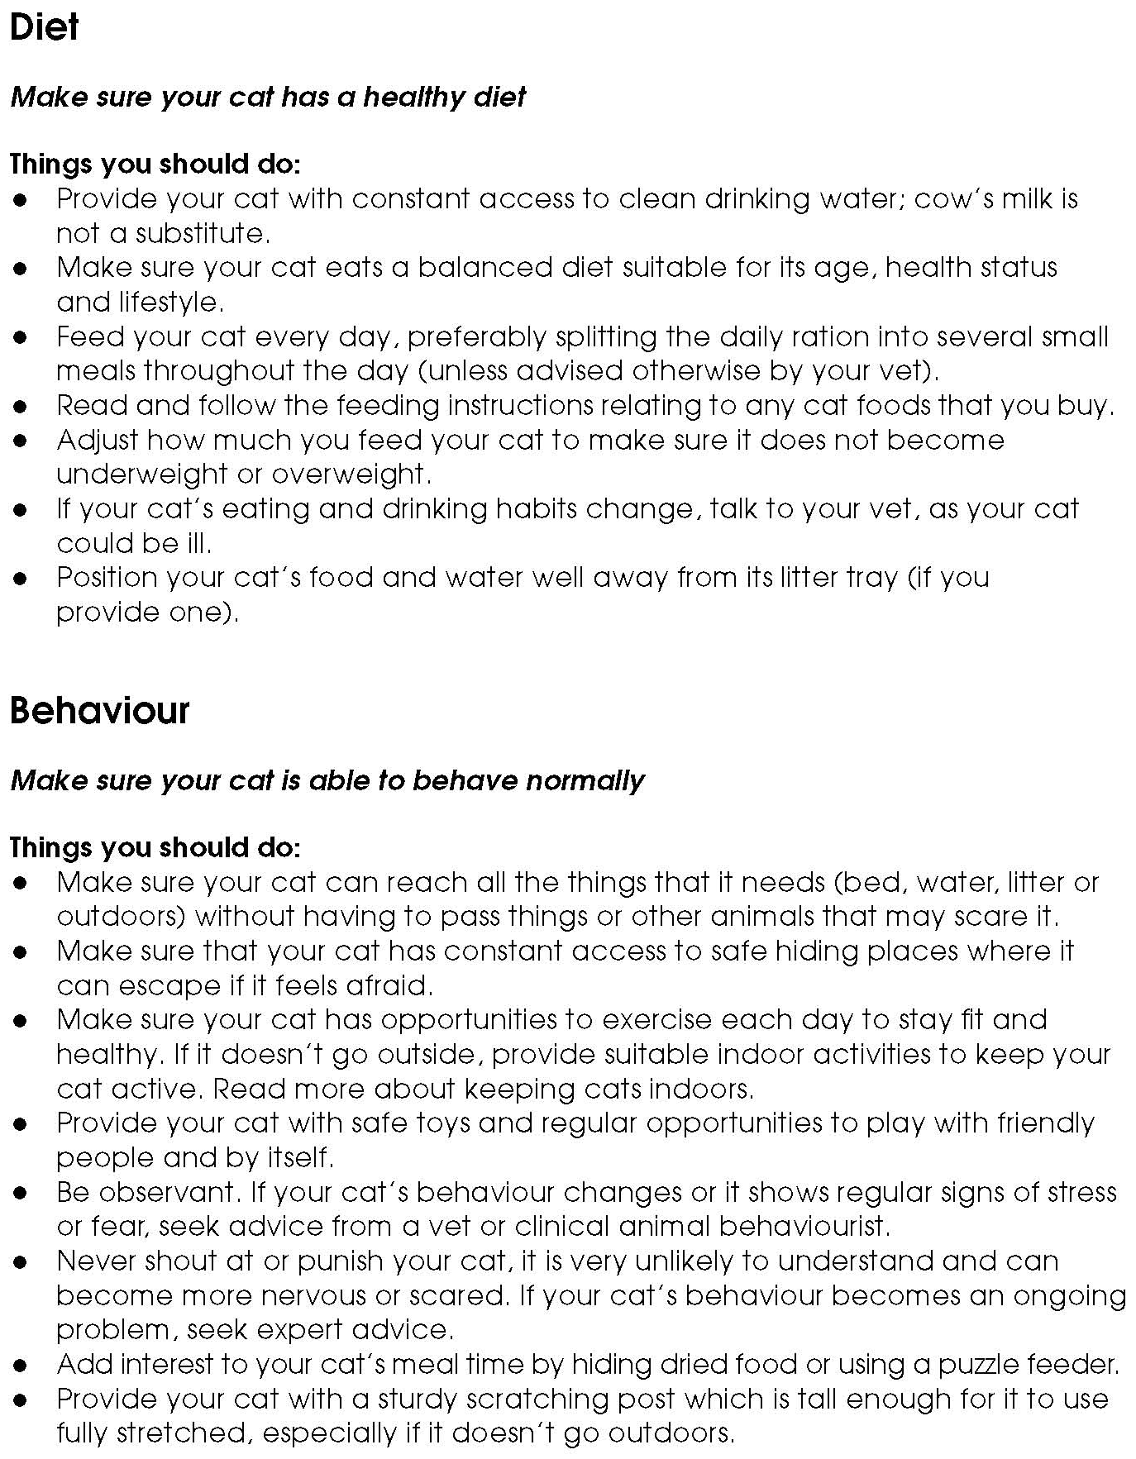
Facilitators notes – Animals’ basic needs: Cats (2)

Facilitators notes – Animals’ basic needs: Cats (3)
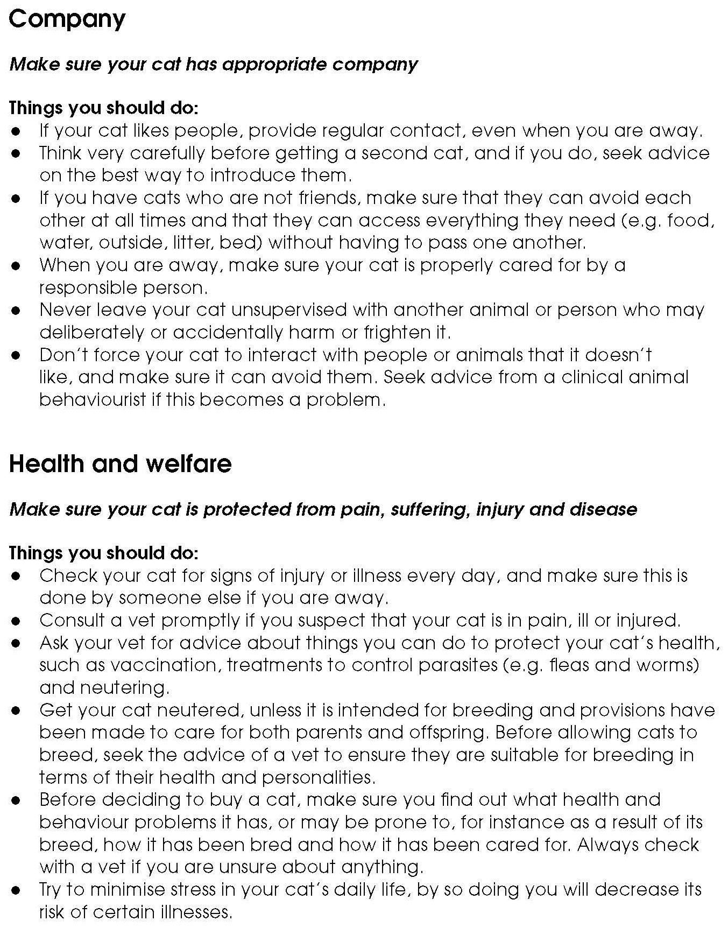

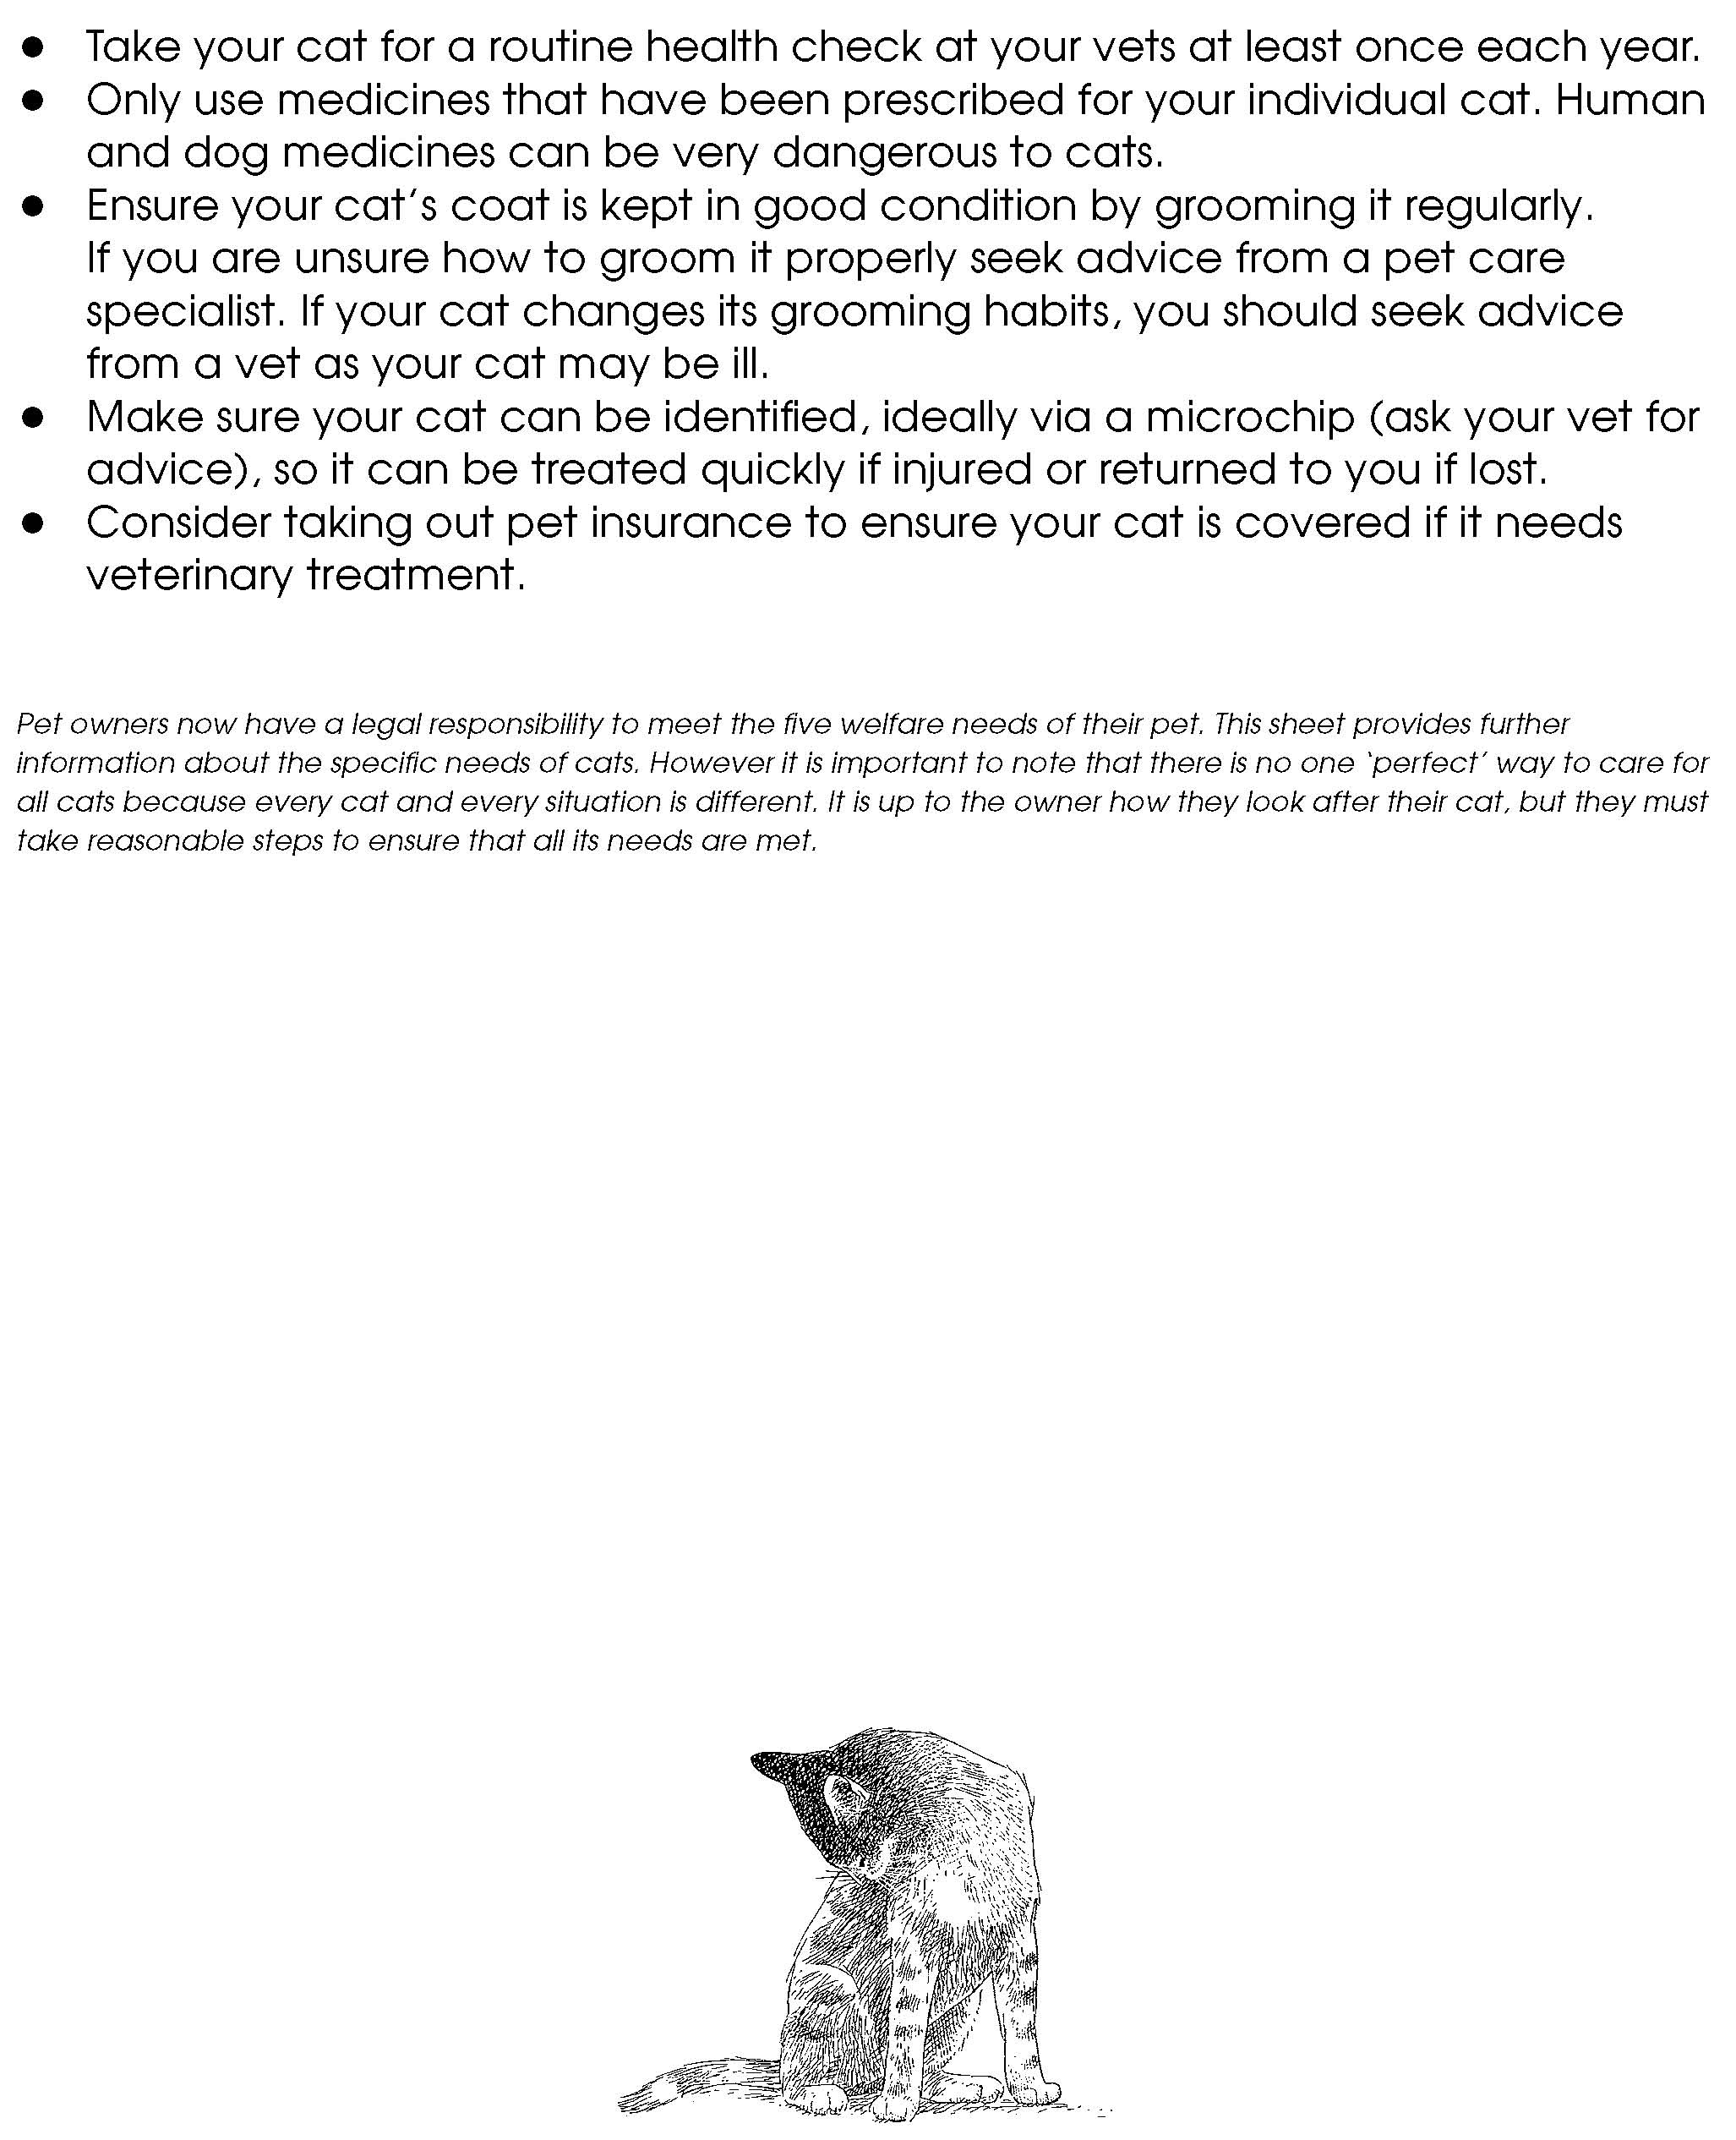
Facilitators notes – Animals’ basic needs: Cats (3)

Facilitators notes – Animals’ basic needs: Hedgehogs (1)

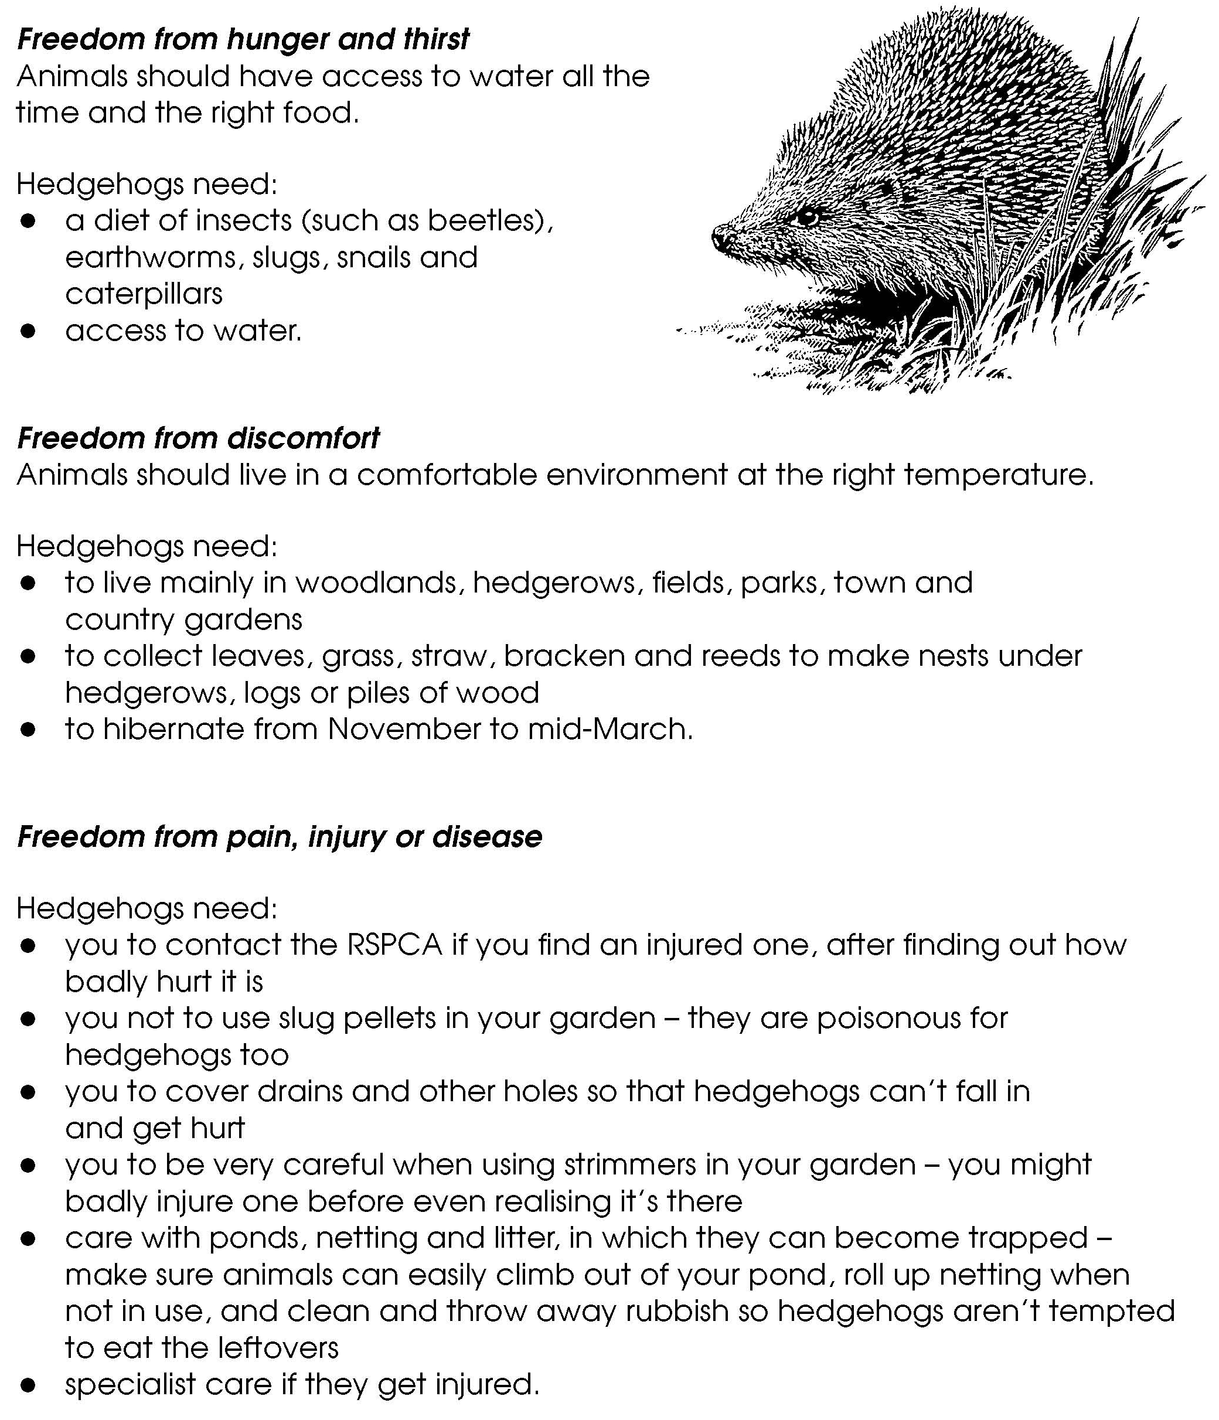

Facilitators notes – Animals’ basic needs: Hedgehogs (2)

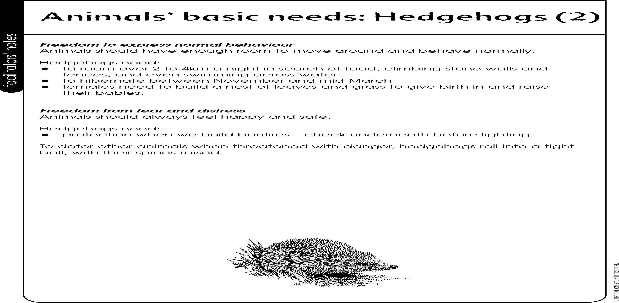
Facilitators notes – Animals’ basic needs: Dogs (1)

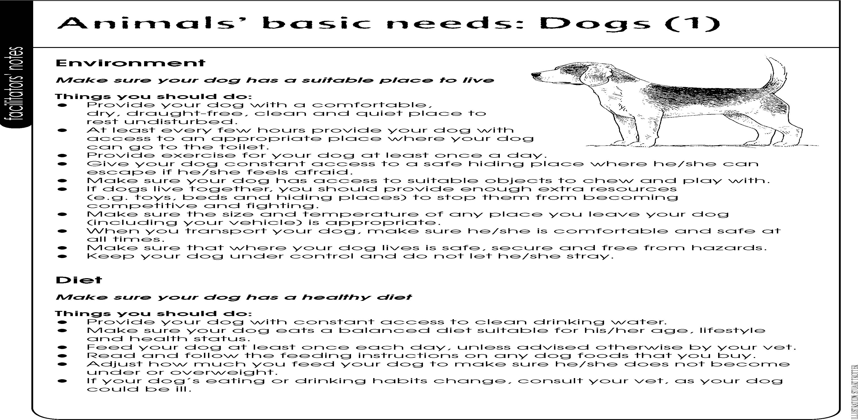

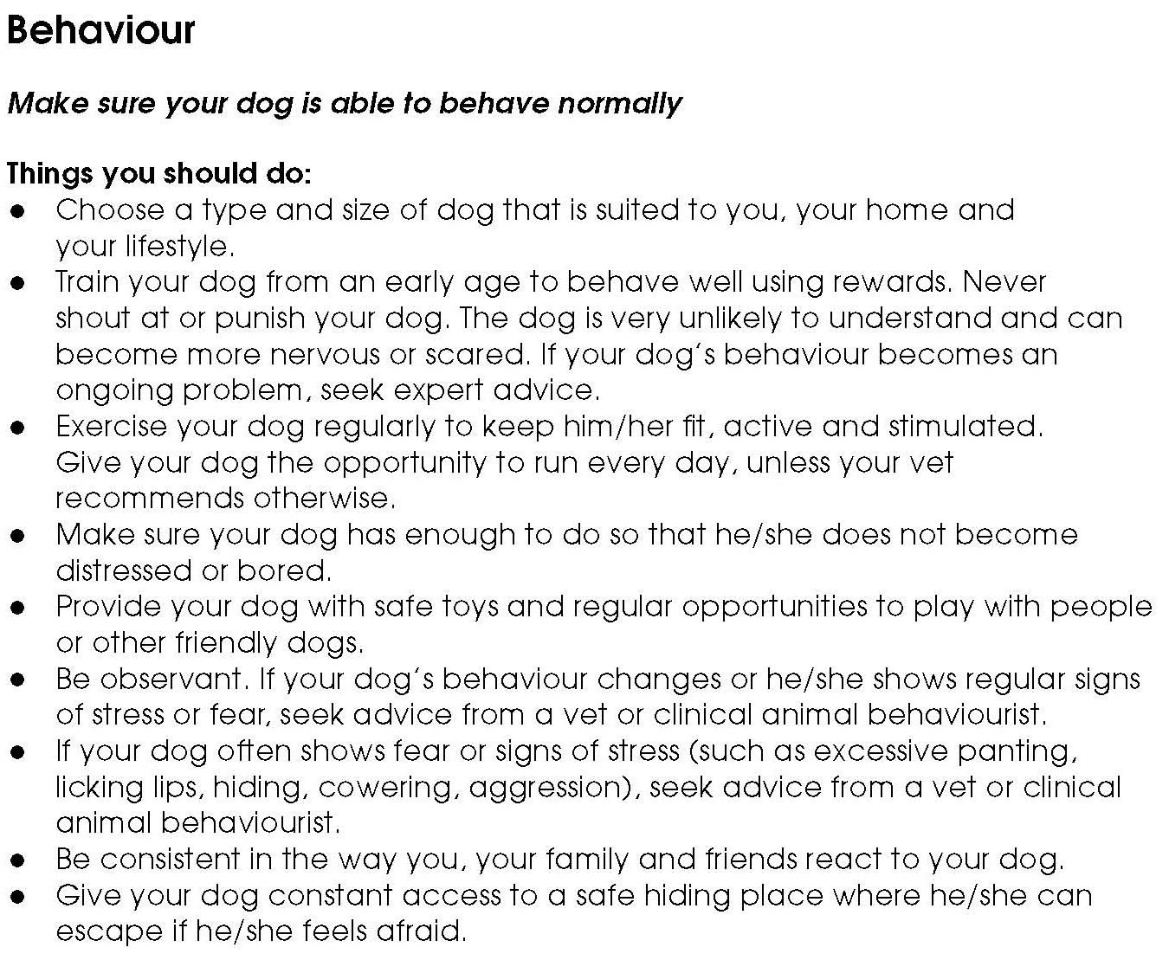
Facilitators notes – Animals’ basic needs: Dogs (2)

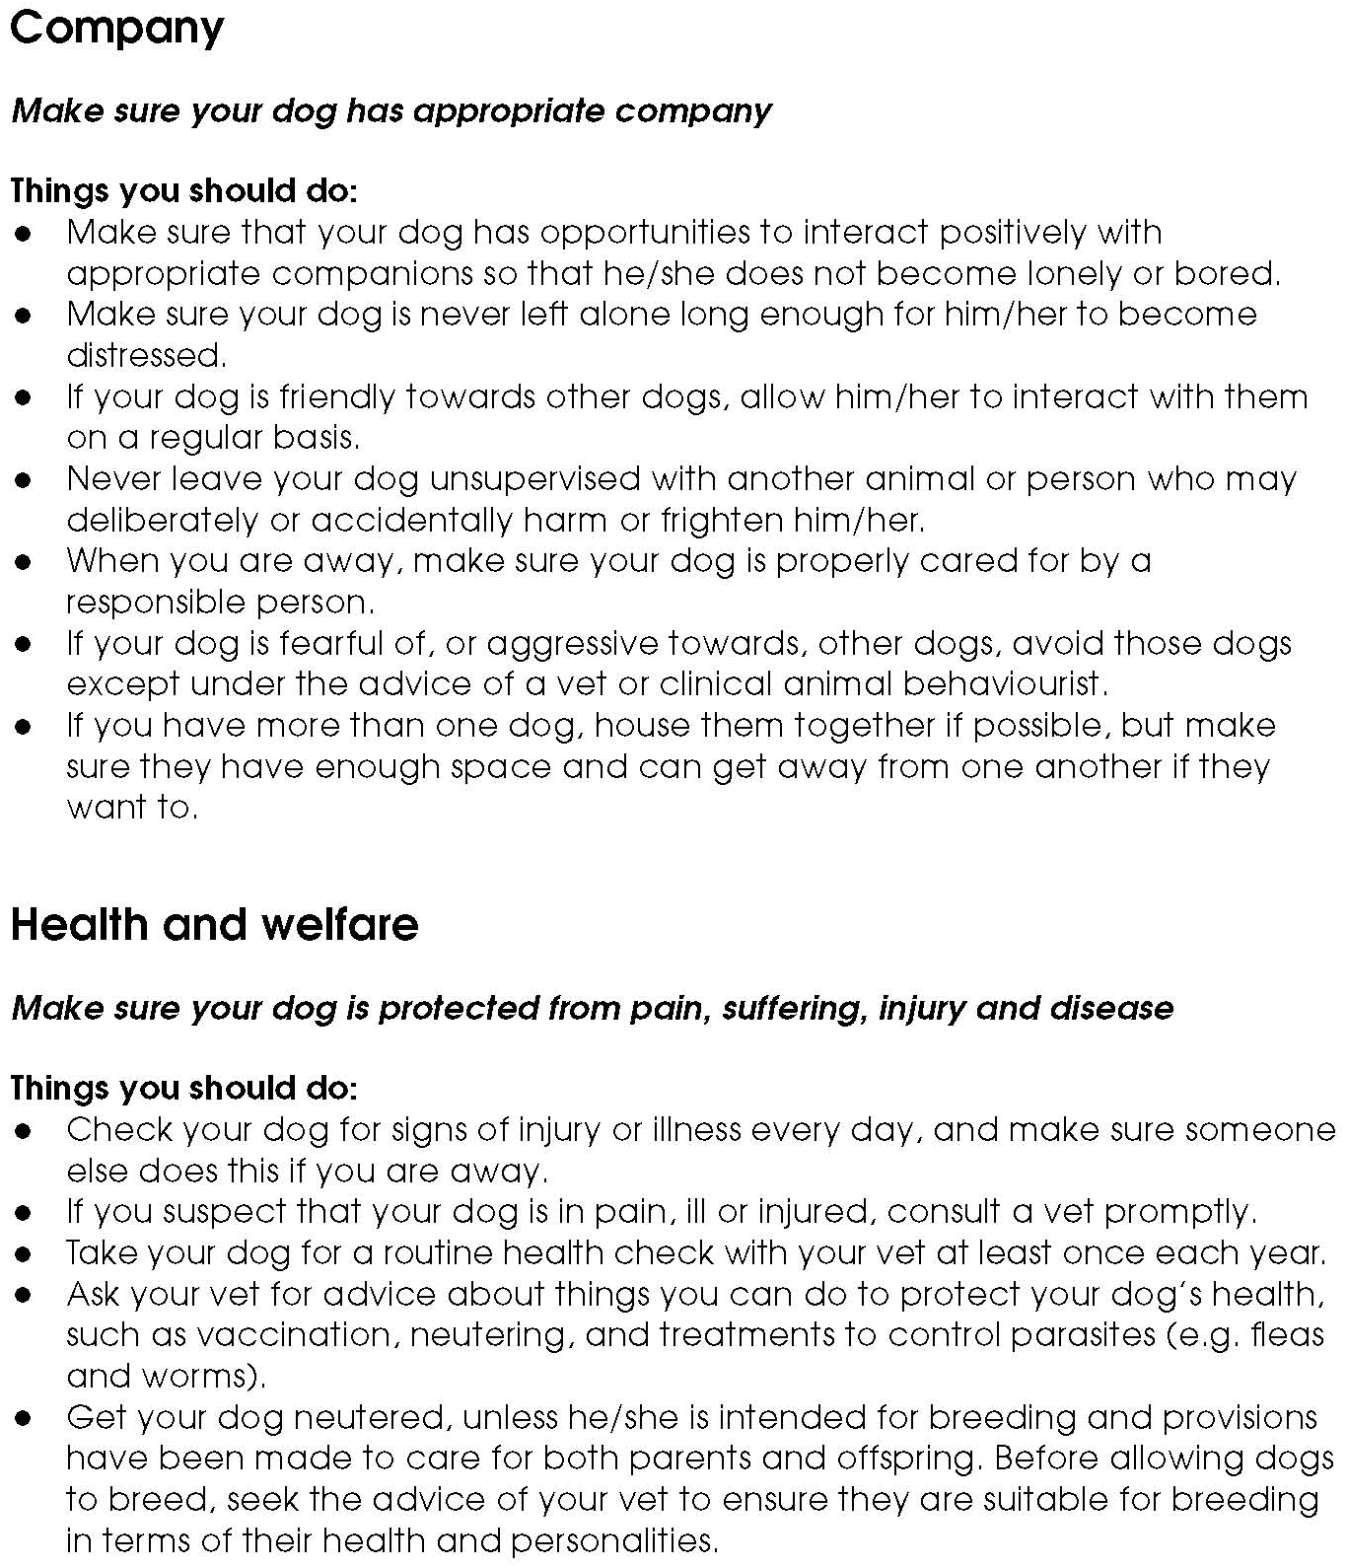
Facilitators notes – Animals’ basic needs: Dogs (3)

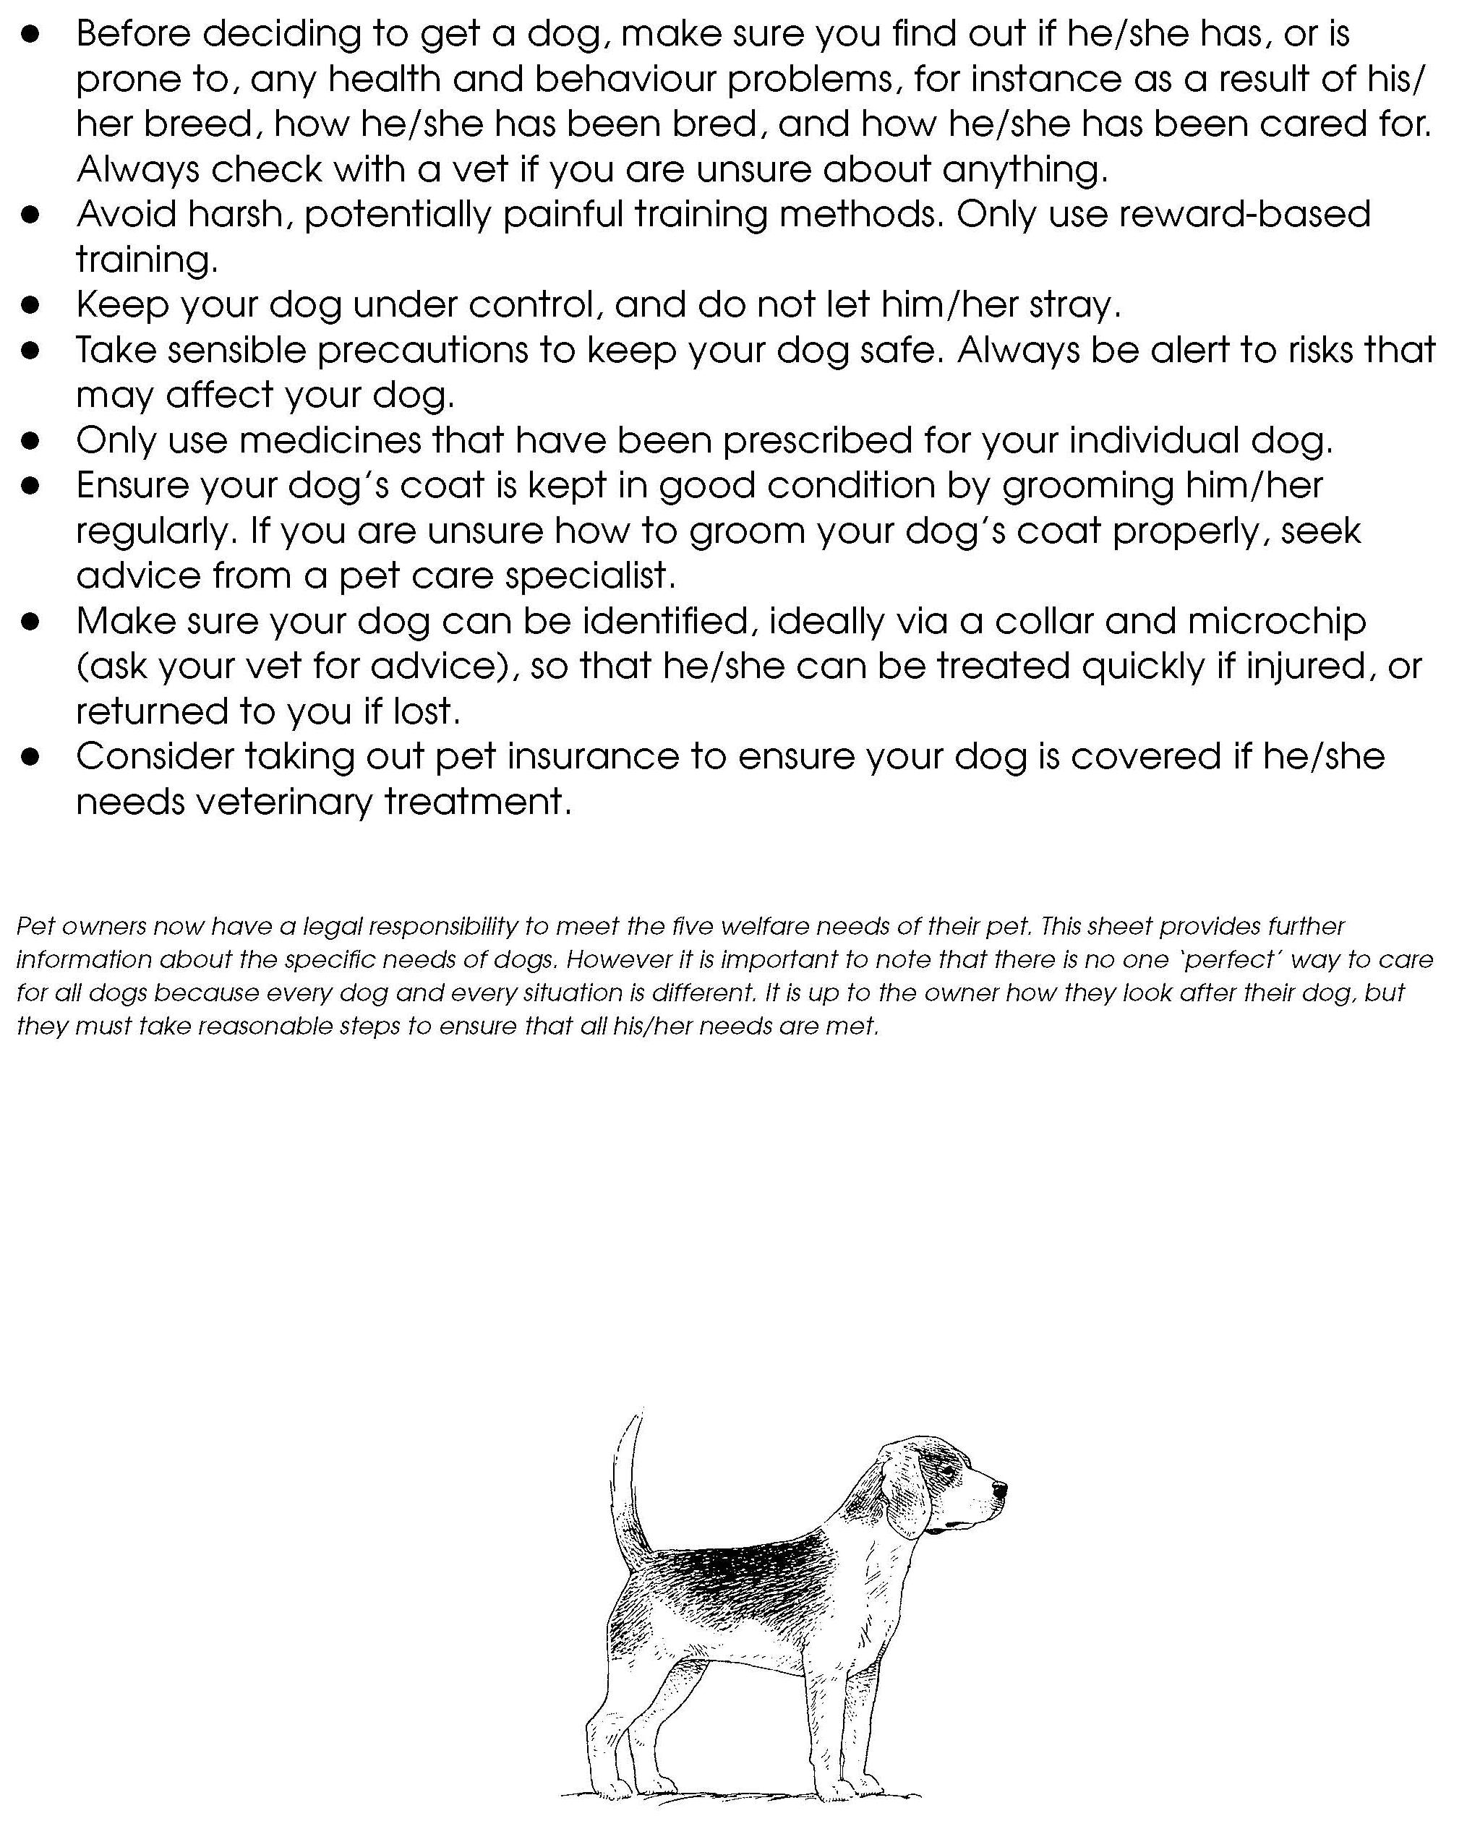
Facilitators notes – Animals’ basic needs: Dogs (4)

Facilitators notes – Animals’ basic needs: Laying hens (1)

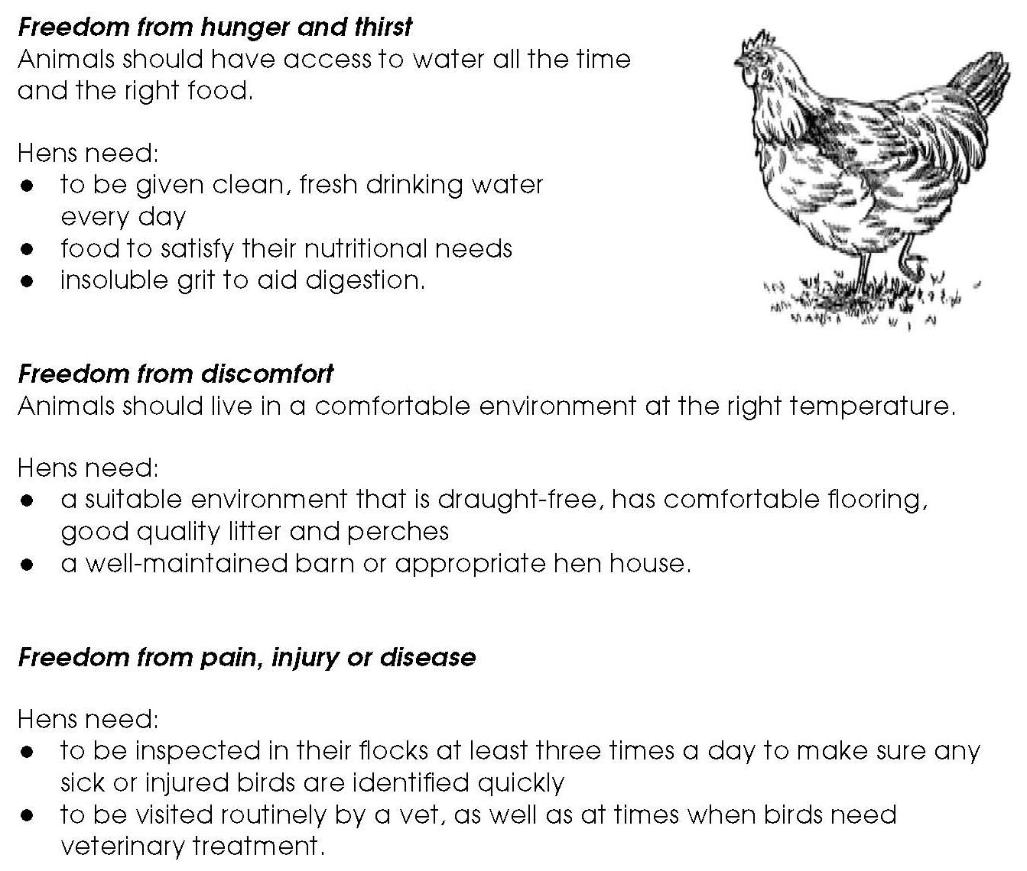

Facilitators notes – Animals’ basic needs: Laying hens (2)

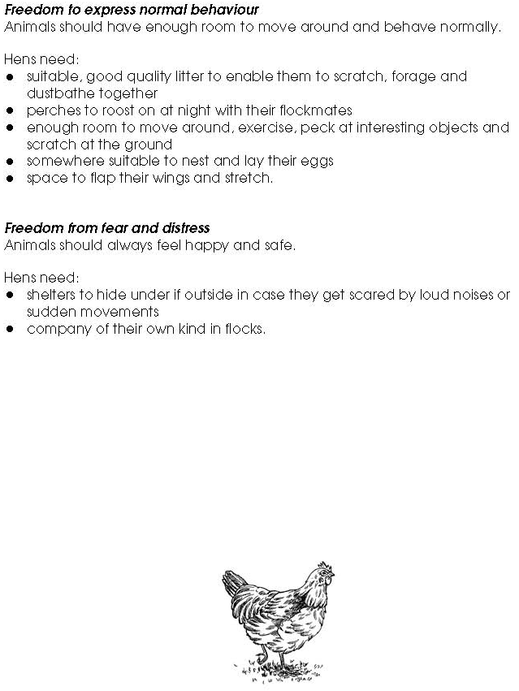

Facilitators notes – Animals’ basic needs: Sheep (1)

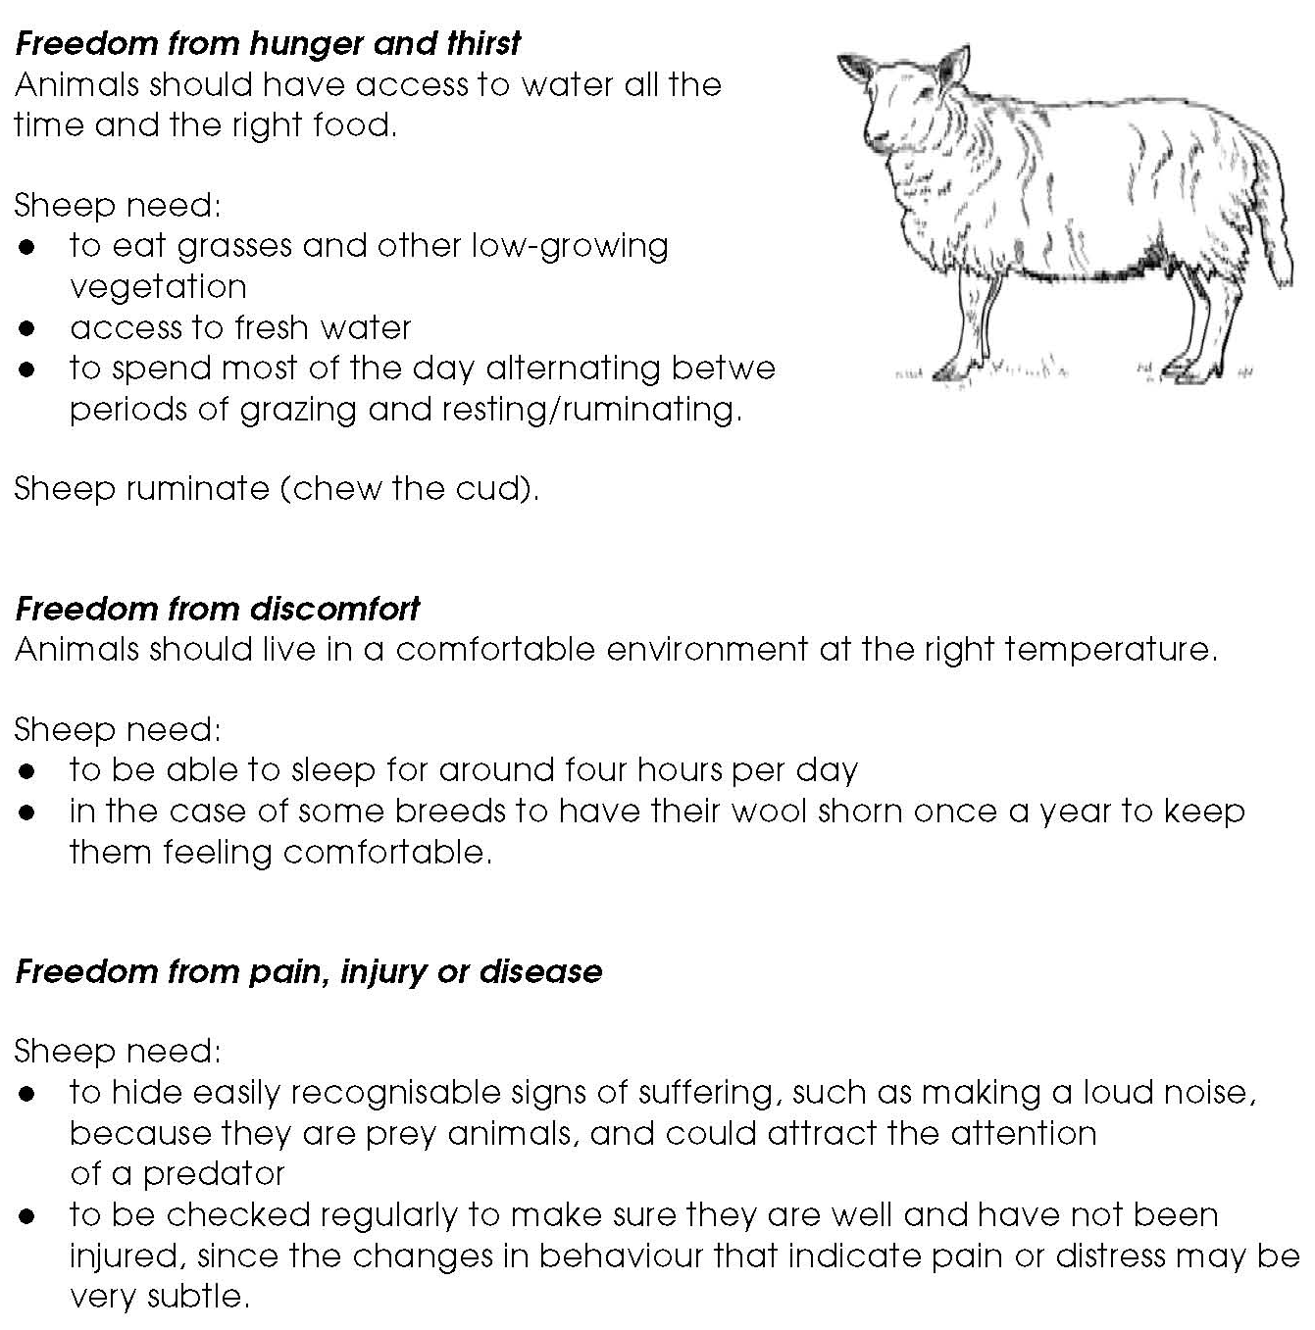

Facilitators notes – Animals’ basic needs: Sheep (2)

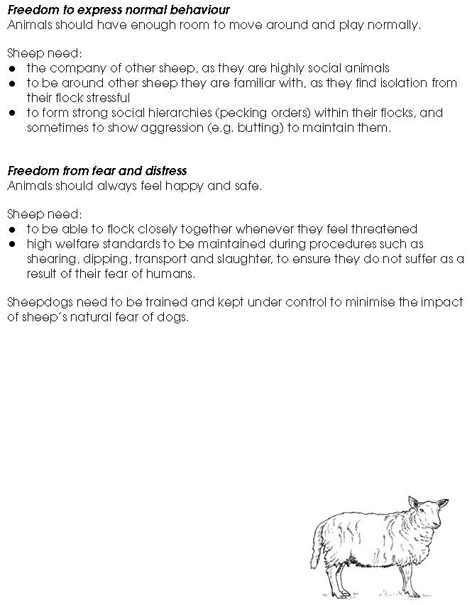
Facilitators notes – Animals’ basic needs: Swans (1)

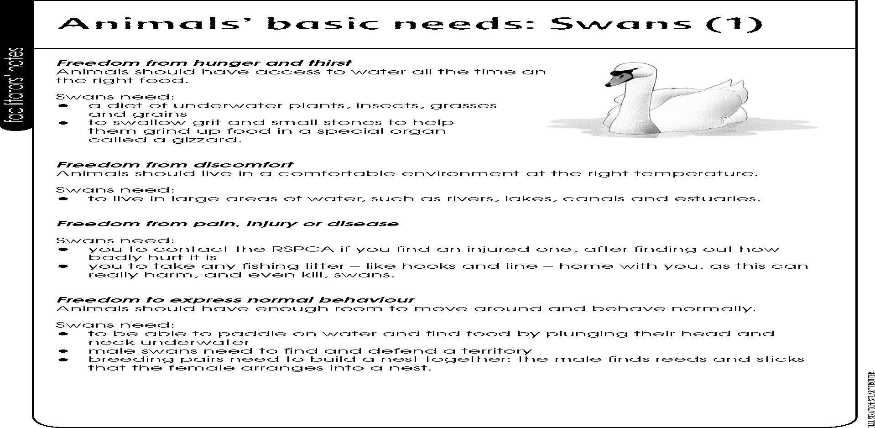

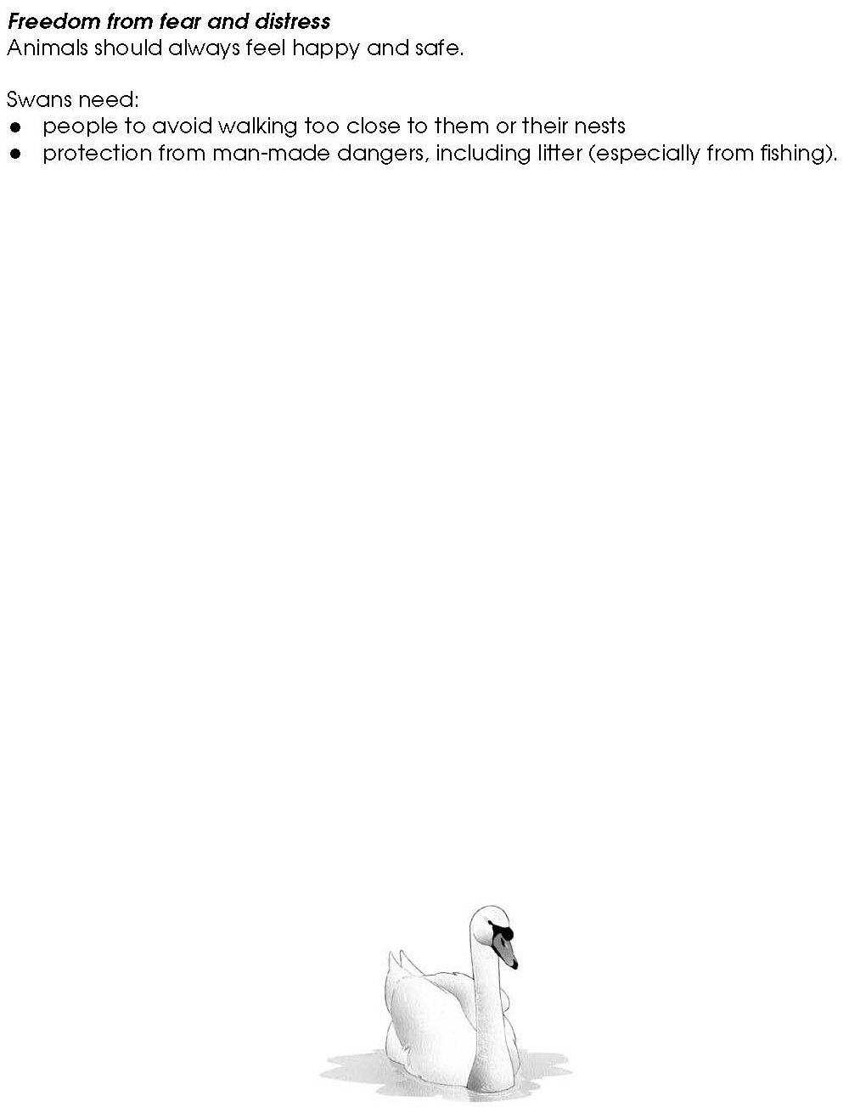
Facilitators notes – Animals’ basic needs: Swans (1)

Facilitators notes – Animals’ basic needs: Rabbits (1)

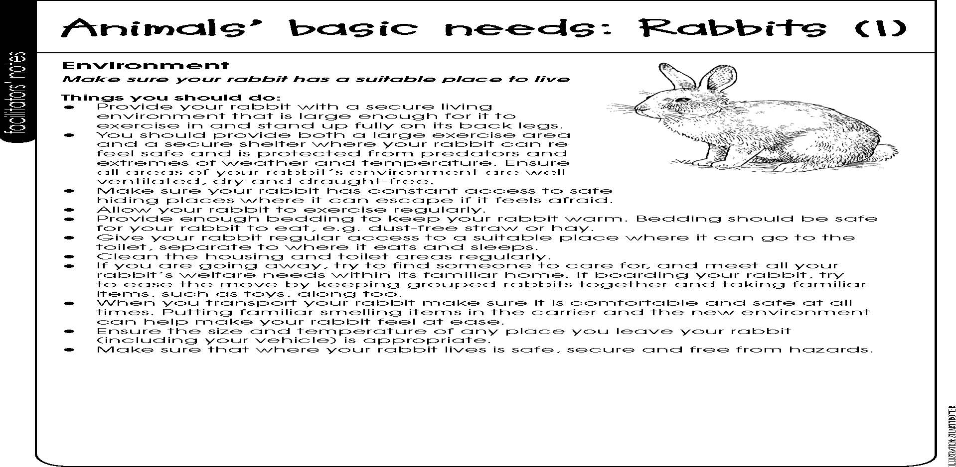

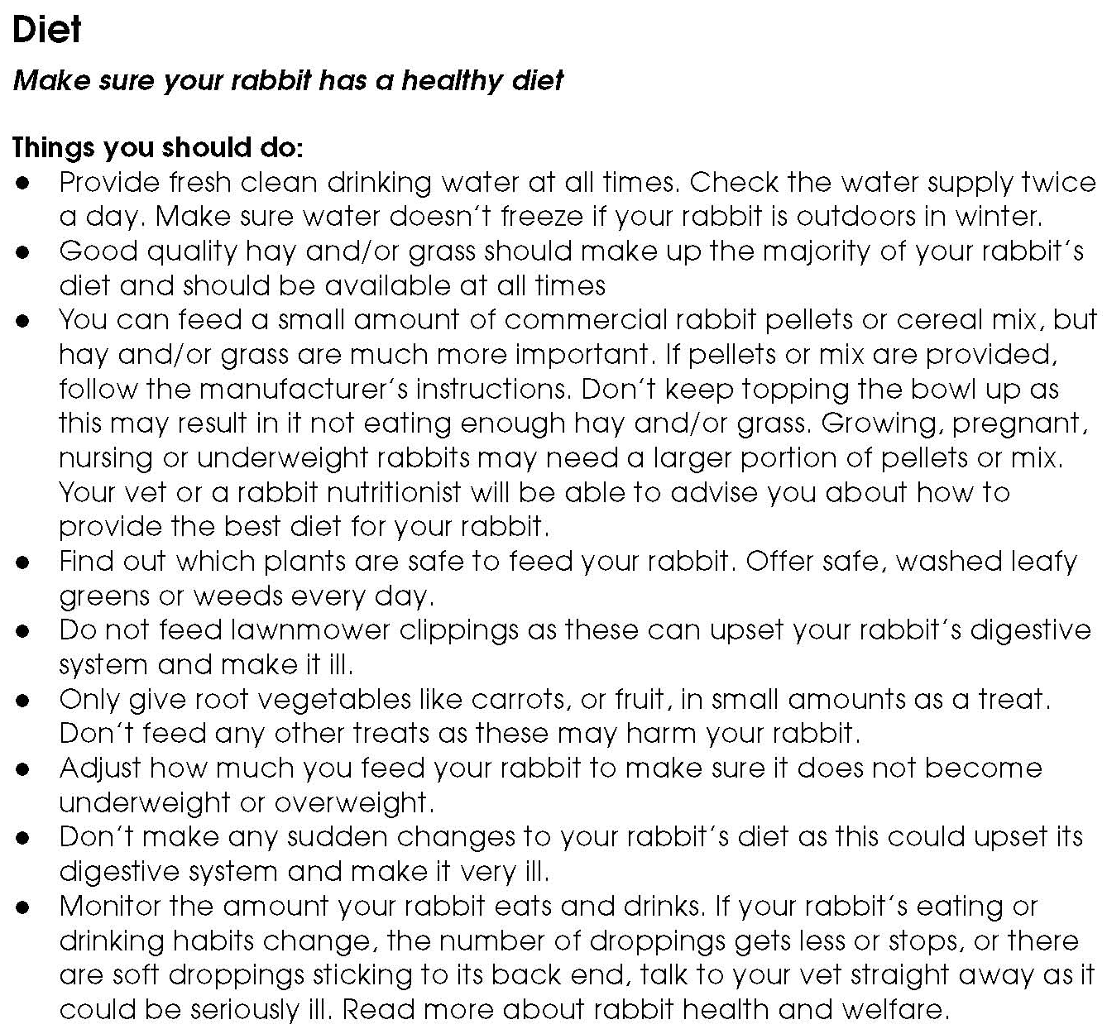
Facilitators notes – Animals’ basic needs: Rabbits (2)

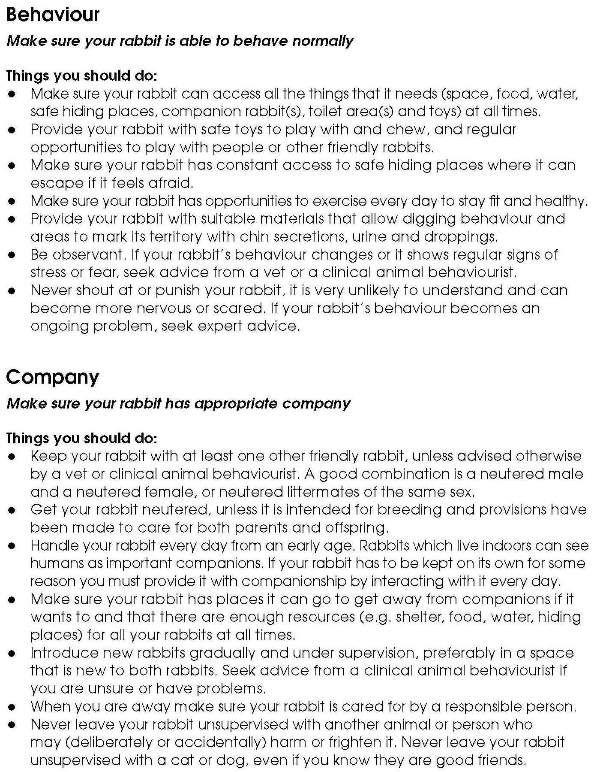
Facilitators notes – Animals’ basic needs: Rabbits (3)
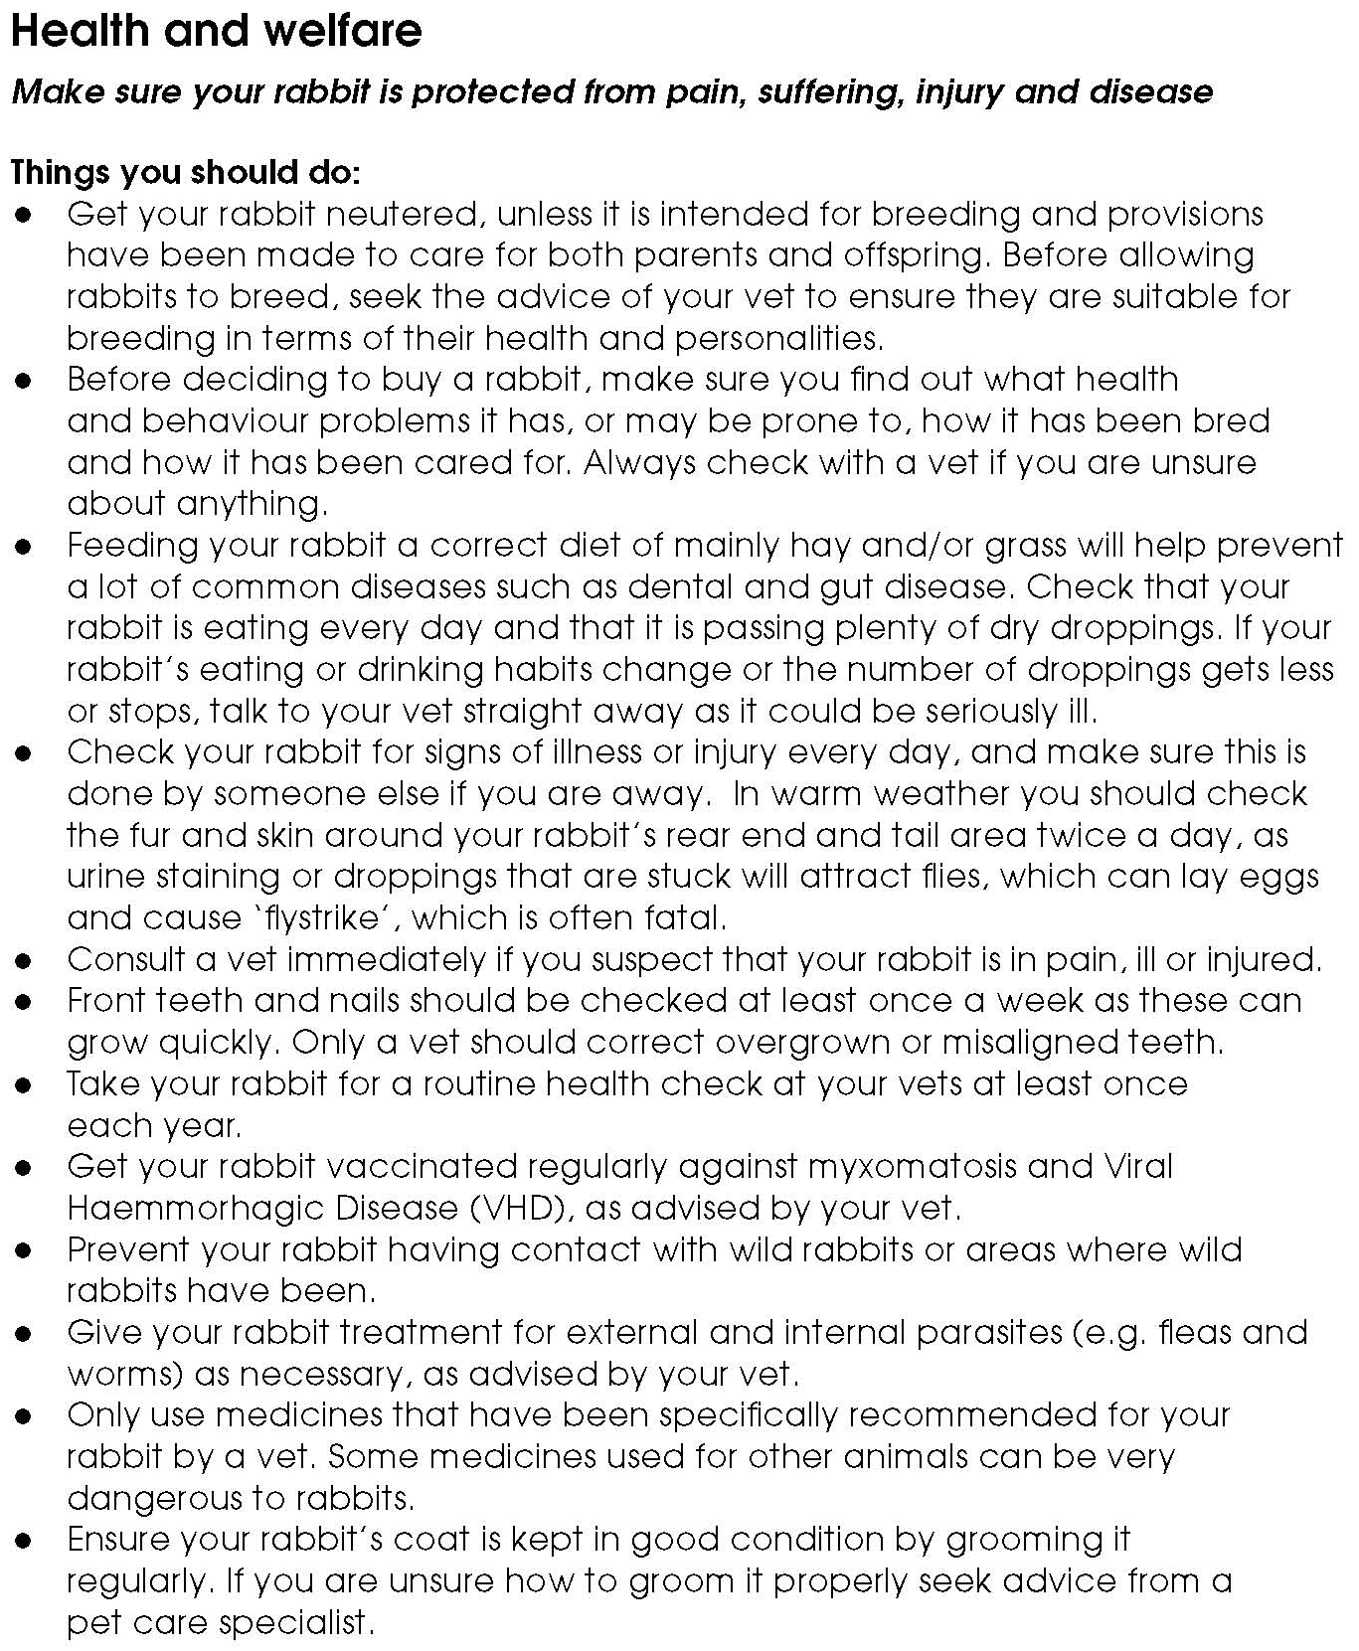
Facilitators notes – Animals’ basic needs: Rabbits (4)

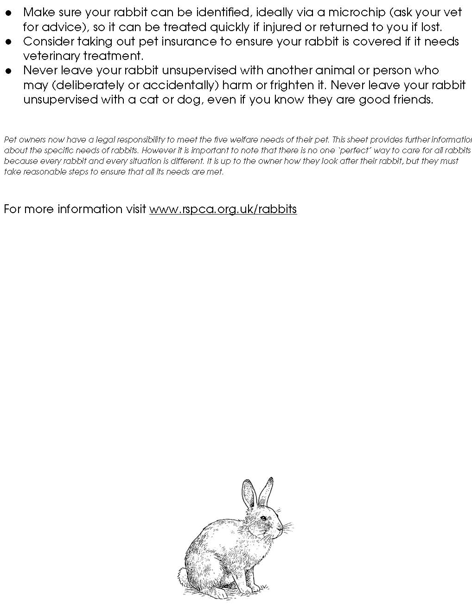
Facilitators notes – Animals’ basic needs: Rabbits (5)

