Ethics of extreme breeding

Instructions

- Read each statement and fill in what you think are the correct missing words from the word bank below.
Word bank: coat, nostrils, tail, cropped, stomach, protruding, wrinkles, ears, temperature
  - Small or closed _______ can severely impact airflow and affect a dog’s ability to exercise, regulate temperature, and sleep comfortably.
  - A _______ snout helps a dog breathe properly.
  - Rats use their tails for regulating their _________ but sadly some rats are bred to have no tail.
  - Excessive skin and _______ around the face can lead to skin problems including infections.
  - Forward folding ______ on a cat are associated with a painful condition which affects their bones and cartilage.
  - Ears should never be _______ unless medically necessary.
  - A cat's _______ is important for protecting the skin from ultraviolet rays.
  - A _______ should be able to move freely to communicate emotions and should not be tightly docked.
  - Rabbits with long hair have difficulty grooming themselves. When grooming they may ingest large amounts of hair which can cause a blockage in their ________.

- Look at the below images on the next pages. For each image:
  - Describe the physical features of the animal
  - Then, add ‘yes’ or ‘no’ next to the issues you think the animal may or may not have from the list provided.
  - Then, consider how these health issues might affect the animal’s behaviour. Write notes on the potential behavioural issues, such as possible signs of discomfort, stress, or frustration.

- Interview three to five people and ask them the below questions. Write a summary of their answers and include some of your own reflections in your summary of findings:
  - What do you think a healthy pet looks like?
  - Would you ever choose a pet with extreme features (e.g., flat-faced dogs)? Why or why not?
  - What problems (health or financial) can arise when animals are bred for extreme physical features?
  - Do you think it is OK to breed pets with extreme features that compromise their health?
  - What changes do you think would encourage people to choose breeds based on health and welfare rather than extreme features?

Images

Image one
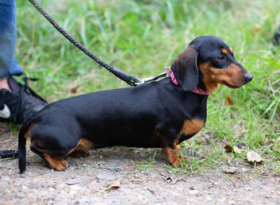
- Physical features:

- Skin sores [Yes/No]
- Difficulty walking [Y/N]
- Spinal conditions [Y/N]
- Joint pain [Y/N]
- Breathing difficulties [Y/N]
- Eye ulcers and infections [Y/N]
- Ear disease [Y/N]
- Dental problems [Y/N]
- Potential behavioural issues:

Image two
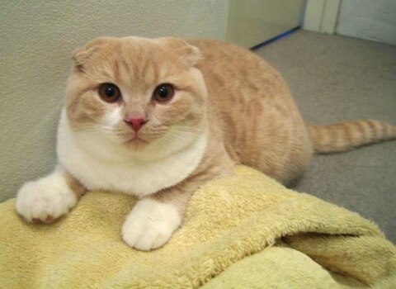
- Physical features:

- Skin sores [Yes/No]
- Difficulty walking [Y/N]
- Spinal conditions [Y/N]
- Joint pain [Y/N]
- Breathing difficulties [Y/N]
- Eye ulcers and infections [Y/N]
- Ear disease [Y/N]
- Dental problems [Y/N]
- Potential behavioural issues:

Image three
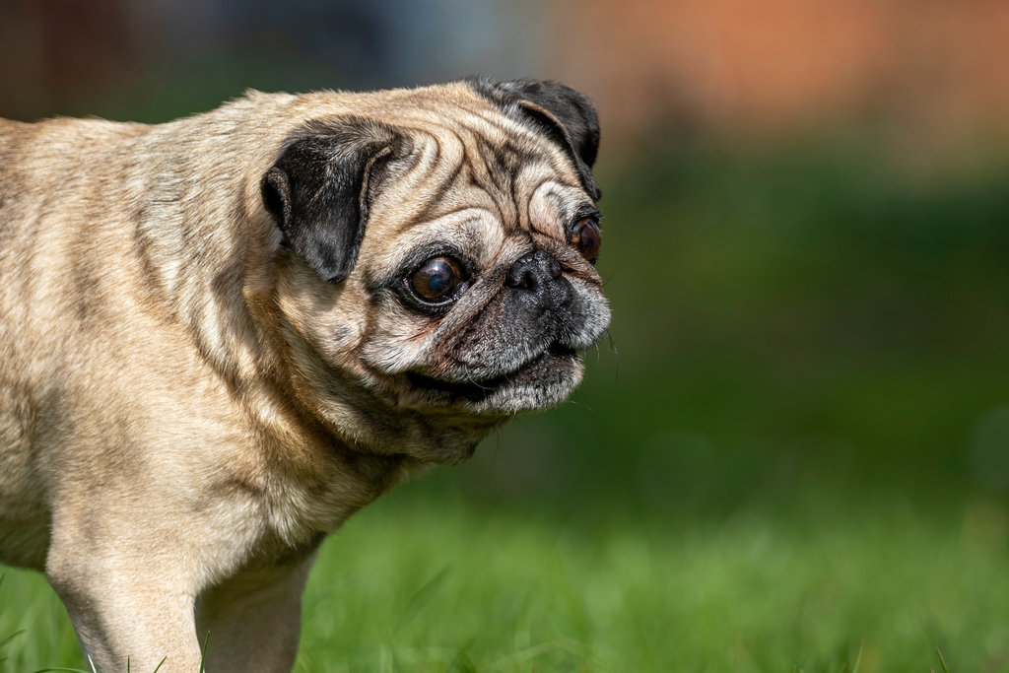
- Physical features:

- Skin sores [Yes/No]
- Difficulty walking [Y/N]
- Spinal conditions [Y/N]
- Joint pain [Y/N]
- Breathing difficulties [Y/N]
- Eye ulcers and infections [Y/N]
- Ear disease [Y/N]
- Dental problems [Y/N]
- Potential behavioural issues:

Image four
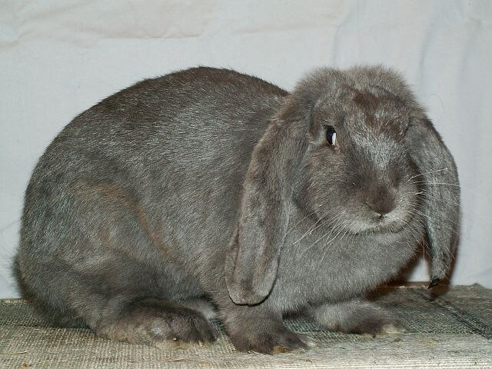
- Physical features:

- Skin sores [Yes/No]
- Difficulty walking [Y/N]
- Spinal conditions [Y/N]
- Joint pain [Y/N]
- Breathing difficulties [Y/N]
- Eye ulcers and infections [Y/N]
- Ear disease [Y/N]
- Dental problems [Y/N]
- Potential behavioural issues:

Image five
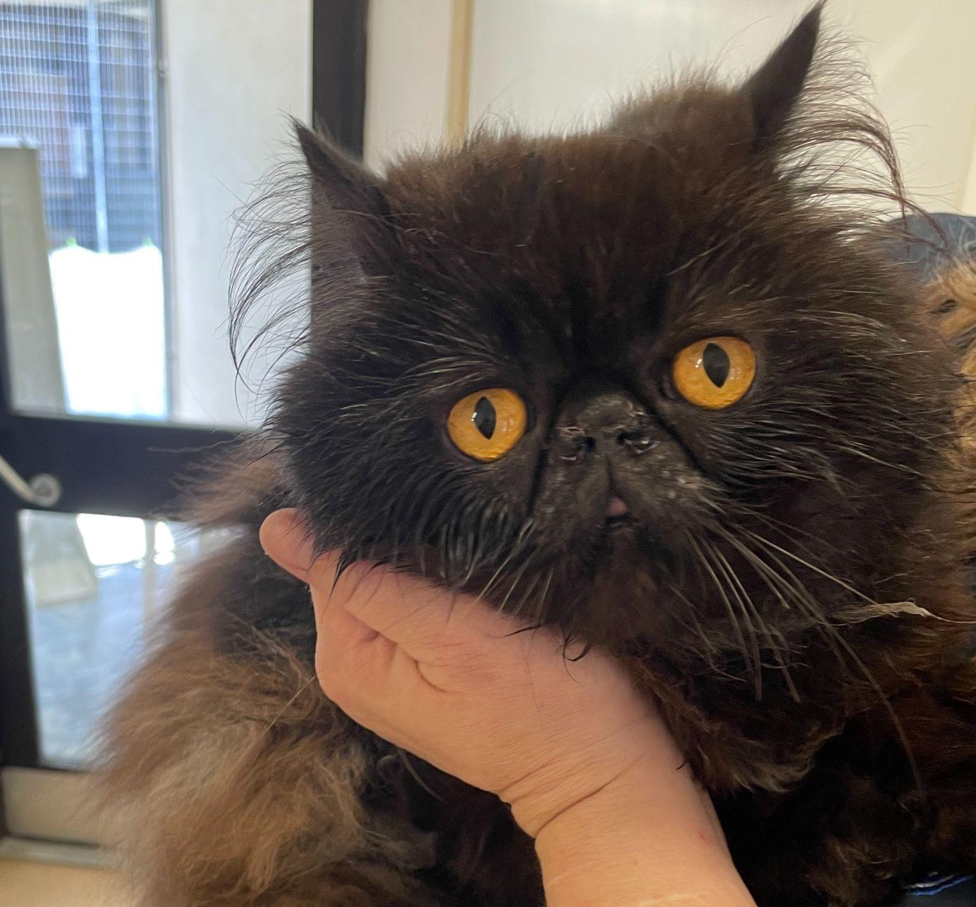
- Physical features:

- Skin sores [Yes/No]
- Difficulty walking [Y/N]
- Spinal conditions [Y/N]
- Joint pain [Y/N]
- Breathing difficulties [Y/N]
- Eye ulcers and infections [Y/N]
- Ear disease [Y/N]
- Dental problems [Y/N]
- Potential behavioural issues:

Image six
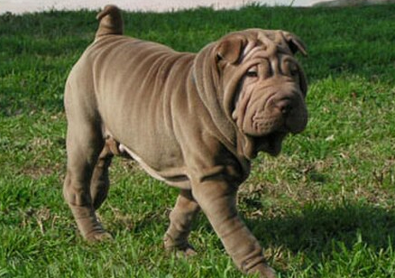
- Physical features:

- Skin sores [Yes/No]
- Difficulty walking [Y/N]
- Spinal conditions [Y/N]
- Joint pain [Y/N]
- Breathing difficulties [Y/N]
- Eye ulcers and infections [Y/N]
- Ear disease [Y/N]
- Dental problems [Y/N]
- Potential behavioural issues:

Summary of your findings

