Ethics of extreme breeding

Instructions

- Fill in the blanks to identify common issues caused by extreme breeding.
- Assess the animal images to determine whether the animals are prone to having health problems.
- Write a one-page summary of your interview findings, ensuring you answer the following questions:
  - How many respondents did you interview?
  - What do your respondents think a healthy pet looks like?
  - What did your respondents say about whether they would choose a pet with extreme features (e.g., flat-faced dogs)? Why or why not?
  - Could your respondents explain what problems (health or financial) can arise when animals are bred for extreme physical features?
  - Did your respondents think it is okay to breed pets with extreme features that compromise their health?
  - What ideas did your respondents have to encourage people to choose breeds based on good health and welfare rather than extreme features?

Common issues

Read each statement and fill in what you think are the correct missing words from the word bank below.
Word bank: coat, nostrils, tail, cropped, stomach, protruding, wrinkles, ears, temperature
- Small or closed _______ can severely impact airflow and affect a dog’s ability to exercise, regulate temperature, and sleep comfortably.
- A _______ snout helps a dog breathe properly.
- Rats use their tails for regulating their _________ but sadly some rats are bred to have no tail.
- Excessive skin and _______ around the face can lead to skin problems including infections.
- Forward folding ______ on a cat is associated with a painful condition which affects their bones and cartilage.
- Ears should never be _______ unless medically necessary.
- A cat's _______ is important for protecting the skin from ultraviolet rays.
- A _______ should be able to move freely to communicate emotions and should not be tightly docked.
- Rabbits with long hair have difficulty grooming themselves. When grooming they may ingest large amounts of hair which can cause a blockage in their ________.

Assessing health problems
- Describe the physical features of the animal.
- Determine how likely you believe each image is to show the specified health problems (it is completely okay to be unsure!).
- Consider how these health issues might affect the animal’s behaviour. Write notes on potential behavioural changes, looking out for signs of discomfort, stress, or frustration.

Image one
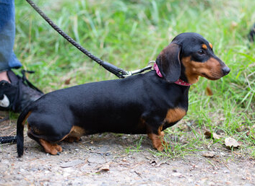
Physical features:

- Eye problems [Likely - Unlikely - Unsure]
- Ear problems [Likely - Unlikely - Unsure]
- Dental problems [Likely - Unlikely - Unsure]
- Spinal problems [Likely - Unlikely - Unsure]
- Difficulty walking and/or joint pains [Likely - Unlikely - Unsure]
- Skin sores [Likely - Unlikely - Unsure]
- Breathing difficulties [Likely - Unlikely - Unsure]

Potential behavioural issues:

Image two
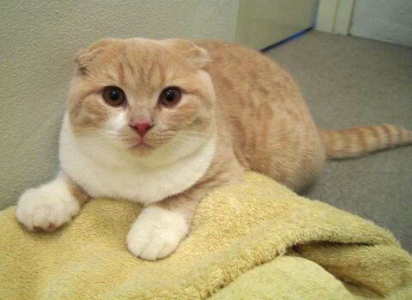
Physical features:

- Eye problems [Likely - Unlikely - Unsure]
- Ear problems [Likely - Unlikely - Unsure]
- Dental problems [Likely - Unlikely - Unsure]
- Spinal problems [Likely - Unlikely - Unsure]
- Difficulty walking and/or joint pains [Likely - Unlikely - Unsure]
- Skin sores [Likely - Unlikely - Unsure]
- Breathing difficulties [Likely - Unlikely - Unsure]

Potential behavioural issues:

Image three
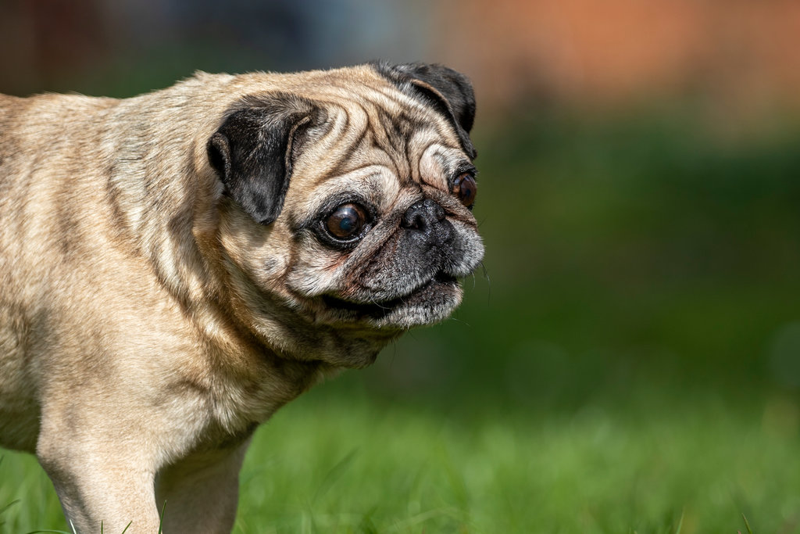
Physical features:

- Eye problems [Likely - Unlikely - Unsure]
- Ear problems [Likely - Unlikely - Unsure]
- Dental problems [Likely - Unlikely - Unsure]
- Spinal problems [Likely - Unlikely - Unsure]
- Difficulty walking and/or joint pains [Likely - Unlikely - Unsure]
- Skin sores [Likely - Unlikely - Unsure]
- Breathing difficulties [Likely - Unlikely - Unsure]

Potential behavioural issues:

Image four
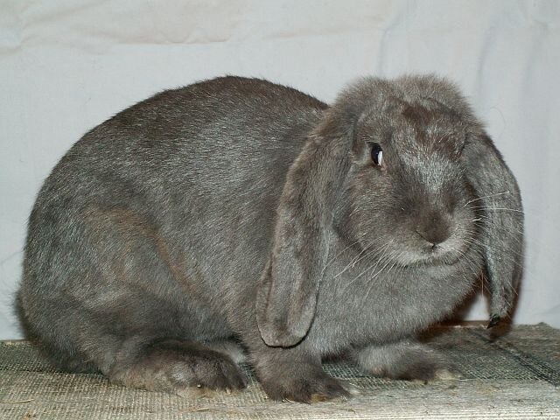
Physical features:

- Eye problems [Likely - Unlikely - Unsure]
- Ear problems [Likely - Unlikely - Unsure]
- Dental problems [Likely - Unlikely - Unsure]
- Spinal problems [Likely - Unlikely - Unsure]
- Difficulty walking and/or joint pains [Likely - Unlikely - Unsure]
- Skin sores [Likely - Unlikely - Unsure]
- Breathing difficulties [Likely - Unlikely - Unsure]

Potential behavioural issues:

Image five
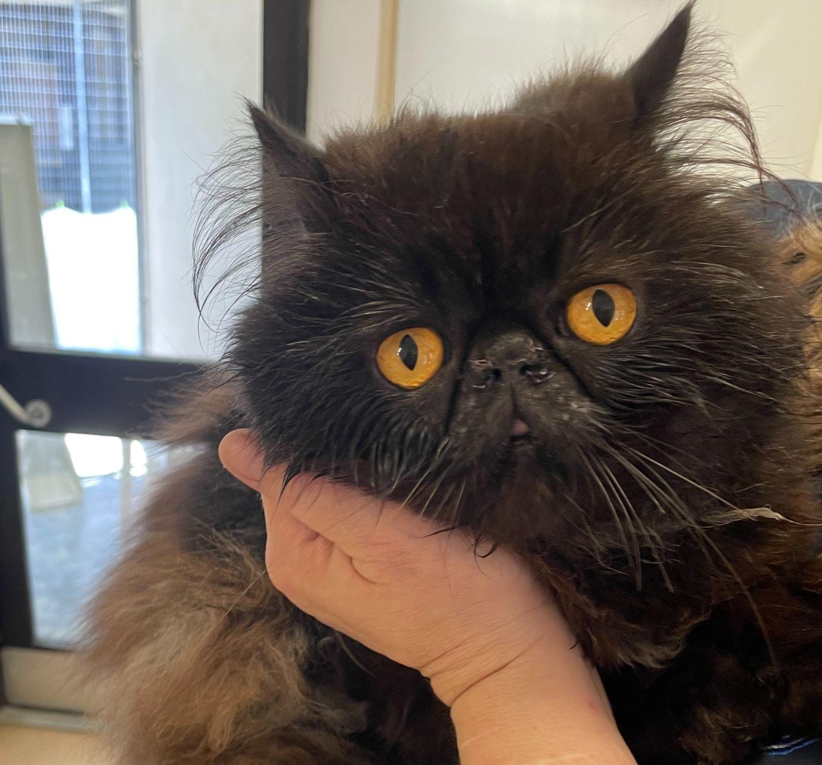
Physical features:

- Eye problems [Likely - Unlikely - Unsure]
- Ear problems [Likely - Unlikely - Unsure]
- Dental problems [Likely - Unlikely - Unsure]
- Spinal problems [Likely - Unlikely - Unsure]
- Difficulty walking and/or joint pains [Likely - Unlikely - Unsure]
- Skin sores [Likely - Unlikely - Unsure]
- Breathing difficulties [Likely - Unlikely - Unsure]

Potential behavioural issues:

Image six
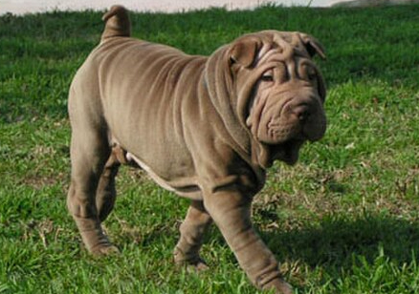
Physical features:

- Eye problems [Likely - Unlikely - Unsure]
- Ear problems [Likely - Unlikely - Unsure]
- Dental problems [Likely - Unlikely - Unsure]
- Spinal problems [Likely - Unlikely - Unsure]
- Difficulty walking and/or joint pains [Likely - Unlikely - Unsure]
- Skin sores [Likely - Unlikely - Unsure]
- Breathing difficulties [Likely - Unlikely - Unsure]

Potential behavioural issues:

Summary of your research findings

